Antonio Calvo

Sentinel_red@live.com

**Quiz around the World**

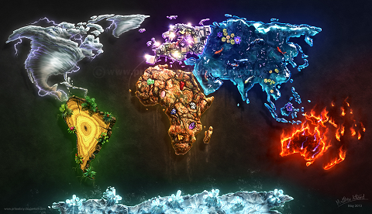

Contents

Design and Plan. 1

Specifications 5

Test Plan 12

Test Log 30

Game´s Code. 64

User Guide. 115

Extra Information 115

Evaluation. 145

***Unit 18: Procedural Programming***

***Assignment Play Game.***

***Quiz around the world***

# Design and Plan.

Game´s name; **Quiz around the Wold.**

Game has 4 levels and each level is divided into the three topics. These topics might change depend in which level the Player is.

I have chosen 8 countries of each continent and all the questions are related to these countries as well as the answers.

1. First level is Europe
   1. First topic is Food
   2. Second topic is Capitals
   3. Third topic is Geography
2. Second level is Africa
   1. First topic is Capitals
   2. Second topic is Animals
   3. Third topic is Geography
3. Second level is Asia
   1. First topic is Capitals
   2. Second topic is Geography
   3. Third topic is Monuments
4. Second level is America
   1. First topic is Food
   2. Second topic is Animals
   3. Third topic is Geography

There are 6 questions into each topic and 18 questions into each level.

The player must answer one right to pass to the next topic and so on.

The questions will pop on the screen randomly to make it more interesting

The player has three attempts to answer the question right. If the player fails, these three attempts he will be asked to carry on playing of quick the Game.

* Saying “No” the game will be over
* Saying “Yes” the player can carry on from the same topic he was playing.
* The player will be able to safe his progress every time a level is completed.

Going to the third level

Fourth Level

Third Level

Second Level

First Level

Going to the second level

Going to the fourth level

# Specifications

1. Welcome screen.
   1. First Text saying welcome to the game.
   2. Displaying the name´s game into the box and my name
   3. Black background and white font and green font for text into the box.
   4. Waiting for the player press a key.
2. Introduction Screen.
   1. Text presenting the game.
   2. Wait background and blue font.
   3. Waiting for the player press a key
3. First Level Europe.
   1. Loading bar should turn up
   2. Text explaining what first level is about.
   3. The text should be written slowly.
   4. Background aguamar and yellow fond.
   5. Waiting for the player press a key.

* Russia.
* Germany.
* France.
* Italy.
* Spain.
* Slovakia.
* UK.
* Netherlands

1. First Topic Food
   1. What the first topic is about it must be shown.
   2. Eight countries should be displayed on the screen.
   3. First question should pop on the screen
   4. Four options or two must be displayed on the screen every of them numbered
   5. A text saying how to answer must be displayed underneath the options.
   6. Only one of the is the right one
   7. The player must pick one of the number are displayed on the screen.
   8. The eight countries which are the question about it should be displayed on the screen
   9. If the player answers right he can pass to the next level. (Some answers display a short explication about the topic its talking about).
      1. Text will pop on the screen saying congratulation and the number of the correct answer.
   10. If the player answers wrongly he can two more opportunities (the question can be different every time the player fail, the question.
   11. If the player fail, these three opportunities the game will ask him if he can quick the game pressing “n” or carry on playing pressing “y”.
   12. Pressing “n” text saying thanks for playing should pop on the screen and then finish the game.
   13. If the player presses “y” he will be asked again about the same topics
   14. .
   15. Background aguamar and yellow fond.
   16. Waiting for the player press a key.
2. Topic completed
   1. When the topic is completed the player will load to the new screen.
   2. Text should pop on the screen introducing that the player is going to face in next Topic.
   3. It must say what the next topic is about.
   4. Aguamarina Black Ground and yellow font.
3. Second topic into First Level Capitals.
   1. The six countries should be displayed on the screen again.
   2. Rules are the same than before.
   3. Colours must be the same (Background and font.)
4. Third topic into First Level Geography.
   1. When the topic is completed the player will load to the new screen.
   2. Text should pop on the screen introducing that the player is going to face in this topic
   3. It must say what the next topic is about.
   4. Aguamarina Black Ground and yellow font1
   5. The six countries should be displayed on the screen again.
   6. Question should show on the screen as well as option to choose the answer.
   7. Rules are the same than before.
   8. Colours must be the same (Background and font.)
5. Second Level Africa
   1. Loading bar must be shown.
   2. Short explication about the Second Level.
   3. Same rules I have explained for the First Level
   4. Black Background and Red Font.

* Madagascar
* Morocco
* Egypt
* Zambia
* South Africa
* Congo
* Tanzania

Kenya

1. First topic into the Second Level Capitals
   1. First question should pop on the screen
   2. Four options or two must be displayed on the screen every of them numbered
   3. Only one of the is the right one
   4. The player must pick one of the number are displayed on the screen.
   5. The eight countries which are the question about it should be displayed on the screen
   6. If the player answers right he can pass to the next level. (Some answers display a short explication about the topic its talking about).
      1. Text will pop on the screen saying congratulation and the number of the correct answer.
   7. If the player answers wrongly he can two more opportunities (the question can be different every time the player fail, the question.
   8. If the player fail, these three opportunities the game will ask him if he can quick the game pressing “n” or carry on playing pressing “y”.
   9. Pressing “n” text saying thanks for playing should pop on the screen and then finish the game.
   10. If the player presses “y” he will be asked again about the same topics
   11. Black background and red fond.
   12. Waiting for the player press a key.
2. Second topic is Animals and Third Geography
   1. Everything have been explained before I would have been the same such as, rules and how the program works.
   2. Black background and red font.
   3. Between Third topic and next level Loading bar must be displayed.
3. Third Level is Asia.
   1. Text explaining what first level is about.
   2. Background Green and black fond.
   3. Waiting for the player press a key.

* India
* China
* Japan
* Nepal
* Thailand
* Saudi Arabia
* Mongolia
* Indonesia

1. First topic in Asia is Capitals, Second Topic is Geography and Third is Monuments.
   1. All of them follow the same rules explained before
   2. Eight countries should be displayed on the screen.
   3. First question should pop on the screen
   4. Four options or two must be displayed on the screen every of them numbered
   5. Only one of the is the right one
   6. The player must pick one of the number are displayed on the screen.
   7. The eight countries which are the question about it should be displayed on the screen
   8. If the player answers right he can pass to the next level. (Some answers display a short explication about the topic its talking about).
      1. Text will pop on the screen saying congratulation and the number of the correct answer.
   9. If the player answers wrongly he can two more opportunities (the question can be different every time the player fail, the question.
   10. If the player fail, these three opportunities the game will ask him if he can quick the game pressing “n” or carry on playing pressing “y”.
   11. Pressing “n” text saying thanks for playing should pop on the screen and then finish the game.
   12. If the player presses “y” he will be asked again about the same topics
   13. .
   14. Background aguamar and yellow fond.
   15. Waiting for the player press a key.
2. Important to specify
   1. The Third Level at the end of the Third Topic the loading bar will pop on the screen.
   2. Background is green and black font.

1. Fourth Level America
2. Text explaining what first level is about.
3. Background Green and black fond.
4. Waiting for the player press a key.

* Brazil
* Argentina
* Chile
* United States
* Peru
* Venezuela
* Mexico
* Canada

1. First topic in Asia is Capitals, Second Topic is Animals and Third is Monuments.
   1. All of them follow the same rules explained before
   2. Eight countries should be displayed on the screen.
   3. First question should pop on the screen
   4. Four options or two must be displayed on the screen every of them numbered
   5. Only one of the is the right one
   6. The player must pick one of the number are displayed on the screen.
   7. The eight countries which are the question about it should be displayed on the screen
   8. If the player answers right he can pass to the next level. (Some answers display a short explication about the topic its talking about).
      1. Text will pop on the screen saying congratulation and the number of the correct answer.
   9. If the player answers wrongly he can two more opportunities (the question can be different every time the player fail, the question.
   10. If the player fail, these three opportunities the game will ask him if he can quick the game pressing “n” or carry on playing pressing “y”.
   11. Pressing “n” text saying thanks for playing should pop on the screen and then finish the game.
   12. If the player presses “y” he will be asked again about the same topics
   13. .
   14. Background aguamar and yellow fond.
   15. Waiting for the player press a key.
2. Important to specify
   1. Background is red and white font.
   2. When Third level is finished, the program will load you to the final screen.
3. Final Screen
   1. Small animation
   2. Text above animation white font.
   3. Text inside the animation green font.
   4. Game Over must be shown on the screen below the animation white font.
   5. Red background

# Test Plan

|  |  |  |  |  |  |  |
| --- | --- | --- | --- | --- | --- | --- |
| ***SYSTEM NAME: C++ Program Game***  ***PROGRAM NAME: Quiz around the world.***  ***MODULE NAME: Procedural Programming.*** | | | ***VERSION NO: 1.1***  ***TESTER NAME: Antonio Calvo Moreno*** | | | ***PAGE NO: 1*** |
| *Test No.* | *Date.* | *Purpose/Type of Test* | | *Input/Filename* | *Expected Output/Filename* | |
| *Welcome Screen* | | | | | | |
| ***1*** | *29/03/2017* | *Running the Game* | | *Yes* | *Welcome screen should be shown on the screen.* | |
| **2** | *29/03/2017* | *Welcome screen is running* | | *Yes* | *It is displayed as it should* | |
| **3** | *29/03/2017* | *Checking if text is displayed* | | *Yes* | *White text out the box*  *And Green text into the box.* | |

|  |  |  |  |  |
| --- | --- | --- | --- | --- |
| **4** | *29/03/2017* | *Checking the text shown* | *Yes* | *Welcome to the Game*  *Game´s name*  *And my name is displayed.* |
| *Menu Screen* | | | | |
| **5** | *29/03/2017* | *Running the screen* | *Yes* | *The options are displayed as well as the animation.* |
| **6** | *29/03/2017* | *Checking colours* | *Yes* | *White background and blue font.* |
| **7** | *29/03/2017* | *Tree options* | *Yes* | 1. *New Game* 2. *Load Game* 3. *End the Game* |
| **8** | *29/03/2017* | *New Game working* | *Yes* | *It takes the user to the introduction screen* |
| **9** | *29/03/2017* | *Load Game working* | *Yes* | *It takes the user to the file are saved.* |

|  |  |  |  |  |
| --- | --- | --- | --- | --- |
| **10** | *29/03/2017* | *End the Game* | *Yes* | *It takes the user to the End screen where the user can back to the main menu or finish the Game.* |
| *Introduction Screen* | | | | |
| **11** | *29/03/2017* | *Running introduction Screen* | *Yes* | *It is shown on the screen.* |
| **12** | *29/03/2017* | *Checking if text is displayed* | *Yes* | *The text is displayed.* |
| **13** | *29/03/2017* | *Checking colours* | *Yes* | *White background and blue font.* |
| **14** | *29/03/2017* | *Checking load bar* | *Yes* | *Load bar is shown.* |
|  | | | | |
| **15** | *29/03/2017* | *Checking the text* | *Yes* | *The text is shown on the screen.* |
| **16** | *29/03/2017* | *Velocity of text* | *Yes* | *Text is written slowly.* |
| **17** | *29/03/2017* | *Checking what text is about* | *Yes* | *Text is about Game´s rule and what the player will find, and the three topics are set.* |

|  |  |  |  |  |
| --- | --- | --- | --- | --- |
| **18** | *29/03/2017* | *Checking colours* | *Yes* | *Aguamarina background and yellow text.* |
| *First Topic* | | | | |
| **19** | *29/03/2017* | *Checking if 8 countries are displayed* | *Yes* | *8 countries are shown* |
| **20** | *29/03/2017* | *Checking what this topic is about it is shown.* | *Yes* | *Above says “European Cousine”* |
| **21** | *29/03/2017* | *Checking if the question is shown* | *Yes* | *First question is shown on the screen.* |
| **22** | *29/03/2017* | *Checking if 4 options minima are displayed* | *Yes* | *Under the question for options are displayed.* |
| **23** | *29/03/2017* | *Checking if under the options there is a text explaining how player should answers* | *Yes* | *“Enter your answer by choosing a number between 1 to 4” it is displayed on the screen.* |
| **24** | *29/03/2017* | *Checking when the player answer 3 time wrongly the questions* | *Yes* | *Test “You have finished all your lives. Do you want to play again? (y/n)” it is shown on the screen.* |
| **25** | *29/03/2017* | *Clicking “y” when the player answer 3 times the wrongly question* | *Yes* | *The new question pop on the screen immediately.* |
| **26** | *29/03/2017* | *Clicking “n” when the player answer 3 times the wrongly question.* | *Yes* | *It takes the player out the Game.* |
| **27** | *29/03/2017* | *Checking the colours are Aguamarina and yellow font* | *Yes* | *Aguamarina Background and yellow font.4* |
| **28** | *29/03/2017* | *Checking when the answer is correctly if the number of the answer and the answer are displayed* | *Yes* | *Number of answer and the answer are displayed on the screen.* |
| *Second Topic* | | | | |
| **29** | *29/03/2017* | *Checking if information about second topic is displayed on the screen* | *Yes* | *The information about second topic is displayed.*  *“Second topic” “Capital in Europe”* |
| **30** | *29/03/2017* | *Checking colours* | *Yes* | *Aguamarina background and yellow font.* |
| **31** | *29/03/2017* | *Checking if 8 countries are displayed* | *Yes* | *8 countries are shown* |
| **32** | *29/03/2017* | *Checking if the question is shown* | *Yes* | *First question is shown on the screen.* |
| **33** | *29/03/2017* | *Checking if 4 options minima are displayed* | *Yes* | *Under the question for options are displayed.* |
| **34** | *29/03/2017* | *Checking if under the options there is a text explaining how player must answers* | *Yes* | *“Enter your answer by choosing a number between 1 to 4” it is displayed on the screen.* |
| **35** | *29/03/2017* | *Checking when the player answer 3 time wrongly the questions* | *Yes* | *Test “You have finished all your lives. Do you want to play again? (y/n)” it is shown on the screen.* |
| **36** | *29/03/2017* | *Clicking “y” when the player answer 3 times the wrongly question* | *Yes* | *The new question pop on the screen immediately.* |
| **37** | *29/03/2017* | *Clicking “n” when the player answer 3 times the wrongly question.* | *Yes* | *It takes the player out the Game.* |
| **38** | *29/03/2017* | *Checking the colours are Aguamarina and yellow font* | *Yes* | *Aguamarina Background and yellow font.4* |
| **39** | *29/03/2017* | *Checking when the answer is correctly if the number of the answer and the answer are displayed* | *Yes* | *Number of answer and the answer are displayed on the screen.* |
| *Third Topic* | | | | |
| **40** | *29/03/2017* | *Checking if information about second topic is displayed on the screen* | *Yes* | *The information about second topic is displayed.*  *“Second topic” “Geography in Europe”* |
| **41** | *29/03/2017* | *Checking colours* | *Yes* | *Aguamarina background and yellow font.* |
| **42** | *29/03/2017* | *Checking if 8 countries are displayed* | *Yes* | *8 countries are shown* |
| **43** | *29/03/2017* | *Checking if the question is shown* | *Yes* | *First question is shown on the screen.* |
| **44** | *29/03/2017* | *Checking if 4 options minima are displayed* | *Yes* | *Under the question for options are displayed.* |
| **45** | *29/03/2017* | *Checking if under the options there is a text explaining how player should answers* | *Yes* | *“Enter your answer by choosing a number between 1 to 4” it is displayed on the screen.* |
| **46** | *29/03/2017* | *Checking when the player answer 3 time wrongly the questions* | *Yes* | *Test “You have finished all your lives. Do you want to play again? (y/n)” it is shown on the screen.* |
| **47** | *29/03/2017* | *Clicking “y” when the player answer 3 times the wrongly question* | *Yes* | *The new question pop on the screen immediately.* |
| **48** | *29/03/2017* | *Clicking “y” when the player answer 3 times the wrongly question* | *Yes* | *The new question pop on the screen immediately.* |
| **49** | *29/03/2017* | *Clicking “n” when the player answer 3 times the wrongly question.* | *Yes* | *It takes the player out the Game.* |
| **50** | *29/03/2017* | *Checking the colours are Aguamarina and yellow font* | *Yes* | *Aguamarina Background and yellow font.4* |
| **51** | *29/03/2017* | *Checking when the answer is correctly if the number of the answer and the answer are displayed* | *Yes* | *Number of answer and the answer are displayed on the screen.* |
| **52** | *29/03/2017* | *Checking load bar* | *Yes* | *Load bar is shown.* |
| *Second Level Africa* | | | | |
| **53** | *29/03/2017* | *Checking the text* | *Yes* | *The text is shown on the screen.* |
| **54** | *29/03/2017* | *Velocity of text* | *Yes* | *Text is written slowly.* |
| **55** | *29/03/2017* | *Checking what text is about* | *Yes* | *Text remain Game´s rule and what the player will find, and the three topics are set. Capital, Animals and Geography* |
| **56** | *29/03/2017* | *Checking colours* | *Yes* | *Black background and red text.* |
| *SL First Topic* | | | | |
| **57** | *29/03/2017* | *Checking if 8 countries are displayed* | *Yes* | *8 countries are shown* |
| **58** | *29/03/2017* | *Checking what this topic is about it is shown.* | *Yes* | *Above says “Capital of Africa” and the level you are “Second level”* |
| **59** | *29/03/2017* | *Checking if the question is shown* | *Yes* | *First question is shown on the screen.* |
| **60** | *29/03/2017* | *Checking if 4 options minimums are displayed* | *Yes* | *Under the question for options are displayed.* |
| **61** | *29/03/2017* | *Checking if under the options there is a text explaining how player should answers* | *Yes* | *“Enter your answer by choosing a number between 1 to 4” it is displayed on the screen.* |
| **62** | *29/03/2017* | *Checking when the player answer 3 time wrongly the questions* | *Yes* | *Test “You have finished all your lives. Do you want to play again? (y/n)” it is shown on the screen.* |
| **63** | *29/03/2017* | *Clicking “y” when the player answer 3 times the wrongly question* | *Yes* | *The new question pop on the screen immediately.* |
| **64** | *29/03/2017* | *Clicking “n” when the player answer 3 times the wrongly question.* | *Yes* | *It takes the player out the Game.* |
| **65** | *29/03/2017* | *Checking the colours are Black and red font* | *Yes* | *Black Background and Red font.4* |
| **66** | *29/03/2017* | *Checking when the answer is correctly if the number of the answer and the answer are displayed* | *Yes* | *Number of answer and the answer are displayed on the screen.* |
| *SL Second Topic* | | | | |
| **64** | *29/03/2017* | *Checking if 8 countries are displayed* | *Yes* | *8 countries are shown* |
| **65** | *29/03/2017* | *Checking what this topic is about it is shown.* | *Yes* | *Above says “Animals in Africa”* |
| **66** | *29/03/2017* | *Checking if the question is shown* | *Yes* | *First question is shown on the screen.* |
| **67** | *29/03/2017* | *Checking if 4 options minimums are displayed* | *Yes* | *Under the question for options are displayed.* |
| **68** | *29/03/2017* | *Checking if under the options there is a text explaining how player should answers* | *Yes* | *“Enter your answer by choosing a number between 1 to 4” it is displayed on the screen.* |
| **69** | *29/03/2017* | *Checking when the player answer 3 time wrongly the questions* | *Yes* | *Test “You have finished all your lives. Do you want to play again? (y/n)” it is shown on the screen.* |
| **70** | *29/03/2017* | *Clicking “y” when the player answer 3 times the wrongly question* | *Yes* | *The new question pop on the screen immediately.* |
| **71** | *29/03/2017* | *Clicking “n” when the player answer 3 times the wrongly question.* | *Yes* | *It takes the player out the Game.* |
| **73** | *29/03/2017* | *Checking the colours are Black and red font* | *Yes* | *Black Background and Red font.4* |
| **74** | *29/03/2017* | *Checking when the answer is correctly if the number of the answer and the answer are displayed* | *Yes* | *Number of answer and the answer are displayed on the screen.* |
| *SL Third**topic* | | | | |
| **76** | *29/03/2017* | *Checking if 8 countries are displayed* | *Yes* | *8 countries are shown* |
| **77** | *29/03/2017* | *Checking what this topic is about it is shown.* | *Yes* | *Above says “Africa Geography”* |
| **78** | *29/03/2017* | *Checking if the question is shown* | *Yes* | *First question is shown on the screen.* |
| **80** | *29/03/2017* | *Checking if 4 options minimums are displayed* | *Yes* | *Under the question for options are displayed.* |
| **81** | *29/03/2017* | *Checking if under the options there is a text explaining how player should answers* | *Yes* | *“Enter your answer by choosing a number between 1 to 4” it is displayed on the screen.* |
| **82** | *29/03/2017* | *Checking when the player answer 3 time wrongly the questions* | *Yes* | *Test “You have finished all your lives. Do you want to play again? (y/n)” it is shown on the screen.* |
| **83** | *29/03/2017* | *Clicking “y” when the player answer 3 times the wrongly question* | *Yes* | *The new question pop on the screen immediately.* |
| **84** | *29/03/2017* | *Clicking “n” when the player answer 3 times the wrongly question.* | *Yes* | *It takes the player out the Game.* |
| **85** | *29/03/2017* | *Checking the colours are Black and red font* | *Yes* | *Black Background and Red font.4* |
| **86** | *29/03/2017* | *Checking when the answer is correctly if the number of the answer and the answer are displayed* | *Yes* | *Number of answer and the answer are displayed on the screen.* |
| **87** | *29/03/2017* | *Checking load bar* | *Yes* | *Load bar is shown.* |
| *Third Level Asia* | | | | |
| **89** | *29/03/2017* | *Checking the text* | *Yes* | *The text is shown on the screen.* |
| **90** | *29/03/2017* | *Velocity of text* | *Yes* | *Text is written slowly.* |
| **91** | *29/03/2017* | *Checking what text is about* | *Yes* | *Text remain Game´s rule and what the player will find, and the three topics are set. Capital, Animals and Geography* |
| **92** | *29/03/2017* | *Checking colours* | *Yes* | *Yellow background and black text.* |

|  |  |  |  |  |
| --- | --- | --- | --- | --- |
| *Th L First Topic* | | | | |
| **93** | *29/03/2017* | *Checking if 8 countries are displayed* | *Yes* | *8 countries are shown* |
| **94** | *29/03/2017* | *Checking what this topic is about it is shown.* | *Yes* | *Above says “Third Level Asia” and “First Topic Capitals”* |
| **95** | *29/03/2017* | *Checking if the question is shown* | *Yes* | *First question is shown on the screen.* |
| **96** | *29/03/2017* | *Checking if 4 options minimums are displayed* | *Yes* | *Under the question for options are displayed.* |
| **97** | *29/03/2017* | *Checking if under the options there is a text explaining how player should answers* | *Yes* | *“Enter your answer by choosing a number between 1 to 4” it is displayed on the screen.* |
| **97** | *29/03/2017* | *Checking when the player answer 3 time wrongly the questions* | *Yes* | *Test “You have finished all your lives. Do you want to play again? (y/n)” it is shown on the screen.* |
| **98** | *29/03/2017* | *Clicking “y” when the player answer 3 times the wrongly question* | *Yes* | *The new question pop on the screen immediately.* |
| **99** | *29/03/2017* | *Clicking “y” when the player answer 3 times the wrongly question* | *Yes* | *The new question pop on the screen immediately.* |
| **100** | *29/03/2017* | *Clicking “n” when the player answer 3 times the wrongly question.* | *Yes* | *It takes the player out the Game.* |
| **101** | *29/03/2017* | *Checking the colours are Black and red font* | *Yes* | *Yellow Background and Black font.4* |
| **102** | *29/03/2017* | *Checking when the answer is correctly if the number of the answer and the answer are displayed* | *Yes* | *Number of answer and the answer are displayed on the screen.* |

|  |  |  |  |  |
| --- | --- | --- | --- | --- |
| *Th L Second Topic* | | | | |
| **103** | *29/03/2017* | *Checking if 8 countries are displayed* | *Yes* | *8 countries are shown* |
| **104** | *29/03/2017* | *Checking what this topic is about it is shown.* | *Yes* | *Above says “Second Topic Geography”* |
| **105** | *29/03/2017* | *Checking if the question is shown* | *Yes* | *First question is shown on the screen.* |
| **106** | *29/03/2017* | *Checking if 4 options minimums are displayed* | *Yes* | *Under the question for options are displayed.* |
| **107** | *29/03/2017* | *Checking if under the options there is a text explaining how player should answers* | *Yes* | *“Enter your answer by choosing a number between 1 to 4” it is displayed on the screen.* |
| **108** | *29/03/2017* | *Checking when the player answer 3 time wrongly the questions* | *Yes* | *Test “You have finished all your lives. Do you want to play again? (y/n)” it is shown on the screen.* |
| **109** | *29/03/2017* | *Clicking “y” when the player answer 3 times the wrongly question* | *Yes* | *The new question pop on the screen immediately.* |
| **110** | *29/03/2017* | *Clicking “y” when the player answer 3 times the wrongly question* | *Yes* | *The new question pop on the screen immediately.* |
| **111** | *29/03/2017* | *Clicking “n” when the player answer 3 times the wrongly question.* | *Yes* | *It takes the player out the Game.* |
| **112** | *29/03/2017* | *Checking the colours are Black and red font* | *Yes* | *Yellow Background and Black font.4* |
| **113** | *29/03/2017* | *Checking when the answer is correctly if the number of the answer and the answer are displayed* | *Yes* | *Number of answer and the answer are displayed on the screen.* |
| *Th L Third Topic* | | | | |
| **114** | *29/03/2017* | *Checking if 8 countries are displayed* | *Yes* | *8 countries are shown* |
| **115** | *29/03/2017* | *Checking what this topic is about it is shown.* | *Yes* | *Above says “Third Topic Monuments”* |
| **116** | *29/03/2017* | *Checking if the question is shown* | *Yes* | *First question is shown on the screen.* |
| **117** | *29/03/2017* | *Checking if 4 options minimums are displayed* | *Yes* | *Under the question for options are displayed.* |
| **118** | *29/03/2017* | *Checking if under the options there is a text explaining how player should answers* | *Yes* | *“Enter your answer by choosing a number between 1 to 4” it is displayed on the screen.* |
| **119** | *29/03/2017* | *Checking when the player answer 3 time wrongly the questions* | *Yes* | *Test “You have finished all your lives. Do you want to play again? (y/n)” it is shown on the screen.* |
| **120** | *29/03/2017* | *Clicking “y” when the player answer 3 times the wrongly question* | *Yes* | *The new question pop on the screen immediately.* |
| **121** | *29/03/2017* | *Clicking “y” when the player answer 3 times the wrongly question* | *Yes* | *The new question pop on the screen immediately.* |
| **122** | *29/03/2017* | *Clicking “n” when the player answer 3 times the wrongly question.* | *Yes* | *It takes the player out the Game.* |
| **123** | *29/03/2017* | *Checking the colours are Yellow and Black font* | *Yes* | *Yellow Background and Black font.4* |
| **124** | *29/03/2017* | *Checking when the answer is correctly if the number of the answer and the answer are displayed* | *Yes* | *Number of answer and the answer are displayed on the screen.* |
| **125** | *29/03/2017* | *Checking load bar* | *Yes* | *Load bar is shown.* |
| *Fourth Level America* | | | | |
| **126** | *29/03/2017* | *Checking the text* | *Yes* | *The text is shown on the screen.* |
| **127** | *29/03/2017* | *Velocity of text* | *Yes* | *Text is written slowly.* |
| **128** | *29/03/2017* | *Checking what text is about* | *Yes* | *Text remain Game´s rule and what the player will find, and the three topics are set. Food, Animal, Geography* |
| **129** | *29/03/2017* | *Checking colours* | *Yes* | *Red background and White text.* |
| *Fth First Topic* | | | | |
| **130** | *29/03/2017* | *Checking if 8 countries are displayed* | *Yes* | *8 countries are shown* |
| **131** | *29/03/2017* | *Checking what this topic is about it is shown.* | *Yes* | *Above says “Fourth level” ““First Topic Food”* |
| **132** | *29/03/2017* | *Checking if the question is shown* | *Yes* | *First question is shown on the screen.* |
| **133** | *29/03/2017* | *Checking if 4 options minimums are displayed* | *Yes* | *Under the question for options are displayed.* |
| **134** | *29/03/2017* | *Checking if under the options there is a text explaining how player should answers* | *Yes* | *“Enter your answer by choosing a number between 1 to 4” it is displayed on the screen.* |
| **135** | *29/03/2017* | *Checking when the player answer 3 time wrongly the questions* | *Yes* | *Test “You have finished all your lives. Do you want to play again? (y/n)” it is shown on the screen.* |
| **136** | *29/03/2017* | *Clicking “y” when the player answer 3 times the wrongly question* | *Yes* | *The new question pop on the screen immediately.* |
| **137** | *29/03/2017* | *Clicking “y” when the player answer 3 times the wrongly question* | *Yes* | *The new question pop on the screen immediately.* |
| **138** | *29/03/2017* | *Clicking “n” when the player answer 3 times the wrongly question.* | *Yes* | *It takes the player out the Game.* |
| **139** | *29/03/2017* | *Checking the colours are Yellow and Black font* | *Yes* | *Yellow Background and Black font.4* |
| **140** | *29/03/2017* | *Checking when the answer is correctly if the number of the answer and the answer are displayed* | *Yes* | *Number of answer and the answer are displayed on the screen.* |
| *Fth Second Topic* | | | | |
| **141** | *29/03/2017* | *Checking if 8 countries are displayed* | *Yes* | *8 countries are shown* |
| **142** | *29/03/2017* | *Checking what this topic is about it is shown.* | *Yes* | *Above says “Second Topic Animals”* |
| **143** | *29/03/2017* | *Checking if the question is shown* | *Yes* | *First question is shown on the screen.* |
| **144** | *29/03/2017* | *Checking if 4 options minimums are displayed* | *Yes* | *Under the question for options are displayed.* |
| **145** | *29/03/2017* | *Checking if under the options there is a text explaining how player should answers* | *Yes* | *“Enter your answer by choosing a number between 1 to 4” it is displayed on the screen.* |
| **146** | *29/03/2017* | *Checking when the player answer 3 time wrongly the questions* | *Yes* | *Test “You have finished all your lives. Do you want to play again? (y/n)” it is shown on the screen.* |
| **147** | *29/03/2017* | *Clicking “y” when the player answer 3 times the wrongly question* | *Yes* | *The new question pop on the screen immediately.* |
| **148** | *29/03/2017* | *Clicking “y” when the player answer 3 times the wrongly question* | *Yes* | *The new question pop on the screen immediately.* |
| **149** | *29/03/2017* | *Clicking “n” when the player answer 3 times the wrongly question.* | *Yes* | *It takes the player out the Game.* |
| **150** | *29/03/2017* | *Checking the colours are Yellow and Black font* | *Yes* | *Yellow Background and Black font.4* |
| **151** | *29/03/2017* | *Checking when the answer is correctly if the number of the answer and the answer are displayed* | *Yes* | *Number of answer and the answer are displayed on the screen.* |
| *Fth Third Topic* | | | | |
| **152** | *29/03/2017* | *Checking if 8 countries are displayed* | *Yes* | *8 countries are shown* |
| **153** | *29/03/2017* | *Checking what this topic is about it is shown.* | *Yes* | *Above says “Third Topic Geography”* |
| **154** | *29/03/2017* | *Checking if the question is shown* | *Yes* | *First question is shown on the screen.* |
| **155** | *29/03/2017* | *Checking if 4 options minimums are displayed* | *Yes* | *Under the question for options are displayed.* |
| **156** | *29/03/2017* | *Checking if under the options there is a text explaining how player should answers* | *Yes* | *“Enter your answer by choosing a number between 1 to 4” it is displayed on the screen.* |
| **157** | *29/03/2017* | *Checking when the player answer 3 time wrongly the questions* | *Yes* | *Test “You have finished all your lives. Do you want to play again? (y/n)” it is shown on the screen.* |
| **158** | *29/03/2017* | *Clicking “y” when the player answer 3 times the wrongly question* | *Yes* | *The new question pop on the screen immediately.* |
| **158** | *29/03/2017* | *Clicking “y” when the player answer 3 times the wrongly question* | *Yes* | *The new question pop on the screen immediately.* |
| **160** | *29/03/2017* | *Clicking “n” when the player answer 3 times the wrongly question.* | *Yes* | *It takes the player out the Game.* |
| **161** | *29/03/2017* | *Checking the colours are Yellow and Black font* | *Yes* | *Yellow Background and Black font.4* |
| **162** | *29/03/2017* | *Checking when the answer is correctly if the number of the answer and the answer are displayed* | *Yes* | *Number of answer and the answer are displayed on the screen.* |
| *Game Over Screen* | | | | |
| **163** | *29/03/2017* | *Text above the animation in white must be displayed* | *Yes* | *Text is displayed in white* |
| **164** | *29/03/2017* | *Animation must make a square* | *Yes* | *Animation is shown* |
| **165** | *29/03/2017* | *Text in green must be shown* | *Yes* | *Into the animation square there is text in green.* |
| **166** | *29/03/2017* | *Below the animation must be a text saying, “Game Over”* | *Yes* | *Below the animation there is a text saying game over.* |
| *End Screen* | | | | |
| **167** | *29/03/2017* | *Running the screen* | *Yes* | *The screen is displayed* |
| **168** | *29/03/2017* | *Checking colours* | *Yes* | *Red background and white text.* |
| **169** | *29/03/2017* | *If the user answer “yes”, the games finished* | *Yes* | *The Games is finished* |
| **170** | *29/03/2017* | *When the user answer “yes” animation is displayed with a text “See you alligator” and end the game* | *Yes* | *The animation is displayed with the correct text.* |
| **180** | *29/03/2017* | *If the user answer “n”. He should be placed to the Main Menu* | *Yes* | *The user is taken to the Main Menu.* |

# Test Log

|  |  |  |  |  |  |  |
| --- | --- | --- | --- | --- | --- | --- |
| ***SYSTEM NAME: C++ Program Game***  ***PROGRAM NAME: Quiz around the world.***  ***MODULE NAME: Procedural Programming.*** | | | ***VERSION NO: 1.1***  ***TESTER NAME: Antonio Calvo Moreno*** | | | ***PAGE NO: 1*** |
| *Test No.* | *Date.* | *Actual Output* | | *Success* | *Comments* | |
| *Welcome Screen* | | | | | | |
| ***1*** | *29/03/2017* | *Running the Game*  *Welcome screen is running*  *Text out and inside the code is displayed*  *Checking if the color of background and text are correct.* | | *Yes* | *Welcome screen should be shown on the screen.*  *It is displayed as it should*  *White text out the box*  *Welcome to the Game*  *Game´s name*  *And my name is displayed.*  *Everything is as it should be.* | |

|  |  |  |  |  |
| --- | --- | --- | --- | --- |
| *Main Menu* | | | | |
| **2** | *29/03/2017* | *Checking if text is displayed* *Checking colours* | *Yes* | *The colours are corrects* |
| **3** | *29/03/2017* | *Checking if 3 options are displayed on the screen* | *Yes* | * *New Game* * *Load Game* * *End the Game* |
| **4** | *29/03/2017* | *Enter option one working* | *Yes* |  |
| **5** | *29/03/2017* | *Enter option two working* | *Yes* | *It takes the user to read file* |

|  |  |  |  |  |
| --- | --- | --- | --- | --- |
| **6** | *29/03/2017* | *Enter option three* | *Yes* | *It takes the user to End Screen* |
| *Introduction Screen* | | | | |
| **7** | *29/03/2017* | *Checking if text is displayed* *Checking colours* | *Yes* | *Text and colours are corrects.* |
| **8** | *29/03/2017* | *Load bar is shown* | *Yes* | *It is shown as it should* |
| **9** |  |  |  |  |
| *Frist Level Europe* | | | | |
| **10** | *29/03/2017* | *Text must be displayed*  *Slow velocity of the text*  *Text about presentation about presentation of First Level Europe*  *Font will be yellow and green back ground* | *Yes* | *Test is shown and slow velocity.*  *Also background and font colors are correct.* |
| *First Topic* | | | | |
| **11** | *29/03/2017* | *8 countries are displayed* *Topic about*  *Checking colours* | *Yes* | *8 countries displayed correctly*  *European cousine topic.*  *Also, Colours are correct*  *Background – Aguamarina*  *Font - Yellow* |
| **12** | *29/03/2017* | *Question must be shown* *4 or two options must be displayed* | *Yes* | *Question and 4 option to answer are displayed.* |
| **13** | *29/03/2017* | *Answering 3 times wrongly a message must be displayed offering to continue playing clicking “y” or quick the Game Clicking “n”* | *Yes* | *It is displayed correctly. Pressing “y” will continue playing but pressing “n” the player will quick the Game.* |
| **14** | *29/03/2017* | *When answer is incorrect a message should pop on the screen saying that and offering to try again.* | *Yes* | *Text and option to play again is displayed correctly* |
| **15** | *29/03/2017* | *When answer is correctly answered, a message will be shown on the screen saying the correct and normally a short extra information about the answer.* | *Yes* | *Number of correct answer is correct and a short explication about the answer it is shown too.* |
| *Second Topic Africa* | | | | |
| **16** | *29/03/2017* | *A screen saying what is the next topic about will be displayed* | *yes* | *It is displayed as it should.*  *Capitals* |
| **17** | *29/03/2017* | *8 countries are displayed* *Checking colours* | *Yes* | *8 countries displayed correctly*  *Also, Colours are correct*  *Background – Aguamarina*  *Font - Yellow* |
| **18** | *29/03/2017* | *Question must be shown* *4 or two options must be displayed* | *Yes* | *Question and 4 option to answer are displayed.* |
| **19** | *29/03/2017* | *Answering 3 times wrongly a message must be displayed offering to continue playing clicking “y” or quick the Game Clicking “n”* | *Yes* | *It is displayed correctly. Pressing “y” will continue playing but pressing “n” the player will quick the Game.* |
| **20** | *29/03/2017* | *When answer is incorrect a message should pop on the screen saying that and offering to try again.* | *Yes* | *Text and option to play again is displayed correctly* |
| **21** | *29/03/2017* | *When answer is correctly answered, a message will be shown on the screen saying the correct and normally a short extra information about the answer.* | *Yes* | *Number of correct answer is correct and a short explication about the answer it is shown too.* |
| **22** |  |  |  |  |
| *Third Topic* | | | | |
| **23** | *29/03/2017* | *A screen saying what is the next topic about will be displayed* | *yes* | *It is displayed as it should.*  *Geography* |
| **24** | *29/03/2017* | *8 countries are displayed* *Checking colours* | *Yes* | *8 countries displayed correctly*  *Also, Colours are correct*  *Background – Aguamarina*  *Font - Yellow* |
| **25** | *29/03/2017* | *Question must be shown* *4 or two options must be displayed* | *Yes* | *Question and 4 option to answer are displayed.* |
| **25** | *29/03/2017* | *Answering 3 times wrongly a message must be displayed offering to continue playing clicking “y” or quick the Game Clicking “n”* | *Yes* | *It is displayed correctly. Pressing “y” will continue playing but pressing “n” the player will quick the Game.* |
| **26** | *29/03/2017* | *When answer is incorrect a message should pop on the screen saying that and offering to try again.* | *Yes* | *Text and option to play again is displayed correctly* |
| **27** | *29/03/2017* | *When answer is correctly answered, a message will be shown on the screen saying the correct and normally a short extra information about the answer.* | *Yes* | *Number of correct answer is correct and a short explication about the answer it is shown too.* |
| **28** | *29/03/2017* | *Passing between 3 topics to Second Level load bar must be shown.* | *Yes* | *Load bar is shown as it should.* |
| **30** |  |  |  |  |
| *Second Level.* | | | | |
| **31** | *29/03/2017* | *Text must be displayed*  *Slow velocity of the text*  *Text about presentation about presentation of Second Level*  *Font will be red and black background* | *Yes* | *Test is shown and slow velocity.*  *Also background and font colors are correct.* |
| **32** |  |  |  |  |
| *SL First Topic* | | | | |
| **33** | *29/03/2017* | *8 countries are displayed* *Topic about*  *Checking colours* | *Yes* | *8 countries displayed correctly*  *Capitals of Africa.*  *Also, Colours are correct*  *Background – Black*  *Font - Red* |
| **34** | *29/03/2017* | *Question must be shown* *4 or two options must be displayed* | *Yes* | *Question and 4 option to answer are displayed.* |
| **35** | *29/03/2017* | *Answering 3 times wrongly a message must be displayed offering to continue playing clicking “y” or quick the Game Clicking “n”* | *Yes* | *It is displayed correctly. Pressing “y” will continue playing but pressing “n” the player will quick the Game.* |
| **36** | *29/03/2017* | *When answer is incorrect a message should pop on the screen saying that and offering to try again.* | *Yes* | *Text and option to play again is displayed correctly* |
| **37** | *29/03/2017* | *When answer is correctly answered, a message will be shown on the screen saying the correct and normally a short extra information about the answer.* | *Yes* | *Number of correct answer is correct and a short explication about the answer it is shown too.* |
| *SL Second Topic* | | | | |
| **38** | *29/03/2017* | *A screen saying what is the next topic about will be displayed* | *yes* | *It is displayed as it should.*  *Animals of Africa* |
| **39** | *29/03/2017* | *8 countries are displayed* *Checking colours* | *Yes* | *8 countries displayed correctly*  *Also, Colours are correct*  *Background – Black*  *Font – Red* |
| **40** | *29/03/2017* | *Question must be shown* *4 or two options must be displayed* | *Yes* | *Question and 4 option to answer are displayed.* |
| **41** | *29/03/2017* | *Answering 3 times wrongly a message must be displayed offering to continue playing clicking “y” or quick the Game Clicking “n”* | *Yes* | *It is displayed correctly. Pressing “y” will continue playing but pressing “n” the player will quick the Game.* |
| **42** | *29/03/2017* | *When answer is incorrect a message should pop on the screen saying that and offering to try again.* | *Yes* | *Text and option to play again is displayed correctly* |
| **43** | *29/03/2017* | *When answer is correctly answered, a message will be shown on the screen saying the correct and normally a short extra information about the answer.* | *Yes* | *Number of correct answer is correct and a short explication about the answer it is shown too.* |
| *SL Third Topic* | | | | |
| **44** | *29/03/2017* | *A screen saying what is the next topic about will be displayed* | *yes* | *It is displayed as it should.*  *Geography* |
| **45** | *29/03/2017* | *8 countries are displayed* *Checking colours* | *Yes* | *8 countries displayed correctly*  *Also, Colours are correct*  *Background – Black*  *Font – Red* |
| **46** | *29/03/2017* | *Question must be shown* *4 or two options must be displayed* | *Yes* | *Question and 4 option to answer are displayed.* |
| **47** | *29/03/2017* | *Answering 3 times wrongly a message must be displayed offering to continue playing clicking “y” or quick the Game Clicking “n”* | *Yes* | *It is displayed correctly. Pressing “y” will continue playing but pressing “n” the player will quick the Game.* |
| **48** | *29/03/2017* | *When answer is incorrect a message should pop on the screen saying that and offering to try again.* | *Yes* | *Text and option to play again is displayed correctly* |
| **49** | *29/03/2017* | *When answer is correctly answered, a message will be shown on the screen saying the correct and normally a short extra information about the answer.* | *Yes* | *Number of correct answer is correct and a short explication about the answer it is shown too.* |
| **50** | *29/03/2017* | *Passing between 3 topics to Third Level load bar must be shown.* | *Yes* | *Load bar is shown as it should.* |
| **51** |  |  |  |  |
| *Third Level Asia* | | | | |
| **52** | *29/03/2017* | *Text must be displayed*  *Slow velocity of the text*  *Text about presentation about presentation of Third Level*  *Font will be Black and Yellow background* | *Yes* | *Test is shown and slow velocity.*  *Also background and font colors are correct.* |
| *ThL First Topic* | | | | |
| **53** | *29/03/2017* | *8 countries are displayed* *Topic about*  *Checking colours* | *Yes* | *8 countries displayed correctly*  *Capitals of Asia*  *Also, Colours are correct*  *Background – Yellow*  *Font - Black* |
| **54** | *29/03/2017* | *Question must be shown* *4 or two options must be displayed* | *Yes* | *Question and 4 option to answer are displayed.* |
| **55** | *29/03/2017* | *Answering 3 times wrongly a message must be displayed offering to continue playing clicking “y” or quick the Game Clicking “n”* | *Yes* | *It is displayed correctly. Pressing “y” will continue playing but pressing “n” the player will quick the Game.* |
| **56** | *29/03/2017* | *When answer is incorrect a message should pop on the screen saying that and offering to try again.* | *Yes* | *Text and option to play again is displayed correctly* |
| **57** | *29/03/2017* | *When answer is correctly answered, a message will be shown on the screen saying the correct and normally a short extra information about the answer.* | *Yes* | *Number of correct answer is correct and a short explication about the answer it is shown too.* |
| *ThL Second Topic* | | | | |
| **58** | *29/03/2017* | *A screen saying what is the next topic about will be displayed* | *yes* | *It is displayed as it should.*  *Geography* |
| **59** | *29/03/2017* | *8 countries are displayed* *Topic about*  *Checking colours* | *Yes* | *8 countries displayed correctly*  *Also, Colours are correct*  *Background – Yellow*  *Font - Black* |
| **60** | *29/03/2017* | *Question must be shown* *4 or two options must be displayed* | *Yes* | *Question and 4 option to answer are displayed.* |
| **61** | *29/03/2017* | *Answering 3 times wrongly a message must be displayed offering to continue playing clicking “y” or quick the Game Clicking “n”* | *Yes* | *It is displayed correctly. Pressing “y” will continue playing but pressing “n” the player will quick the Game.* |
| **62** | *29/03/2017* | *When answer is incorrect a message should pop on the screen saying that and offering to try again.* | *Yes* | *Text and option to play again is displayed correctly* |
| **63** | *29/03/2017* | *When answer is correctly answered, a message will be shown on the screen saying the correct and normally a short extra information about the answer.* | *Yes* | *Number of correct answer is correct and a short explication about the answer it is shown too.* |
| *ThL Third Topic* | | | | |
| **64** | *29/03/2017* | *A screen saying what is the next topic about will be displayed* | *yes* | *It is displayed as it should.*  *Monuments* |
| **65** | *29/03/2017* | *8 countries are displayed* *Topic about*  *Checking colours* | *Yes* | *8 countries displayed correctly*  *Capitals of Asia.*  *Also, Colours are correct*  *Background – Yellow*  *Font - Black* |
| **66** | *29/03/2017* | *Question must be shown* *4 or two options must be displayed* | *Yes* | *Question and 4 option to answer are displayed.* |
| **67** | *29/03/2017* | *Answering 3 times wrongly a message must be displayed offering to continue playing clicking “y” or quick the Game Clicking “n”* | *Yes* | *It is displayed correctly. Pressing “y” will continue playing but pressing “n” the player will quick the Game.* |
| **68** | *29/03/2017* | *When answer is incorrect a message should pop on the screen saying that and offering to try again.* | *Yes* | *Text and option to play again is displayed correctly* |
| **69** | *29/03/2017* | *When answer is correctly answered, a message will be shown on the screen saying the correct and normally a short extra information about the answer.* | *Yes* | *Number of correct answer is correct and a short explication about the answer it is shown too.* |
| **70** | *29/03/2017* | *Passing between 3 topics to Third Level load bar must be shown.* | *Yes* | *Load bar is shown as it should.* |
| **71** |  |  |  |  |

|  |  |  |  |  |
| --- | --- | --- | --- | --- |
| *Fourth Level America* | | | | |
| **72** | *29/03/2017* | *Text must be displayed*  *Slow velocity of the text*  *Text about presentation about presentation of Third Level*  *Font will be Black and Yellow background* | *Yes* | *Test is shown and slow velocity.*  *Also background and font colors are correct.* |
| *Fth First topic* | | | | |
| **73** | *29/03/2017* | *8 countries are displayed* *Topic about*  *Checking colours* | *Yes* | *8 countries displayed correctly*  *Food topic.*  *Also, Colours are correct*  *Background – Red*  *Font - White* |
| **74** | *29/03/2017* | *Question must be shown* *4 or two options must be displayed* | *Yes* | *Question and 4 option to answer are displayed.* |
| **75** | *29/03/2017* | *Answering 3 times wrongly a message must be displayed offering to continue playing clicking “y” or quick the Game Clicking “n”* | *Yes* | *It is displayed correctly. Pressing “y” will continue playing but pressing “n” the player will quick the Game.* |
| **76** | *29/03/2017* | *When answer is incorrect a message should pop on the screen saying that and offering to try again.* | *Yes* | *Text and option to play again is displayed correctly* |
| **77** | *29/03/2017* | *When answer is correctly answered, a message will be shown on the screen saying the correct and normally a short extra information about the answer.* | *Yes* | *Number of correct answer is correct and a short explication about the answer it is shown too.* |
| *Fth Second topic* | | | | |
| **78** |  | *A screen saying what is the next topic about will be displayed* | *yes* | *It is displayed as it should.*  *Animals* |
| **79** | *29/03/2017* | *8 countries are displayed* *Topic about*  *Checking colours* | *Yes* | *8 countries displayed correctly*  *European cousine topic.*  *Also, Colours are correct*  *Background – Red*  *Font - White* |
| **80** | *29/03/2017* | *Question must be shown* *4 or two options must be displayed* | *Yes* | *Question and 4 option to answer are displayed.* |
| **81** | *29/03/2017* | *Answering 3 times wrongly a message must be displayed offering to continue playing clicking “y” or quick the Game Clicking “n”* | *Yes* | *It is displayed correctly. Pressing “y” will continue playing but pressing “n” the player will quick the Game.* |
| **82** | *29/03/2017* | *When answer is incorrect a message should pop on the screen saying that and offering to try again.* | *Yes* | *Text and option to play again is displayed correctly* |
| **83** | *29/03/2017* | *When answer is correctly answered, a message will be shown on the screen saying the correct and normally a short extra information about the answer.* | *Yes* | *Number of correct answer is correct and a short explication about the answer it is shown too.* |

|  |  |  |  |  |
| --- | --- | --- | --- | --- |
| *Fth Third topic* | | | | |
| **84** |  | *A screen saying what is the next topic about will be displayed* | *yes* | *It is displayed as it should.*  *Geography* |
| **85** | *29/03/2017* | *8 countries are displayed* *Topic about*  *Checking colours* | *Yes* | *8 countries displayed correctly*  *European cousine topic.*  *Also, Colours are correct*  *Background – Red*  *Font - White* |
| **86** | *29/03/2017* | *Question must be shown* *4 or two options must be displayed* | *Yes* | *Question and 4 option to answer are displayed.* |
| **87** | *29/03/2017* | *Answering 3 times wrongly a message must be displayed offering to continue playing clicking “y” or quick the Game Clicking “n”* | *Yes* | *It is displayed correctly. Pressing “y” will continue playing but pressing “n” the player will quick the Game.* |
| **88** | *29/03/2017* | *When answer is incorrect a message should pop on the screen saying that and offering to try again.* | *Yes* | *Text and option to play again is displayed correctly* |
| **90** | *29/03/2017* | *When answer is correctly answered, a message will be shown on the screen saying the correct and normally a short extra information about the answer.* | *Yes* | *Number of correct answer is correct and a short explication about the answer it is shown too.* |
| *Game Over Screen* | | | | |
| **91** |  | *Text above the animation in white must be displayed*  * *Animation must make a square.* * *Text in green must be shown* * *Below the animation must be a text saying, “Game Over”* | *Yes* | *White text above the animation is displayed*  *Animation is shown*  *Intro the animation square there is text in green*  *Below the animation there is a text saying Game Over.*  *Everything is as it should.* |
| *End Screen* | | | | |
| **92** | *29/03/2017* | *Running the screen* | *Yes* | *The screen is displayed* |
| **93** | *29/03/2017* | *Checking colours* | *Yes* | *Red background and white text.* |
| **94** | *29/03/2017* | *If the user answer “yes”, the games finished* | *Yes* | *The Games is finished* |
| **95** | *29/03/2017* | *When the user answer “yes” animation is displayed with a text “See you alligator” and end the game* | *Yes* | *The animation is displayed with the correct text.* |

# Game´s Code.

1. 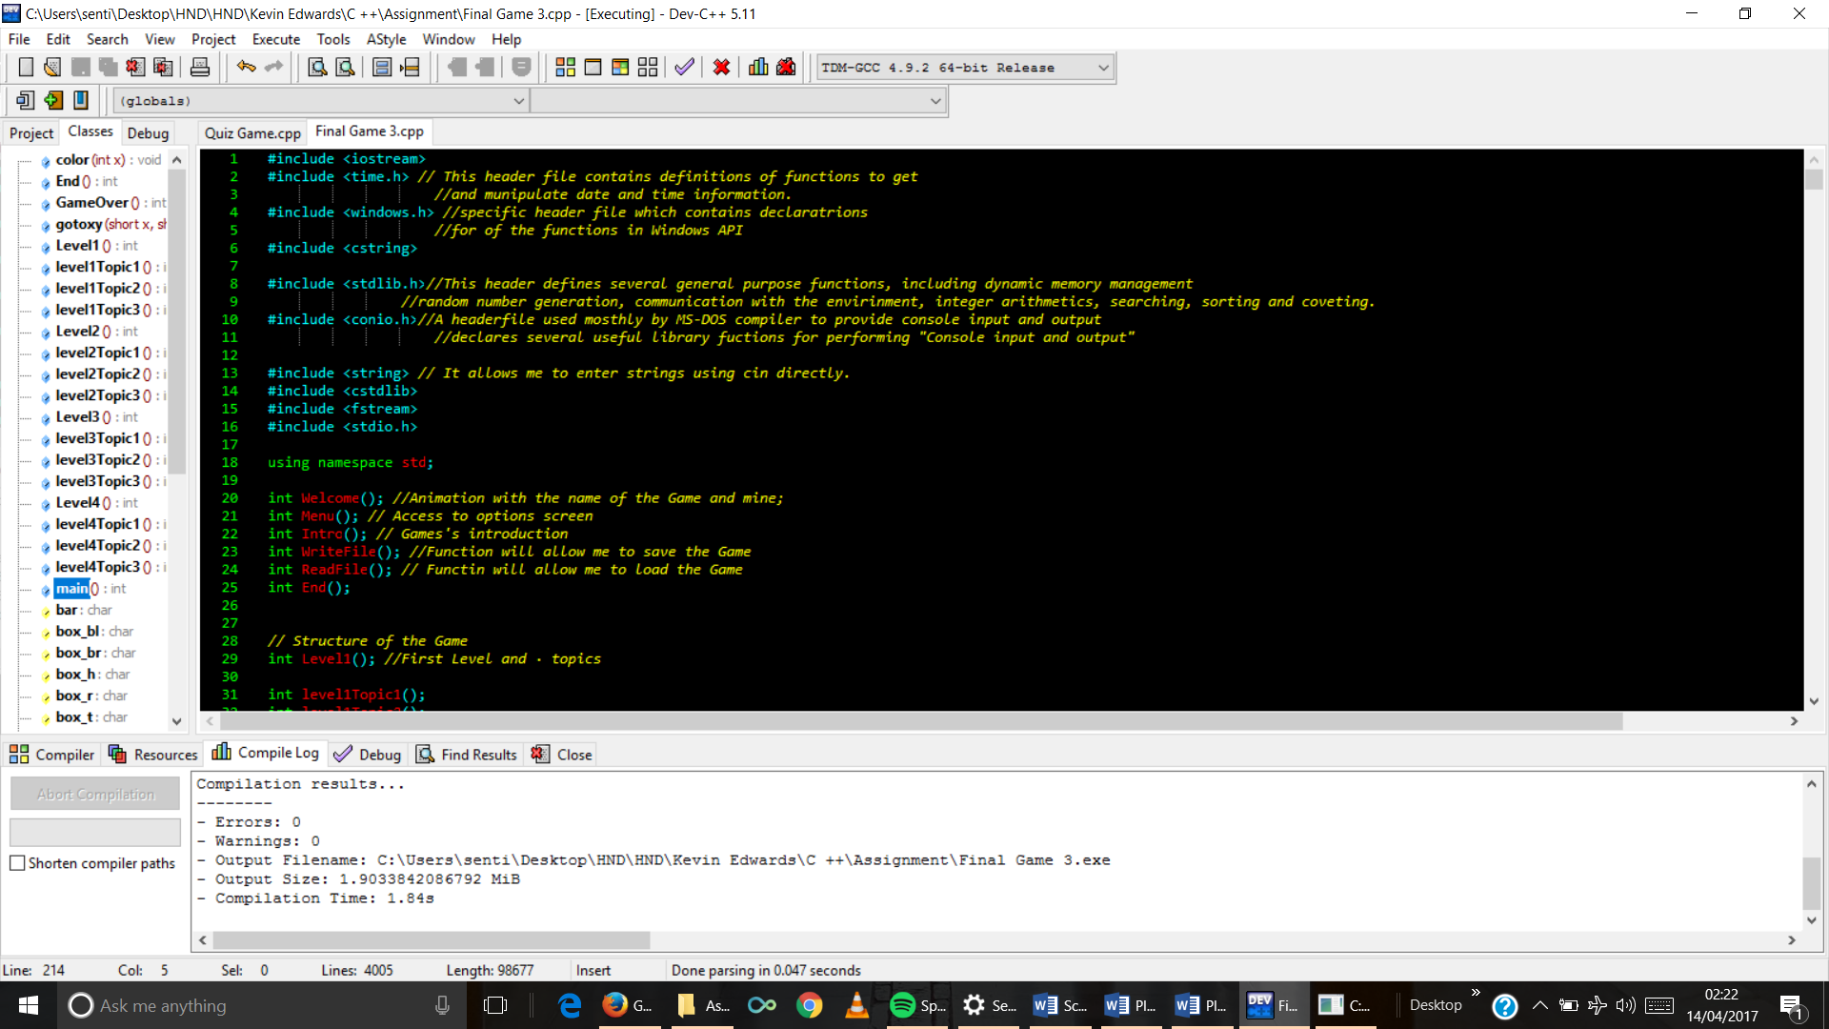Functions declared.

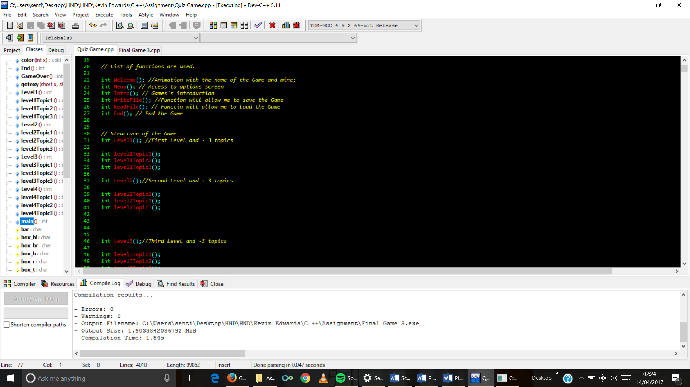

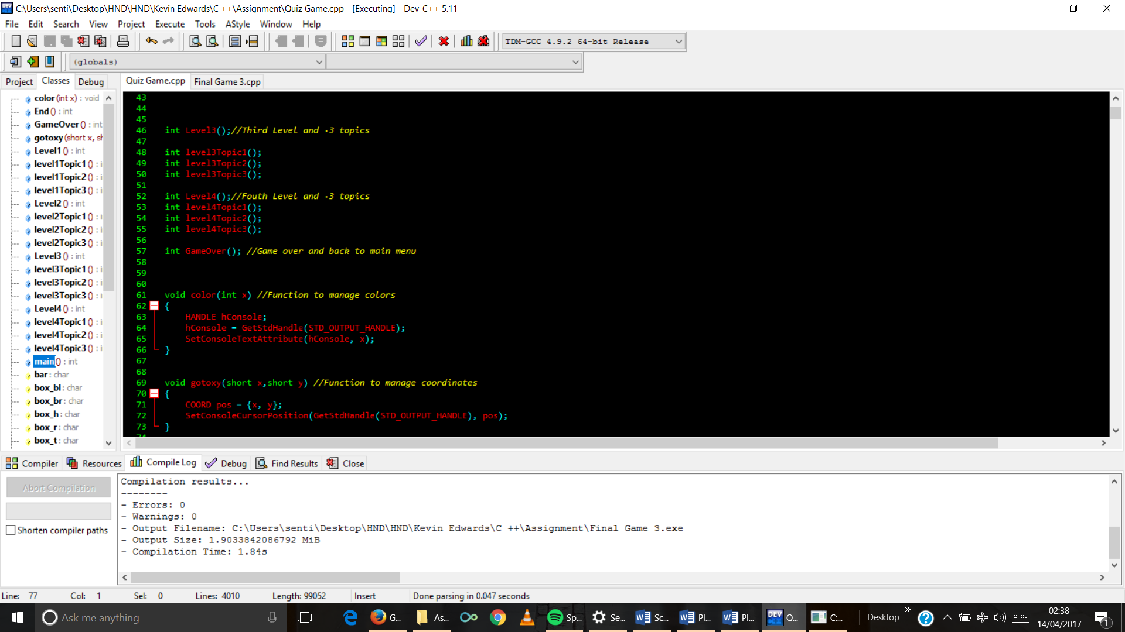

1. 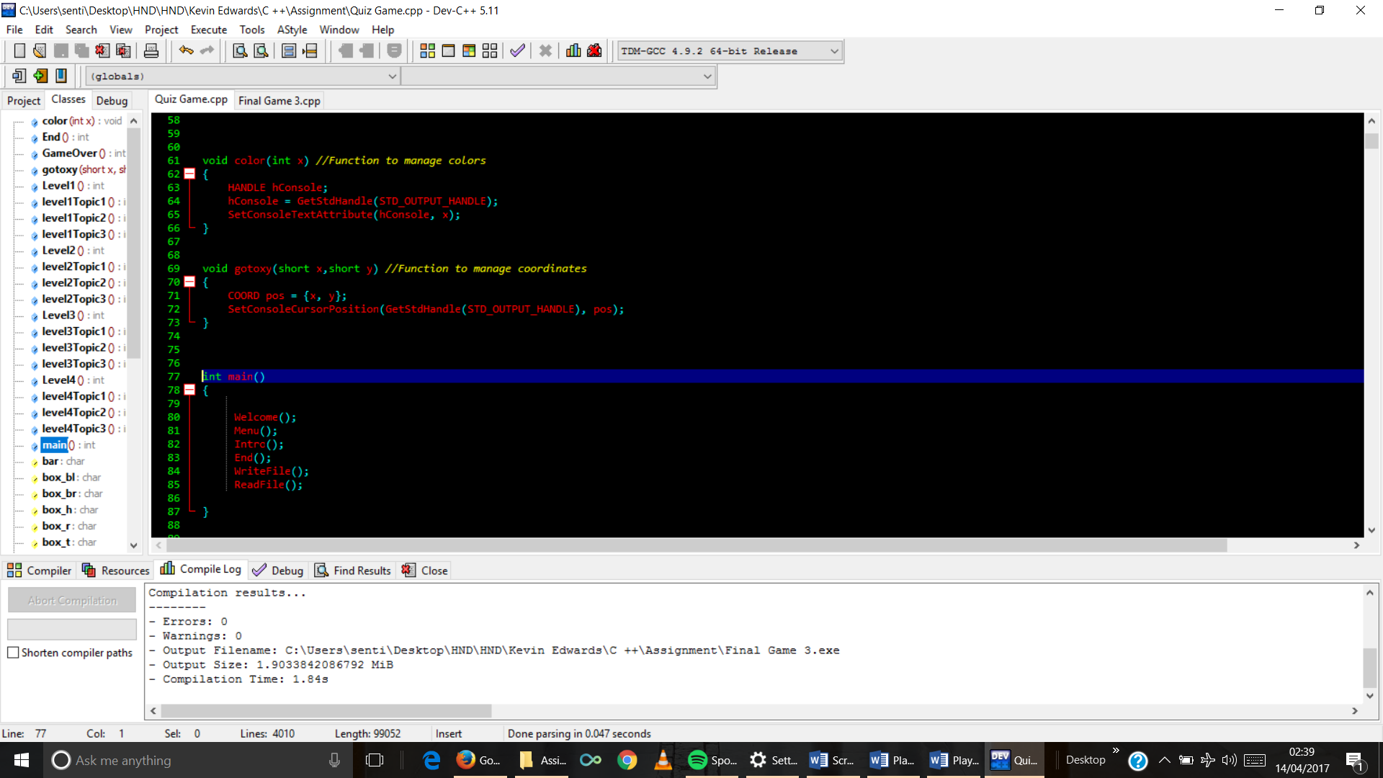Functions to manage colours and coordinates.
2. Main functions

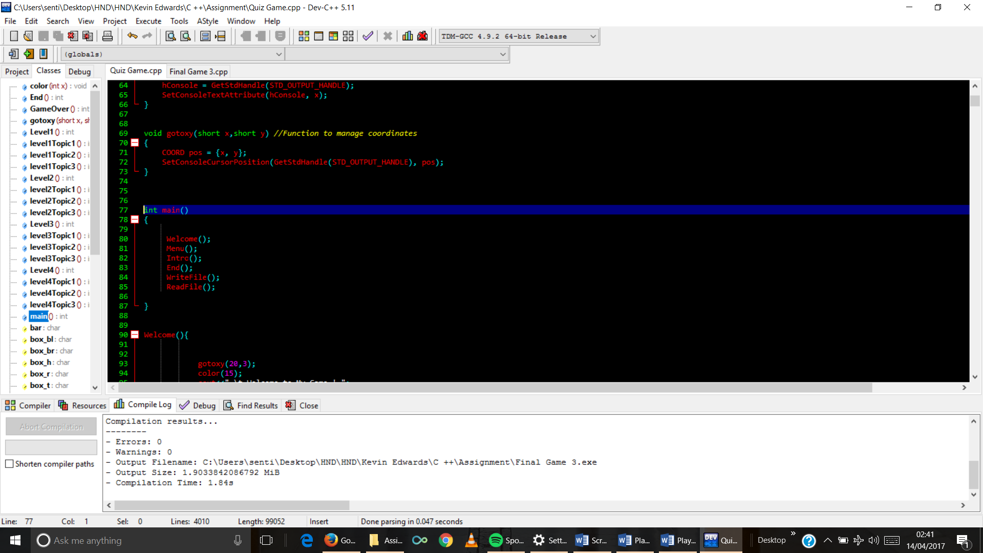

1. Welcome function code

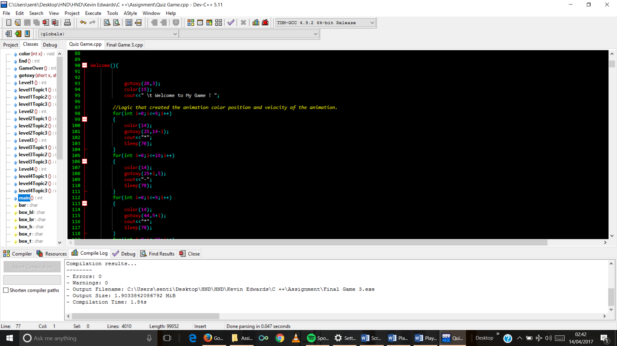

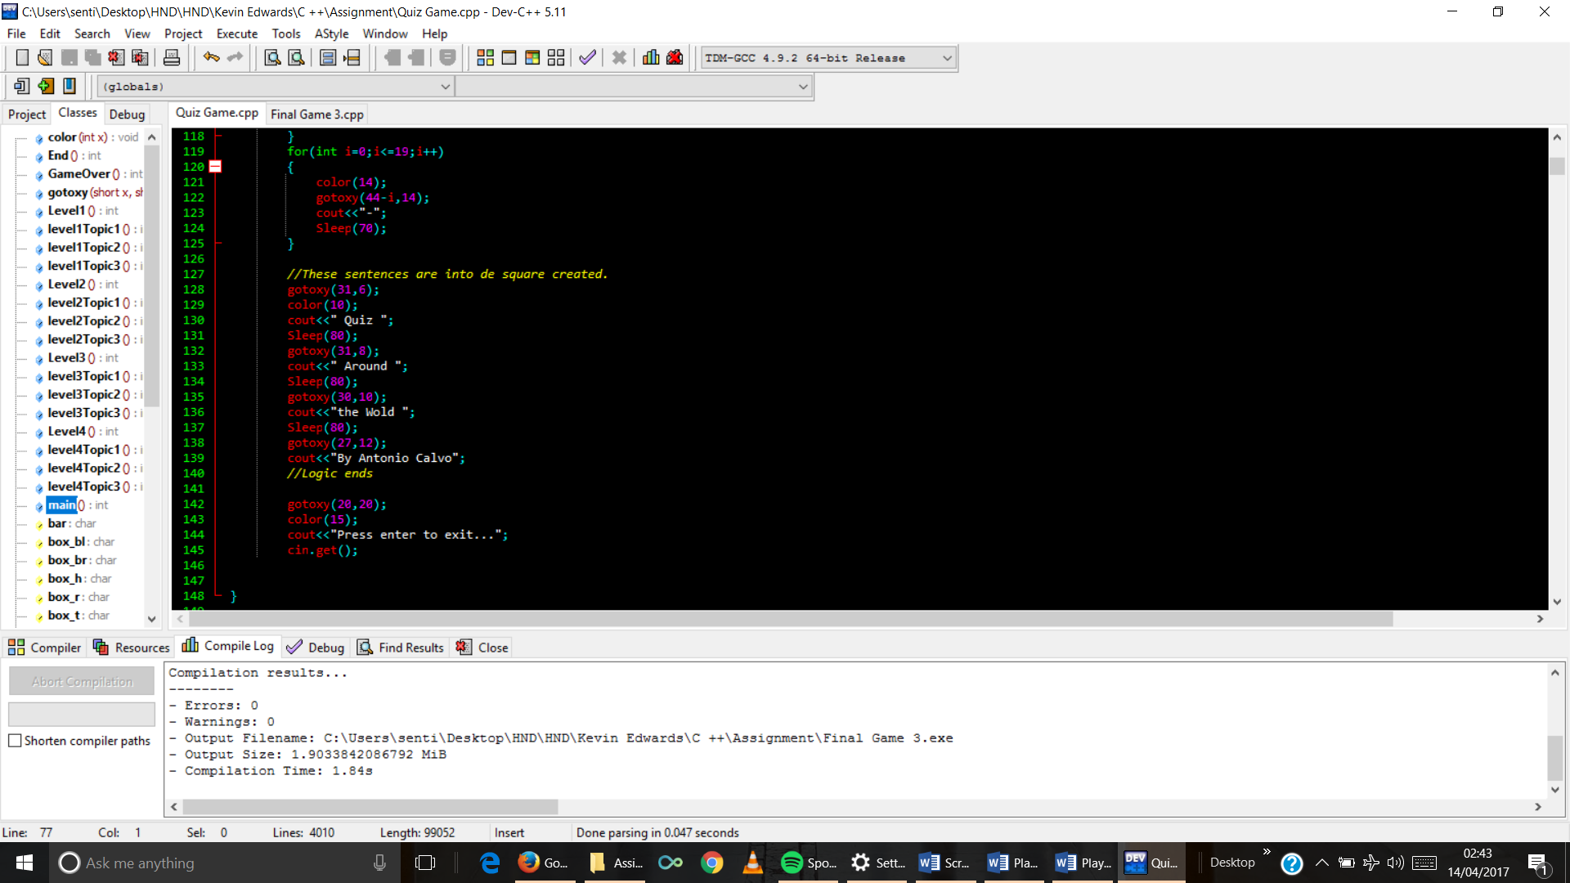

1. Menu function code

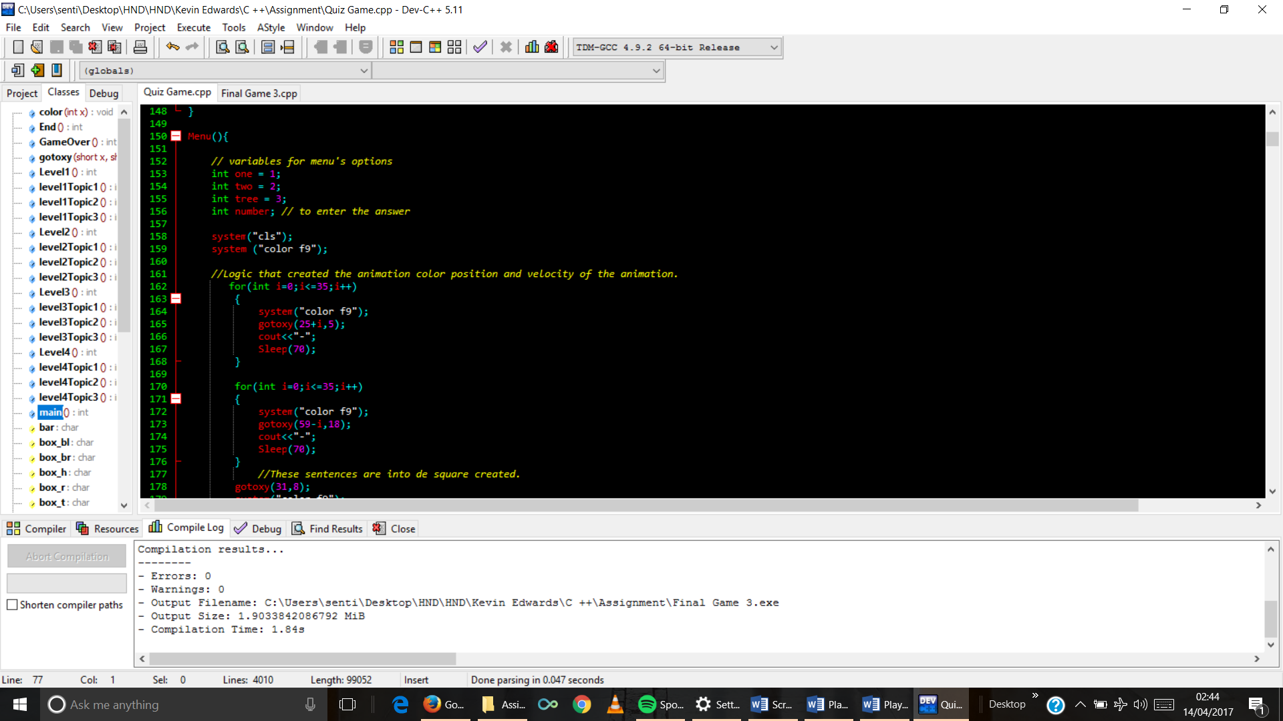

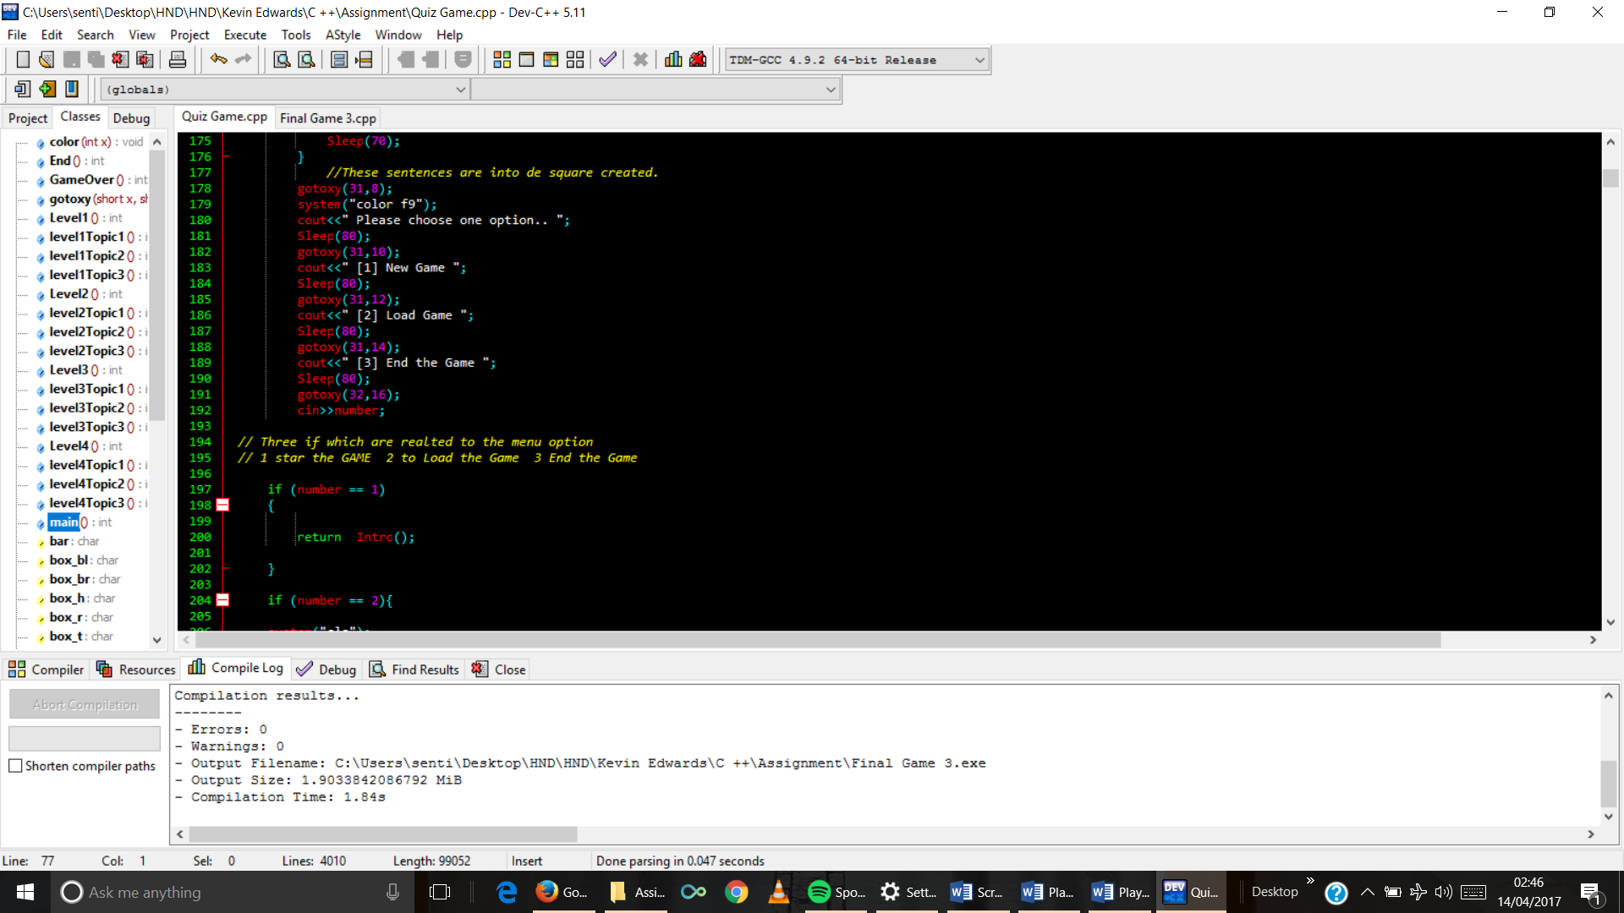

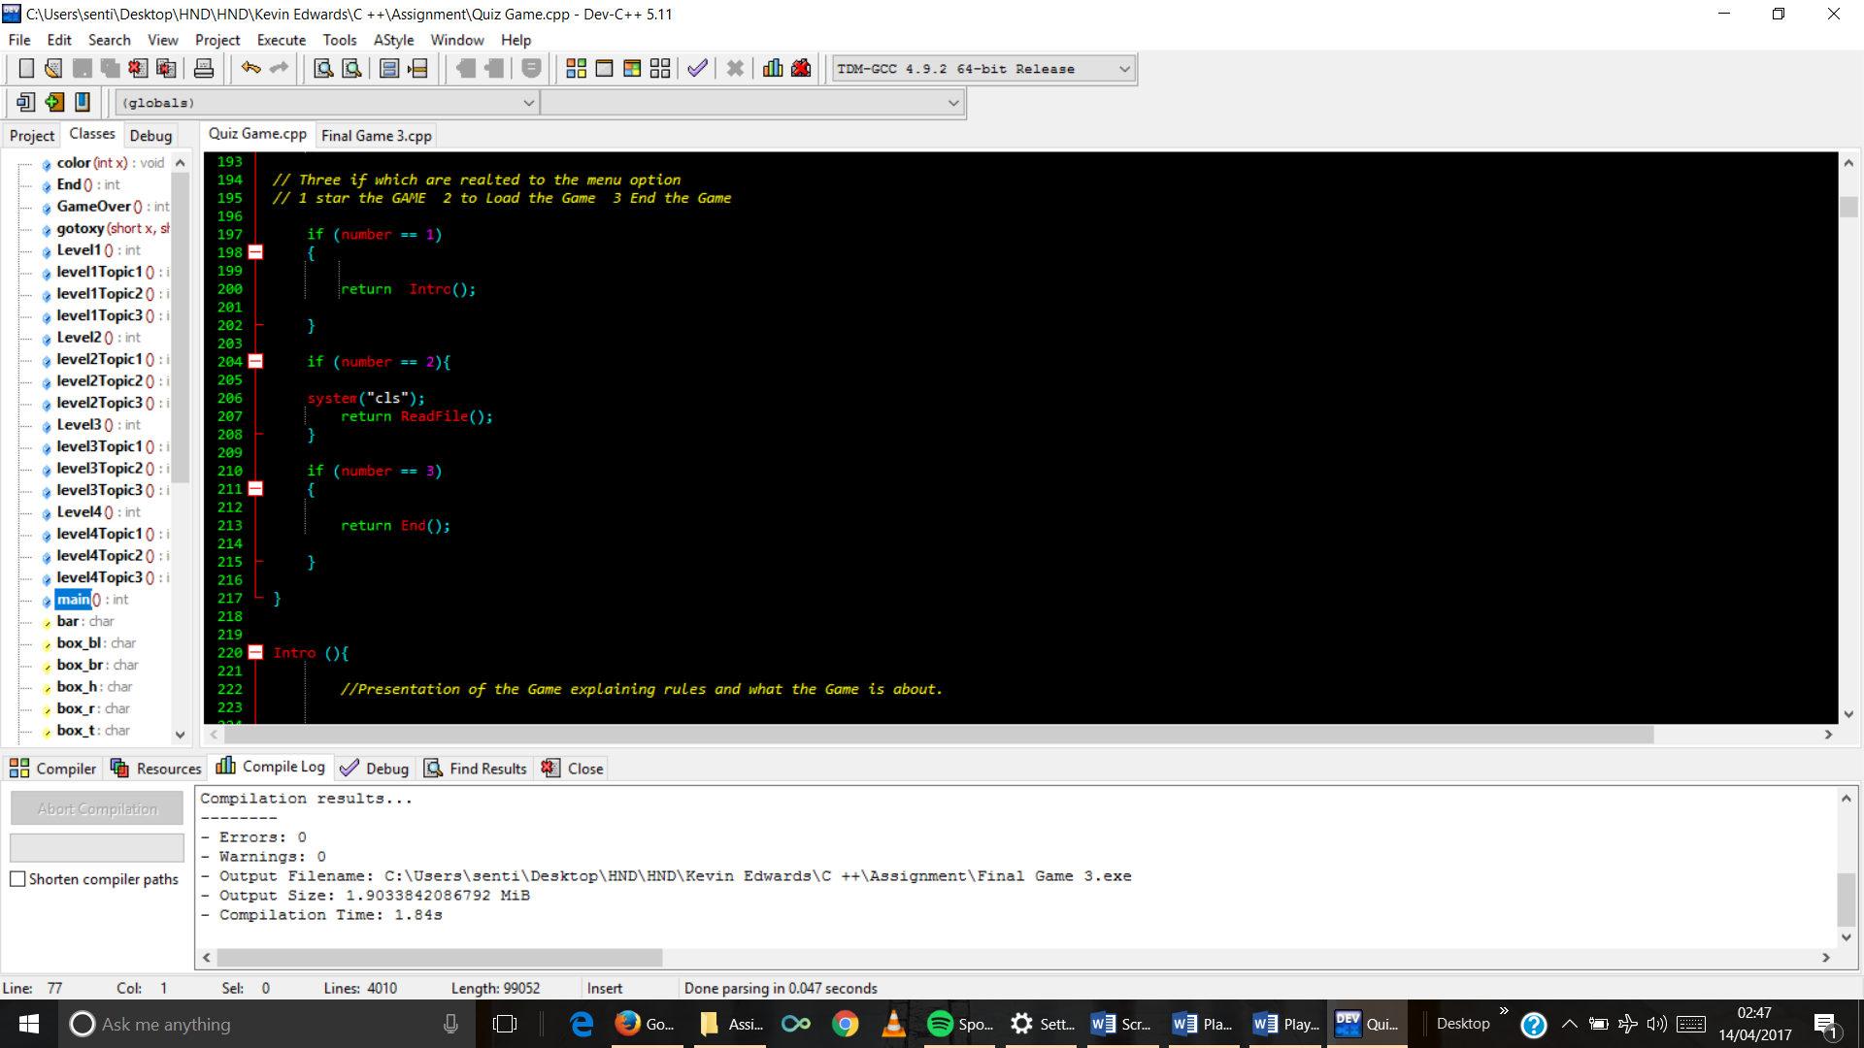

1. Intro function code.

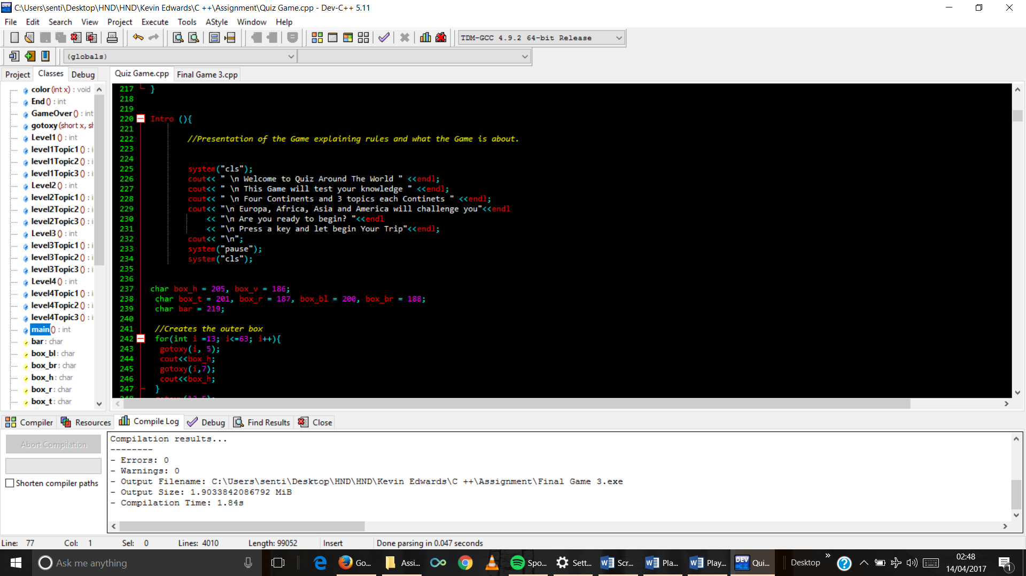

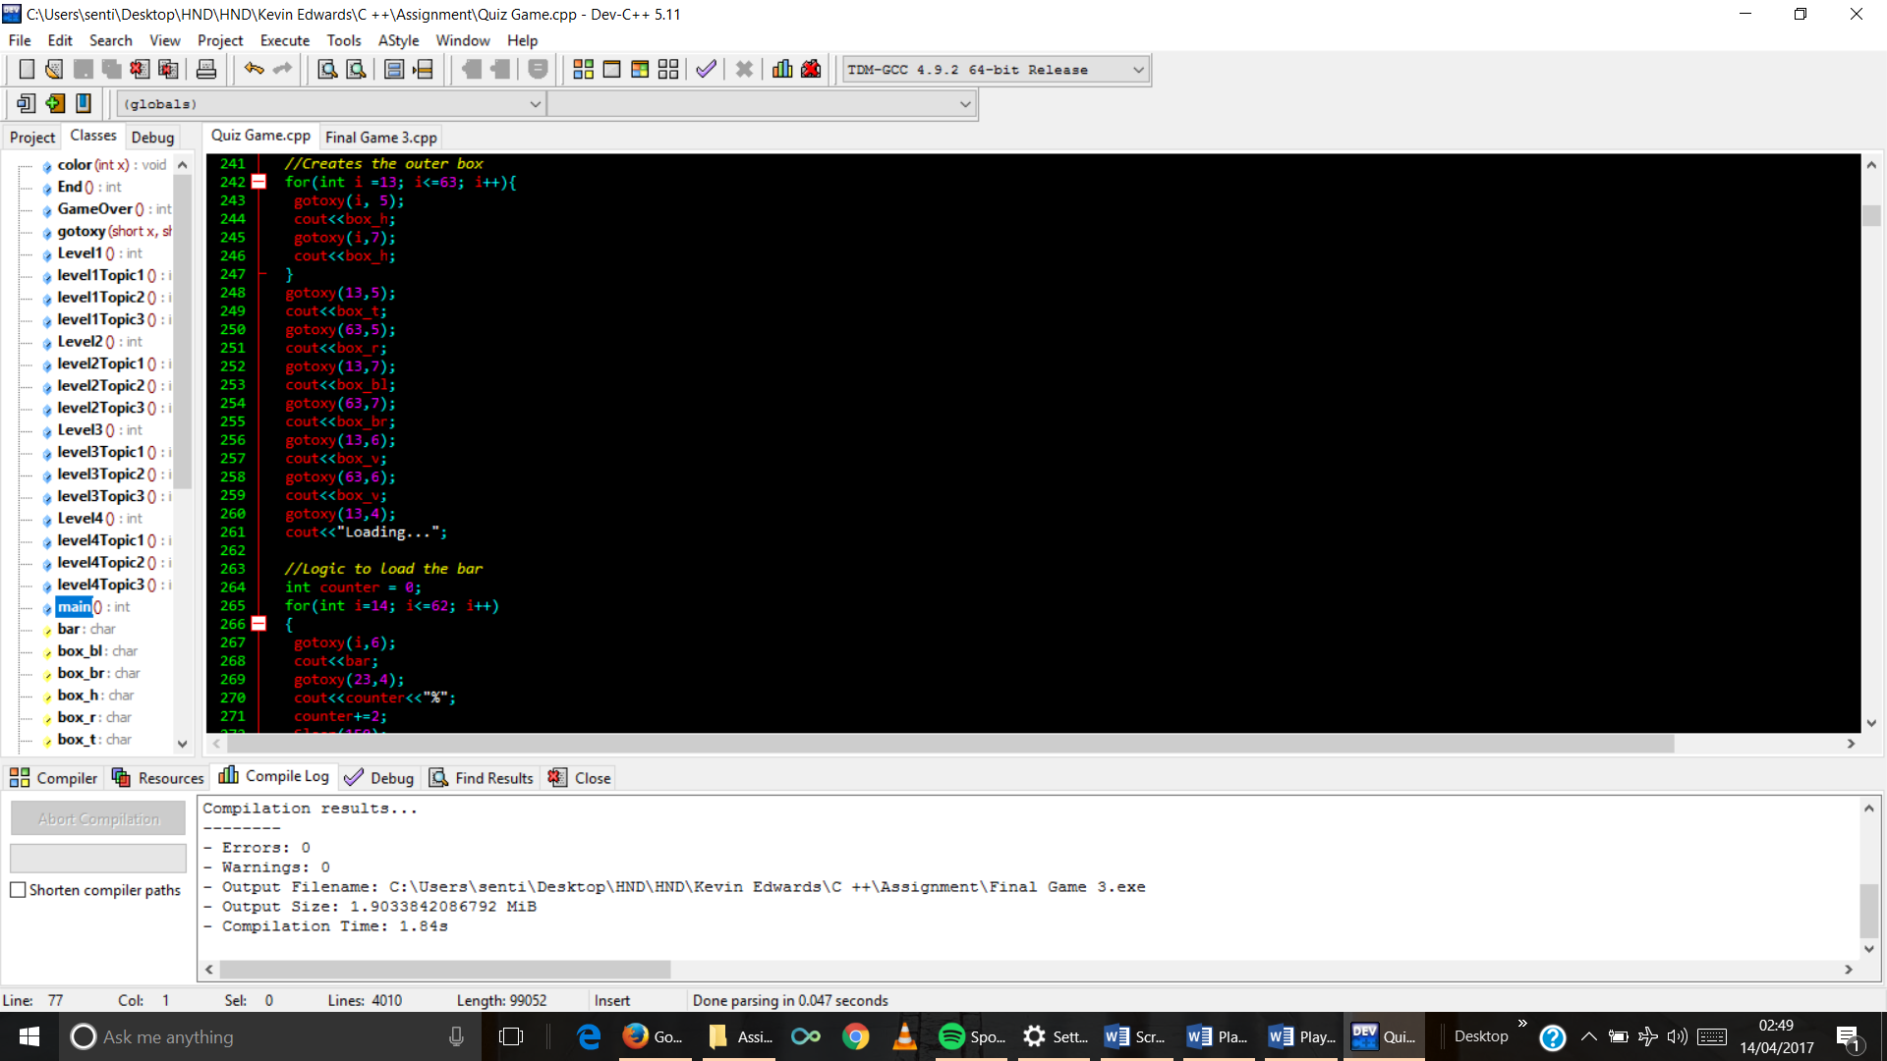

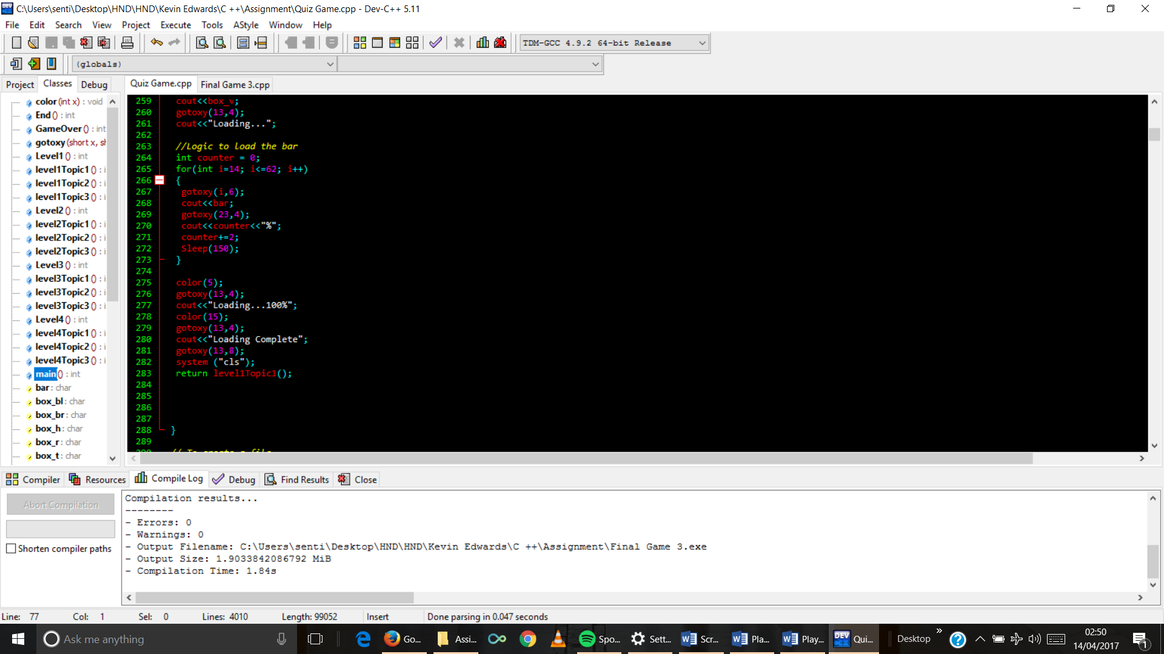

1. WriteFile Function code

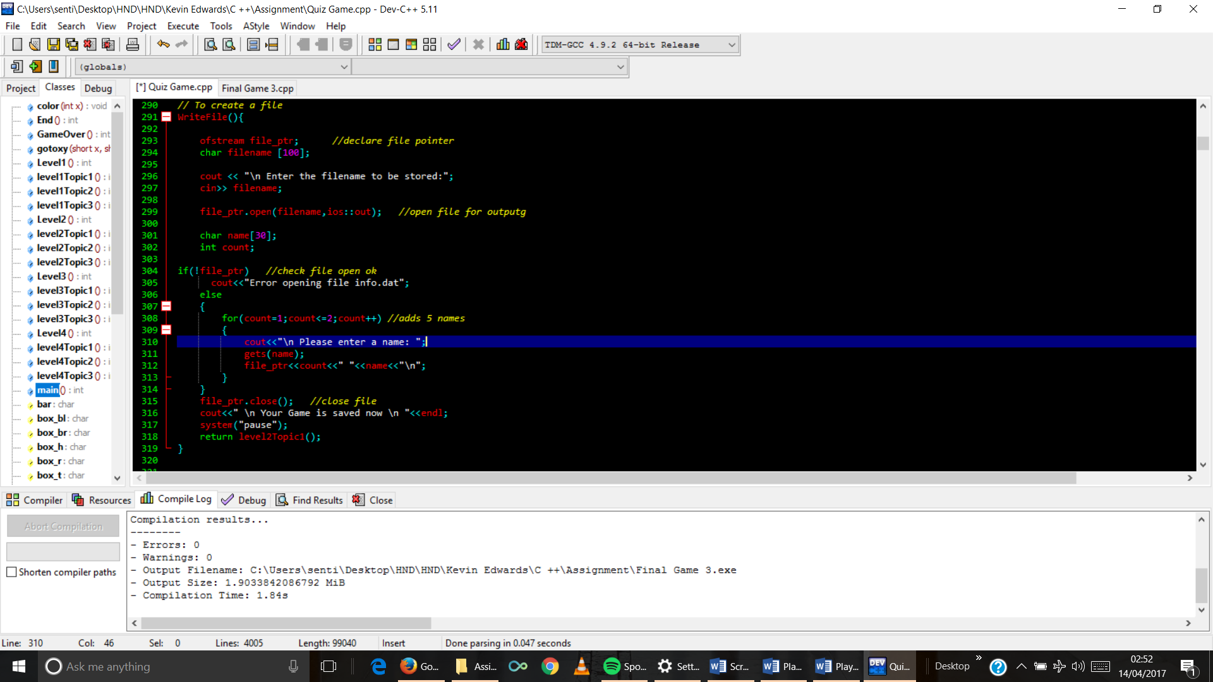

1. ReadFile Function code

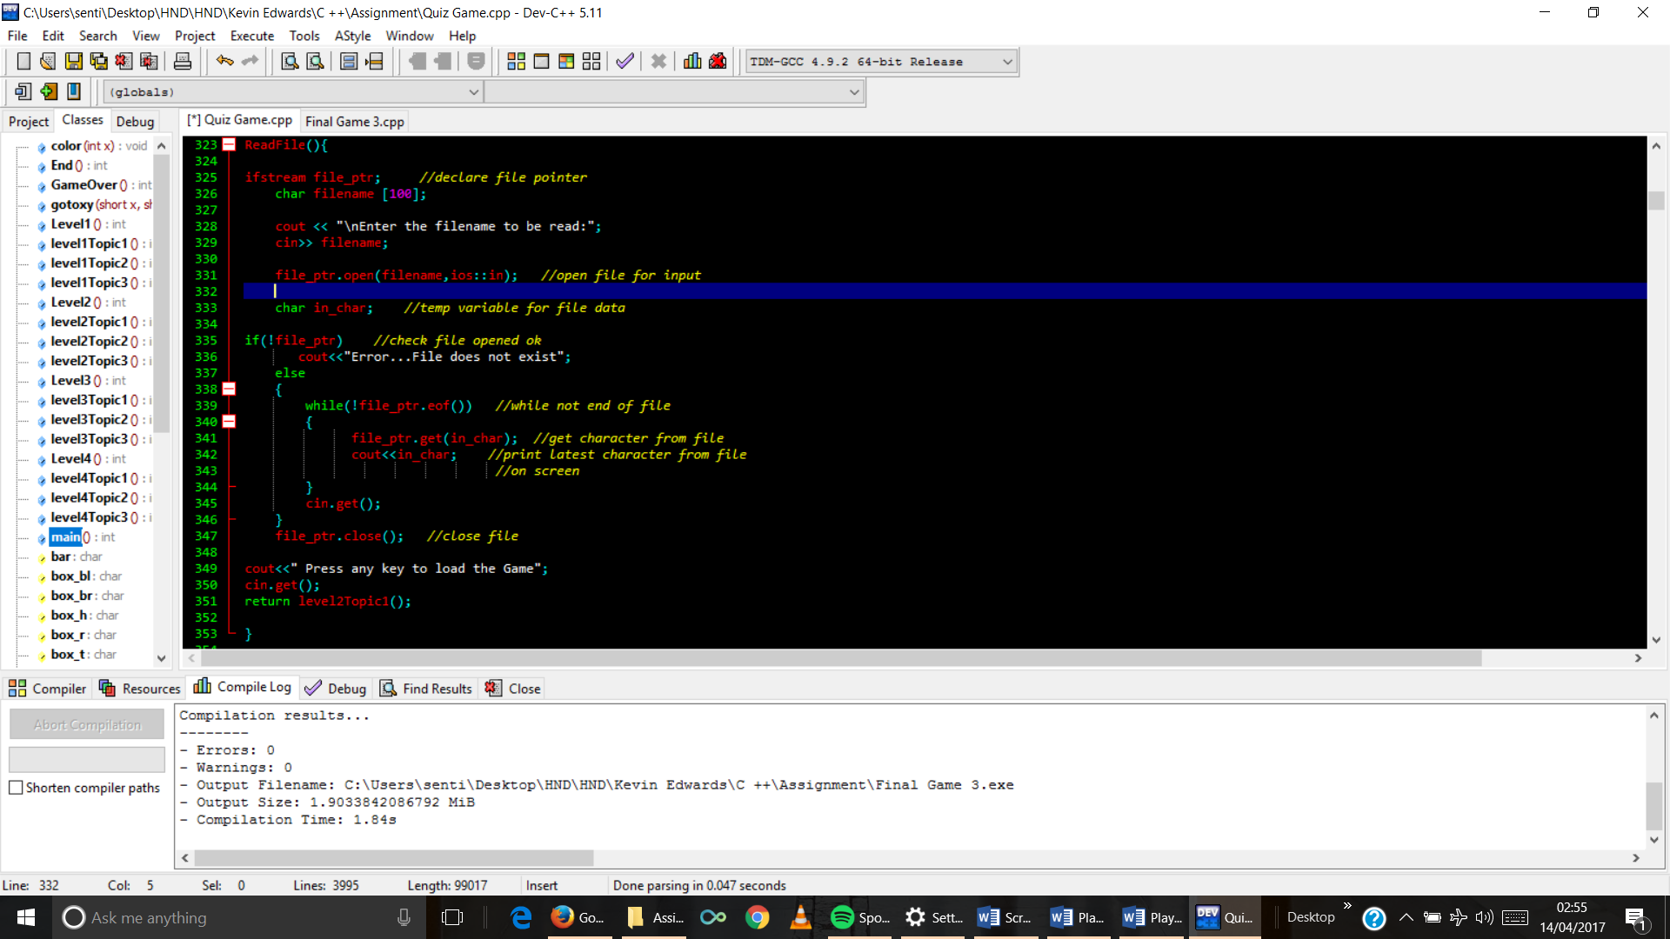

1. End function code

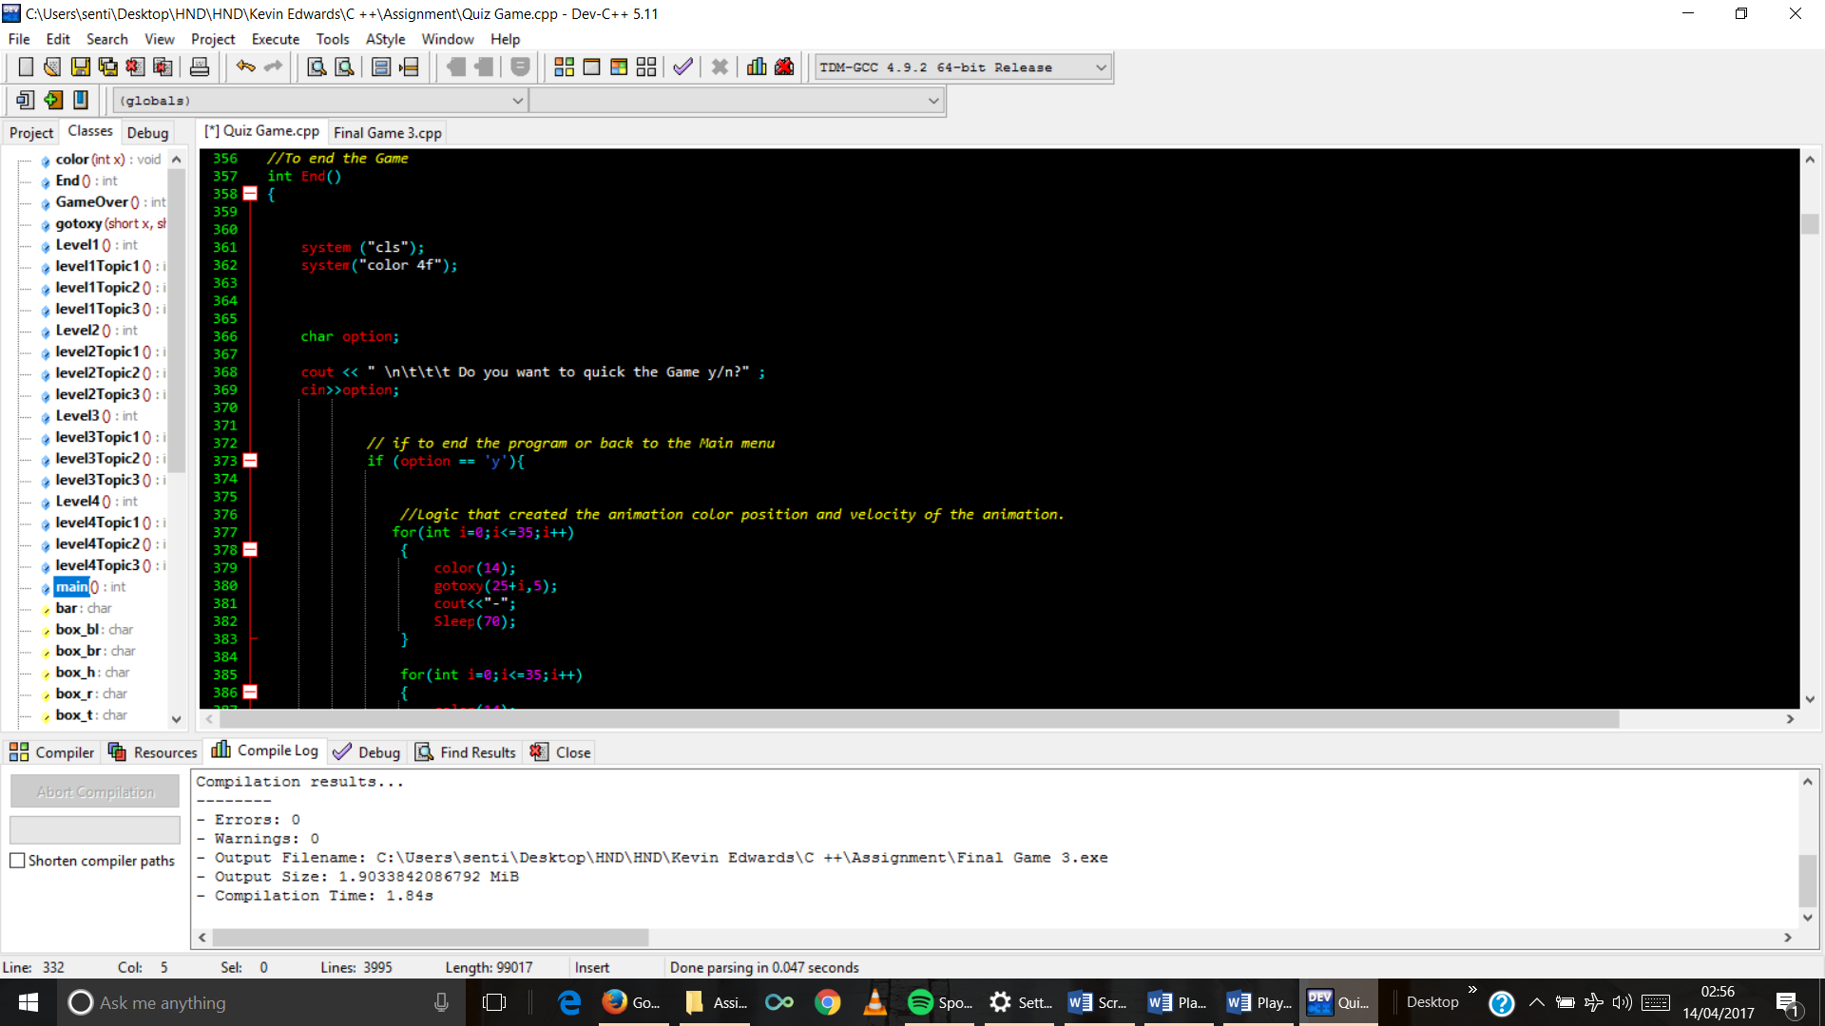

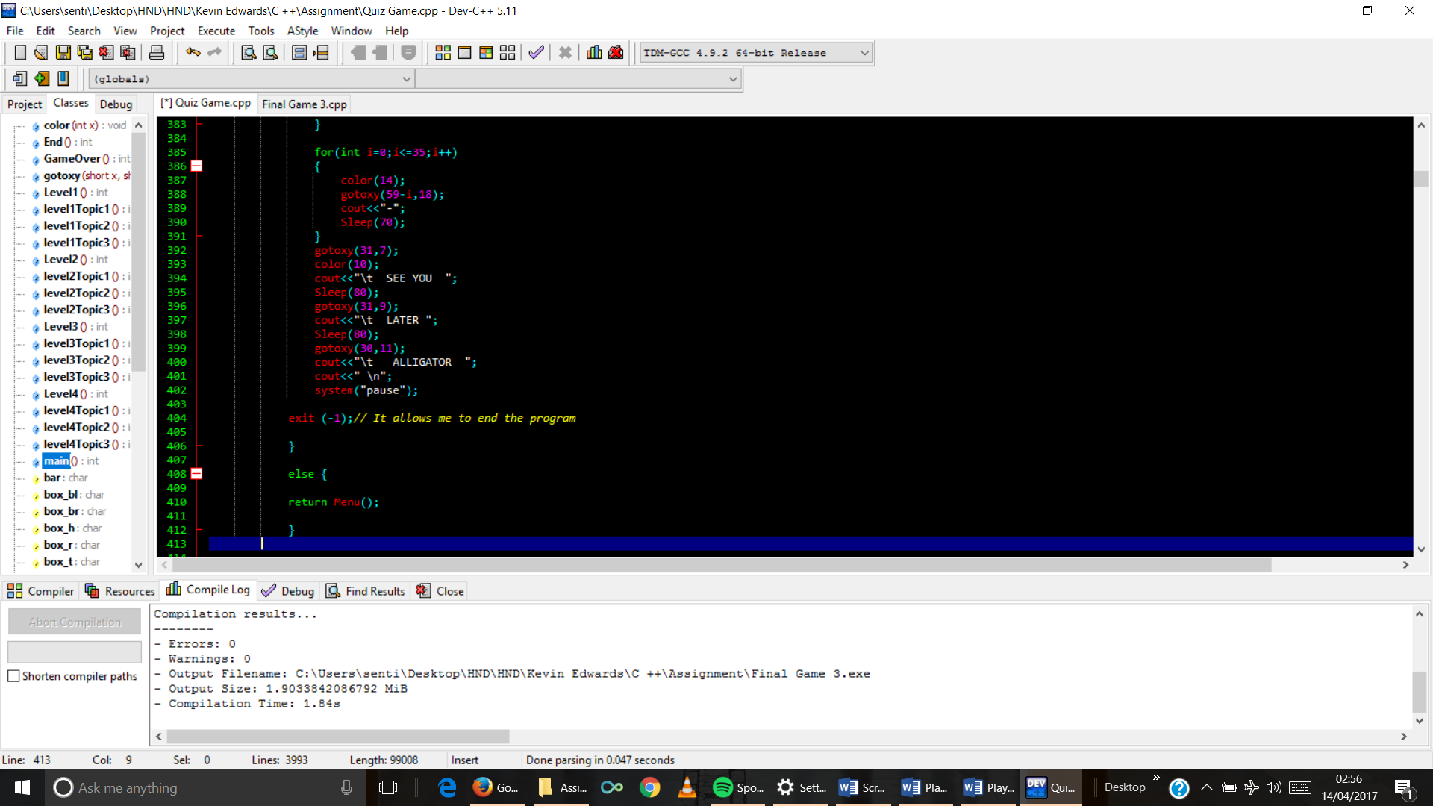

1. First Leve code

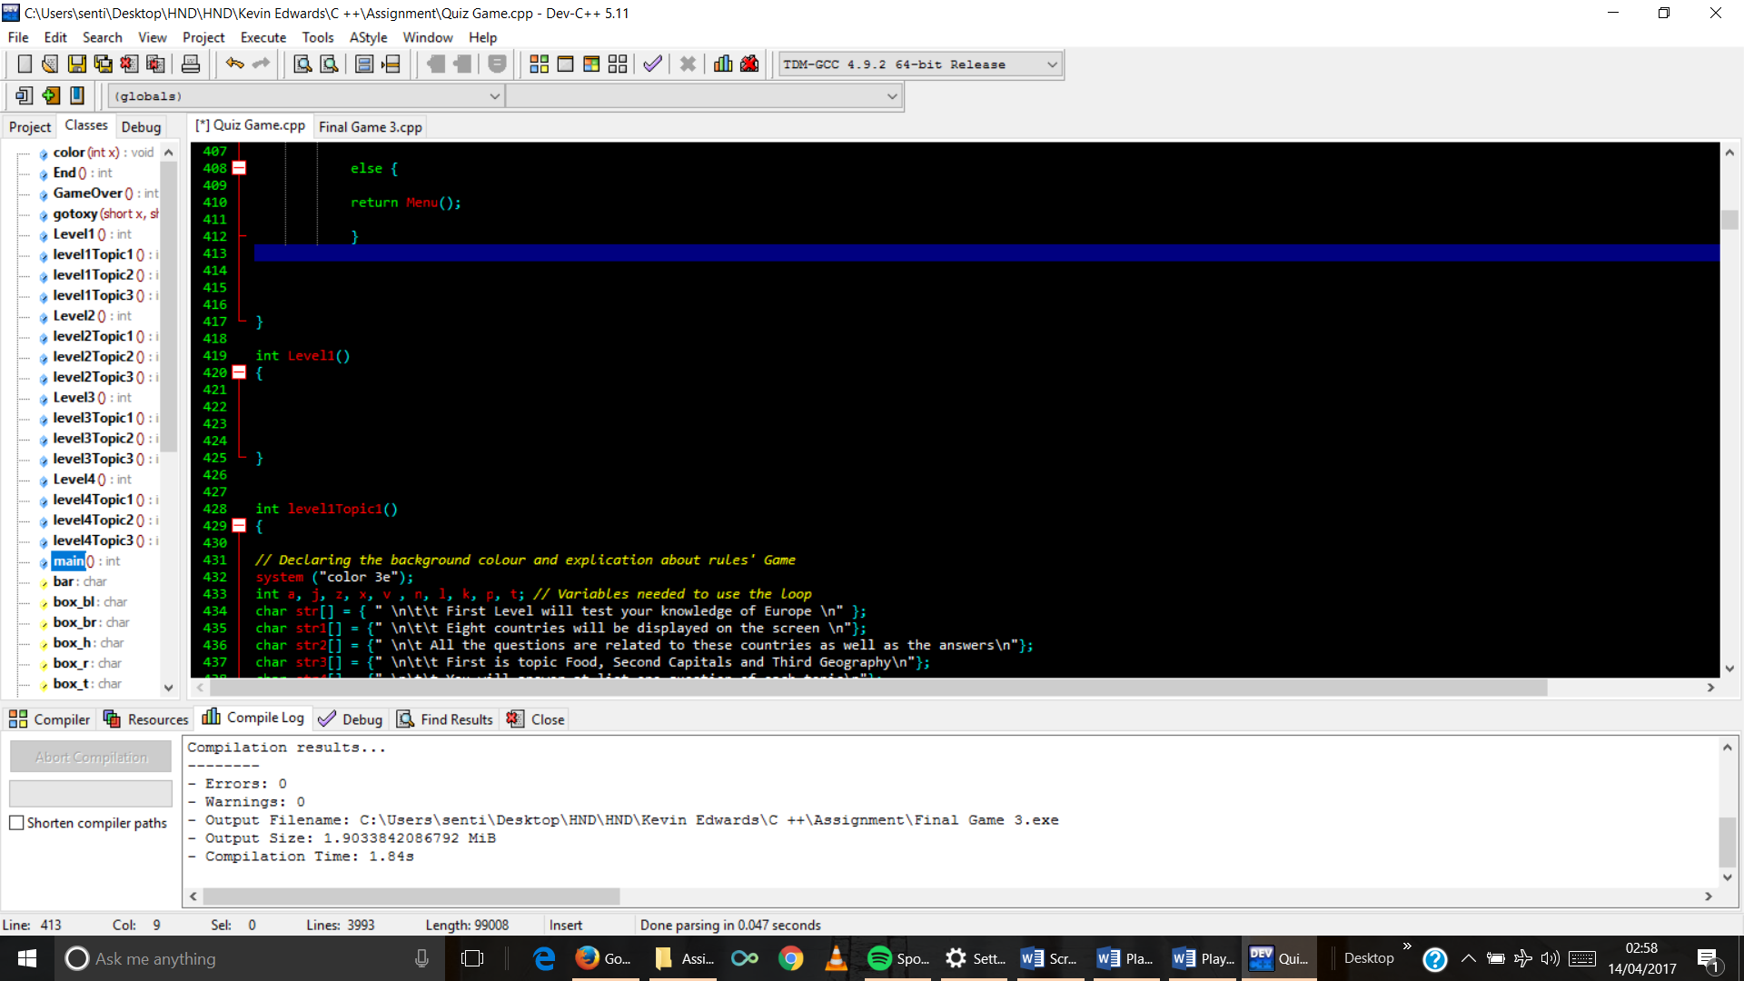

1. FirstTopic 1 code

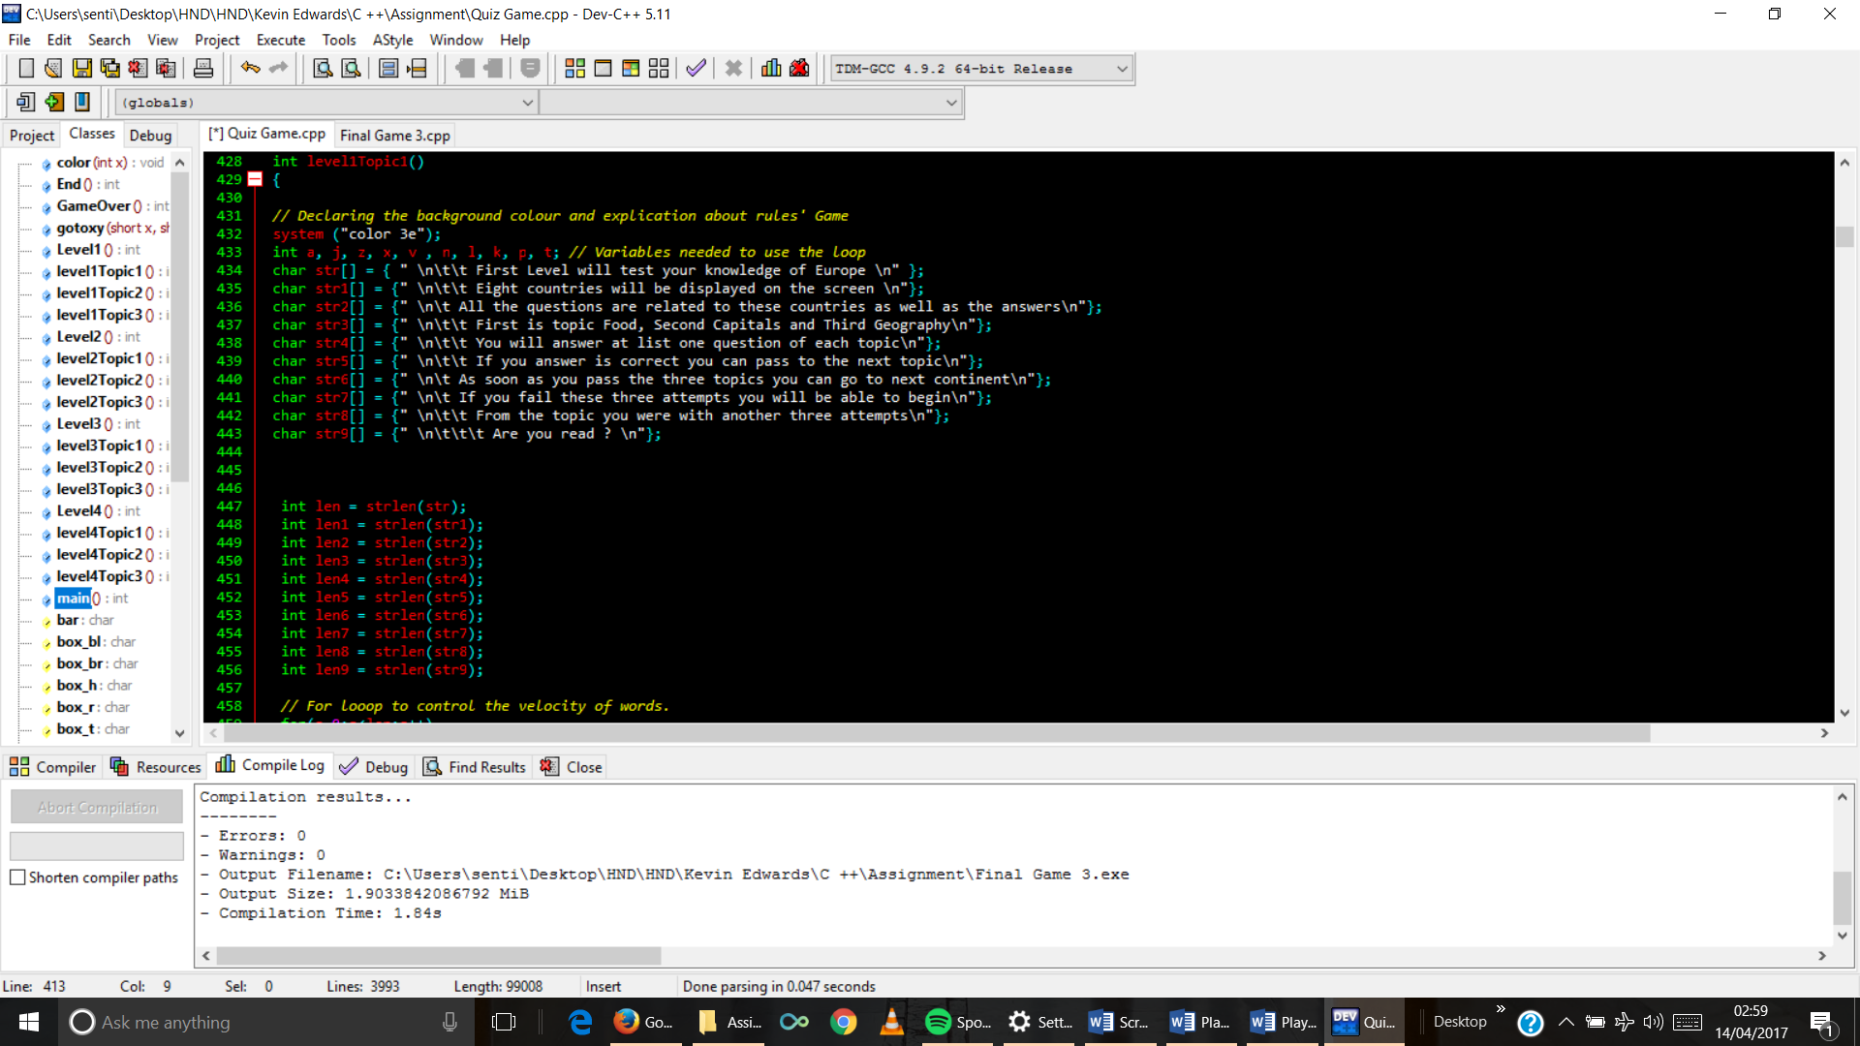

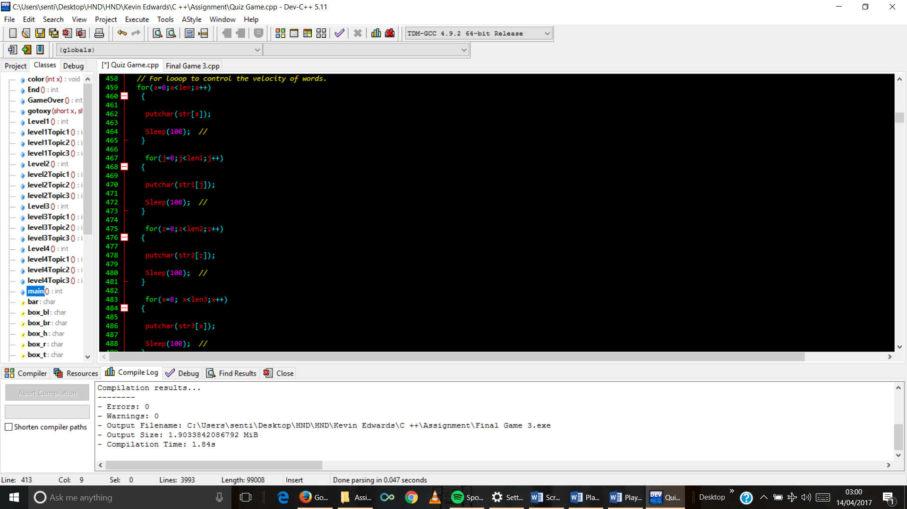

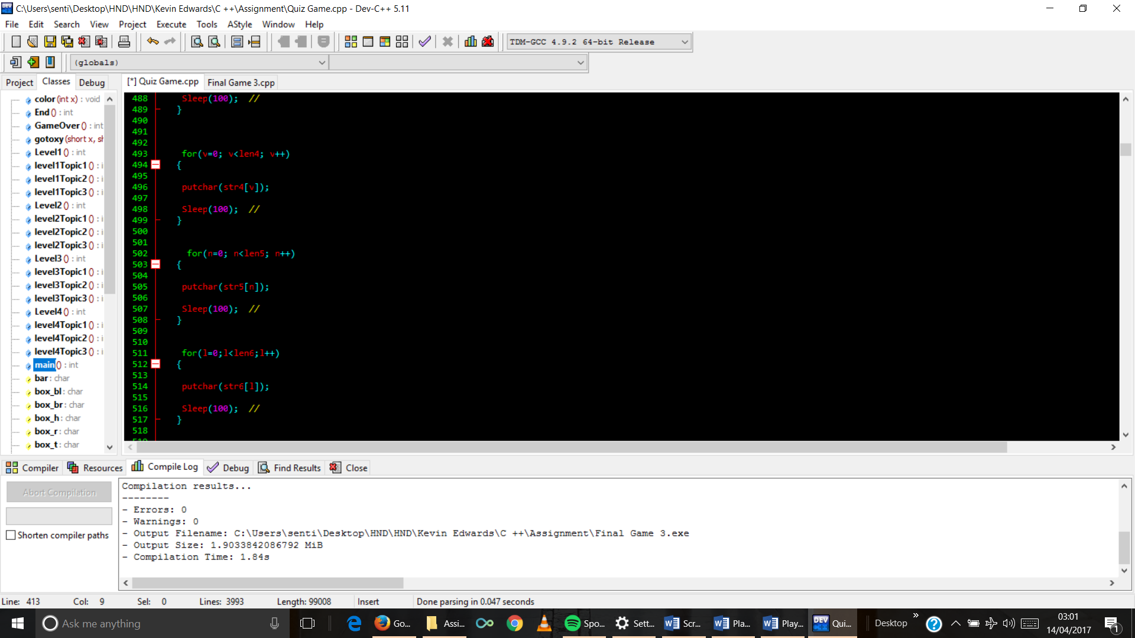

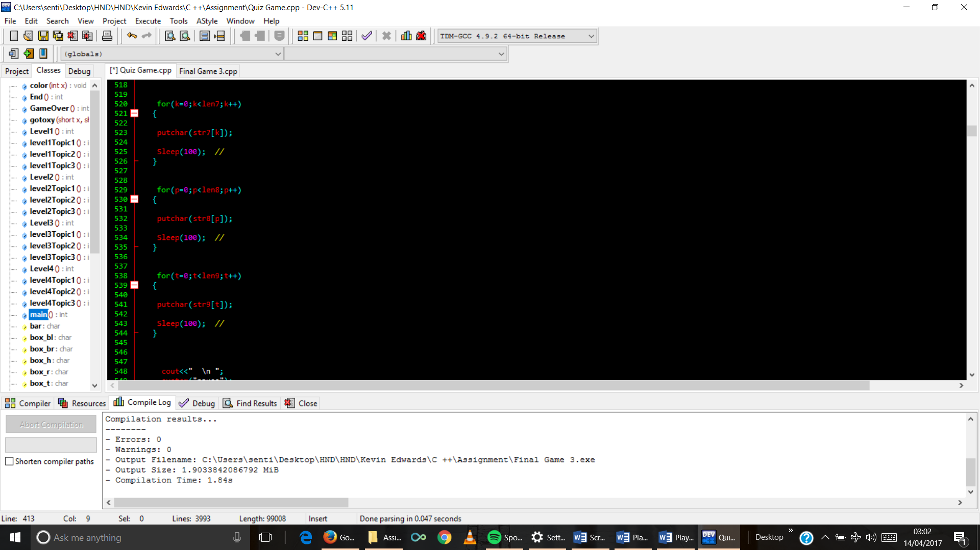

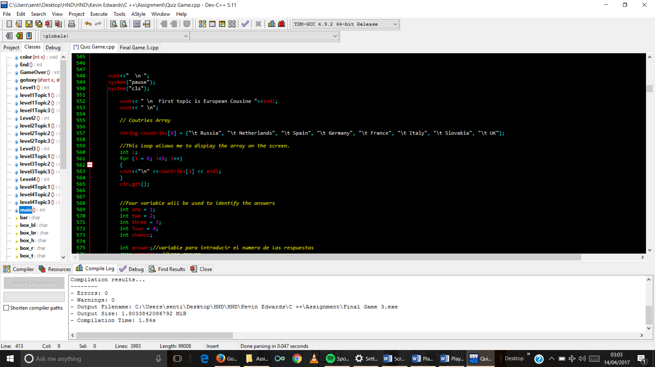

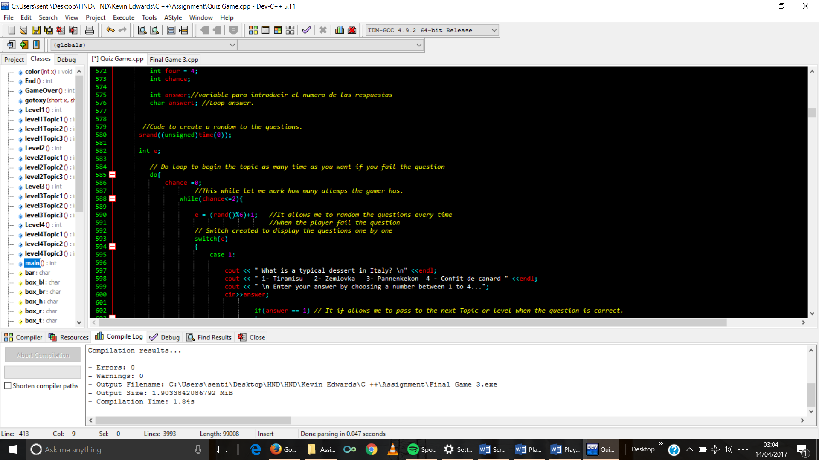

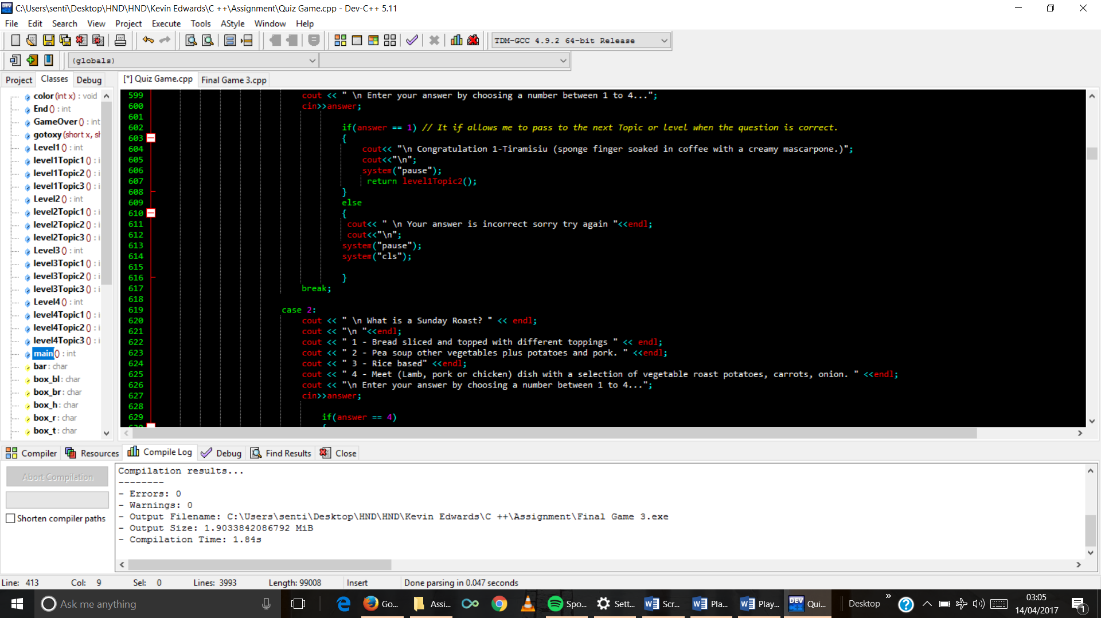

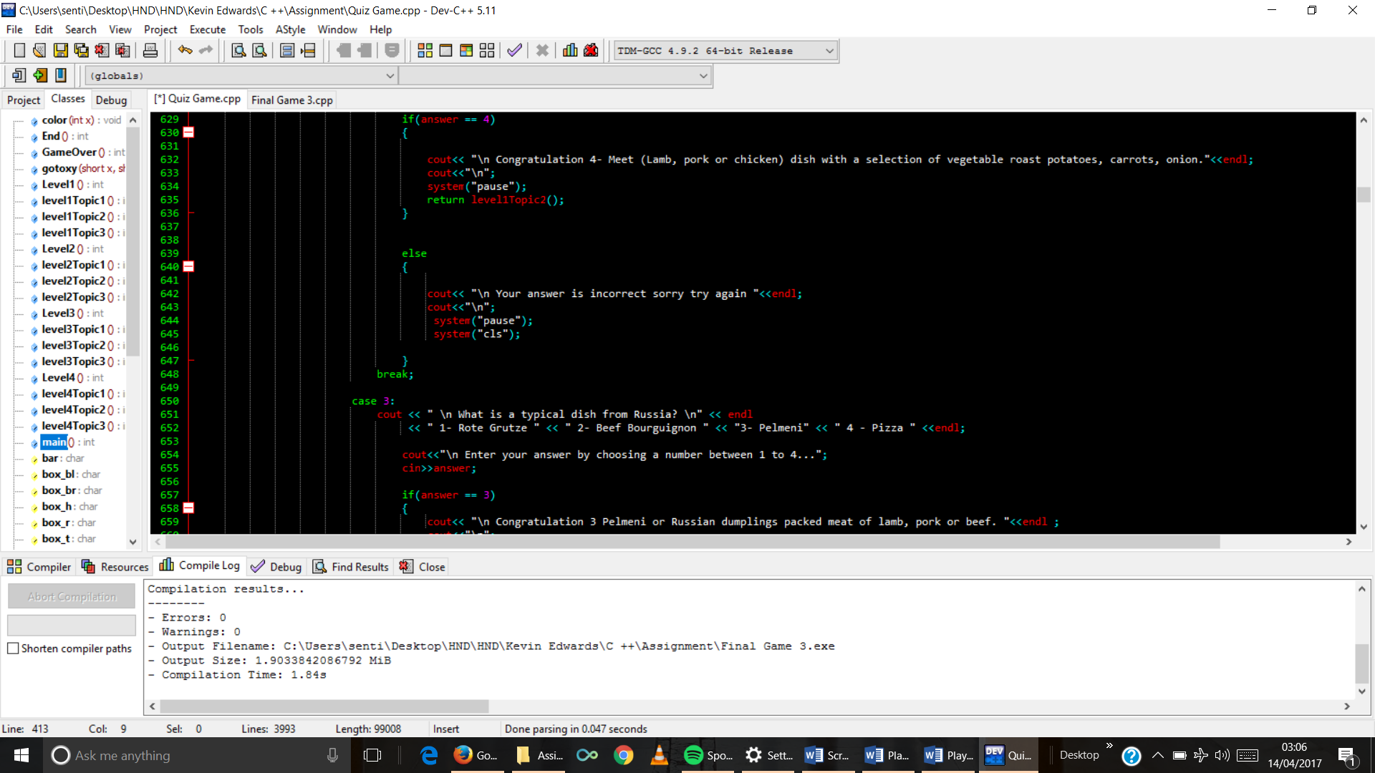

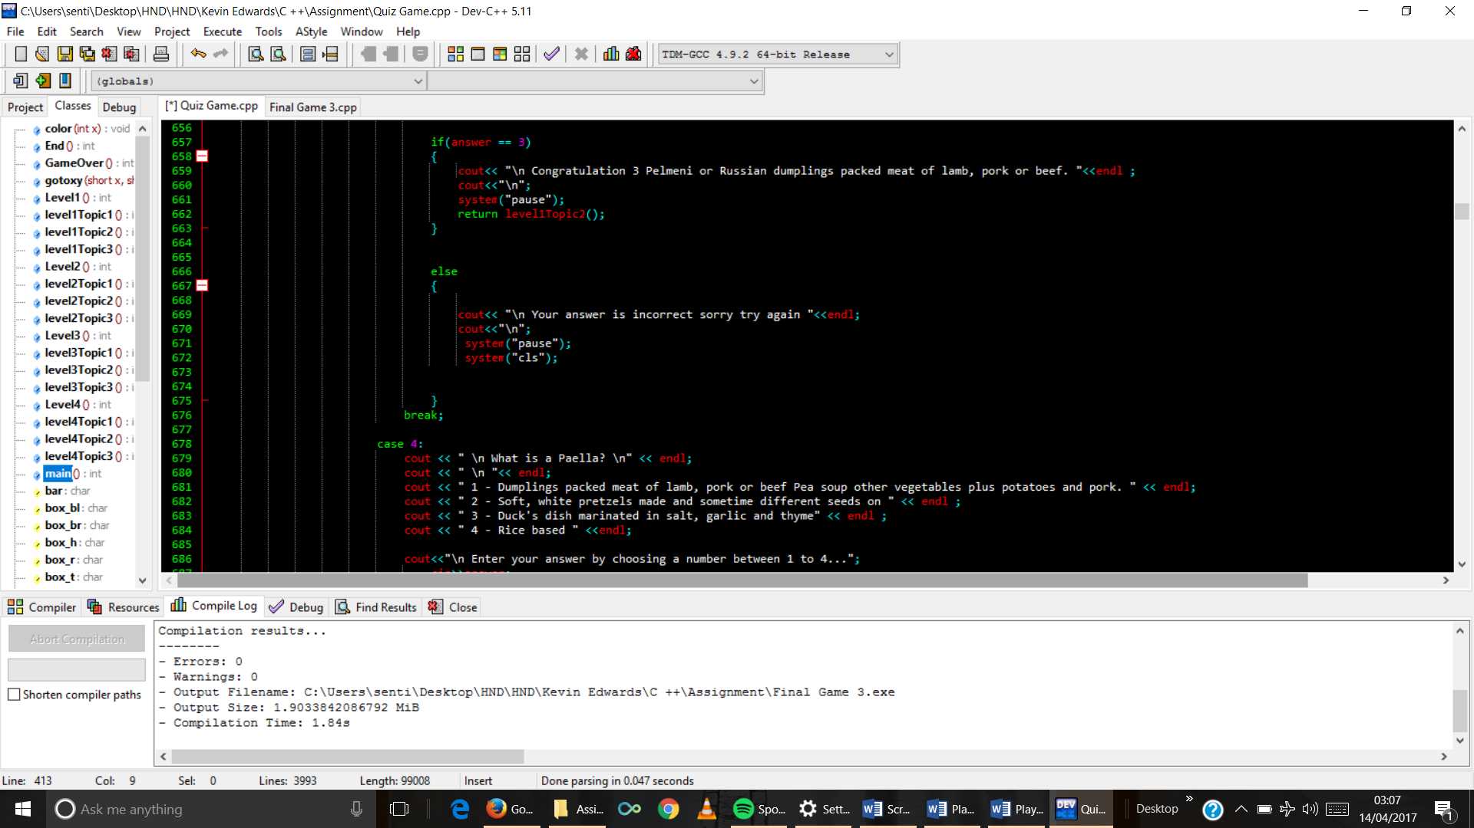

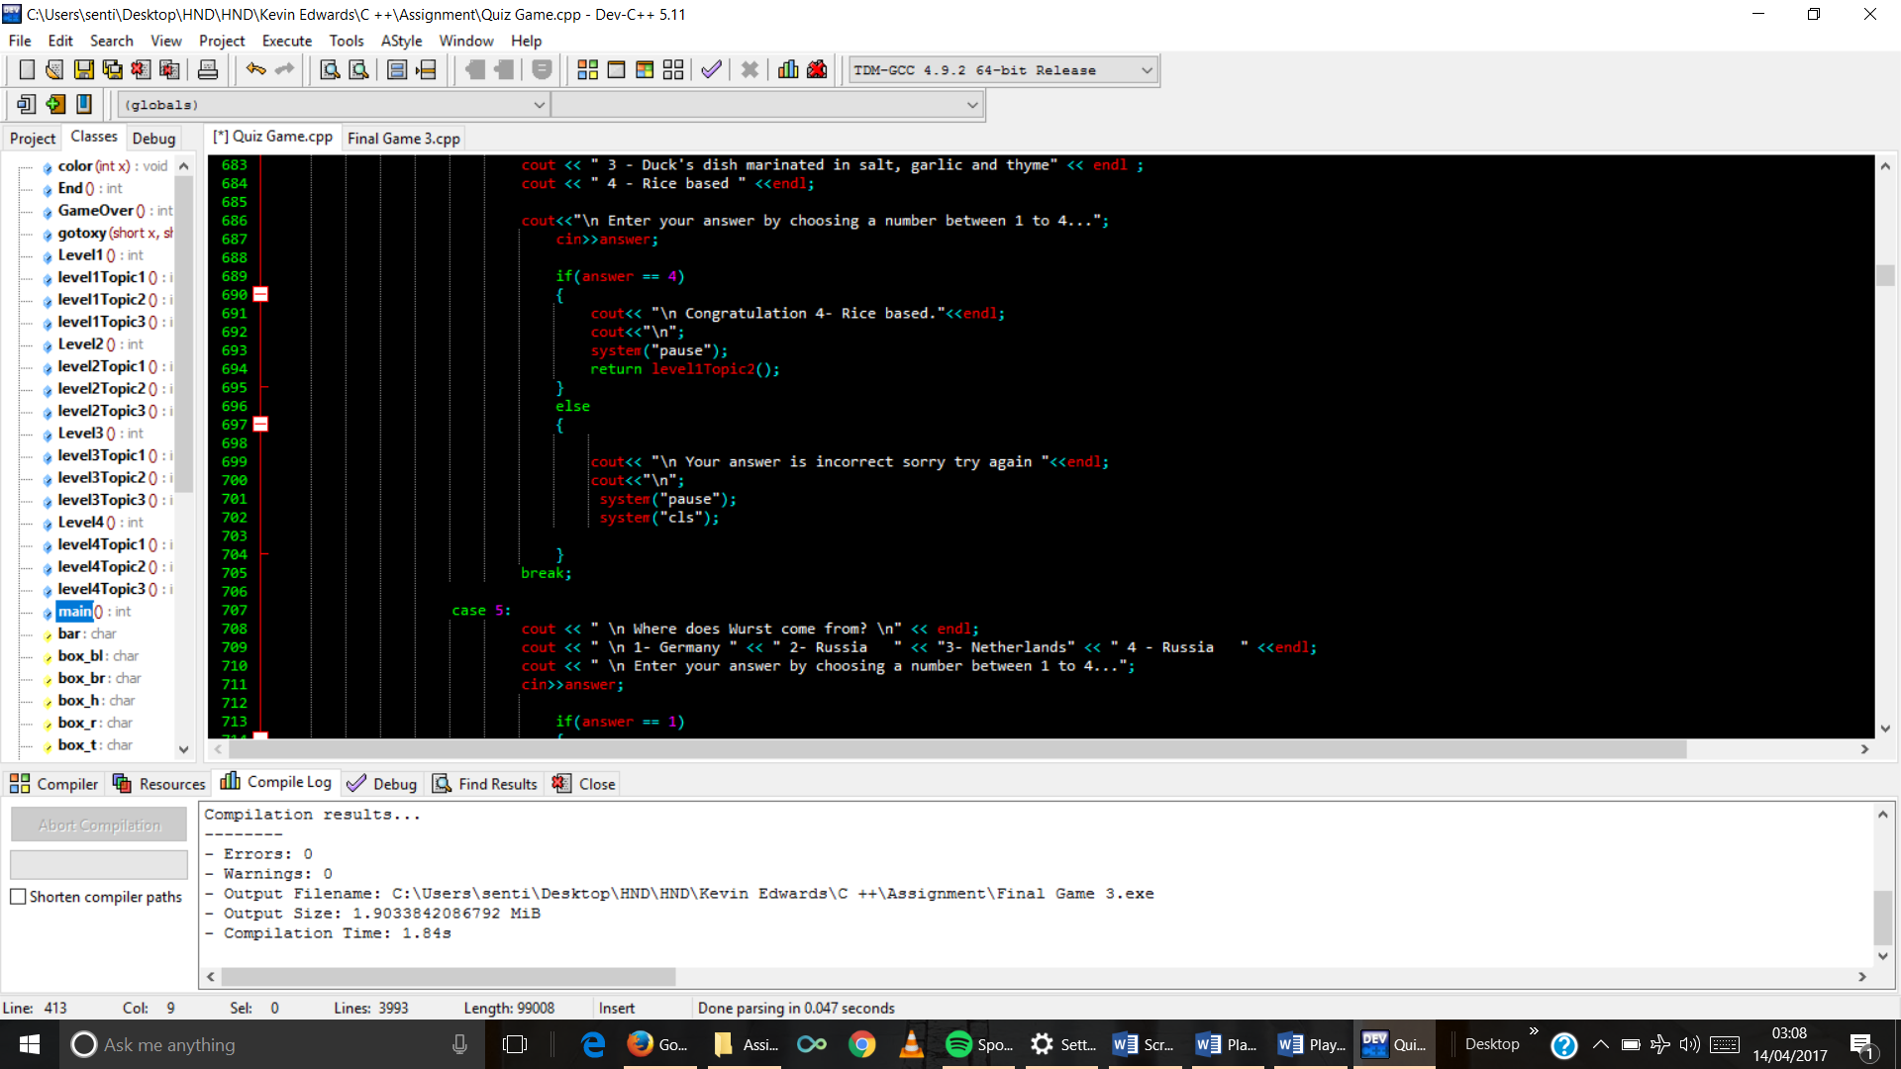

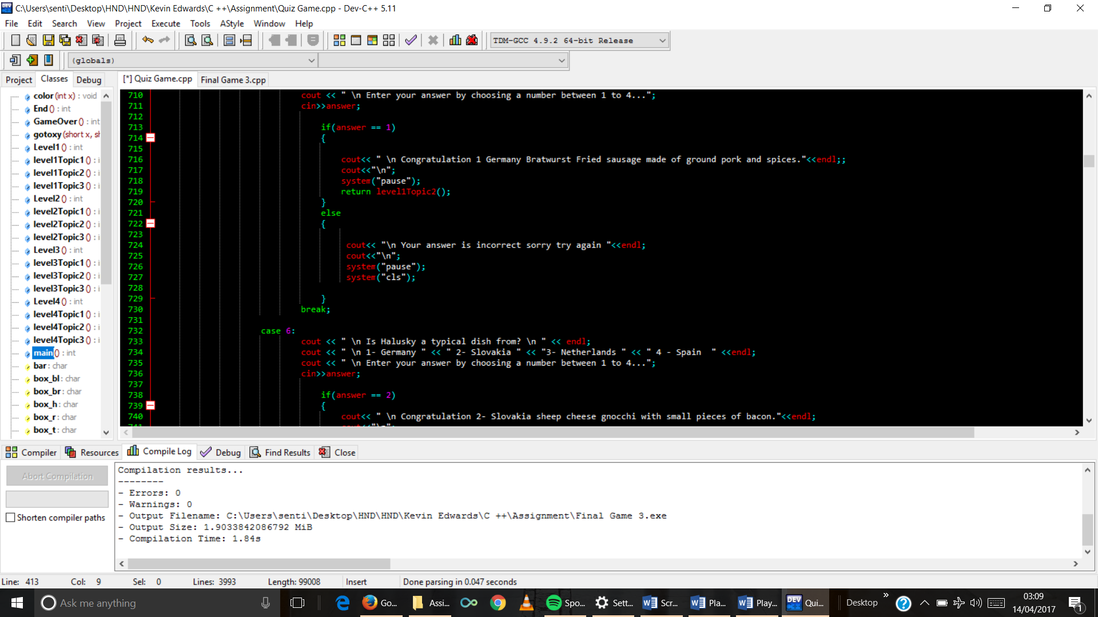

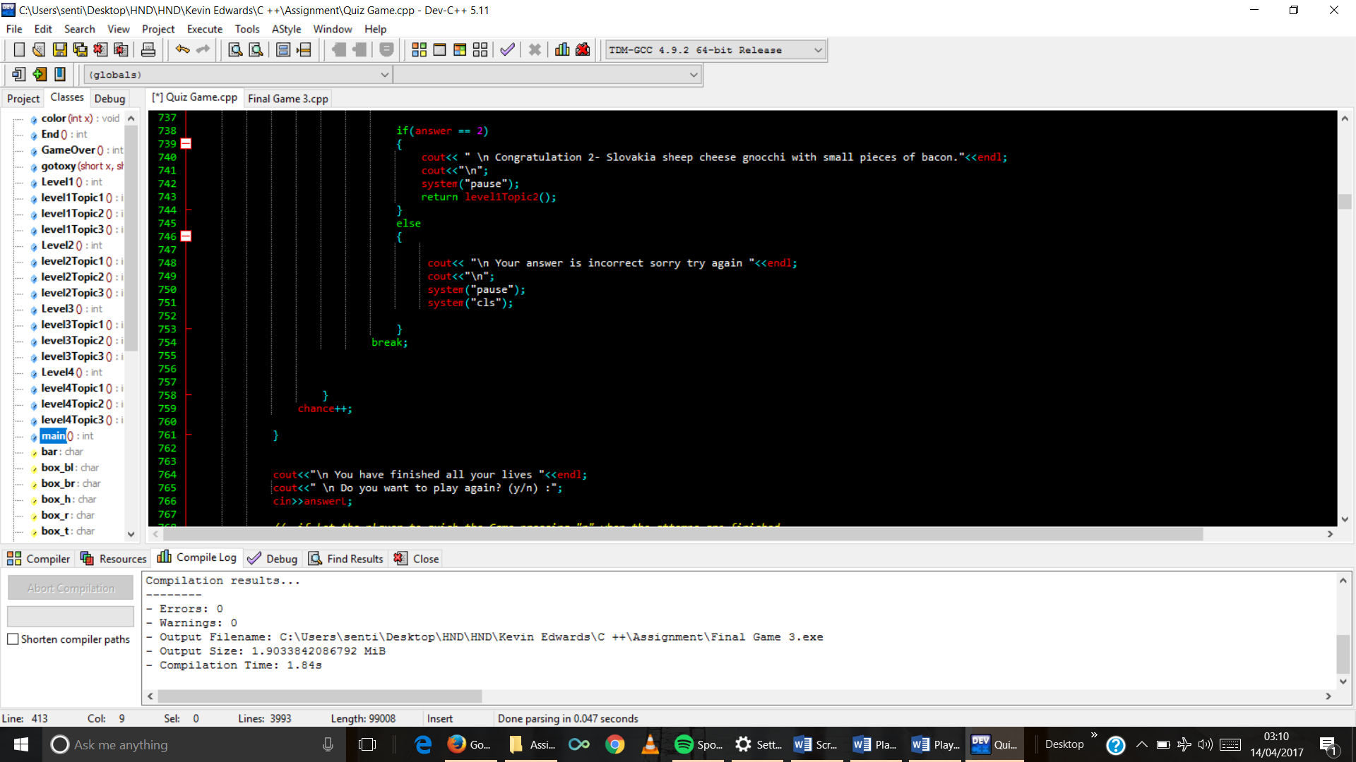

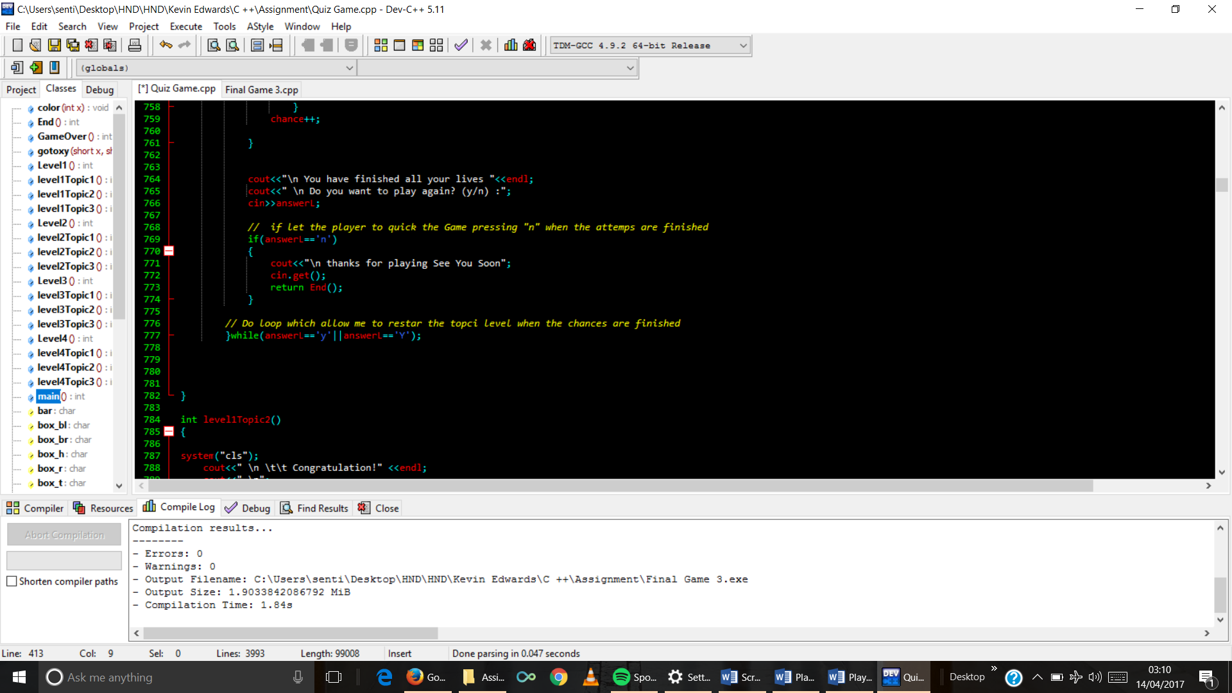

1. Topic 2 function code

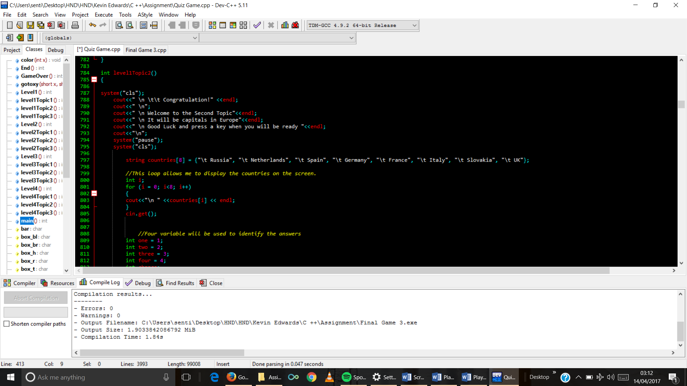

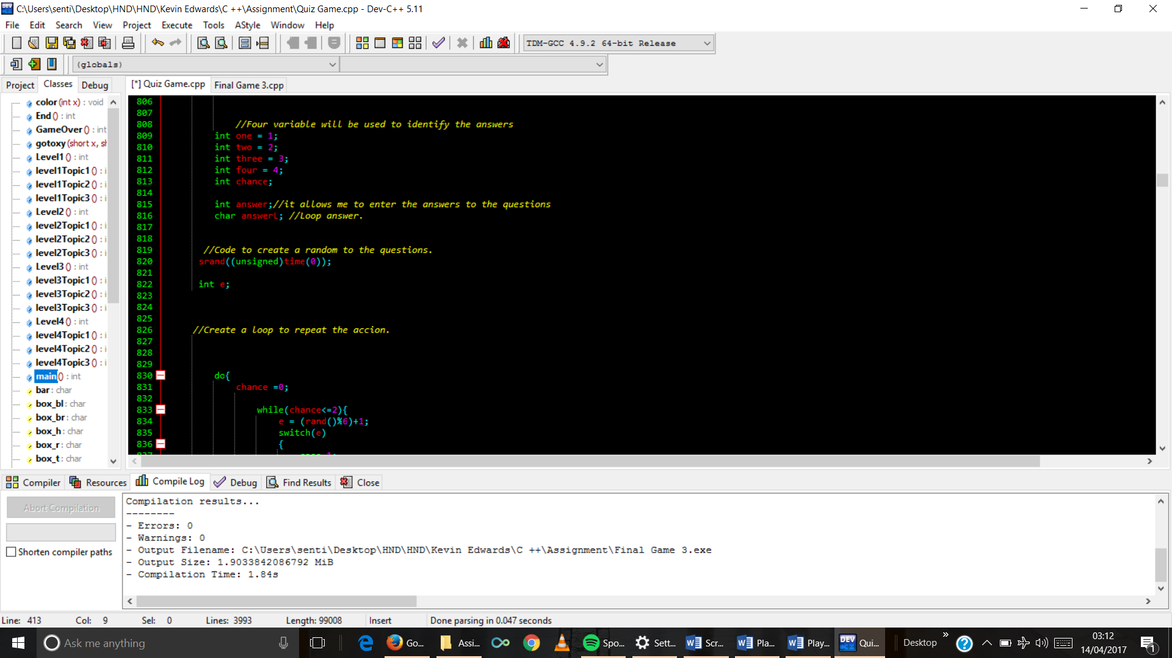

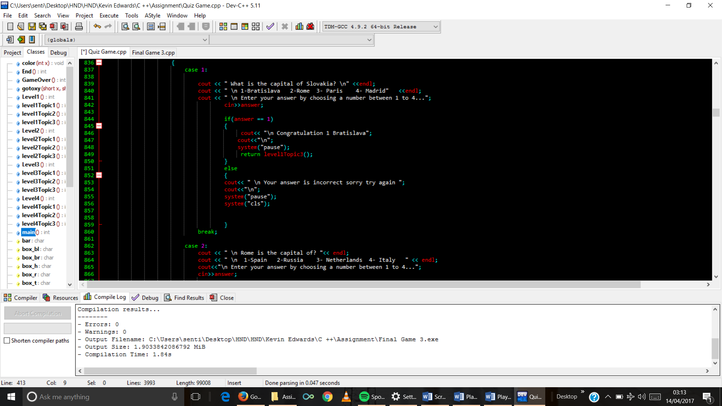

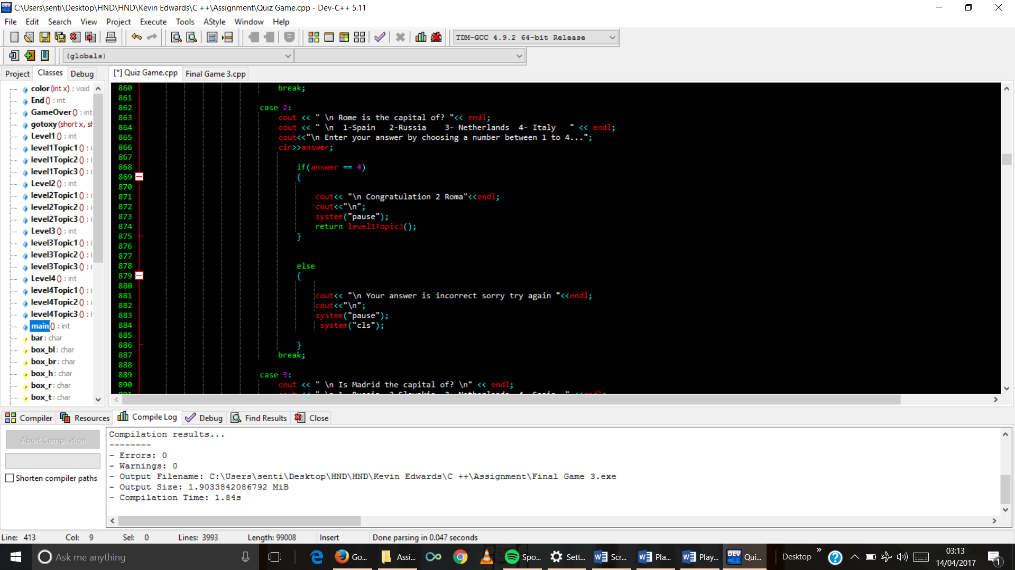

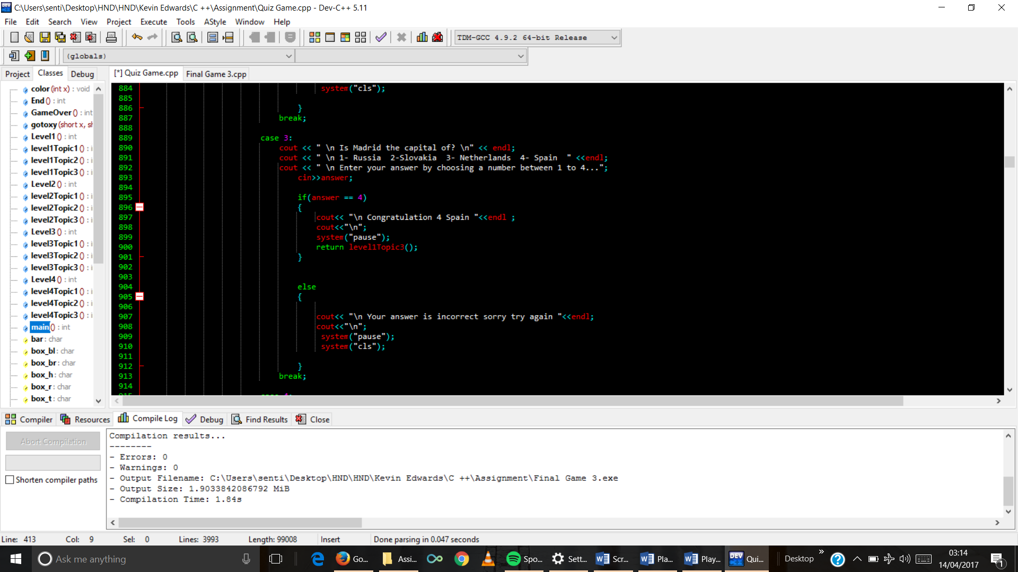

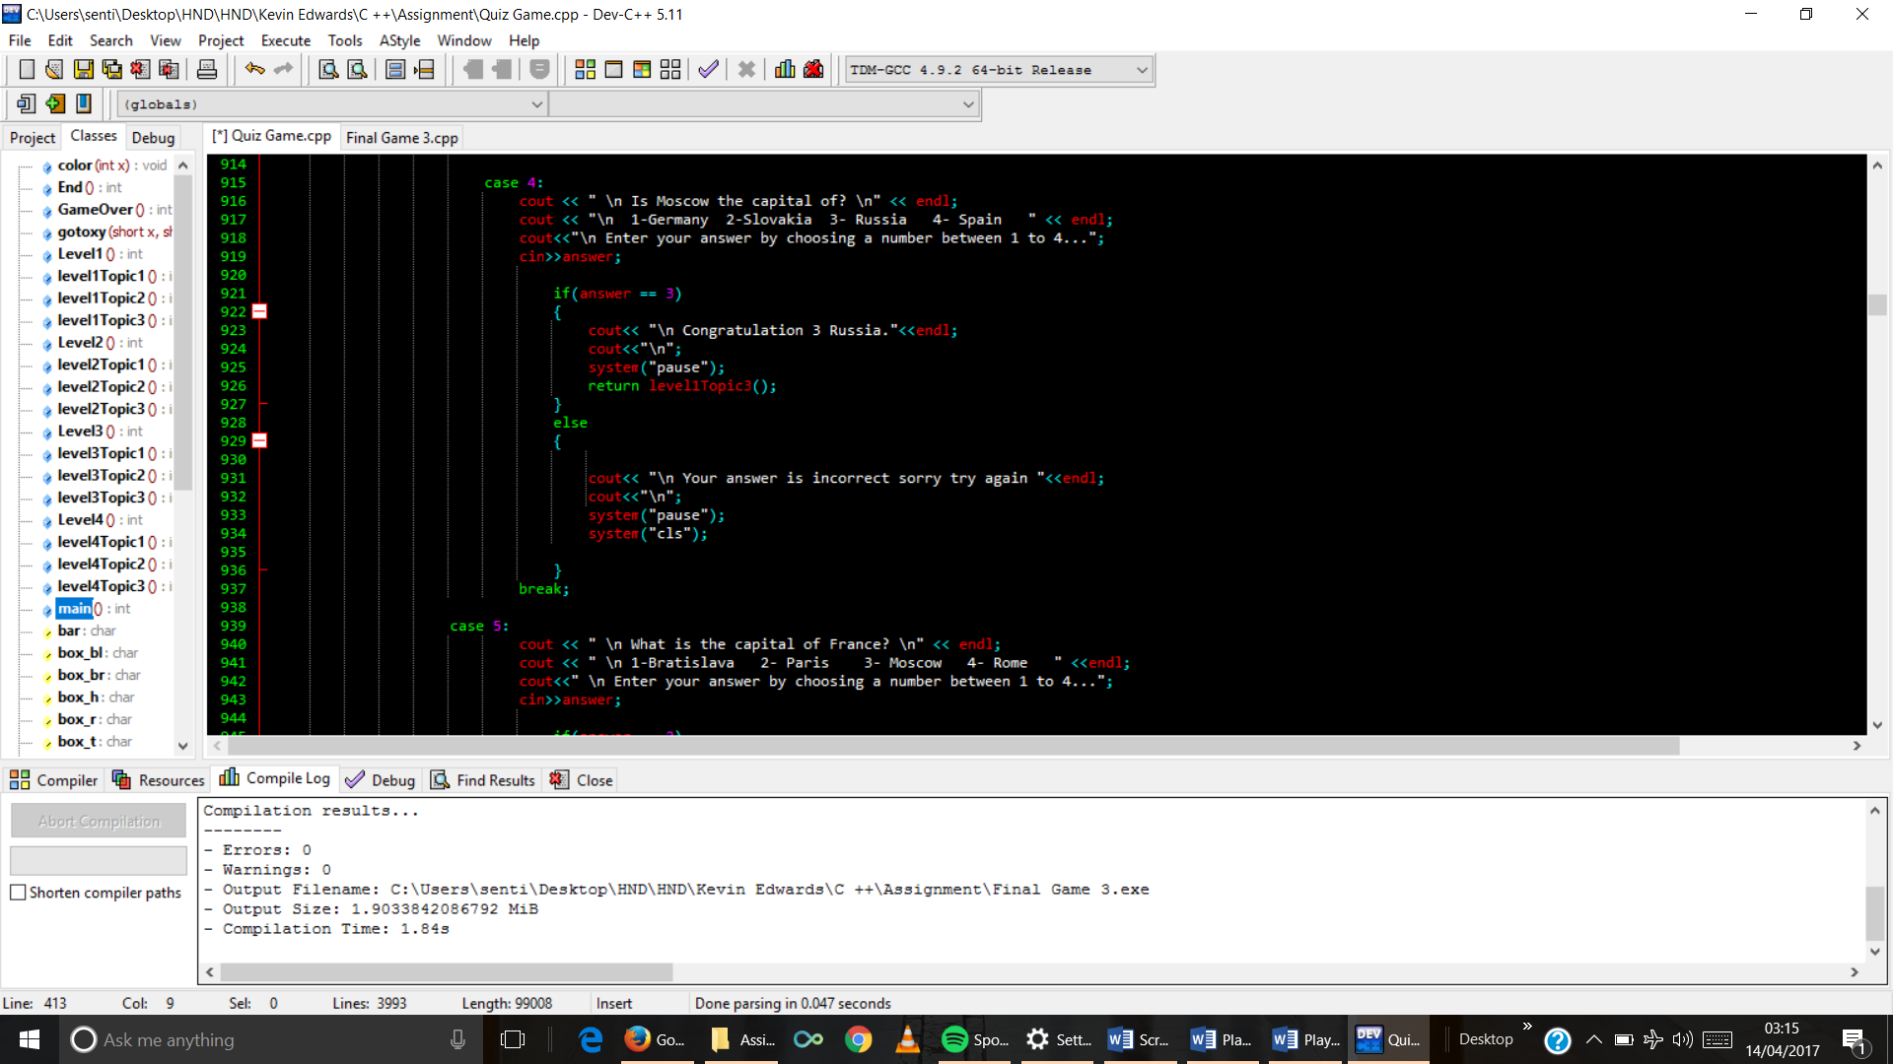

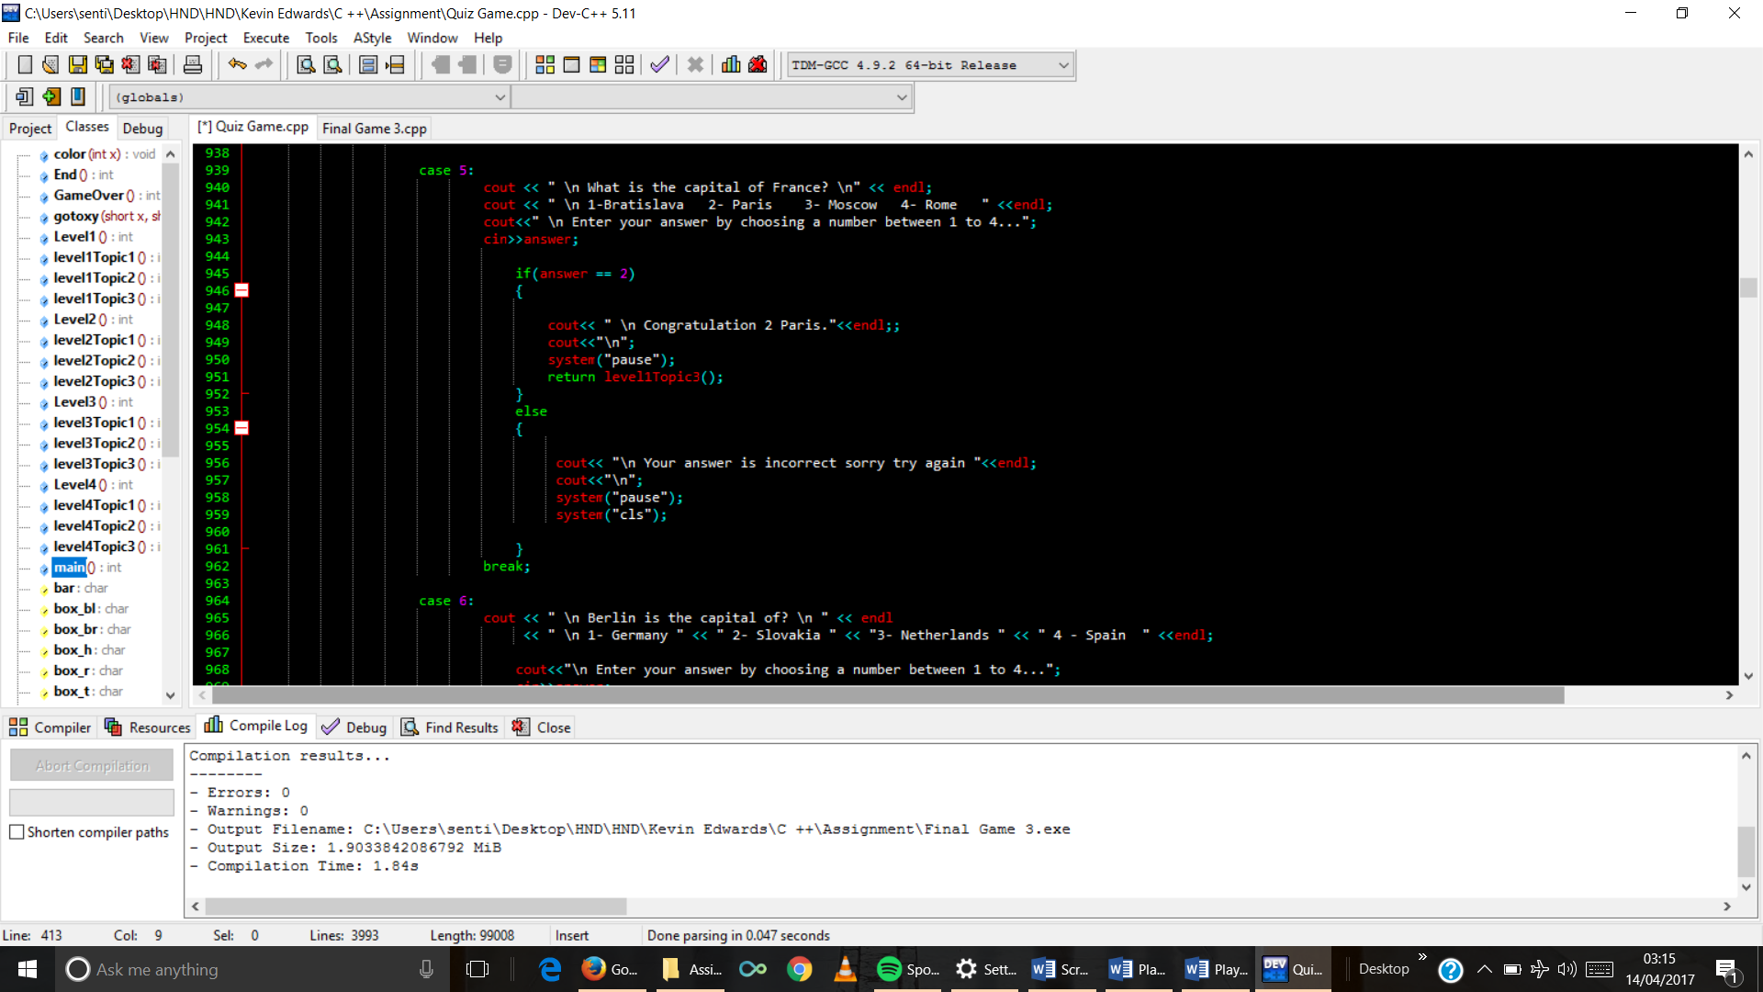

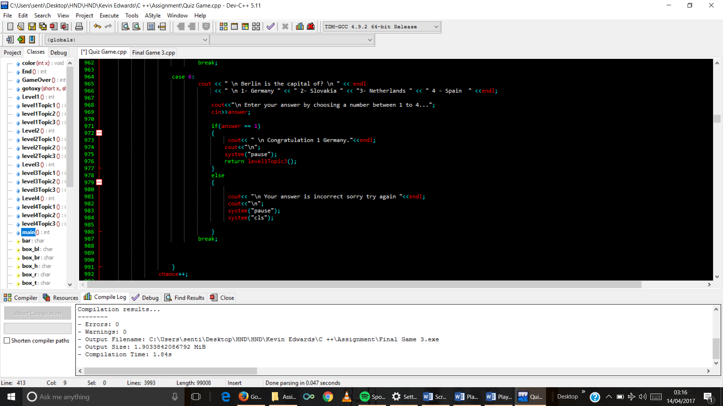

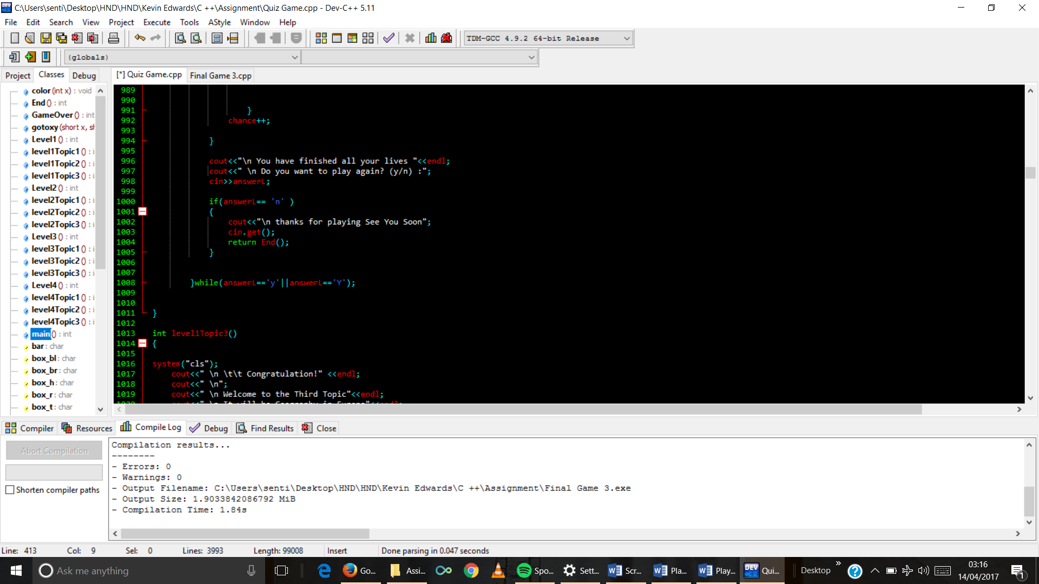

1. Topic 3 function code

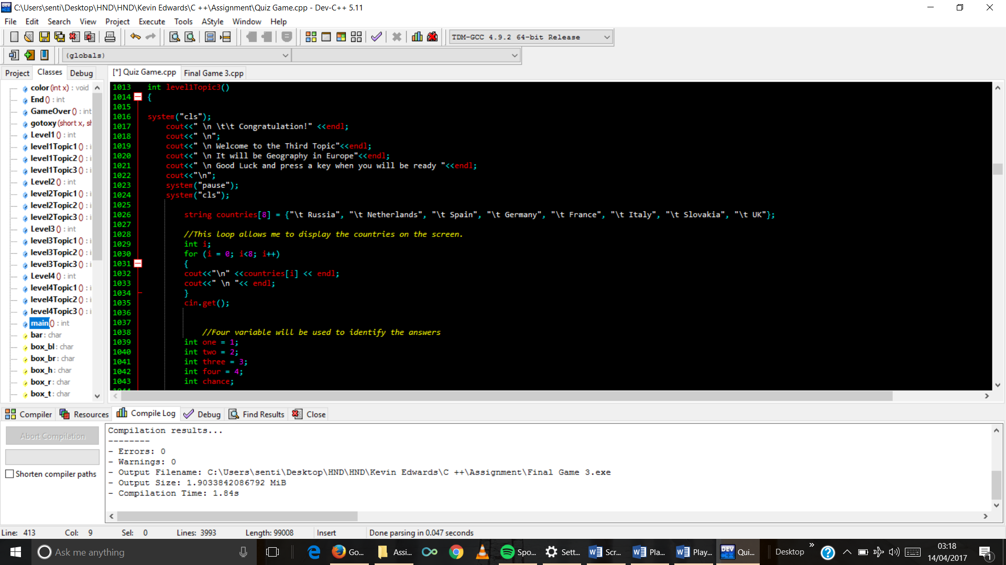

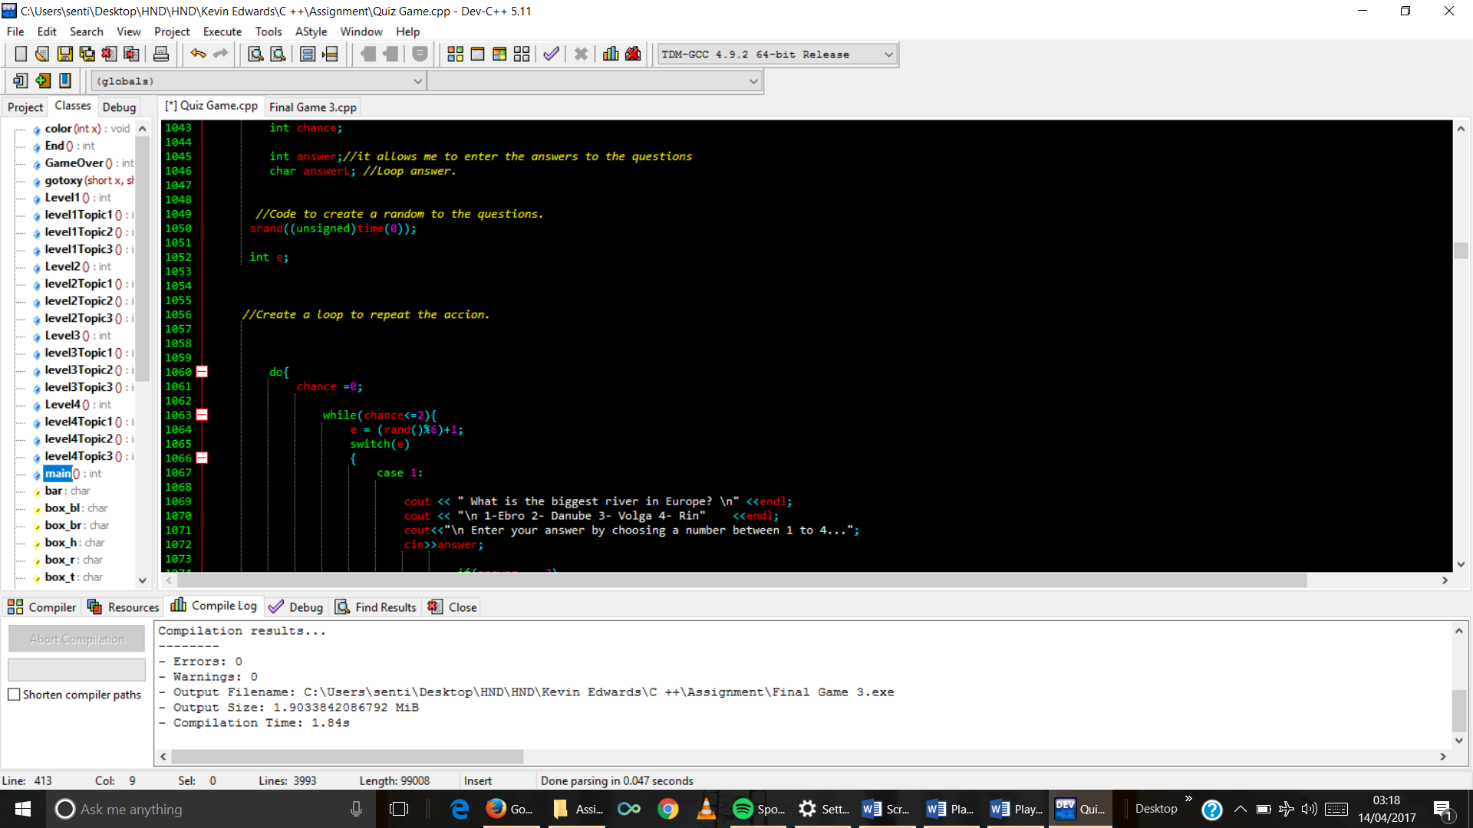

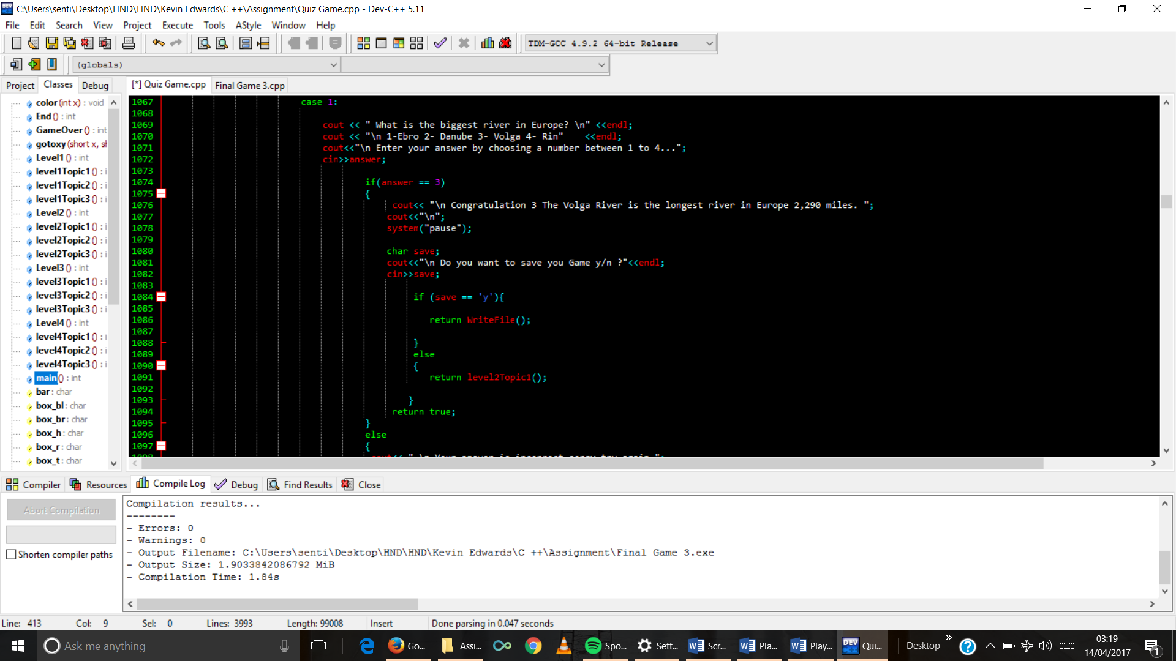

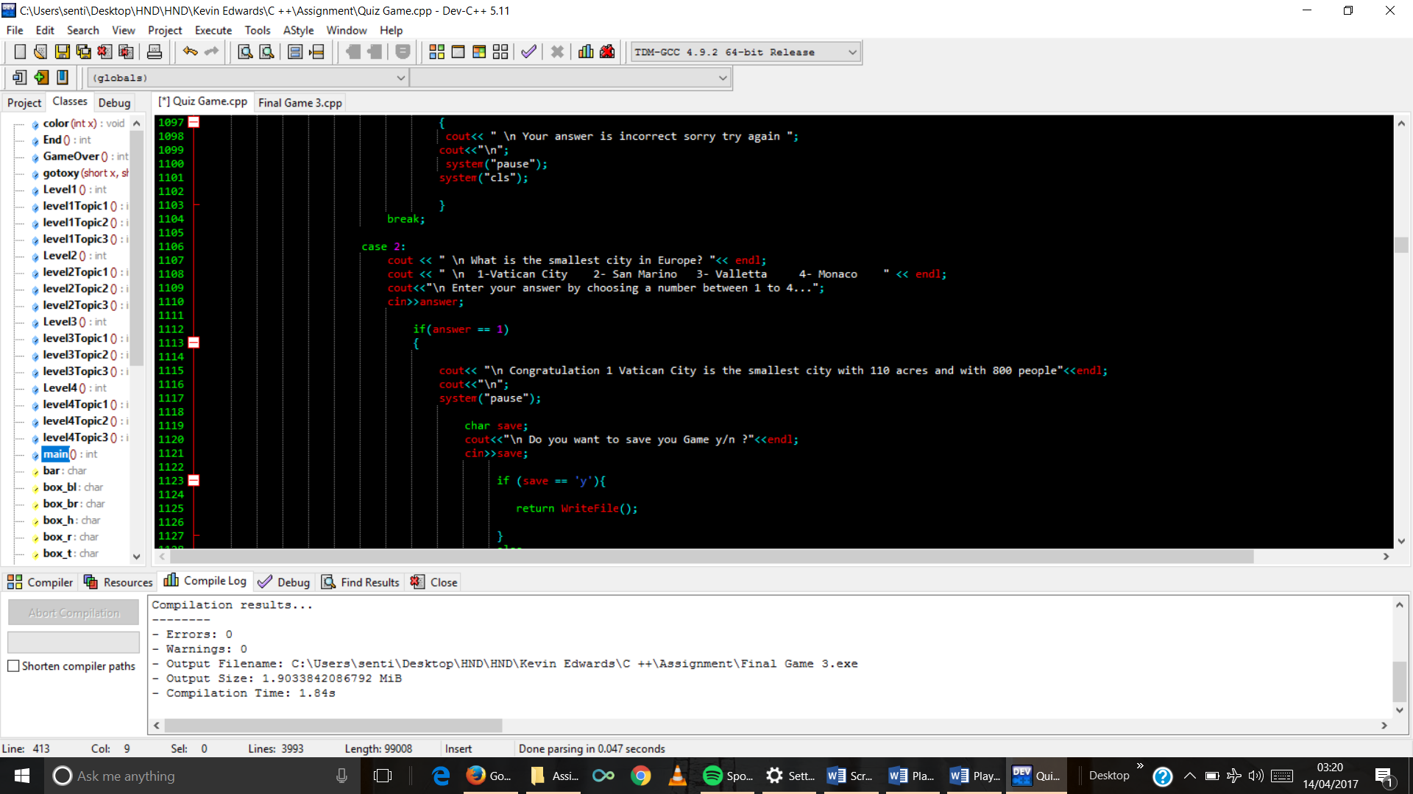

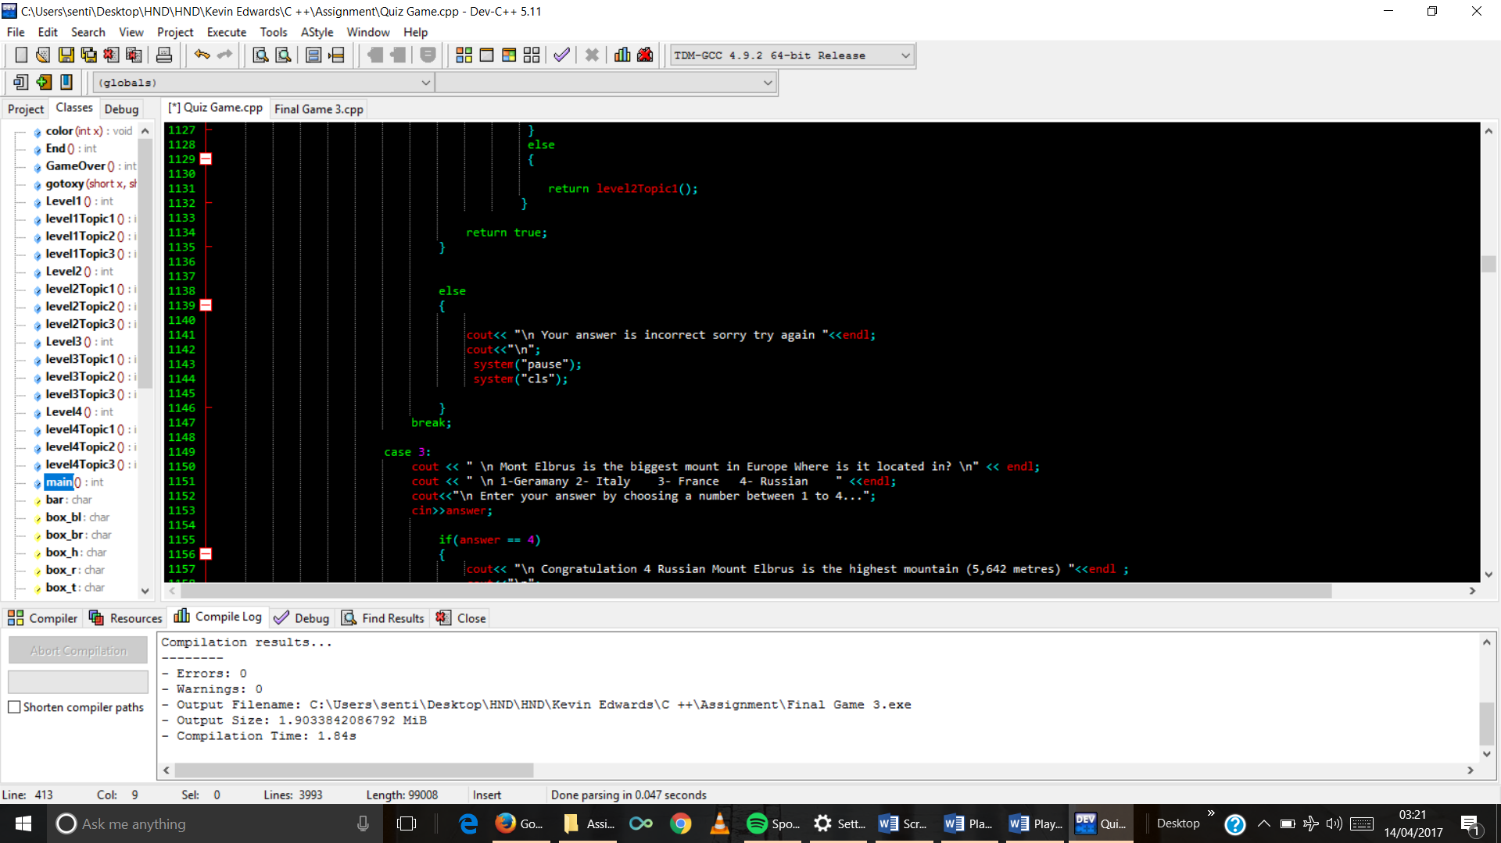

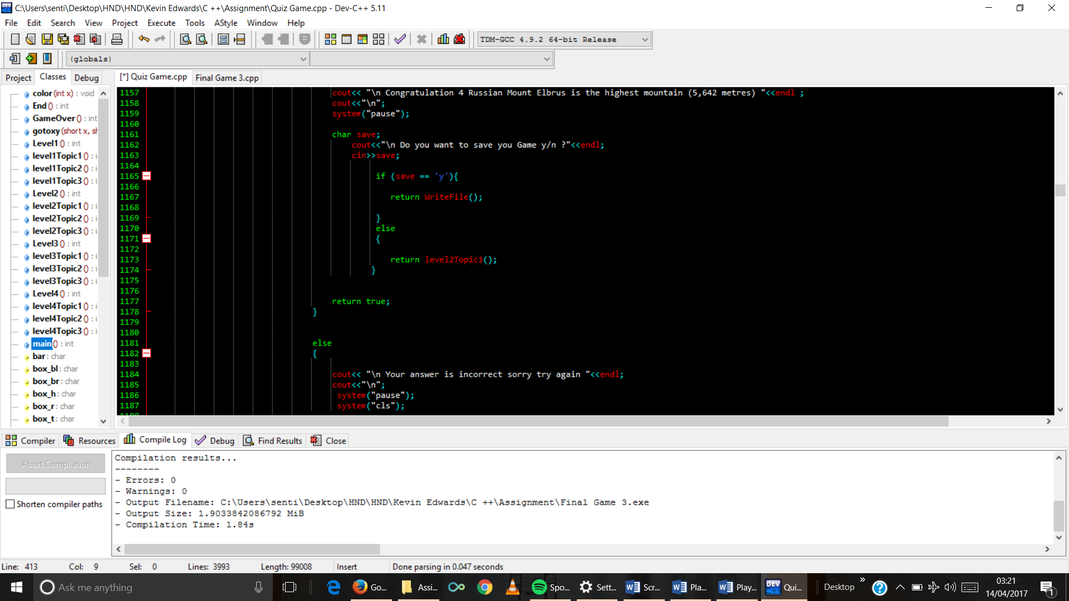

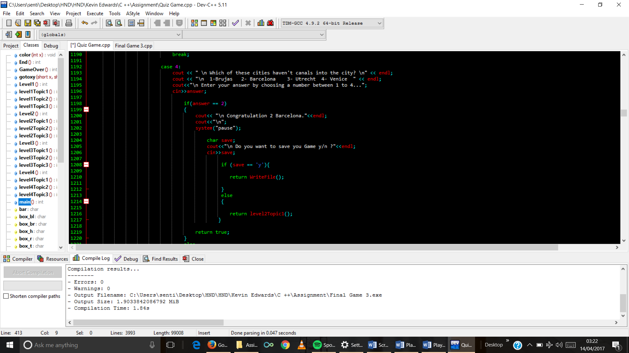

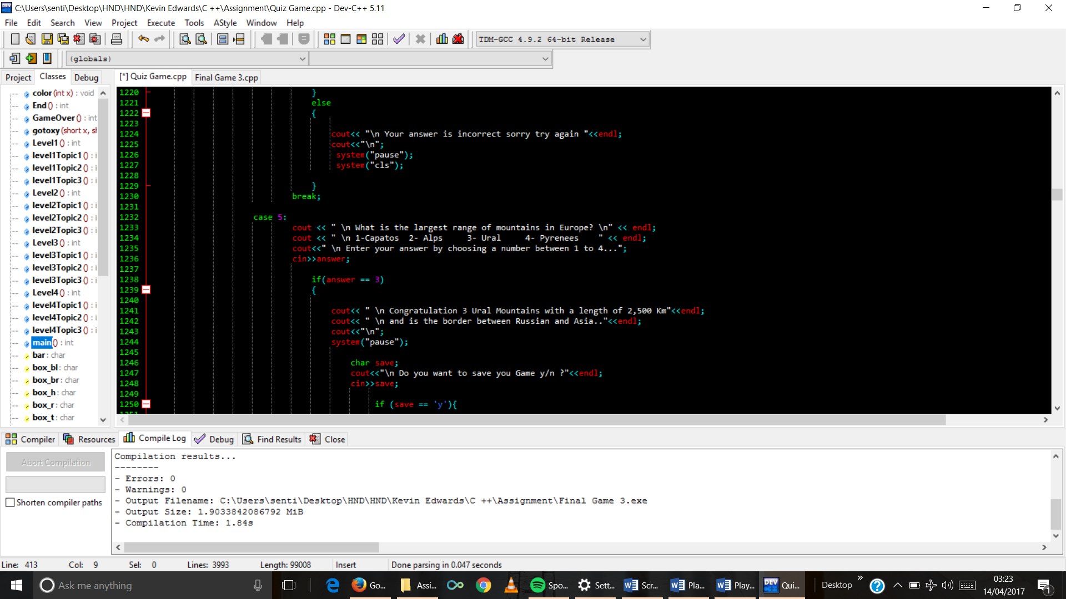

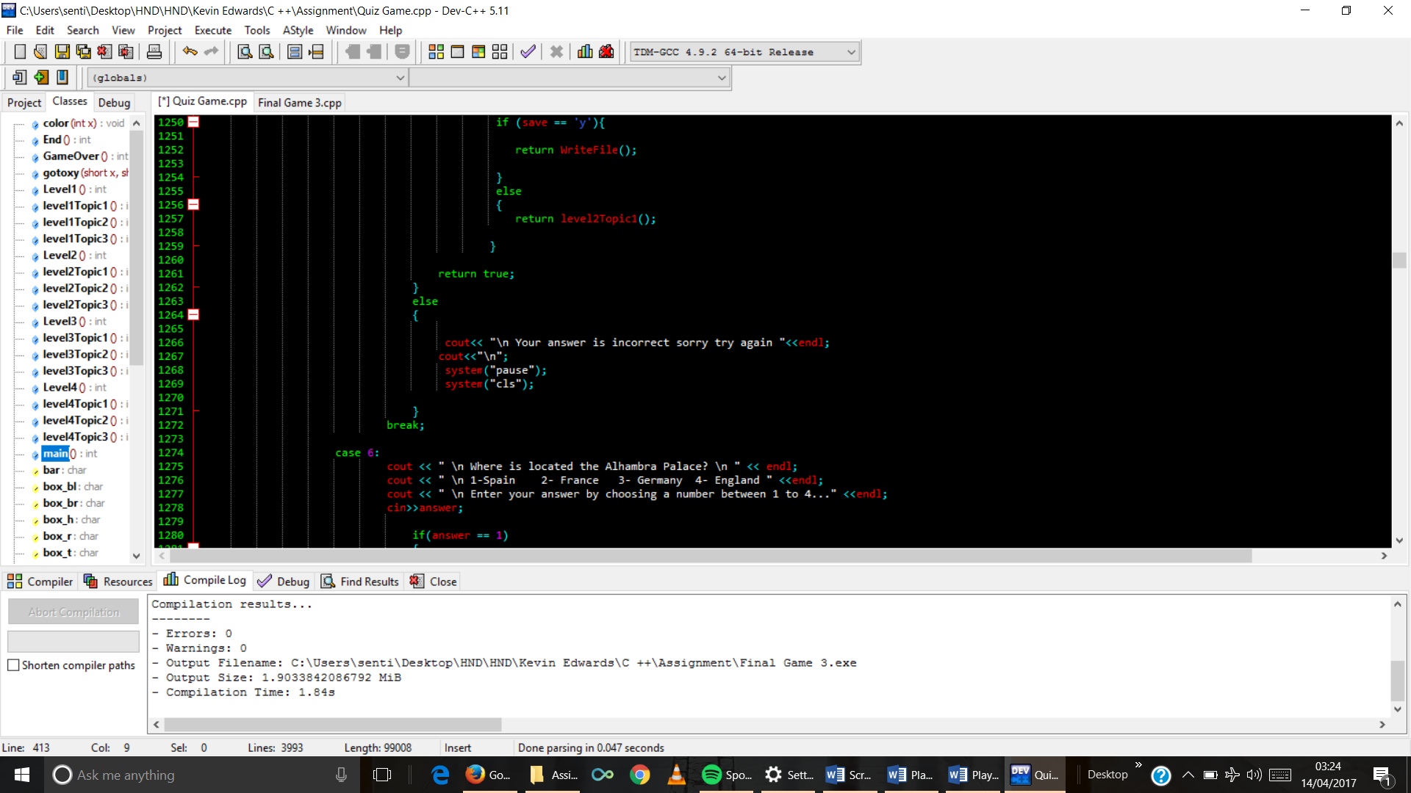

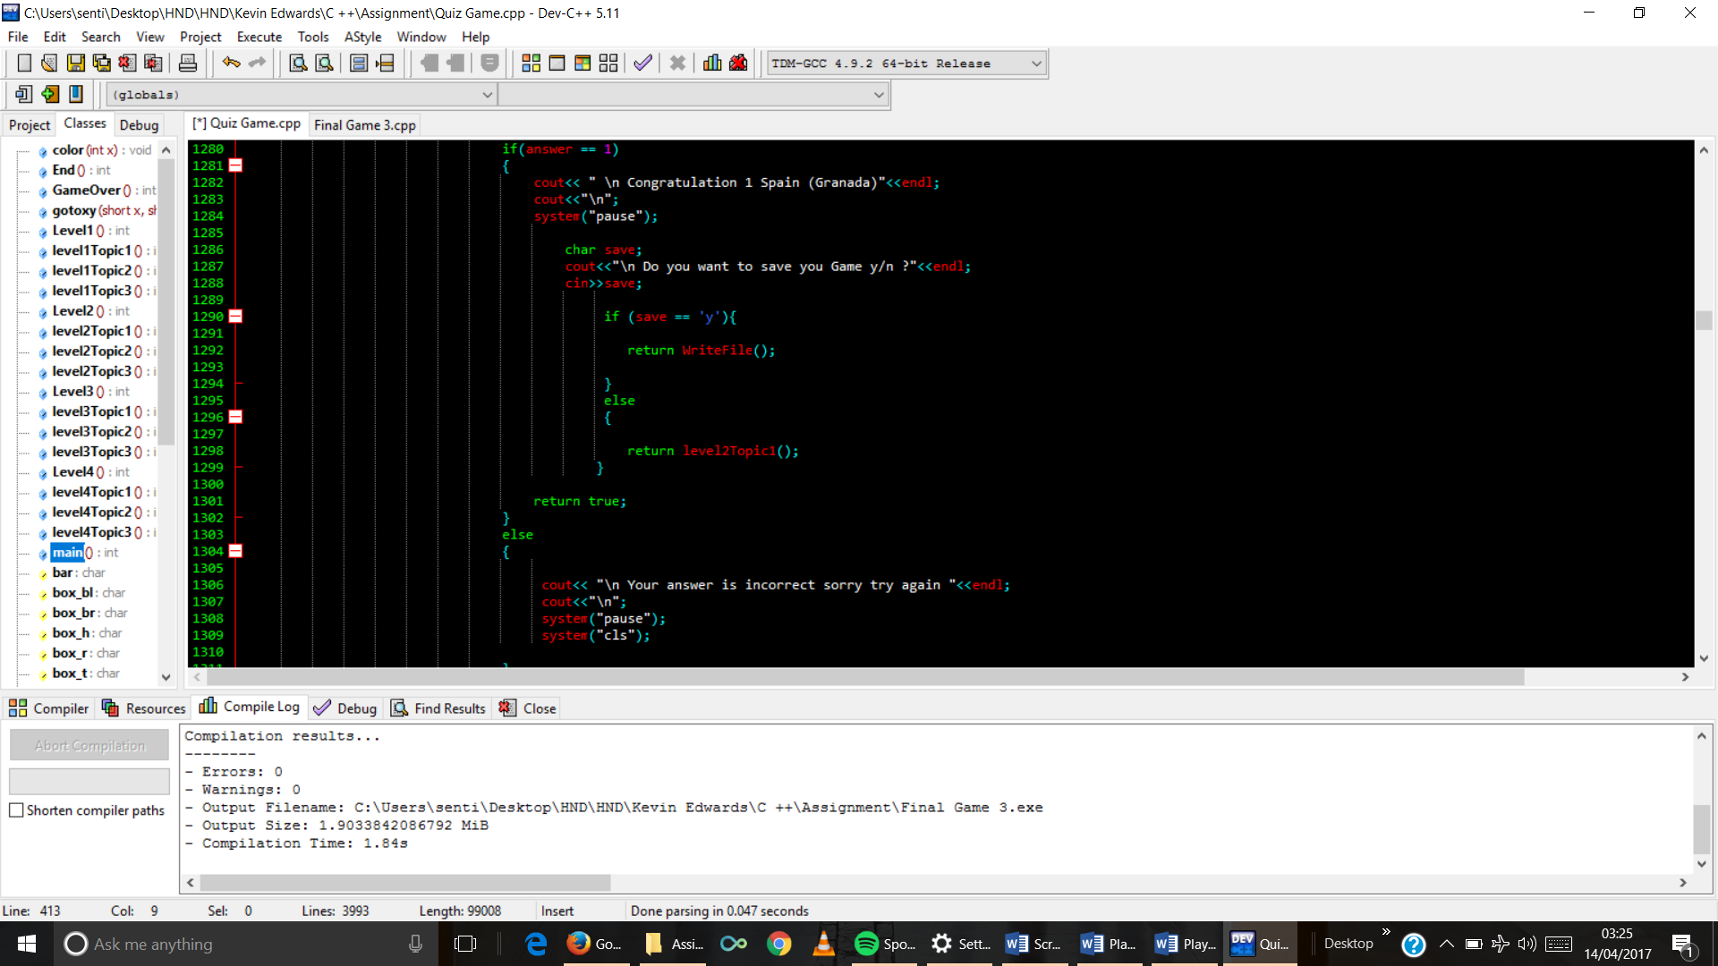

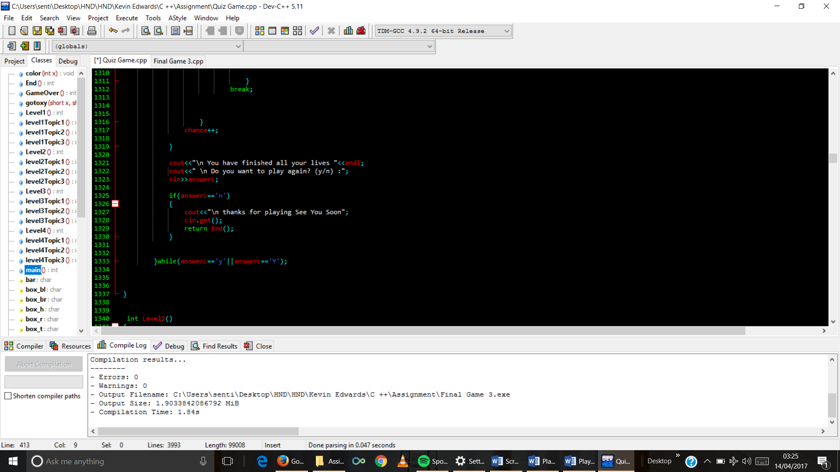

1. Level 2 Function code

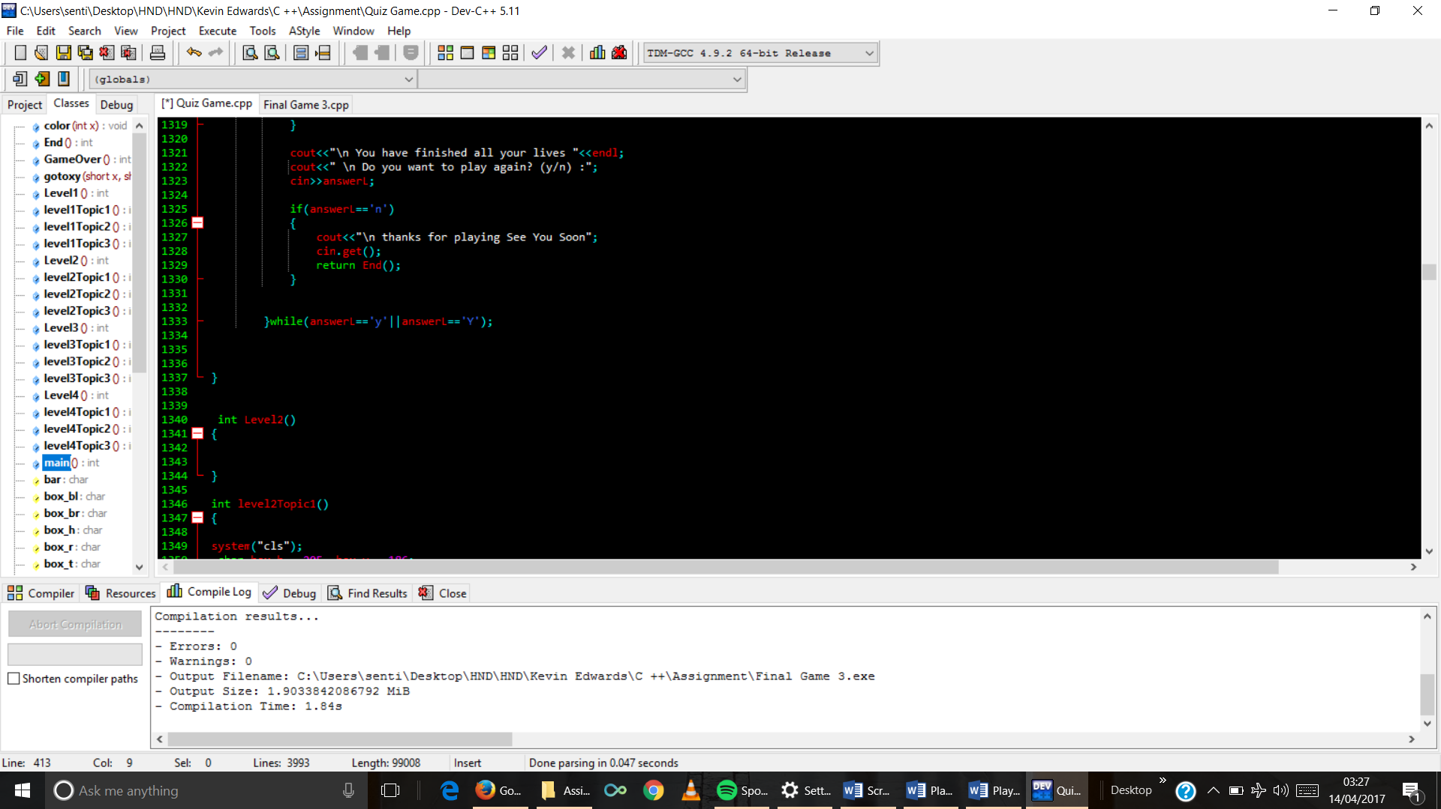

1. Topic1 function code

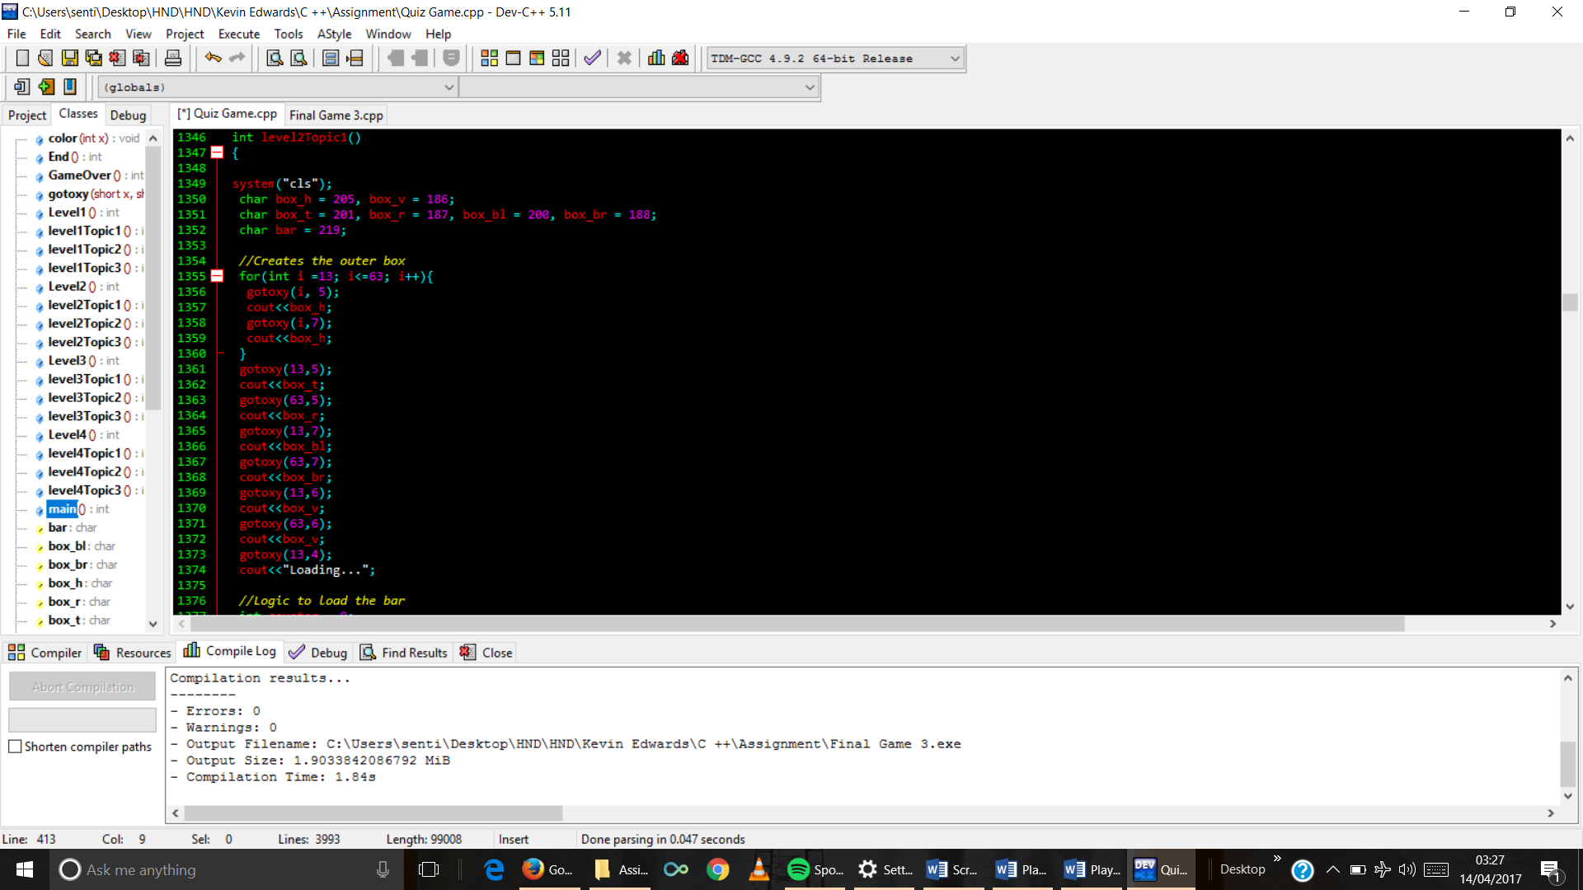

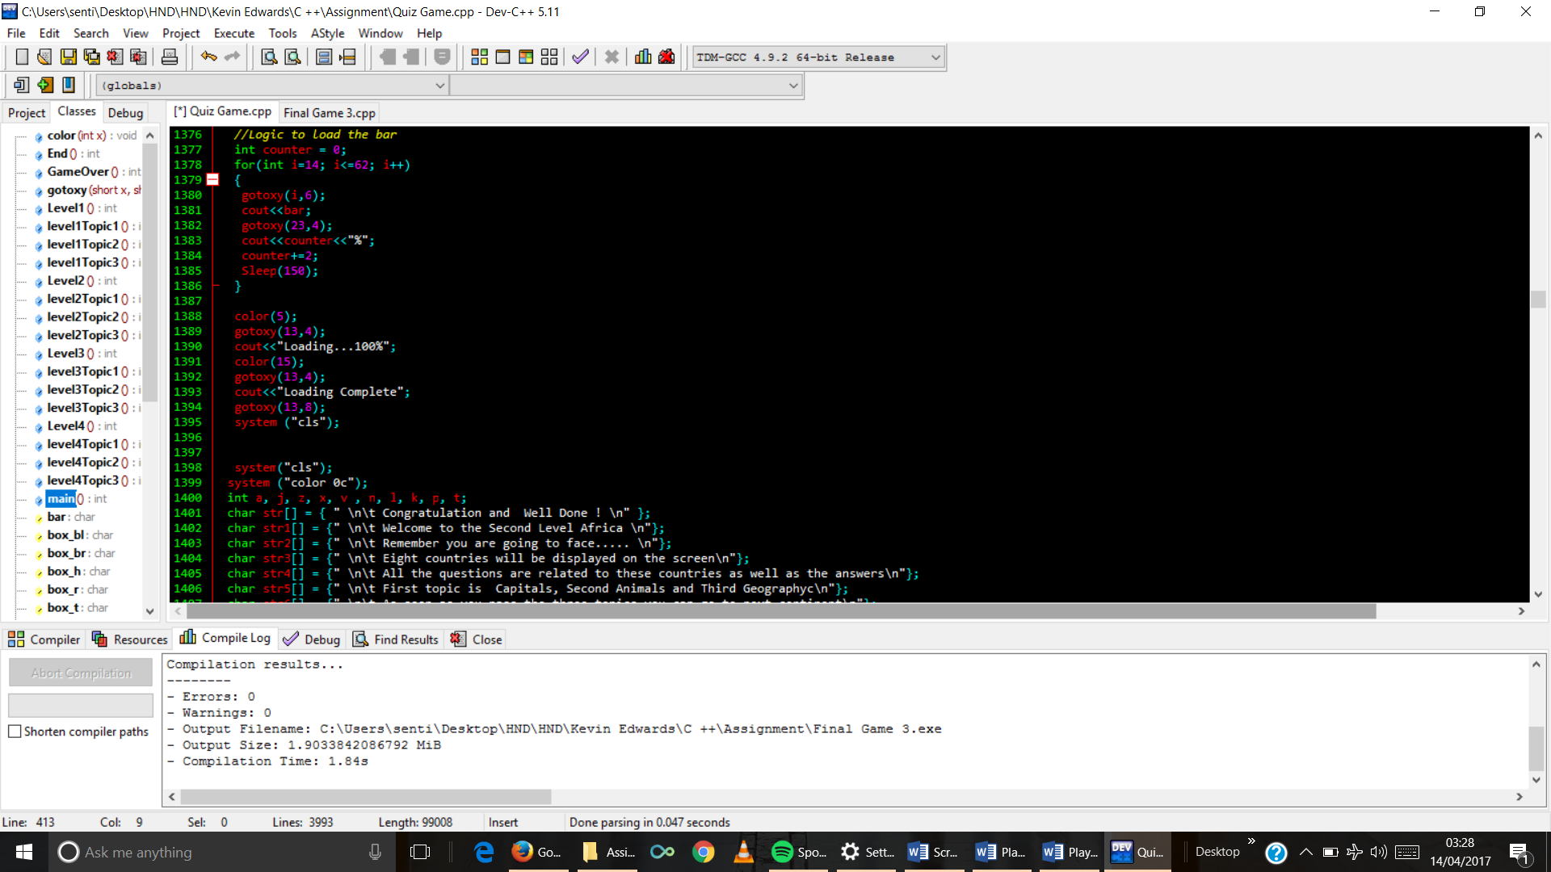

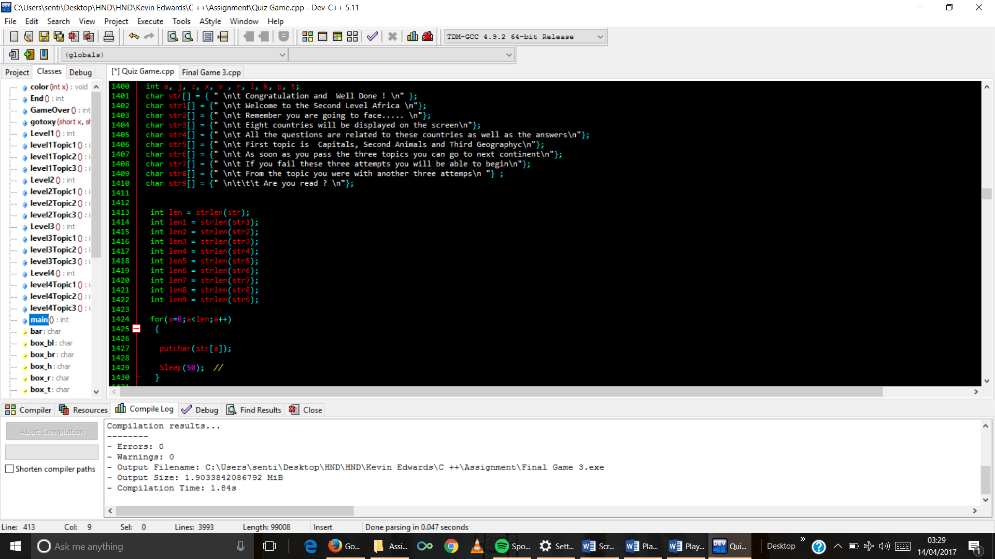

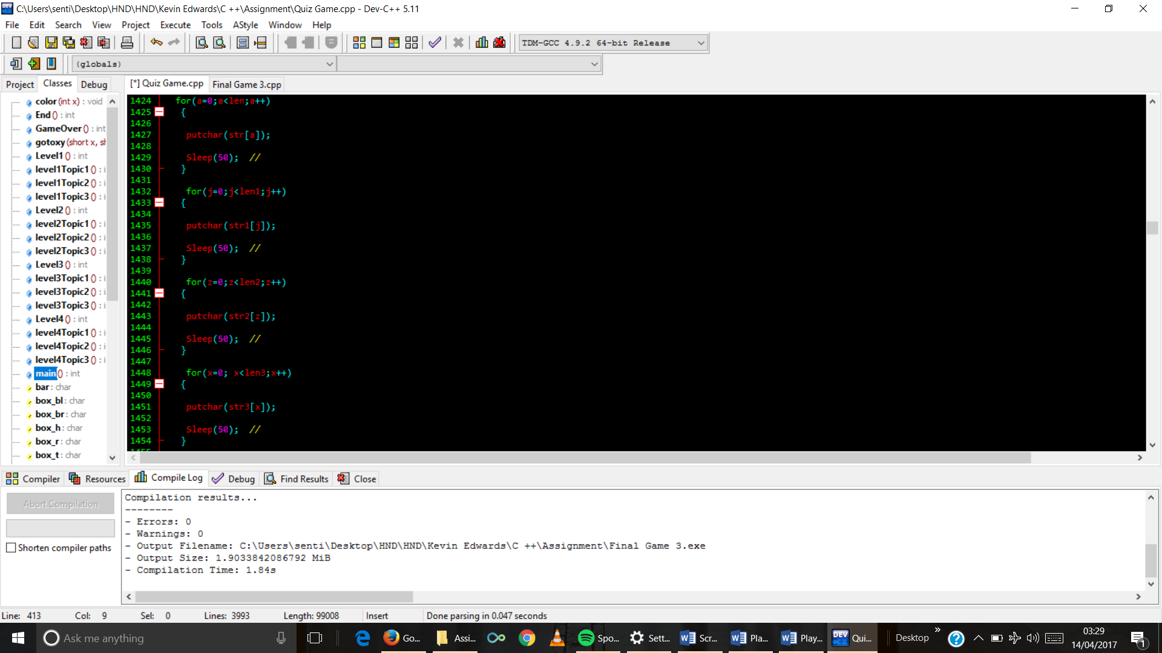

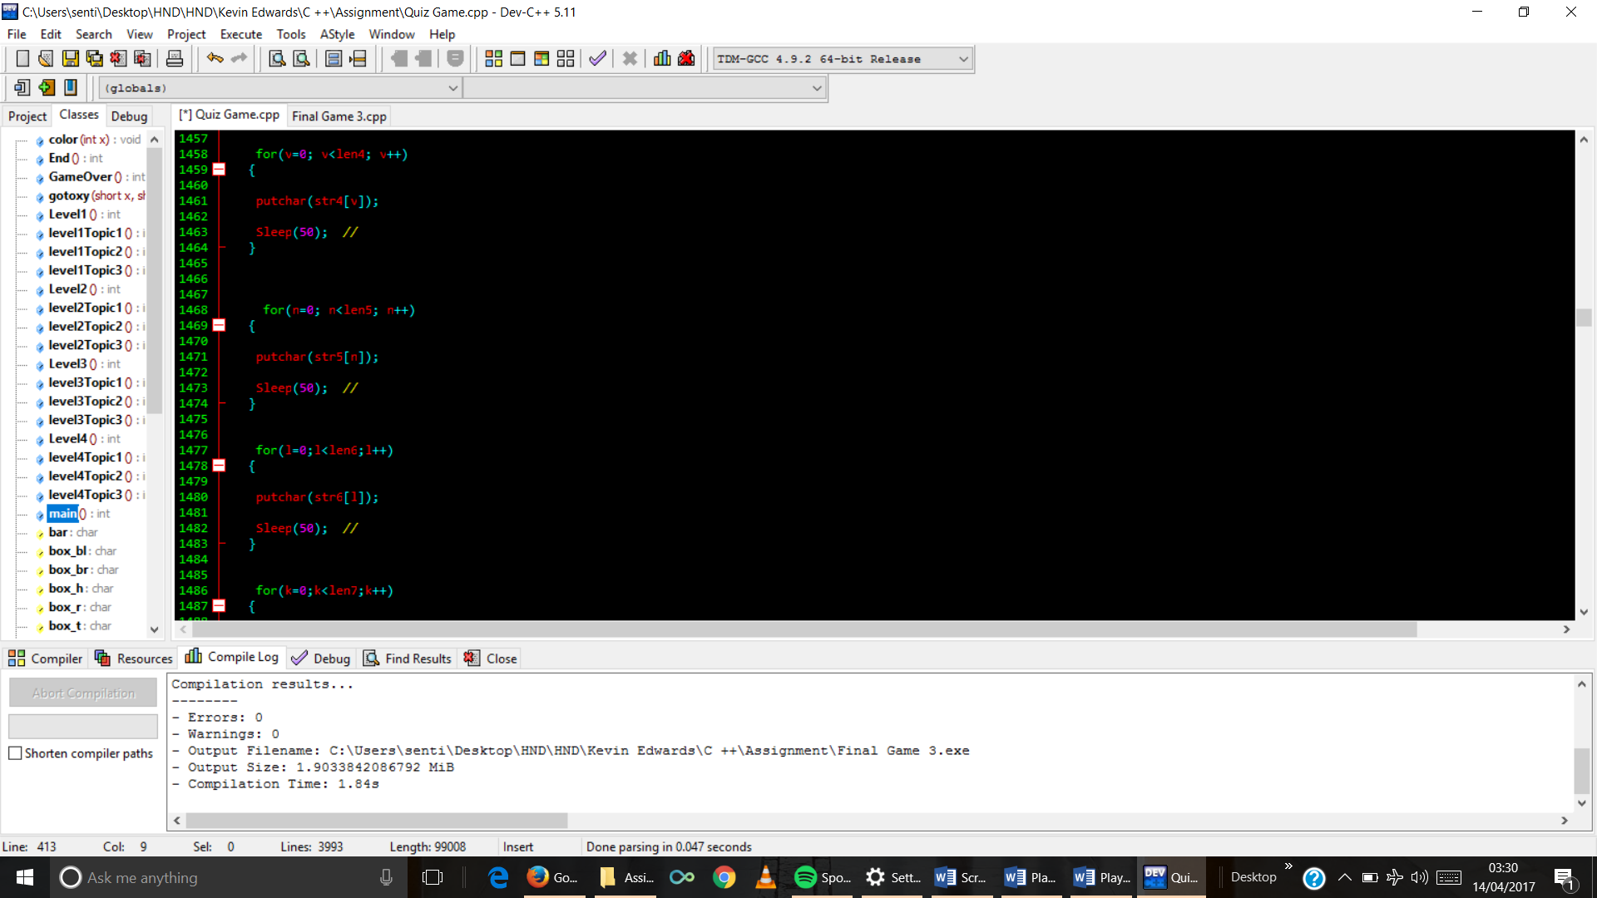

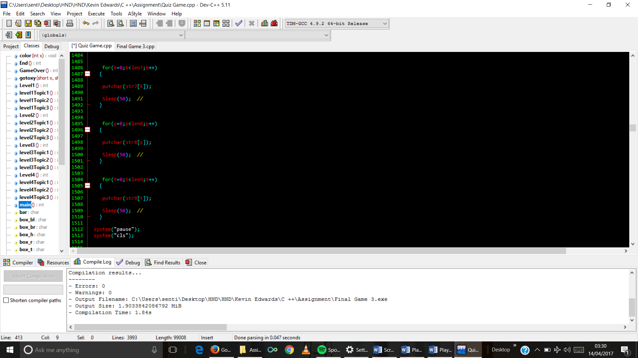

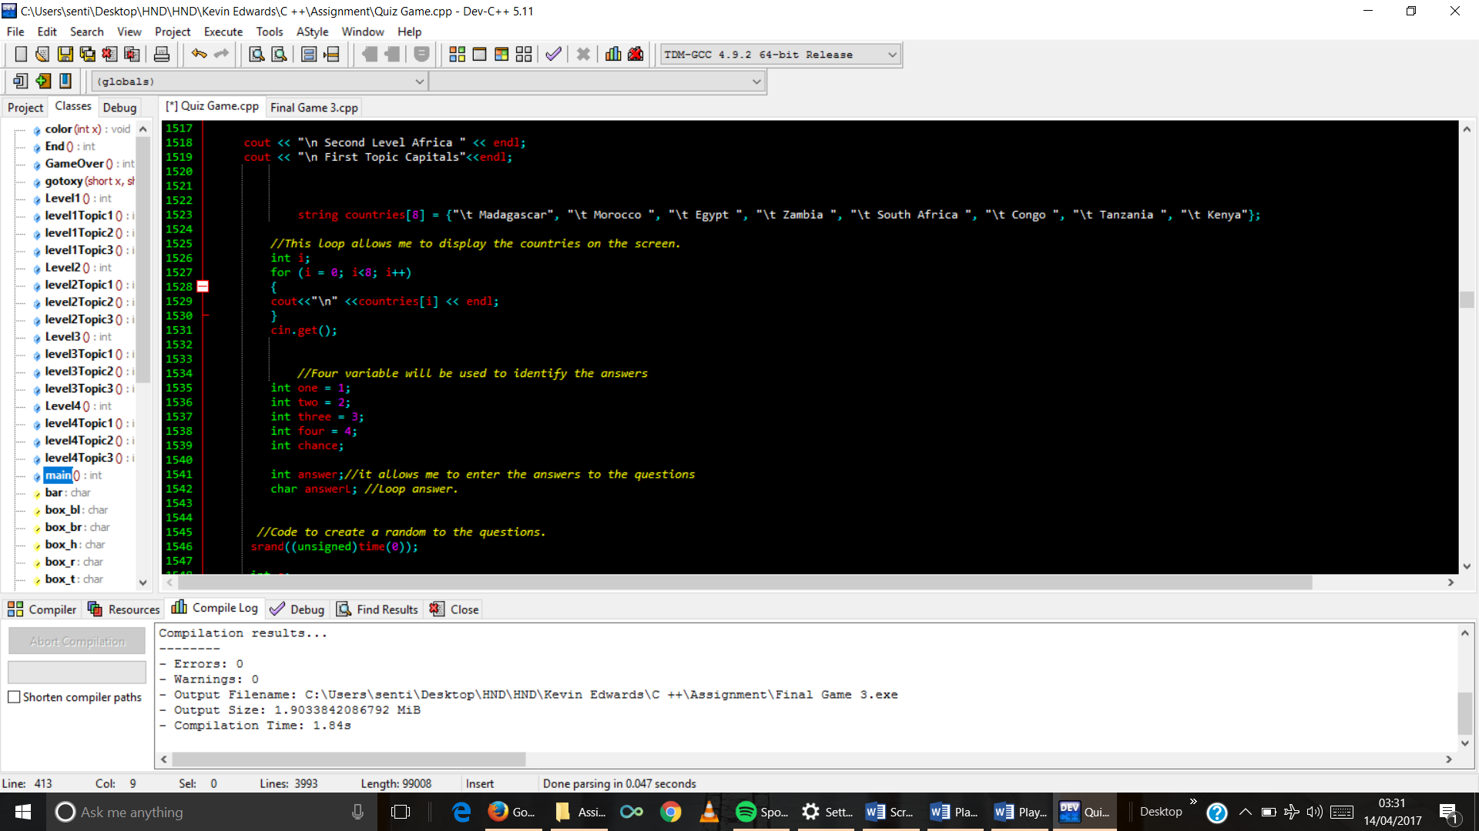

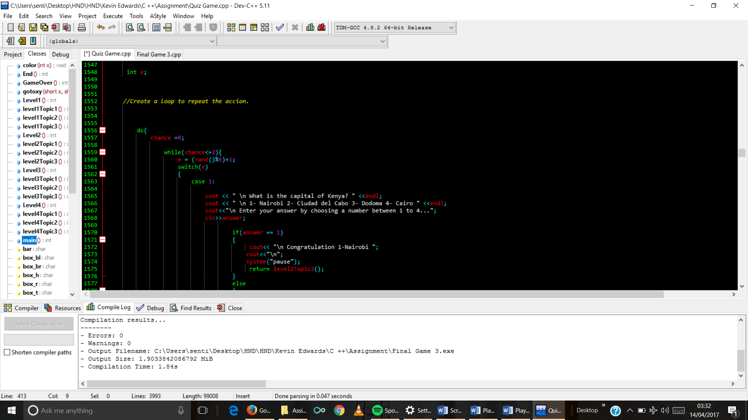

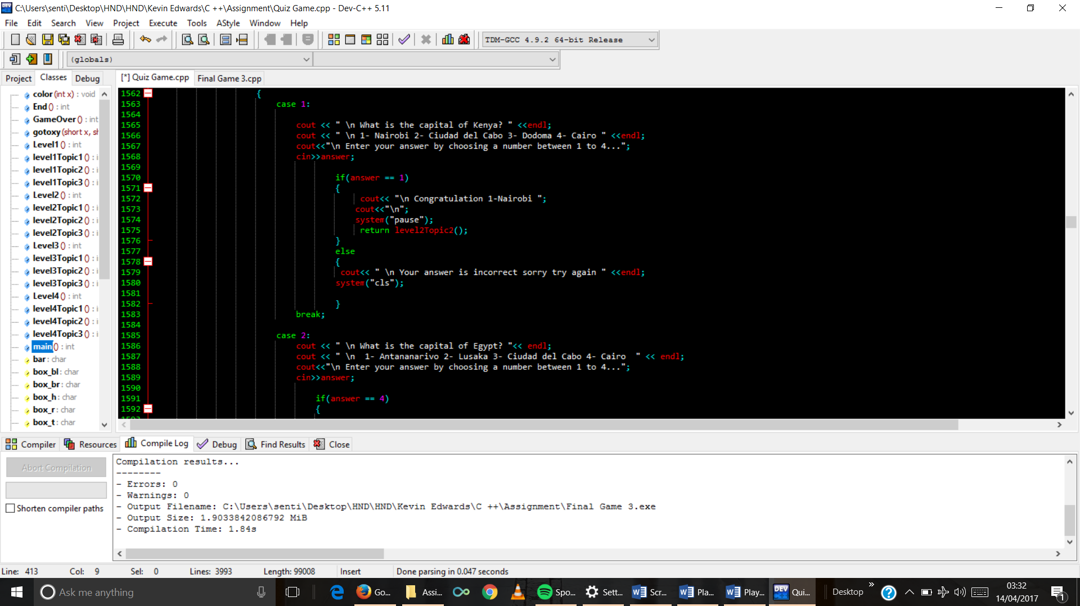

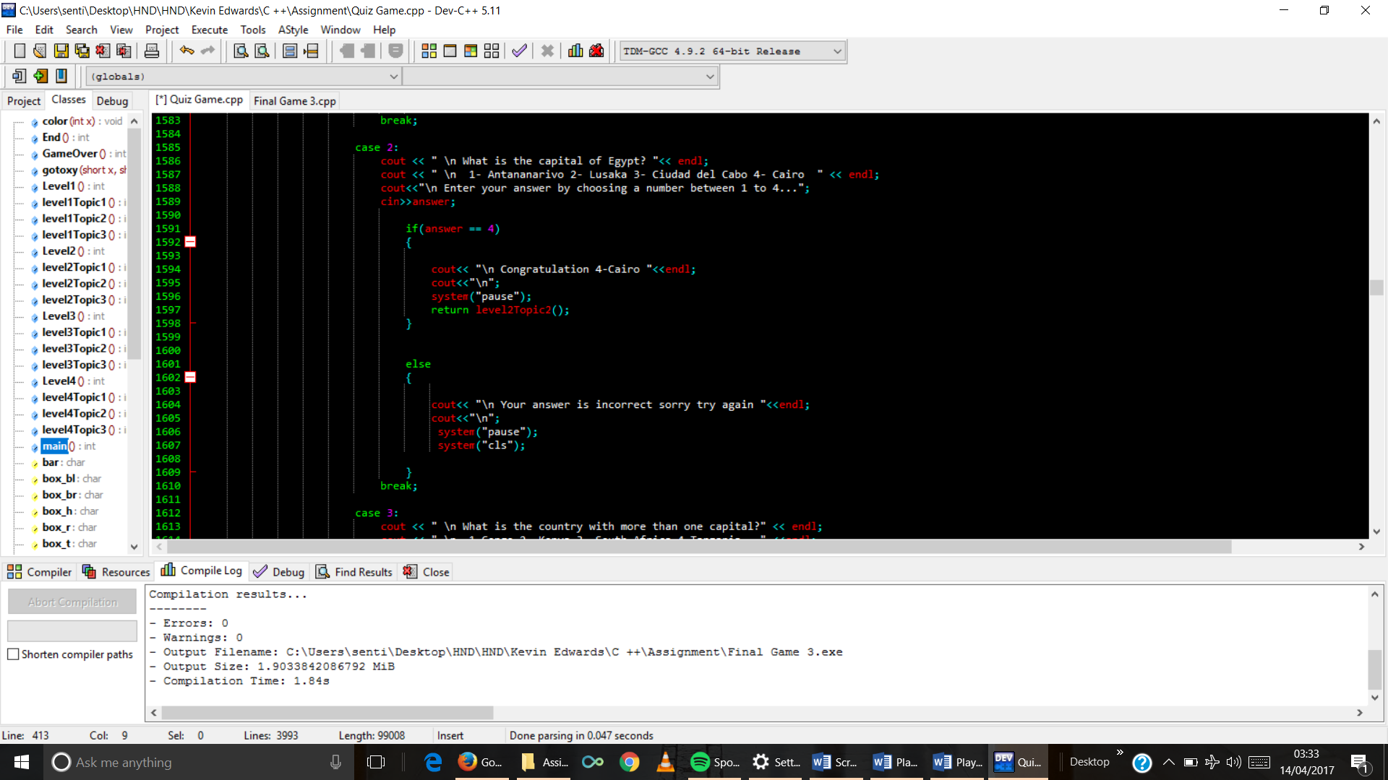

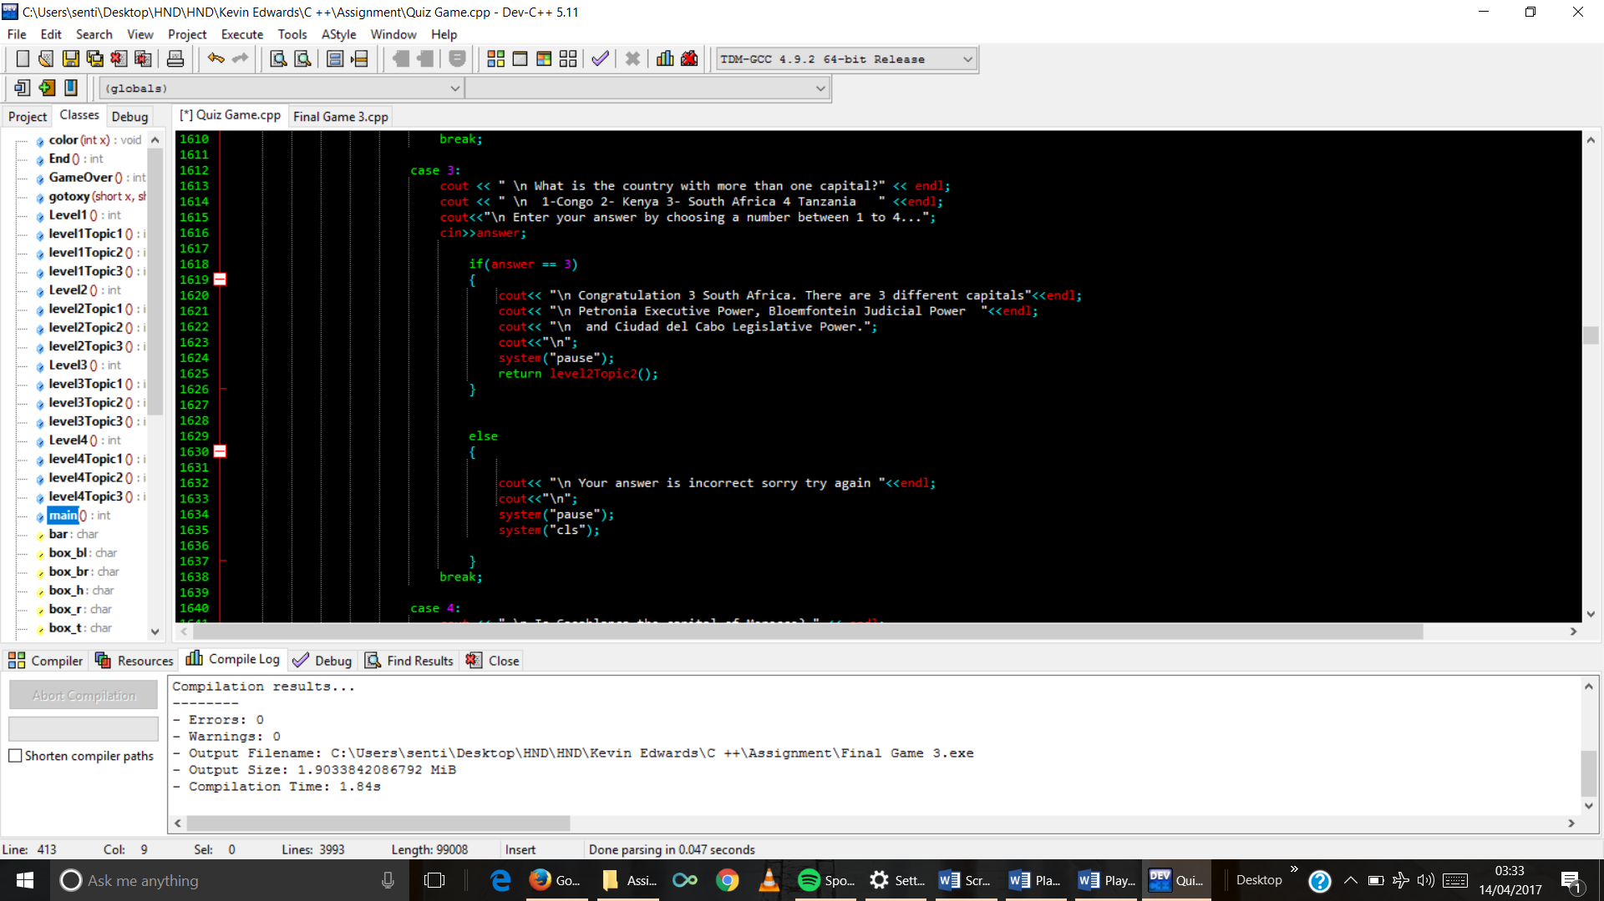

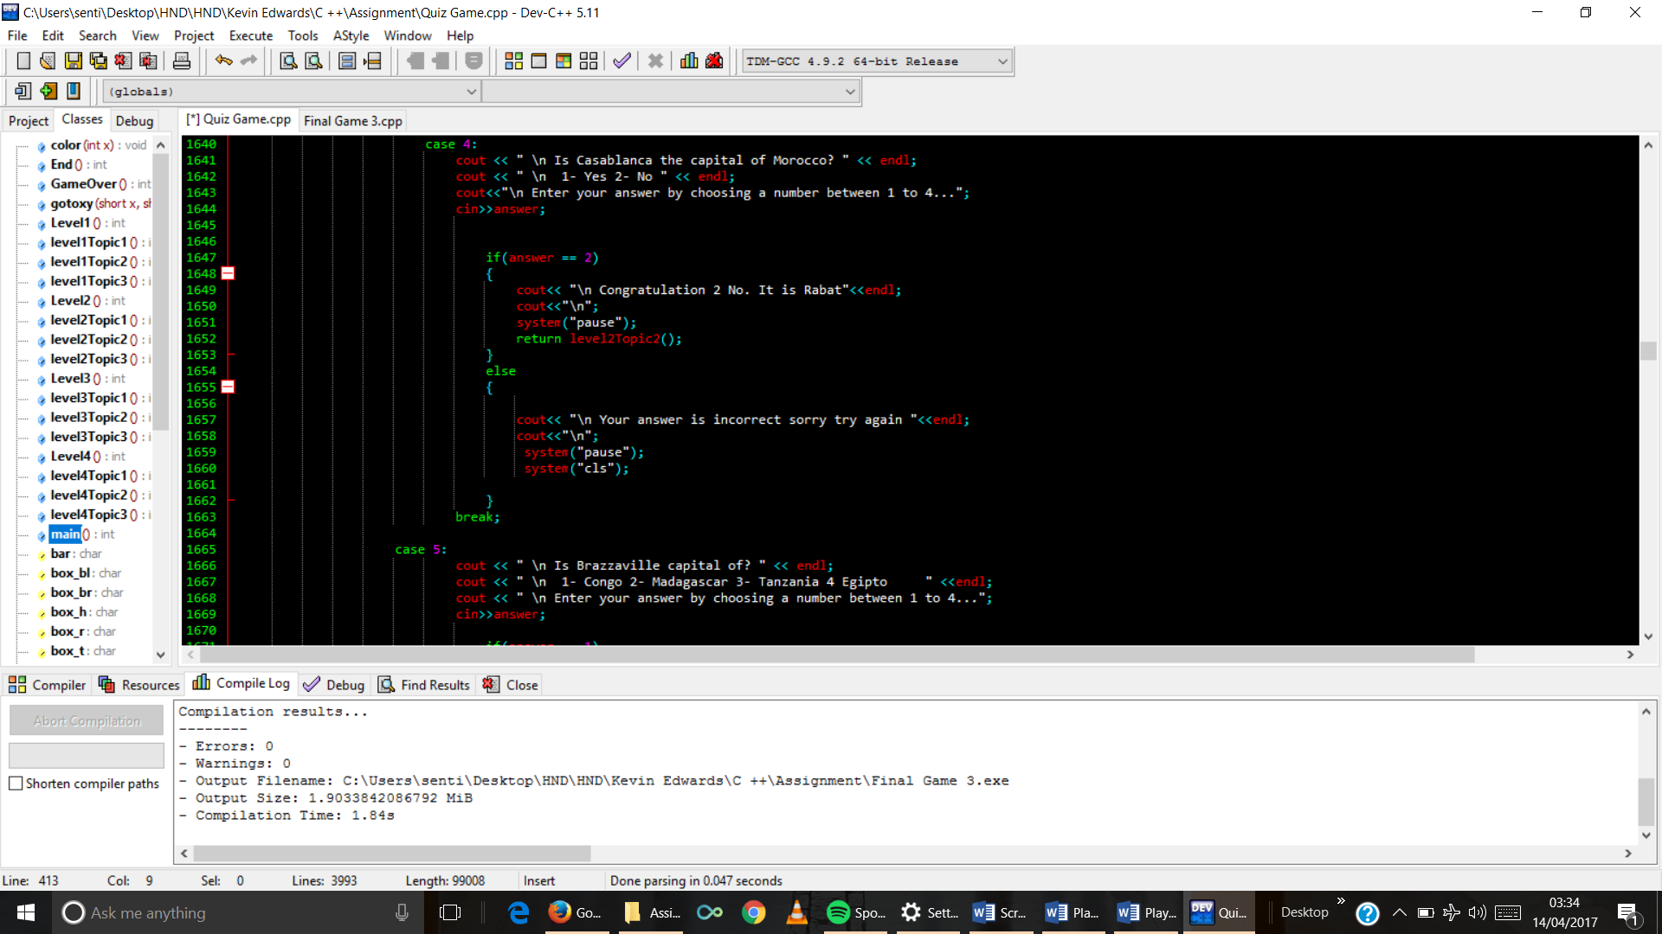

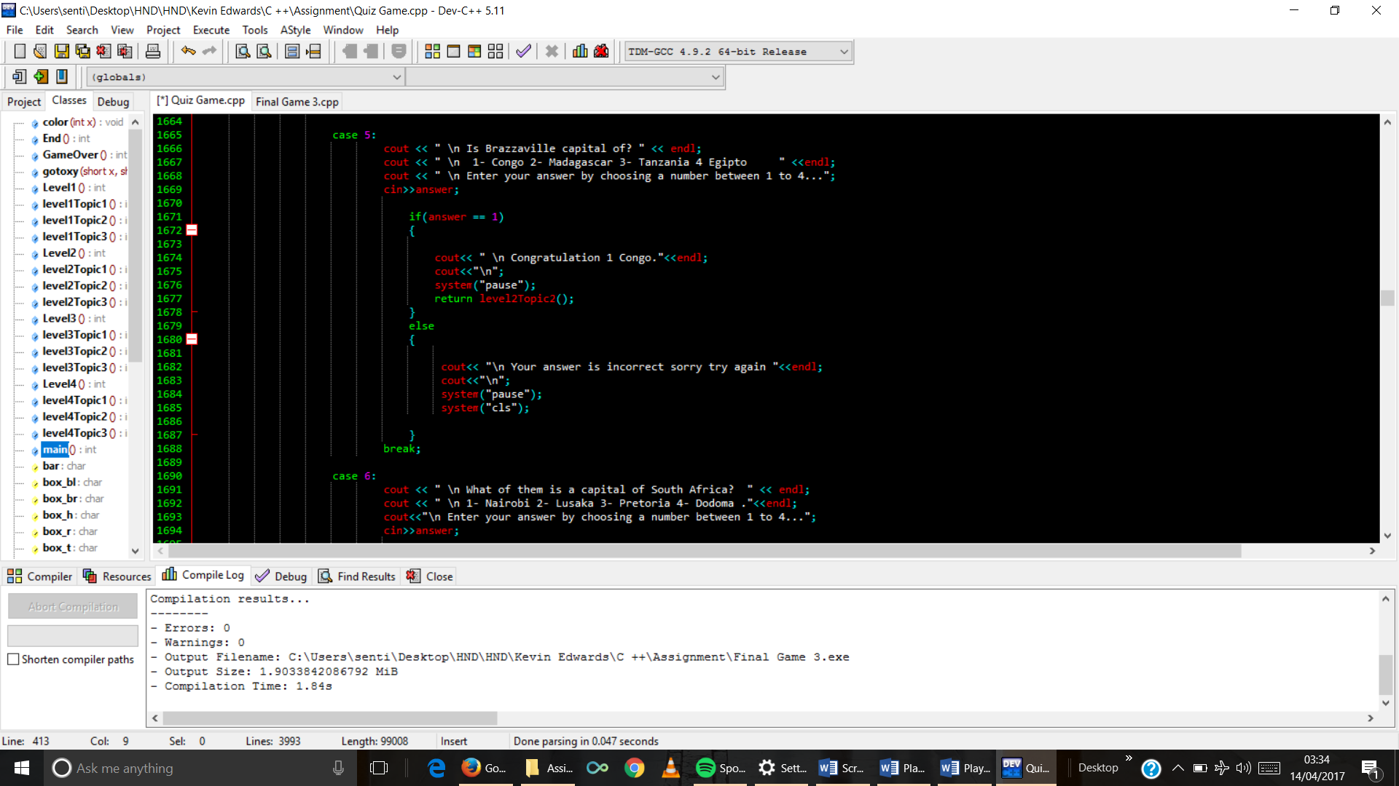

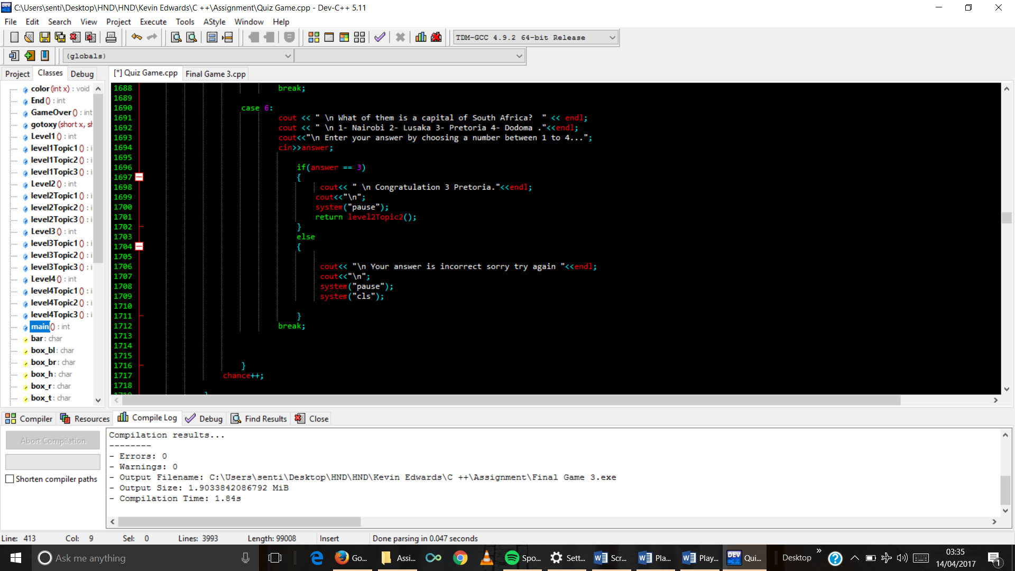

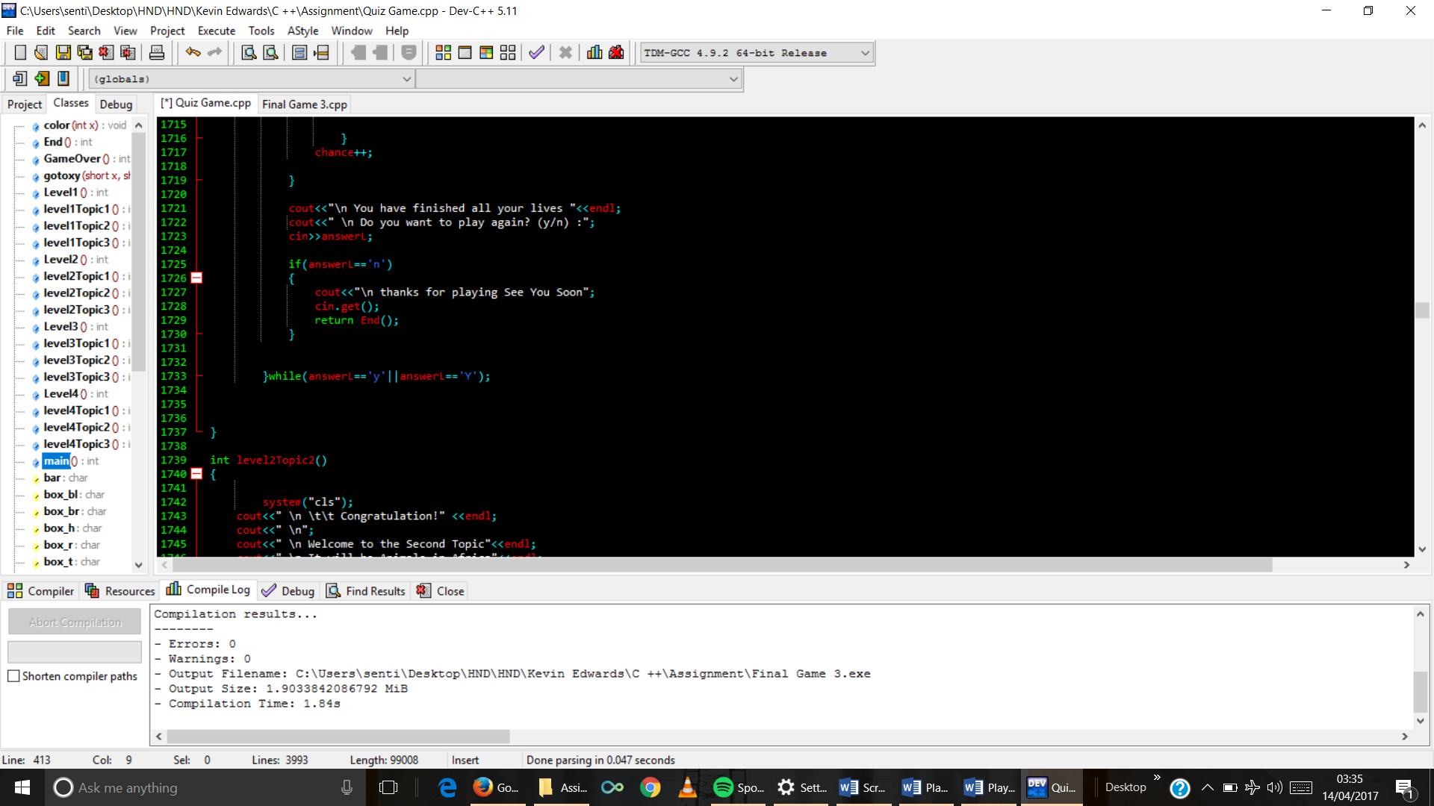

1. Topic 2 function code

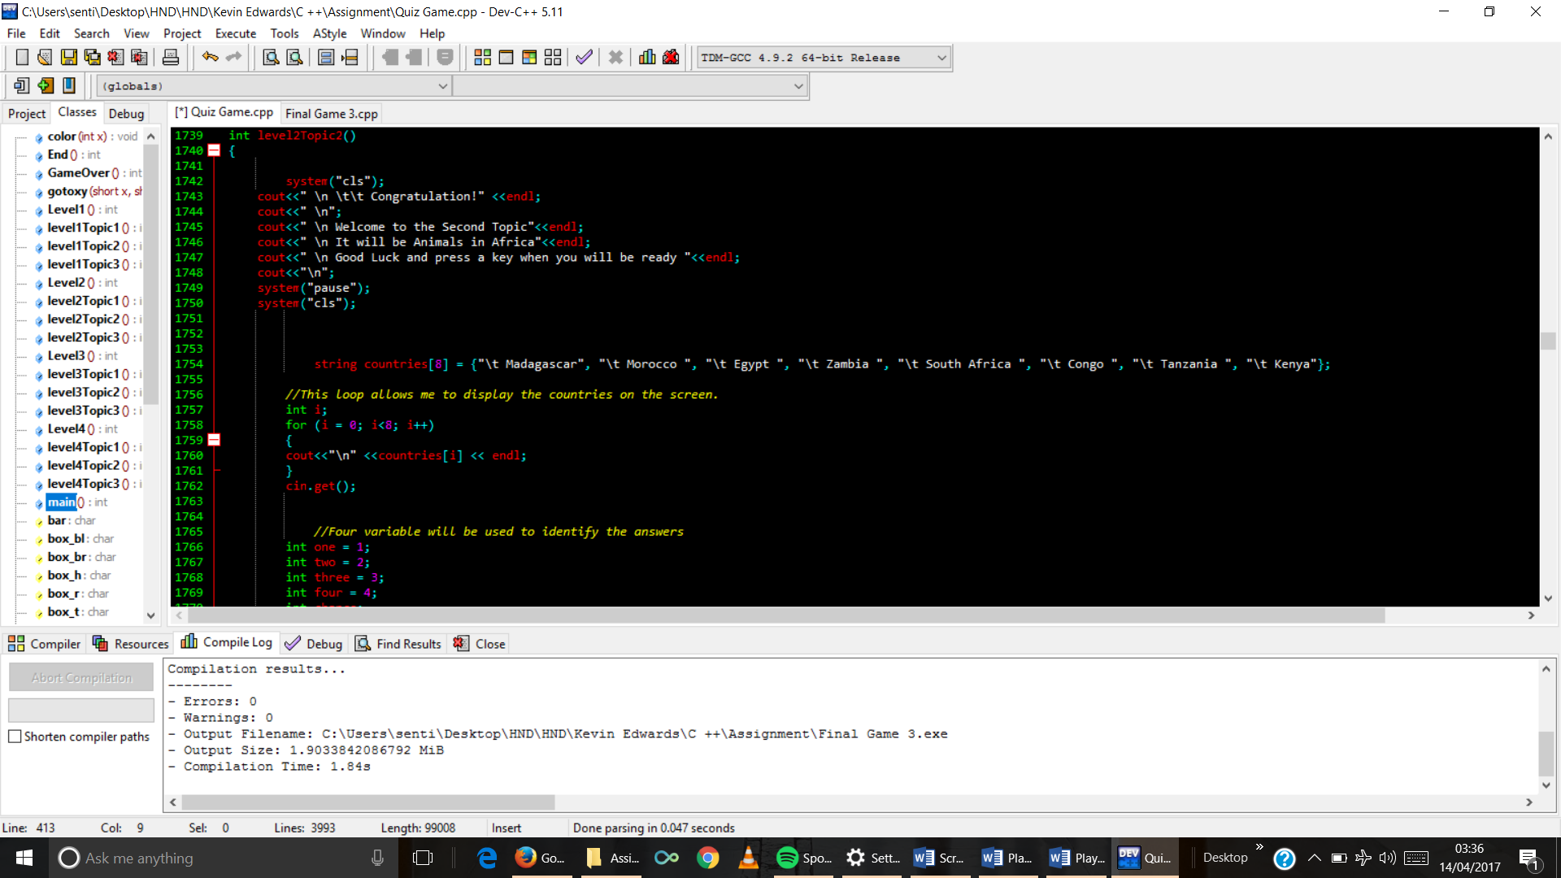

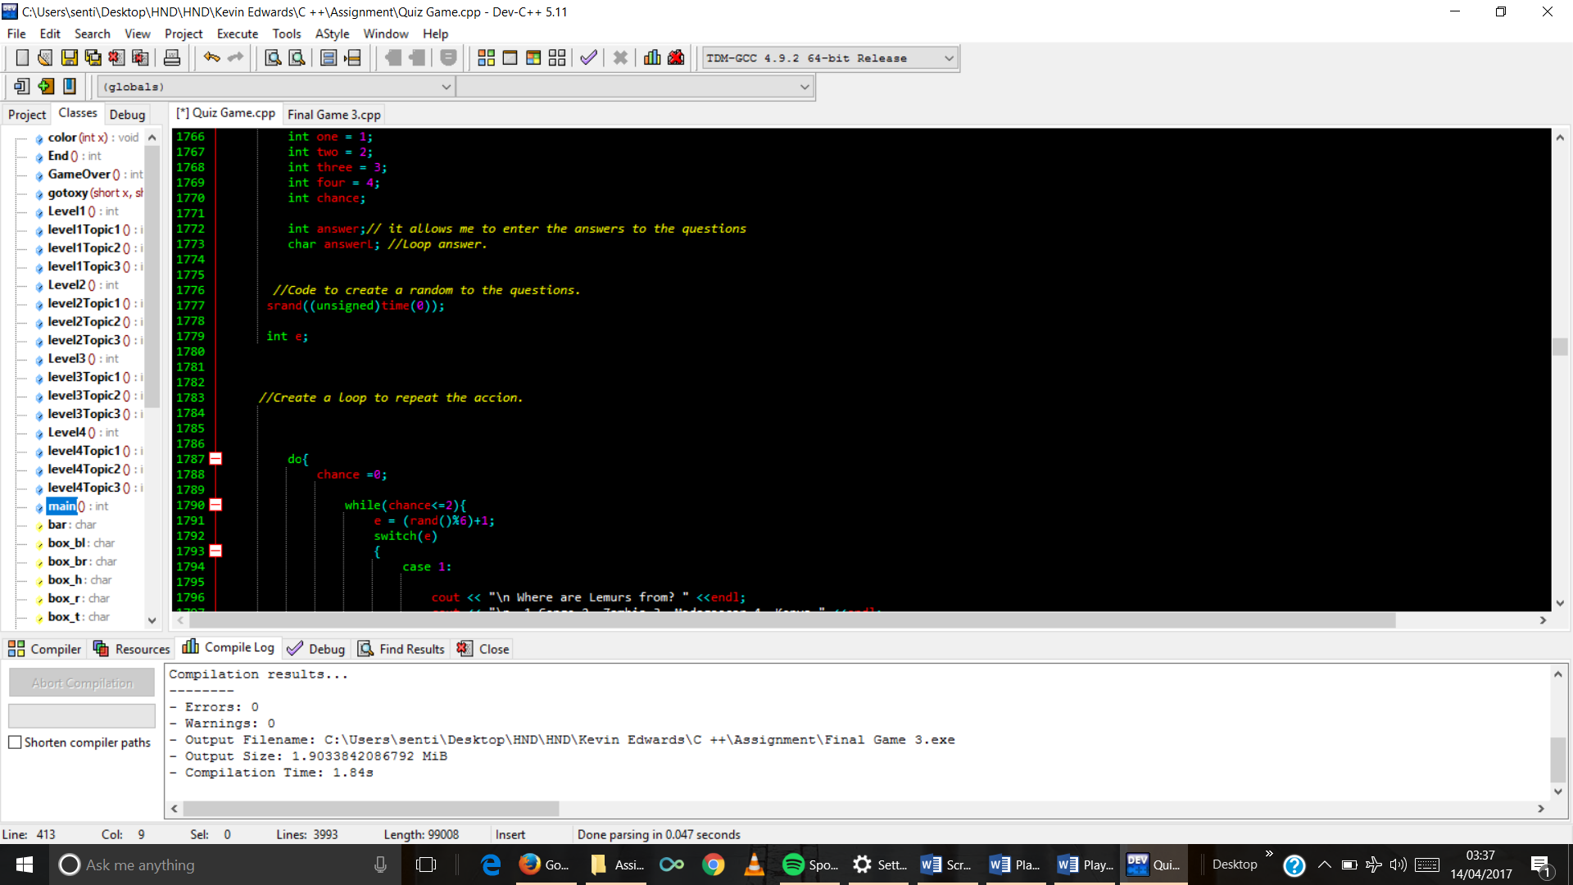

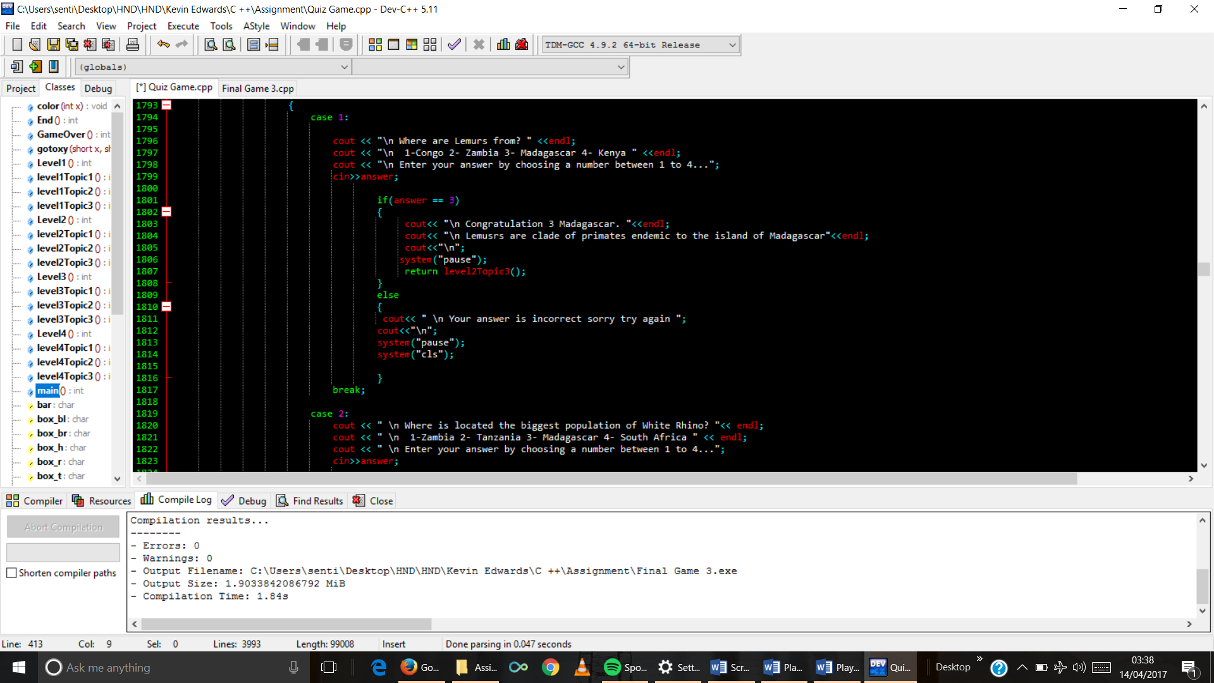

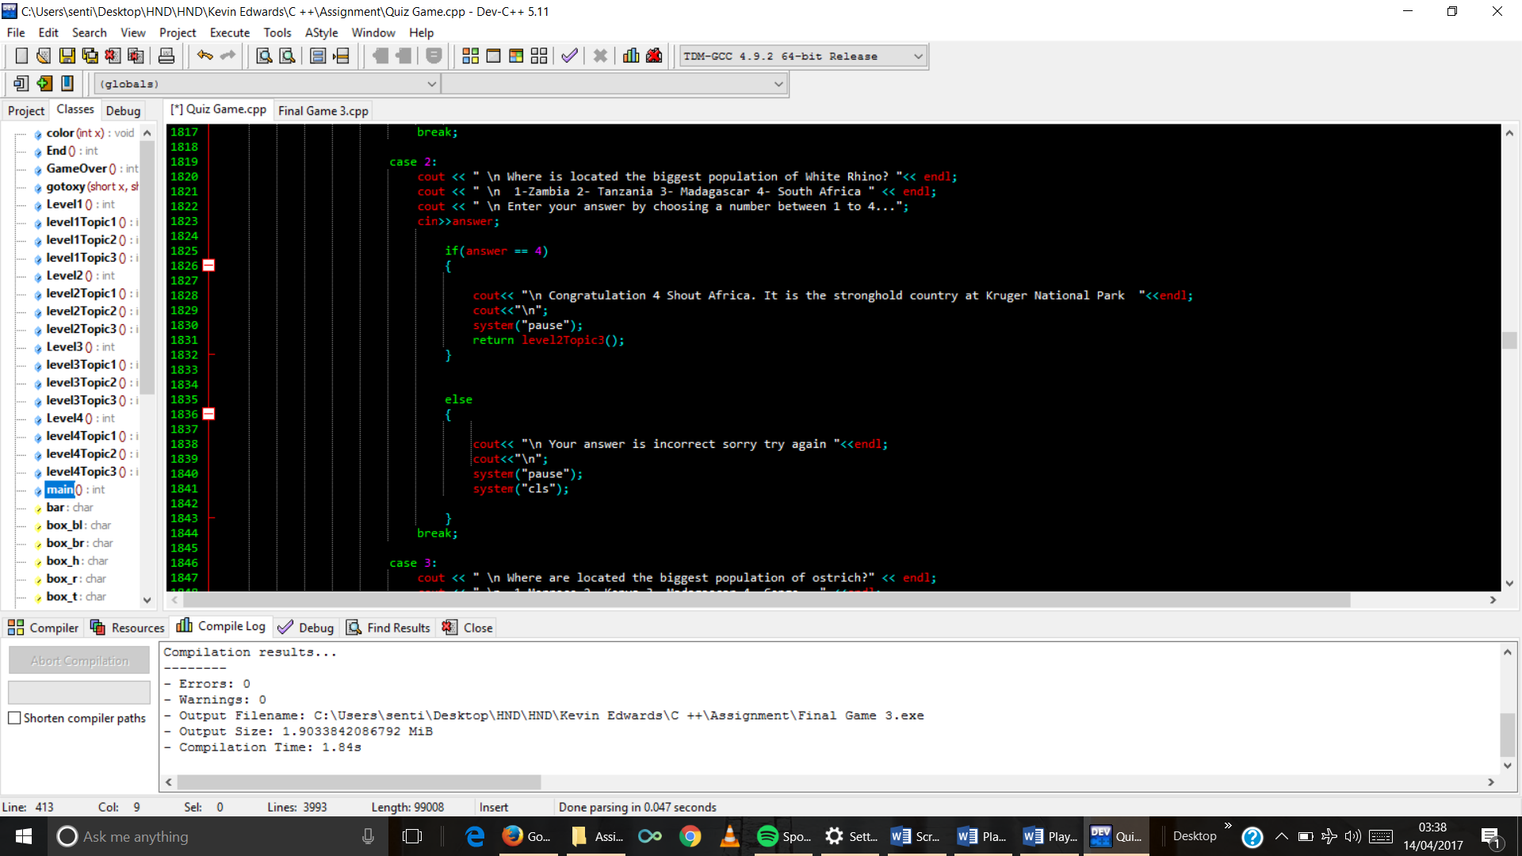

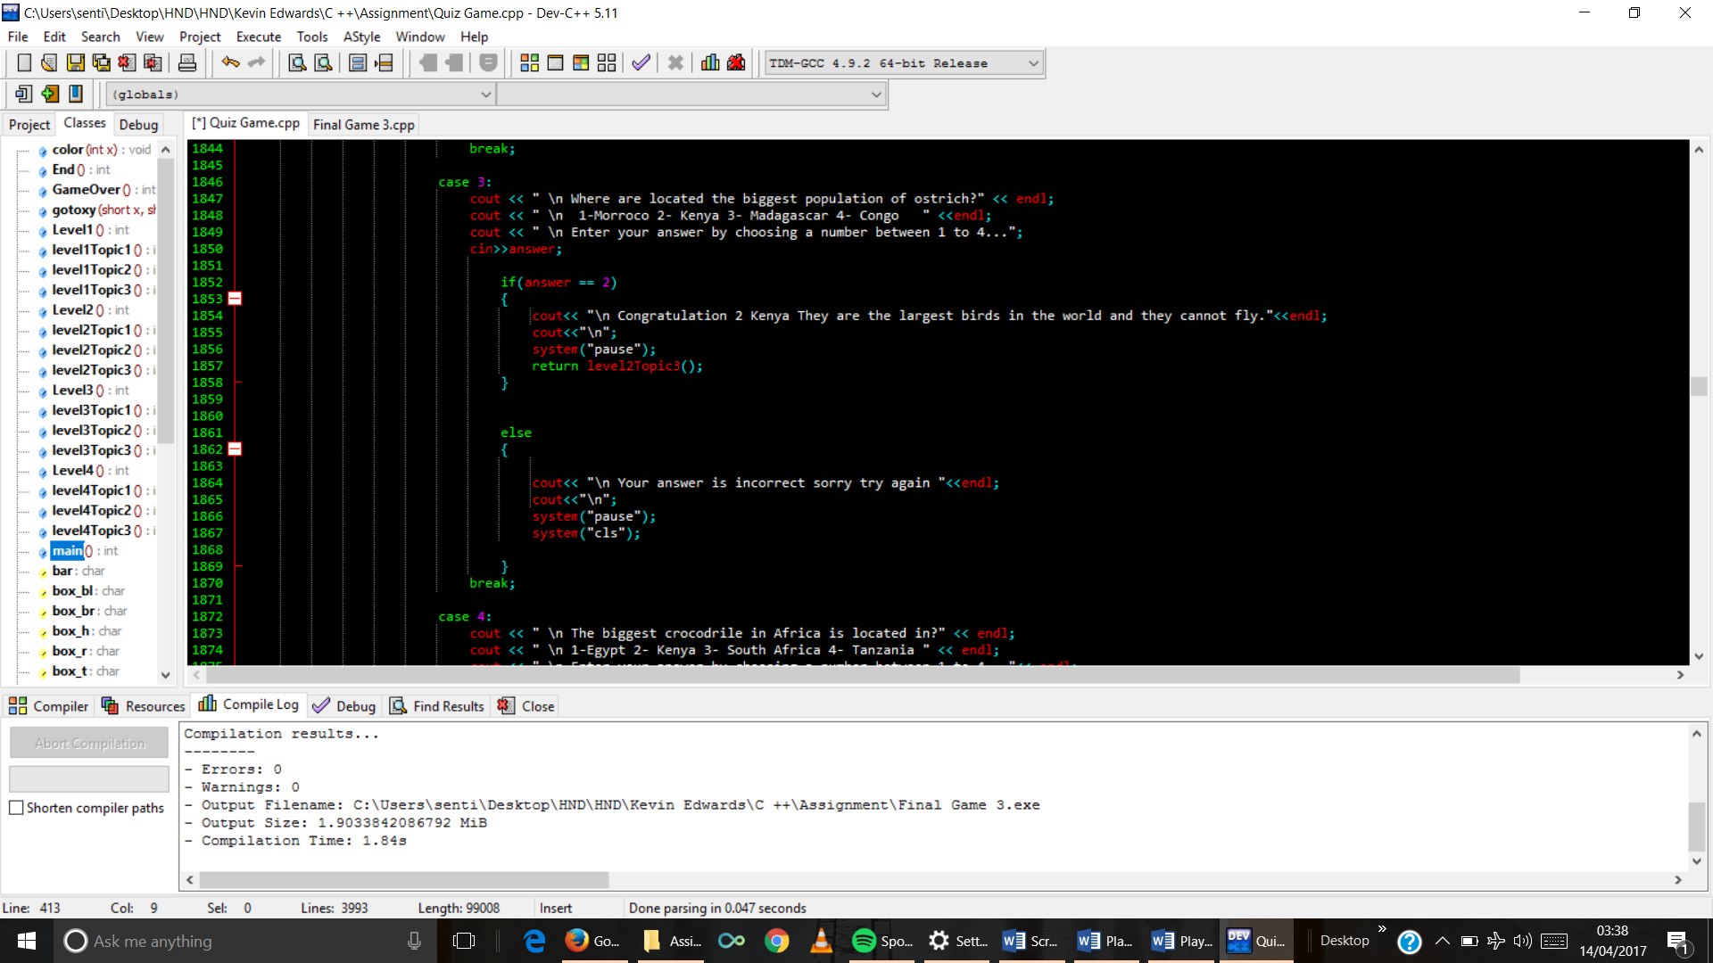

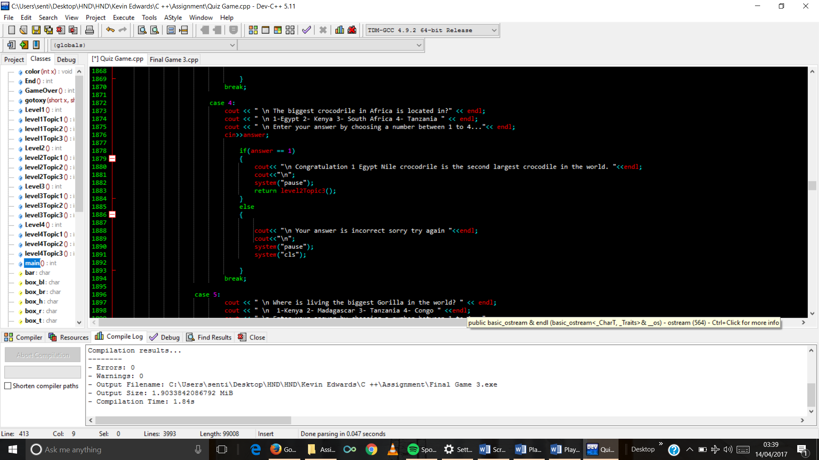

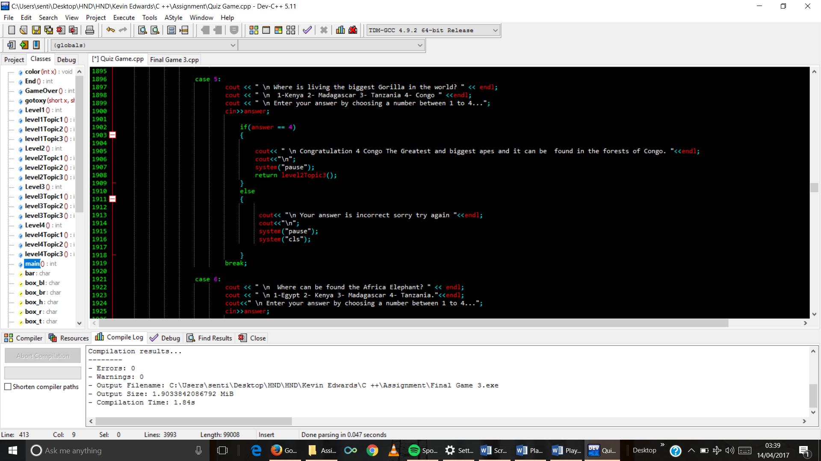

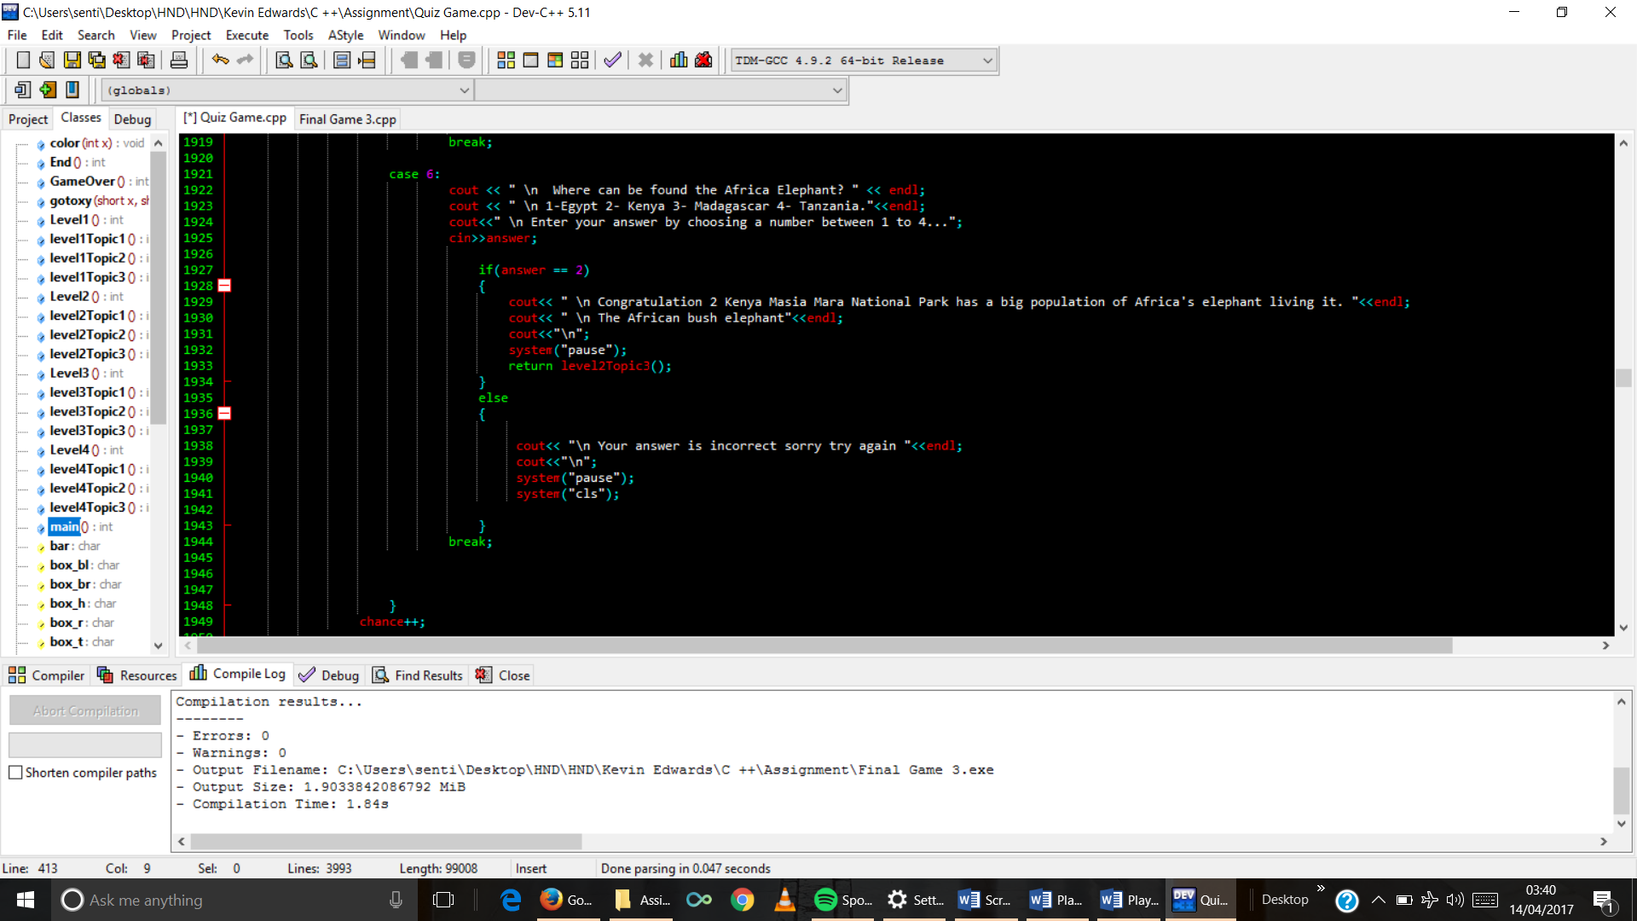

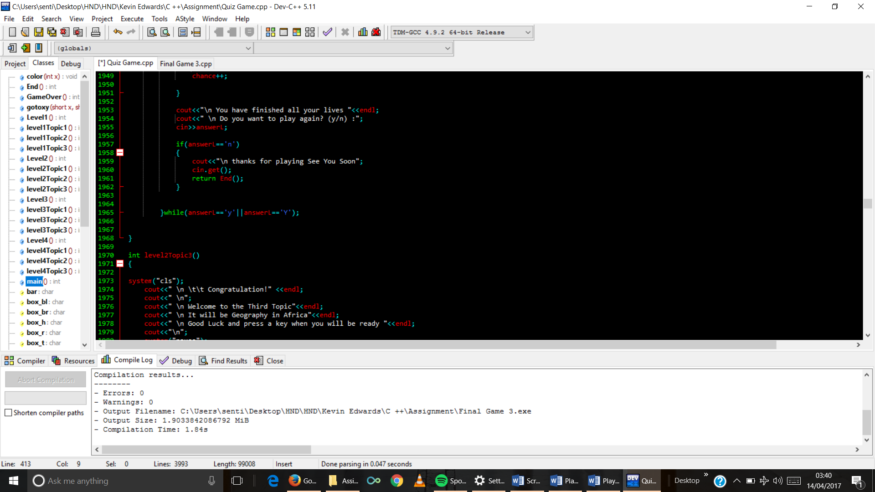

1. Topic 3 function code

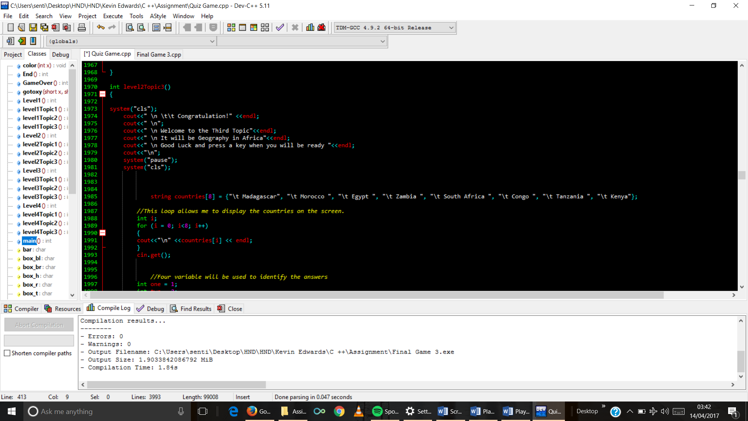

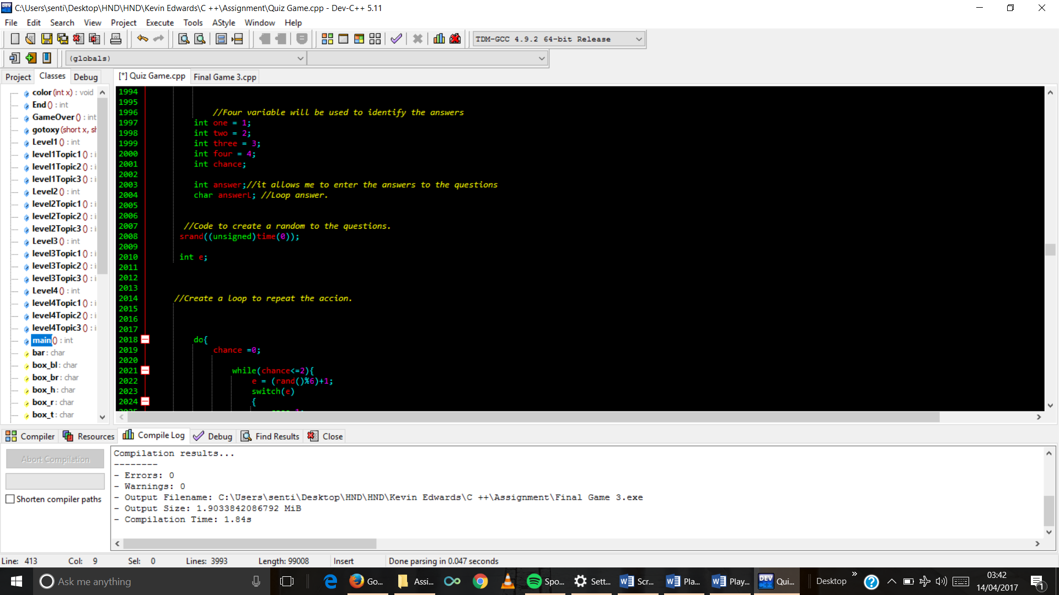

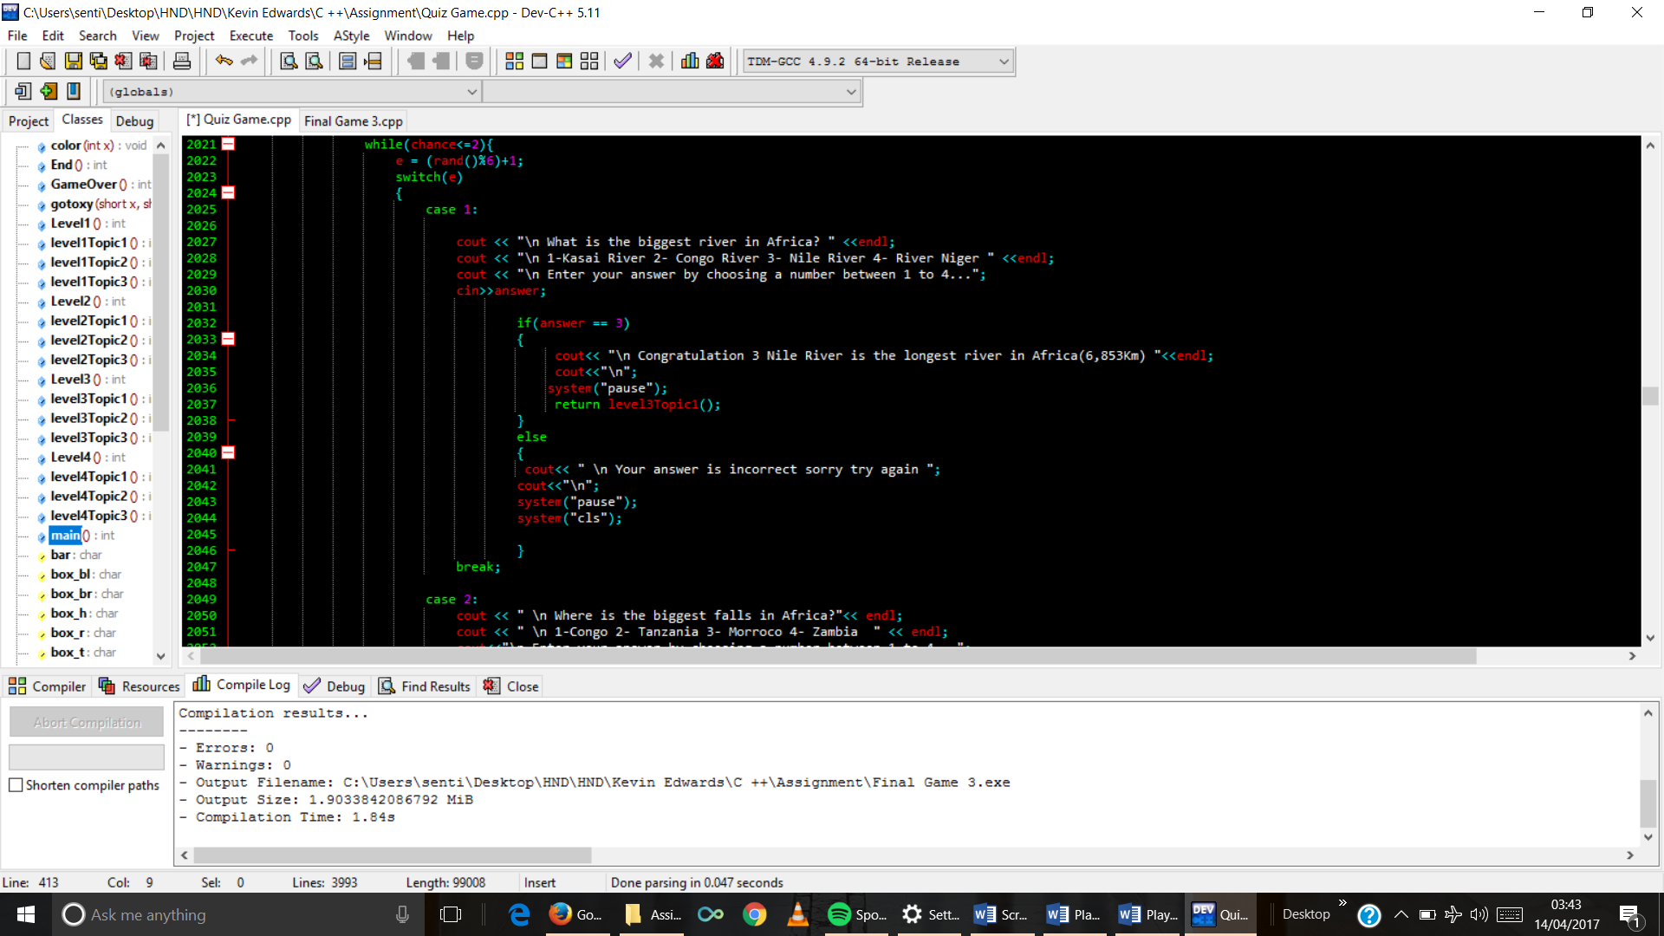

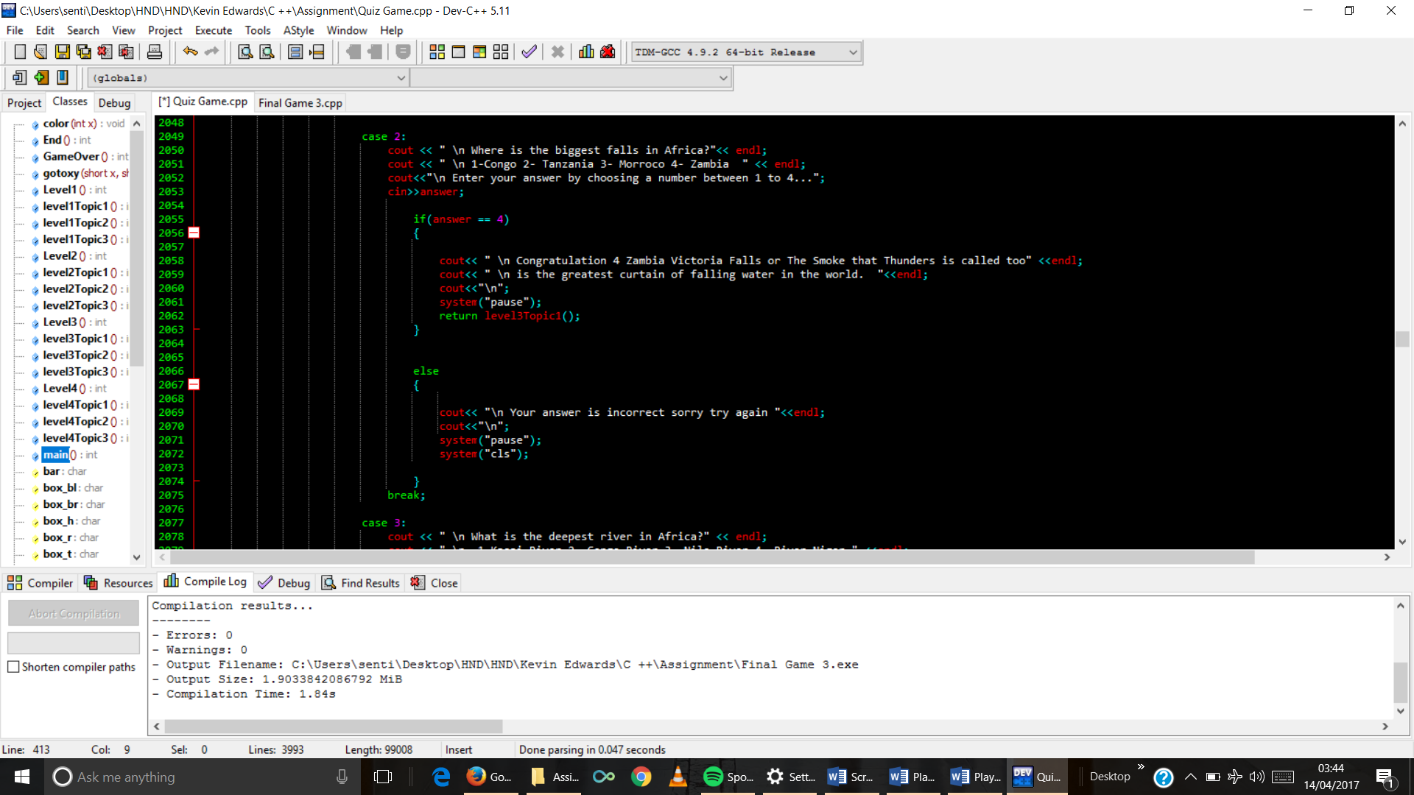

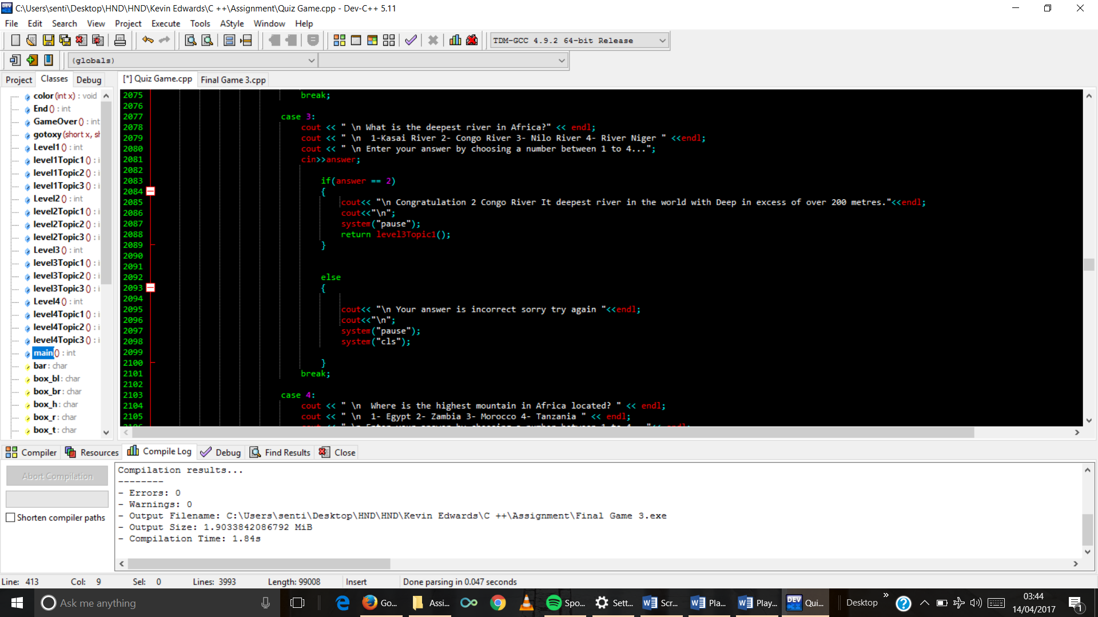

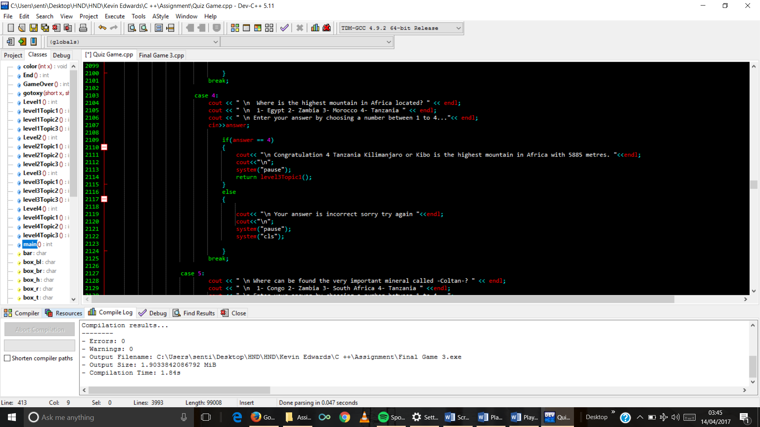

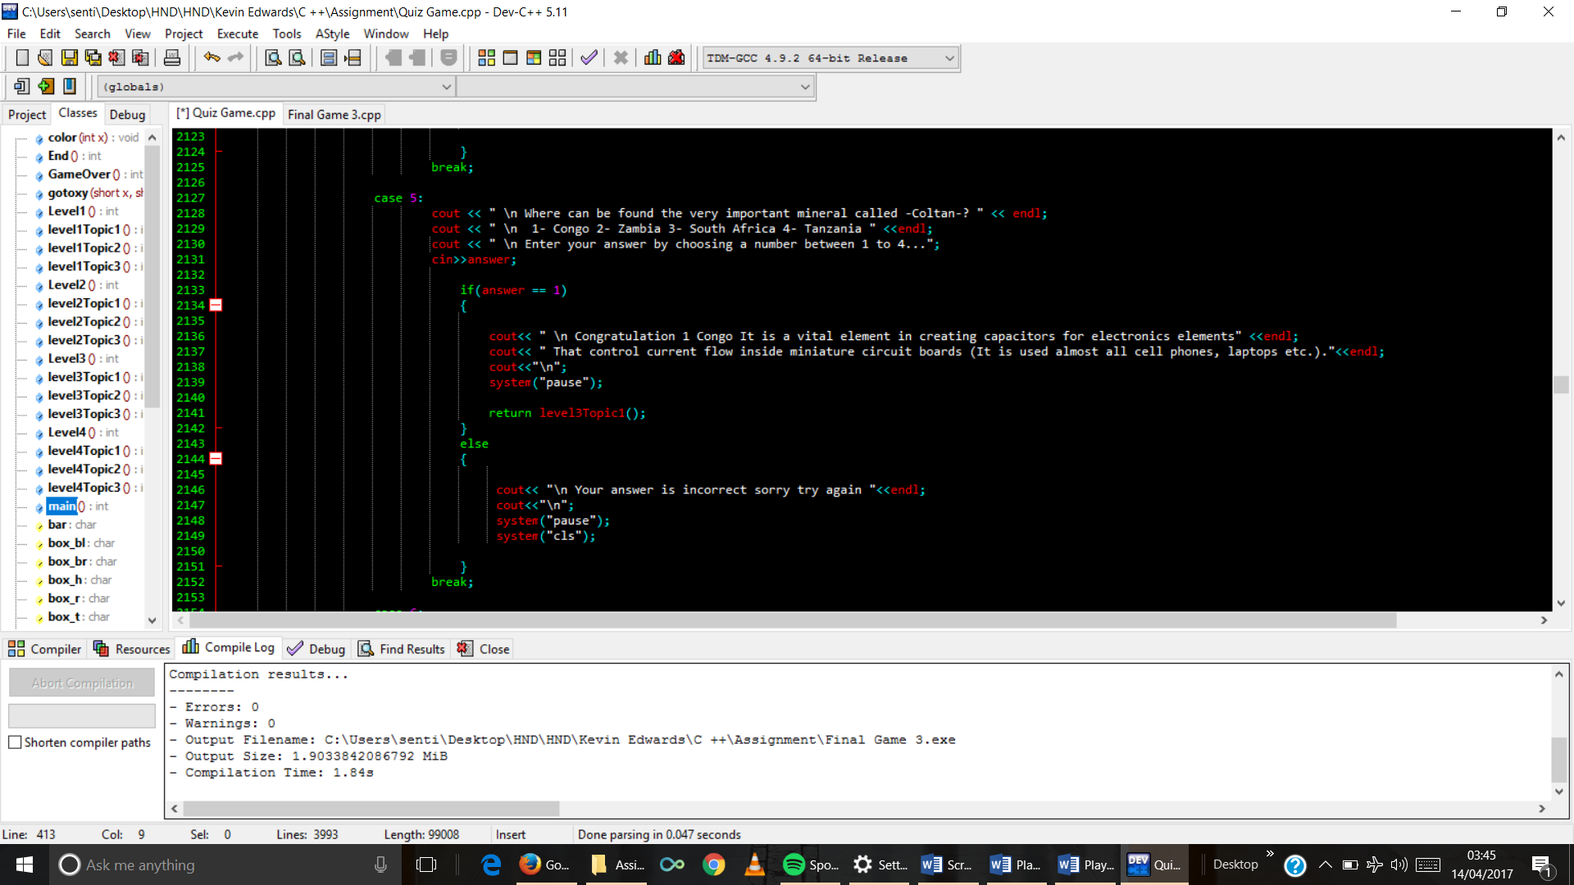

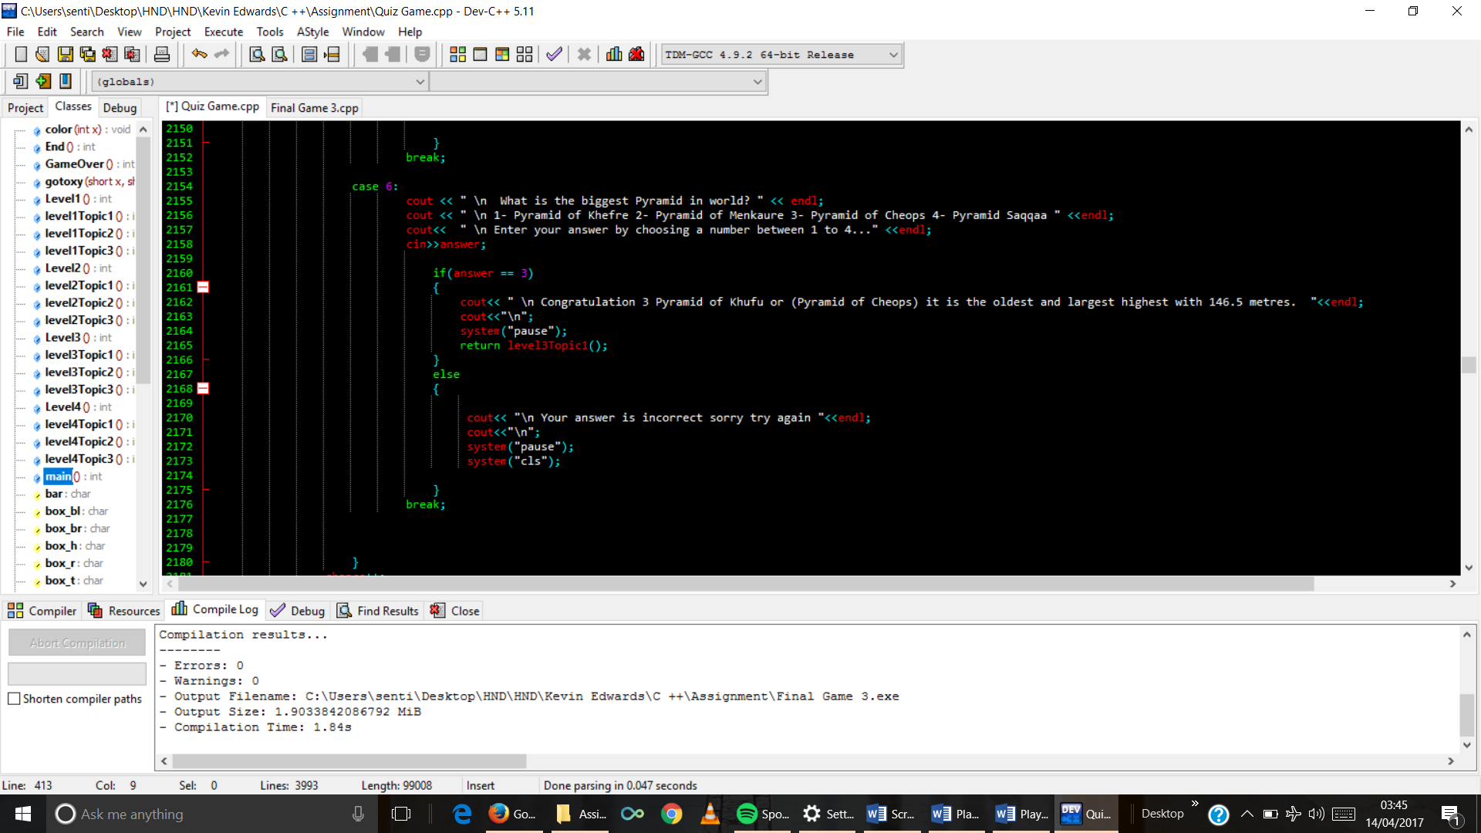

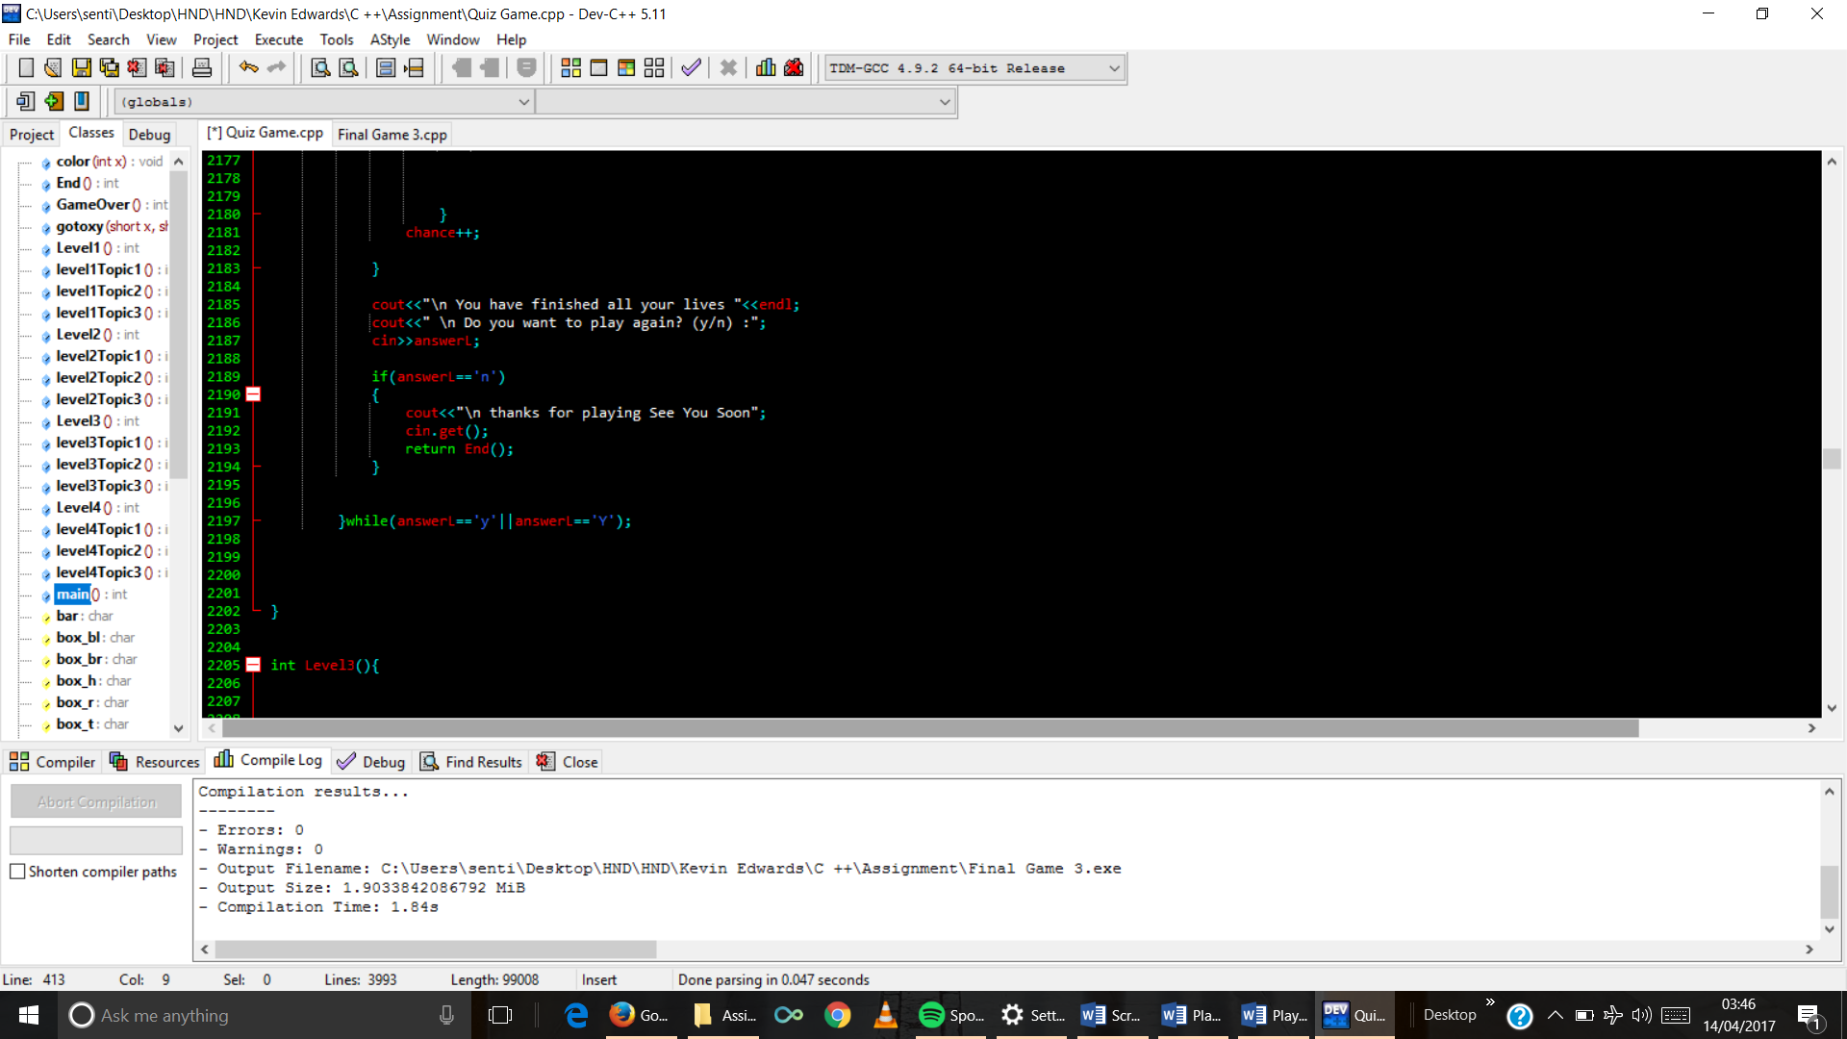

1. Level 3 function code

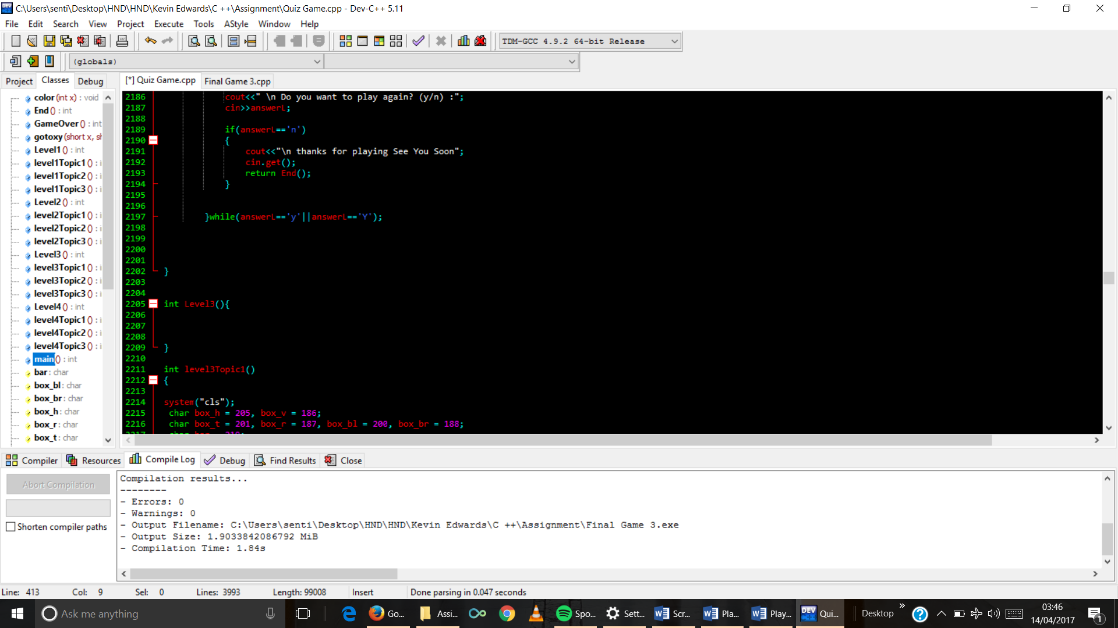

1. Topic 1 function code

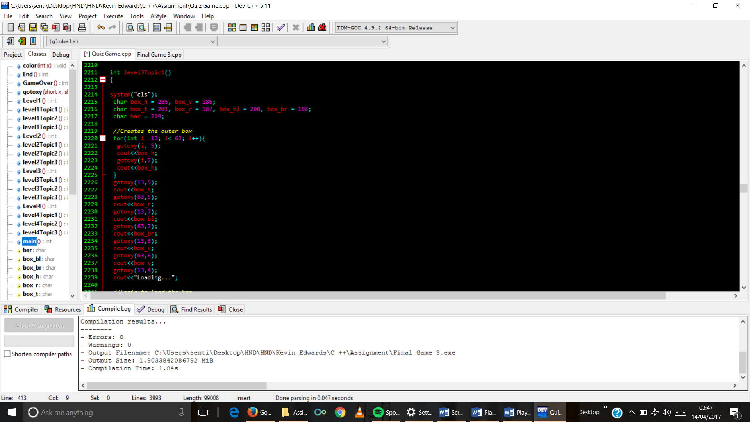

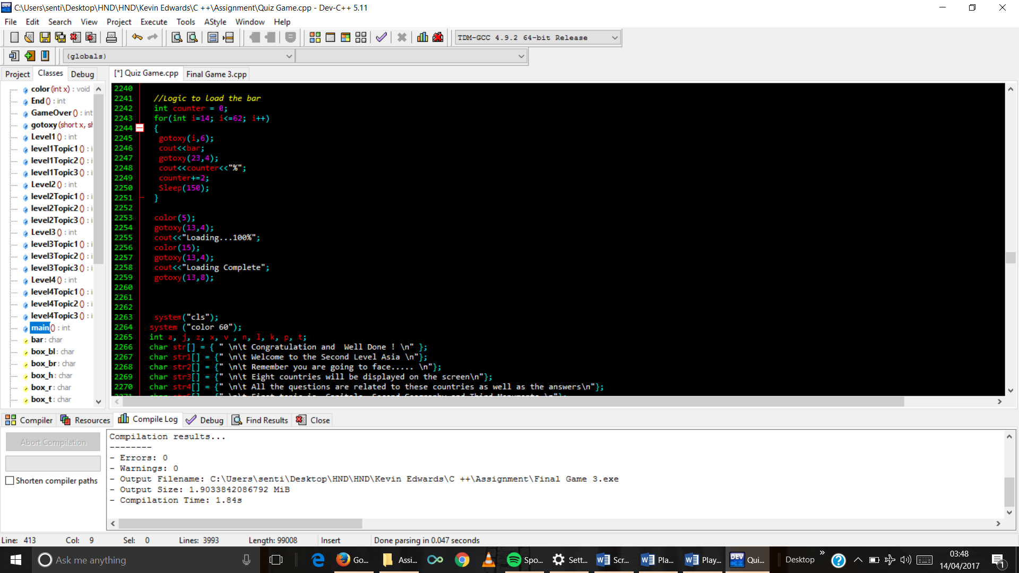

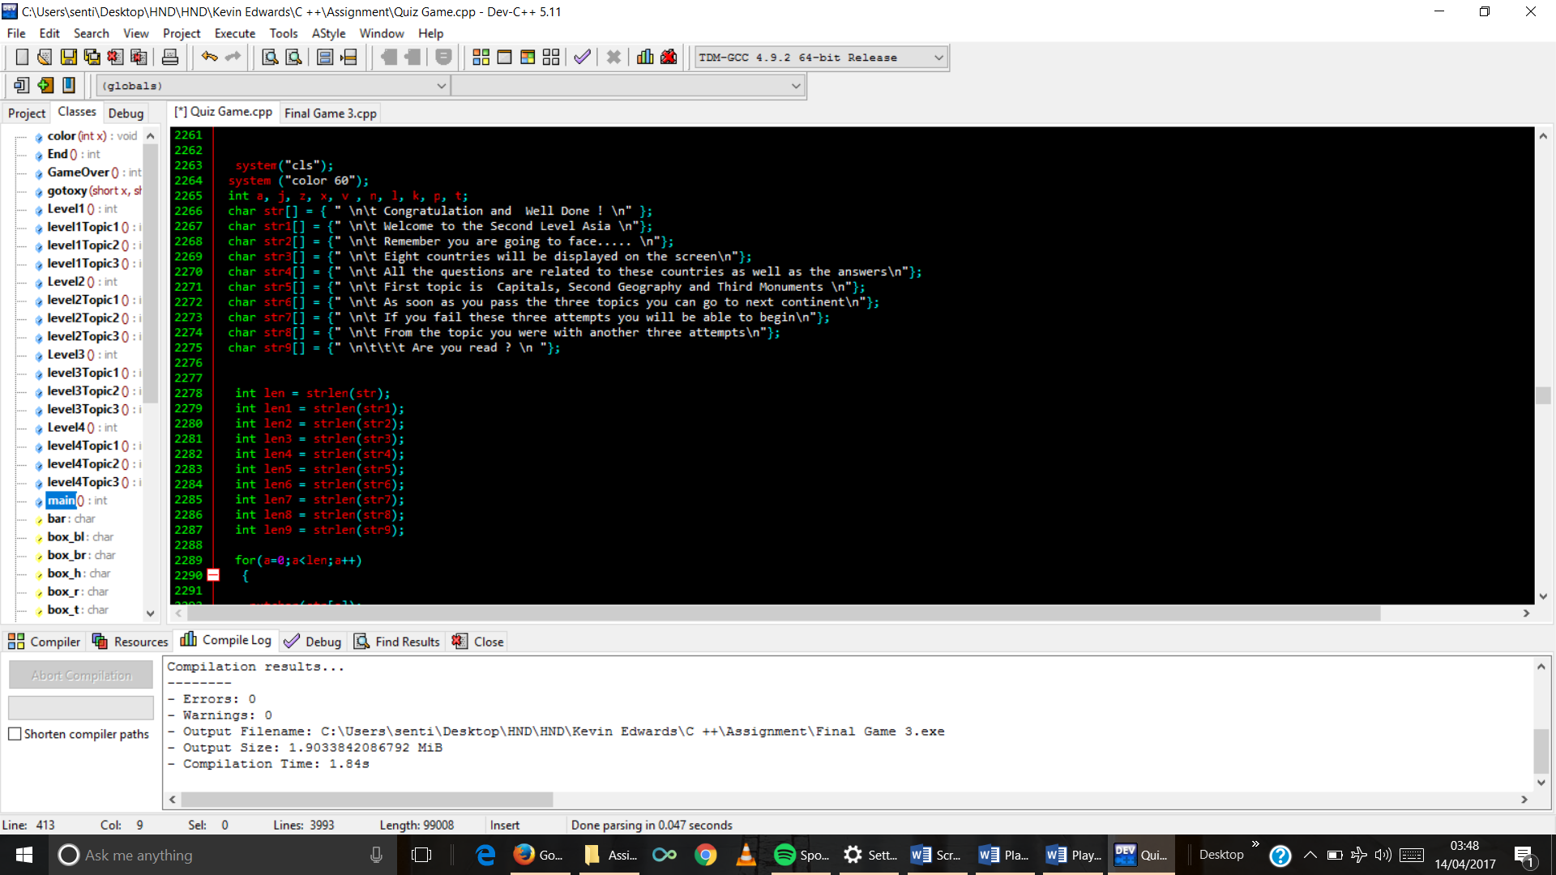

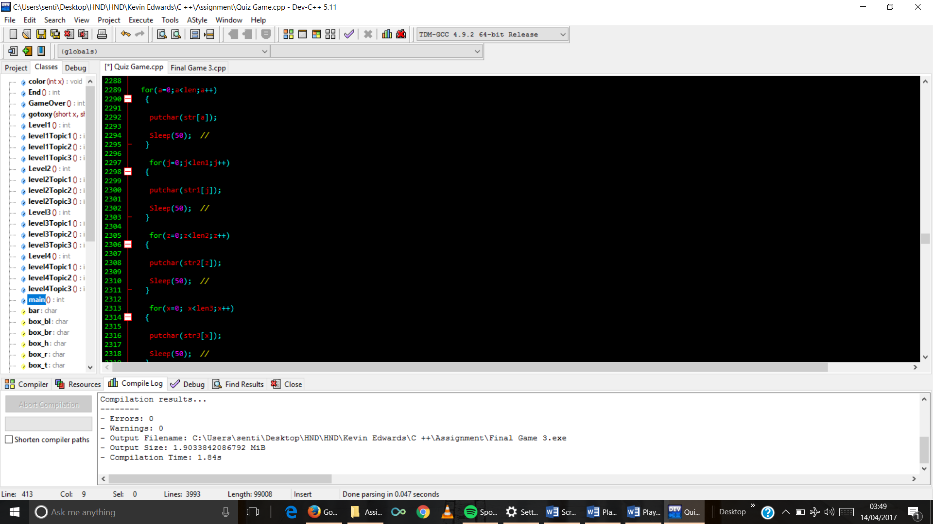

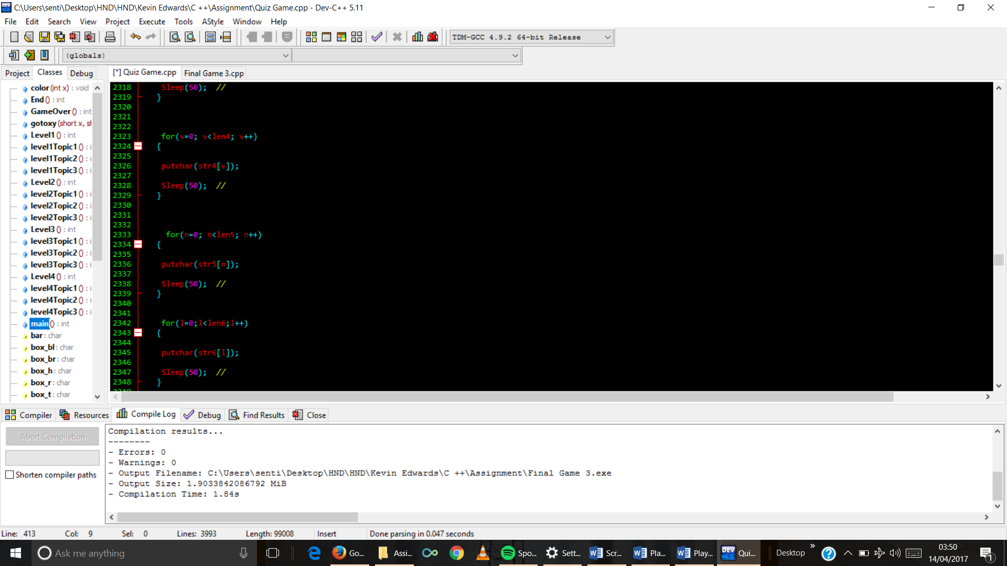

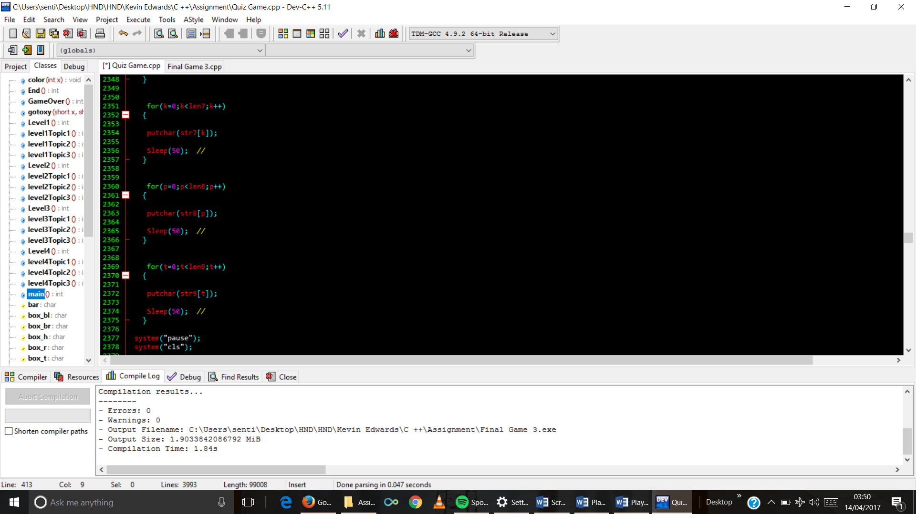

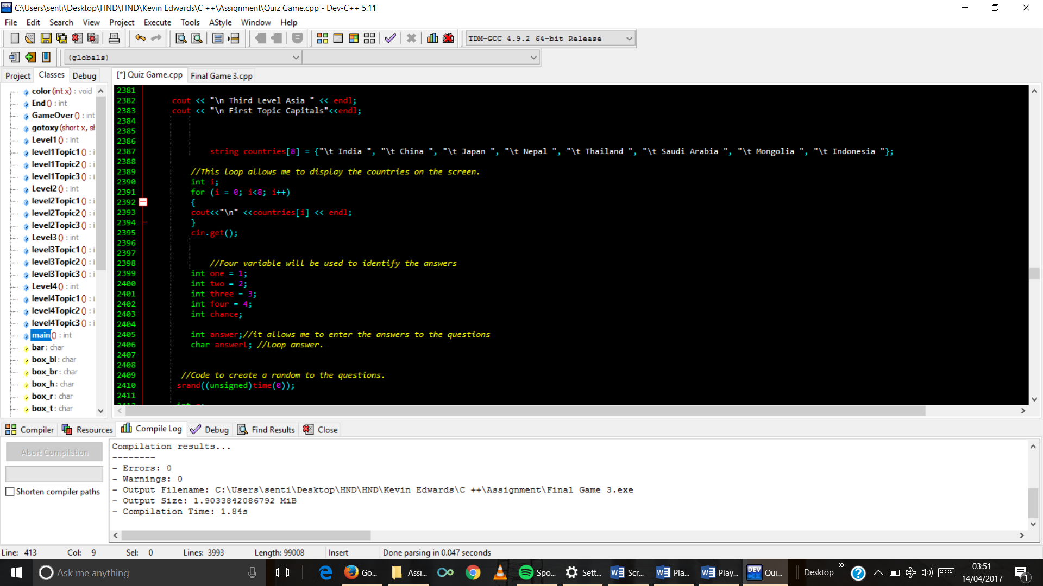

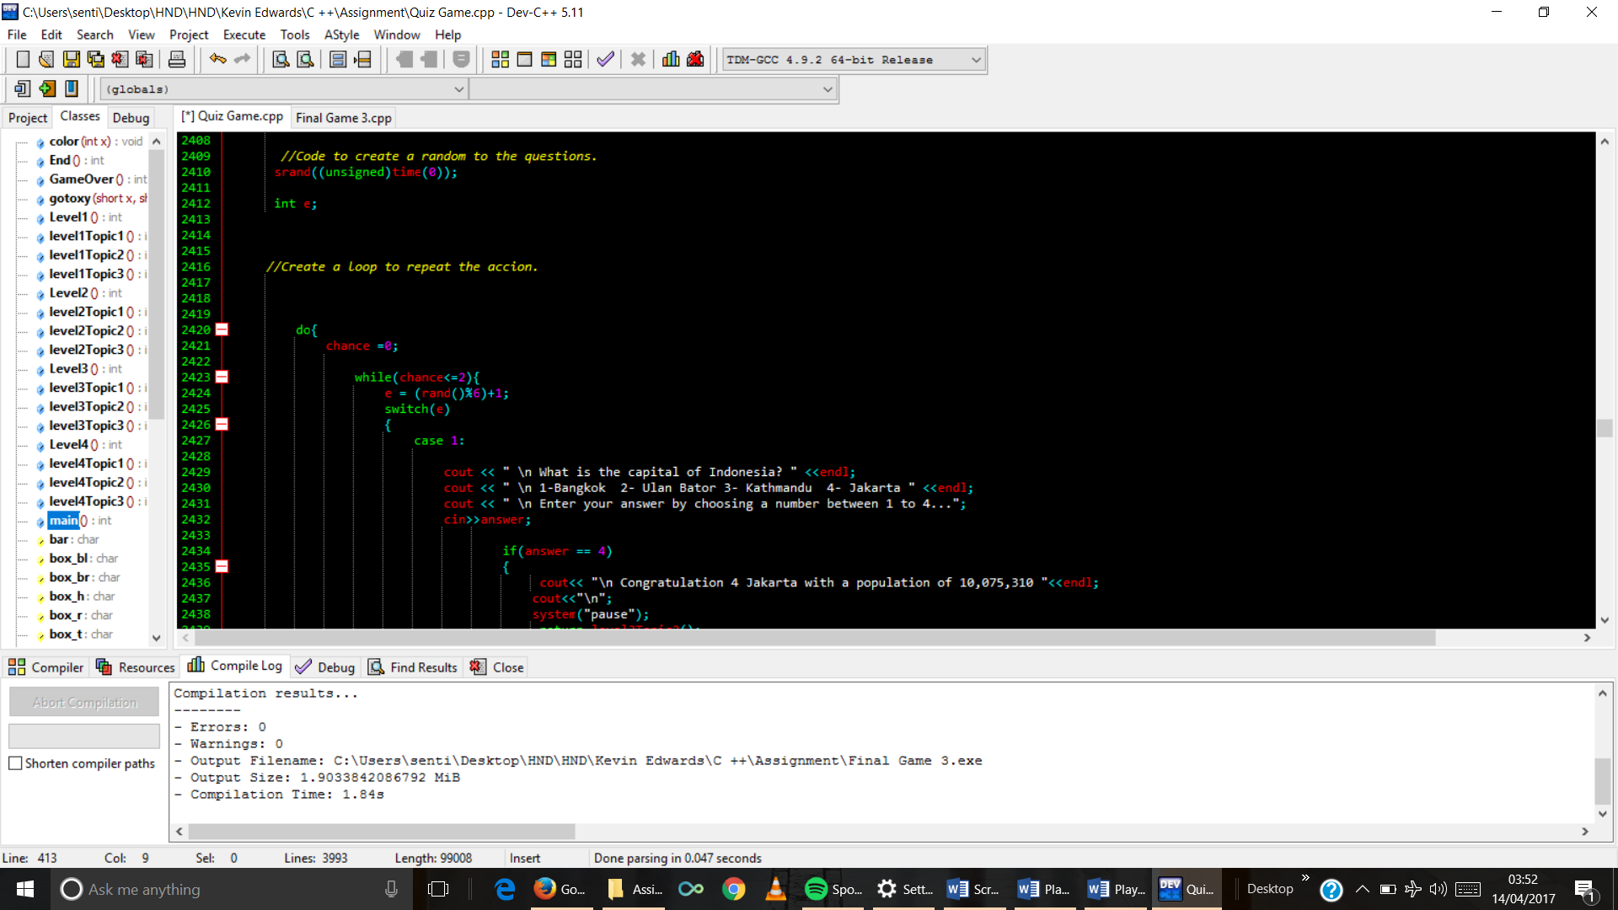

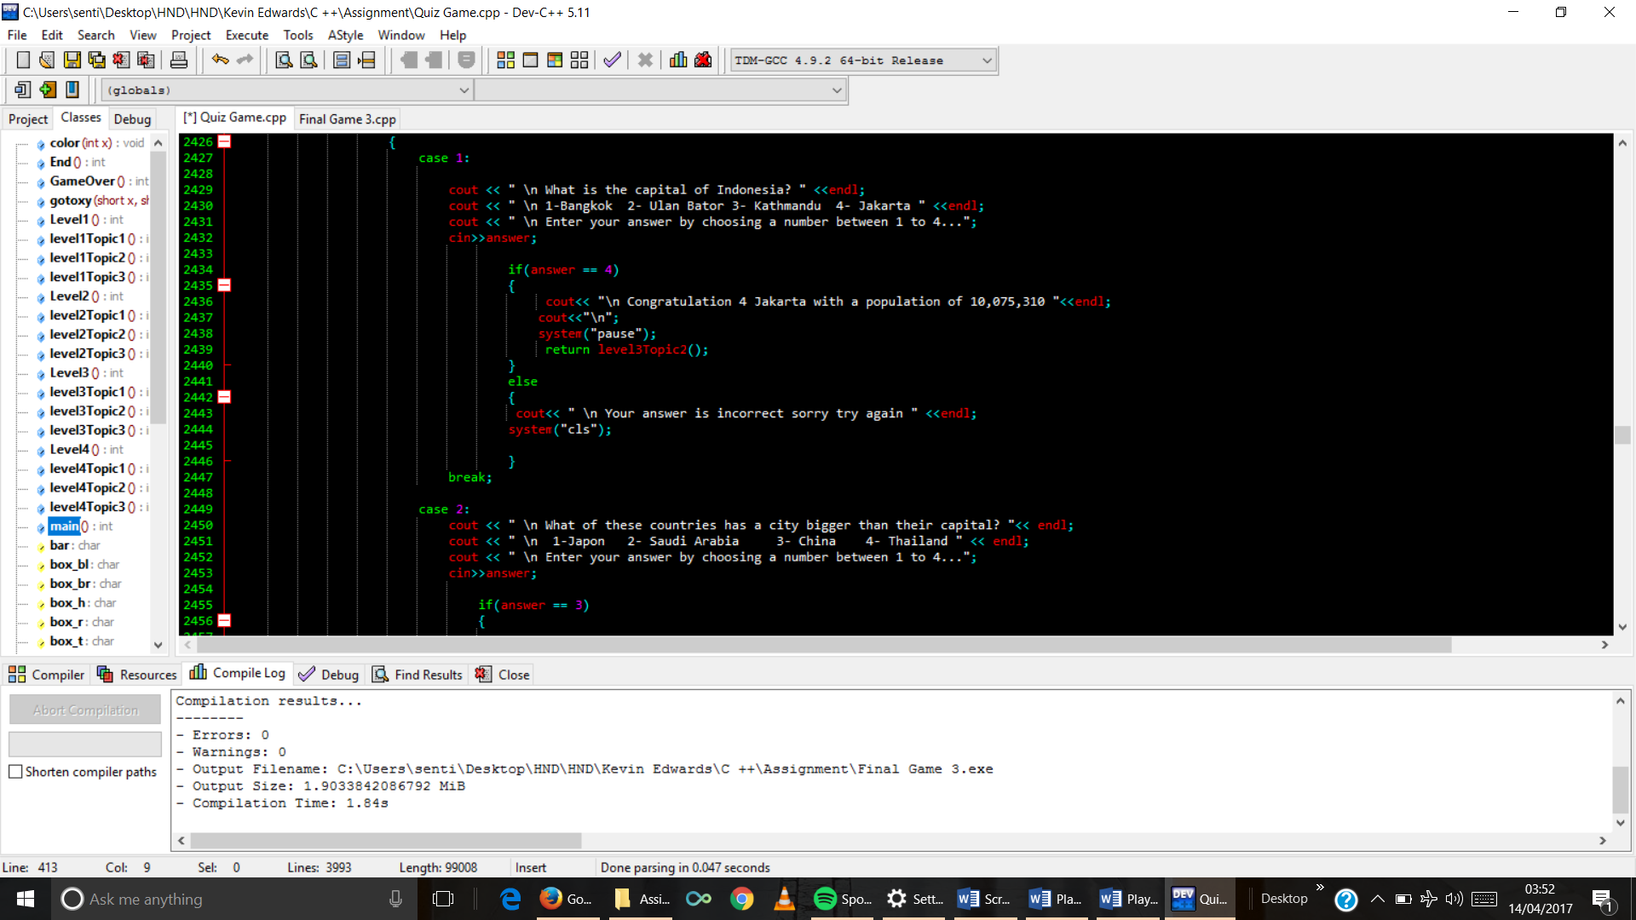

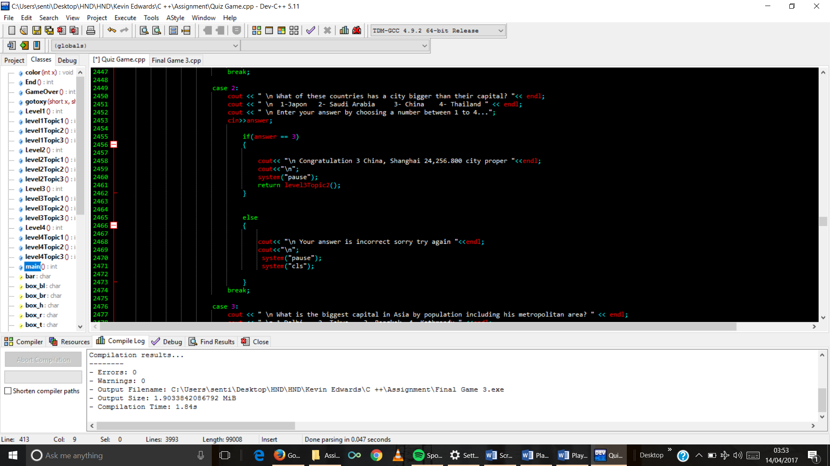

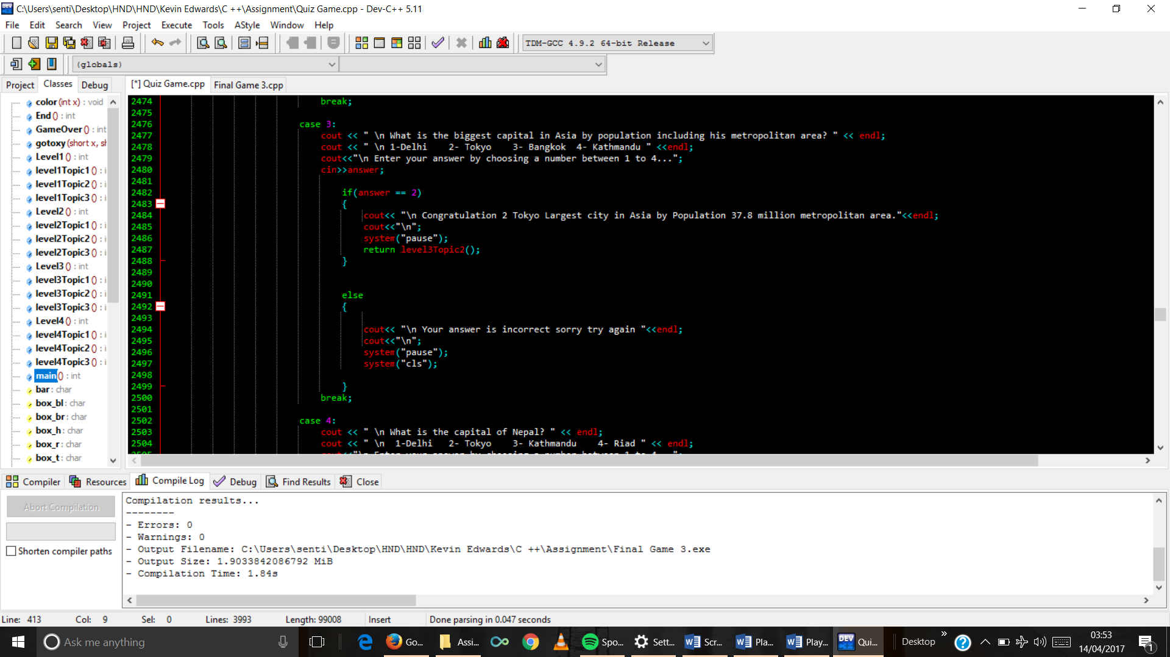

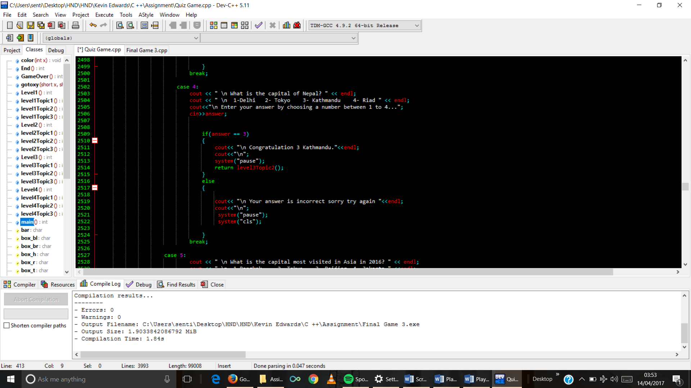

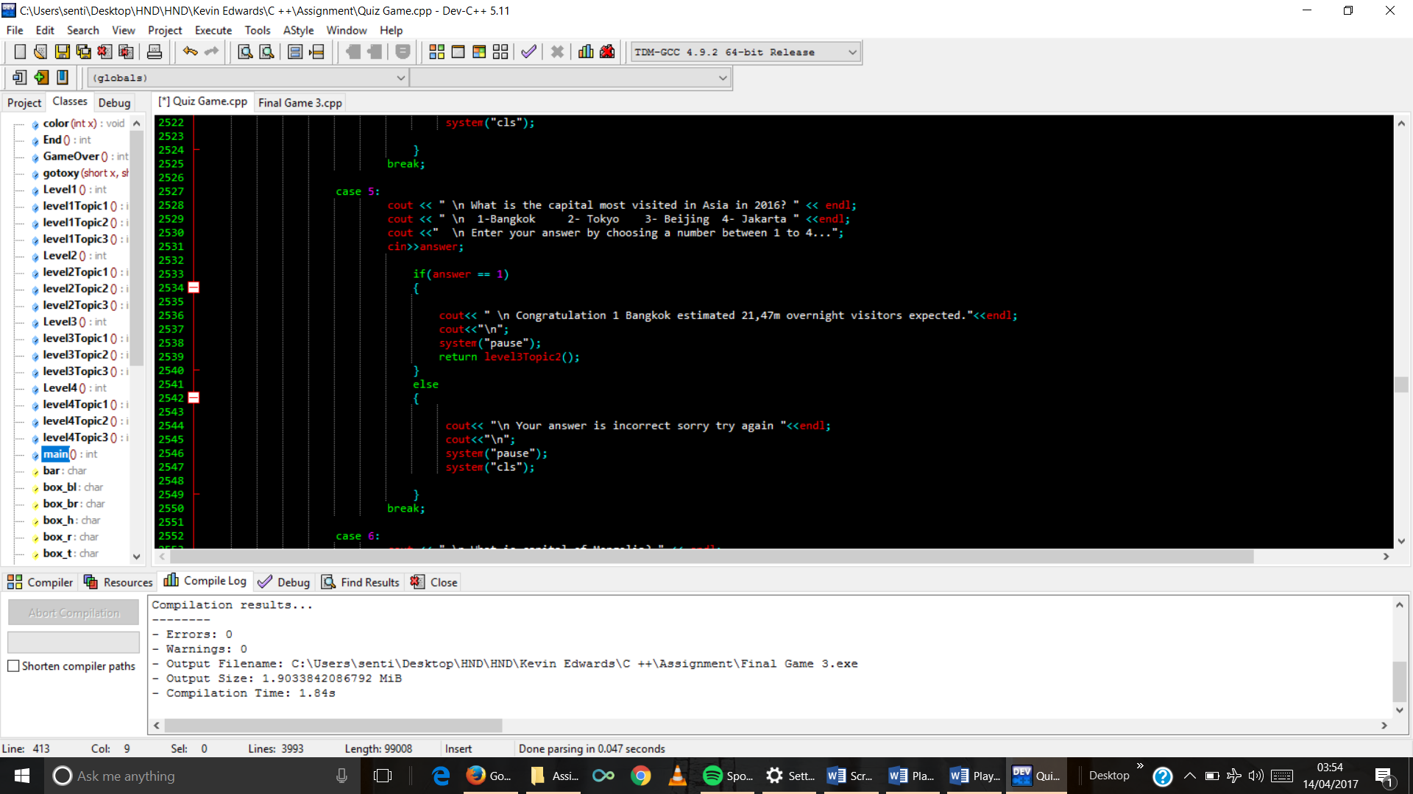

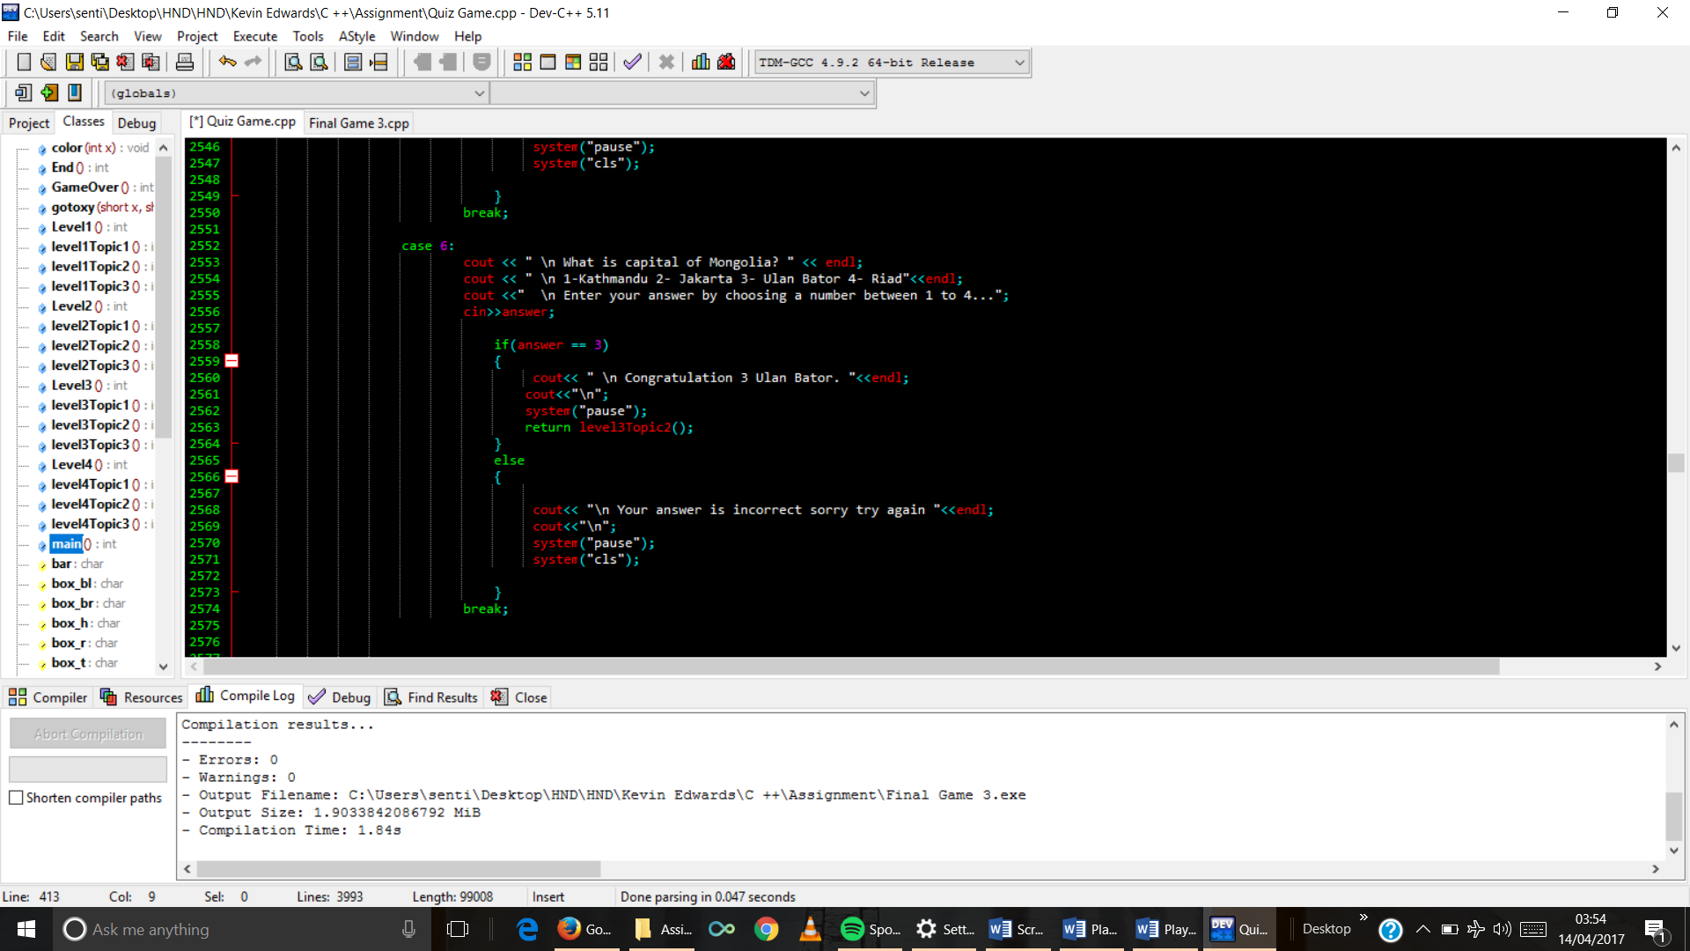

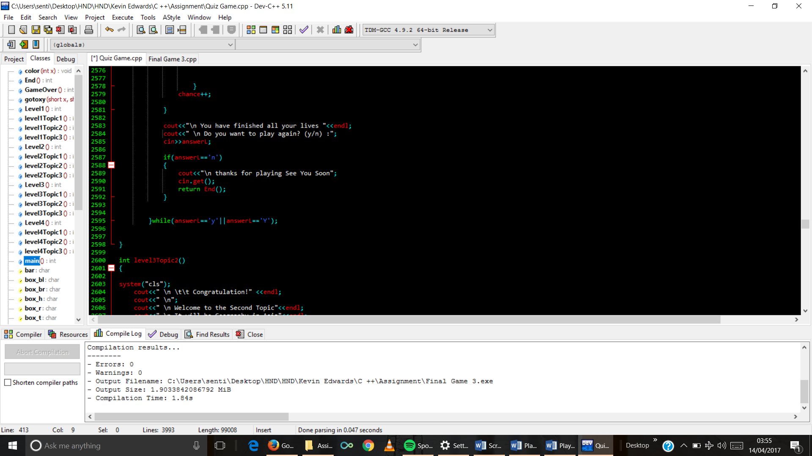

1. Topic 2 Function code

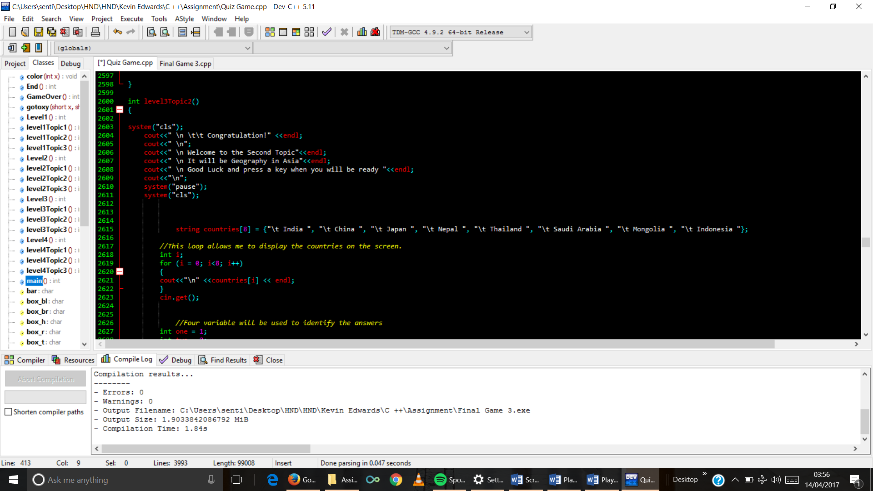

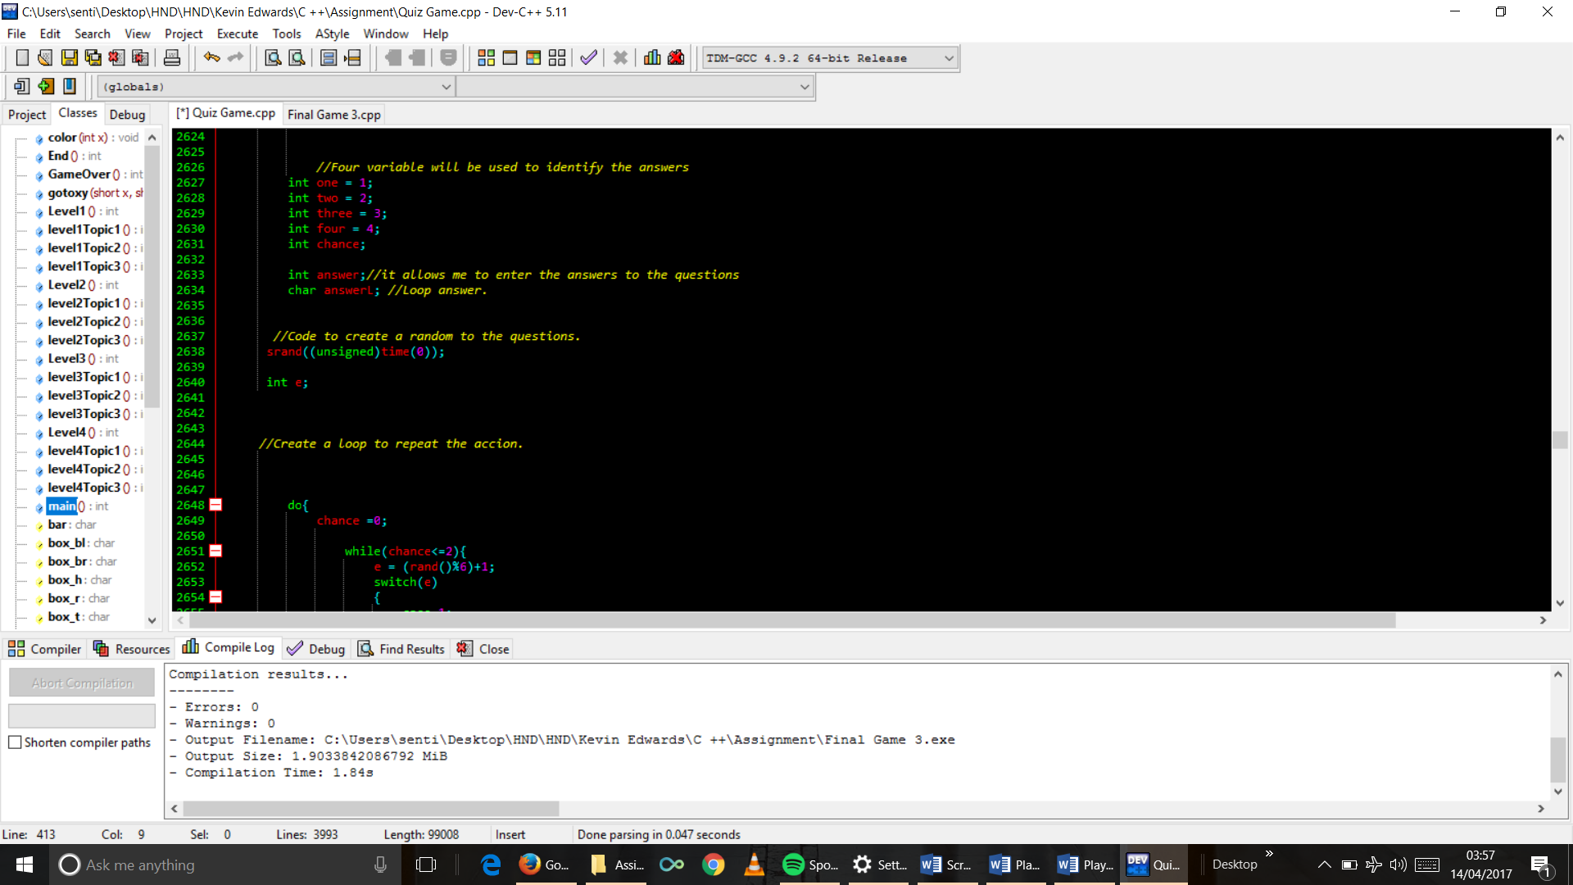

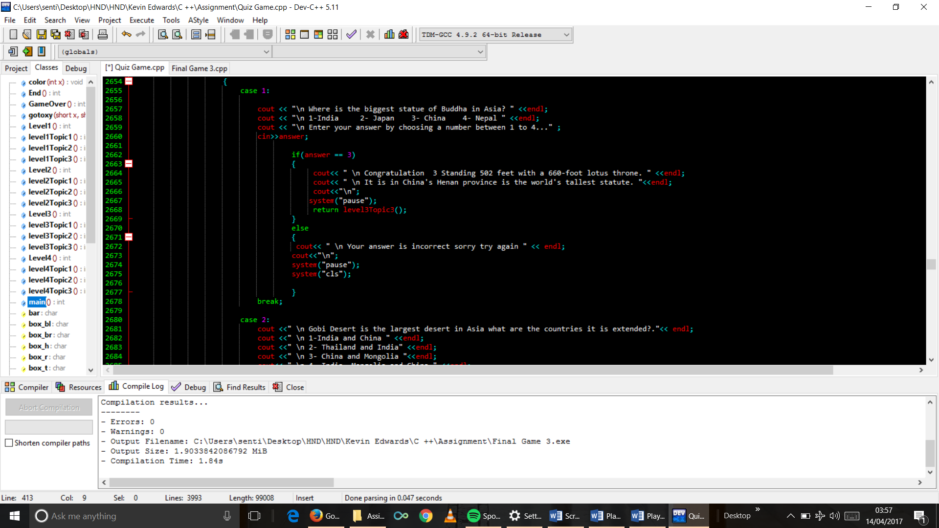

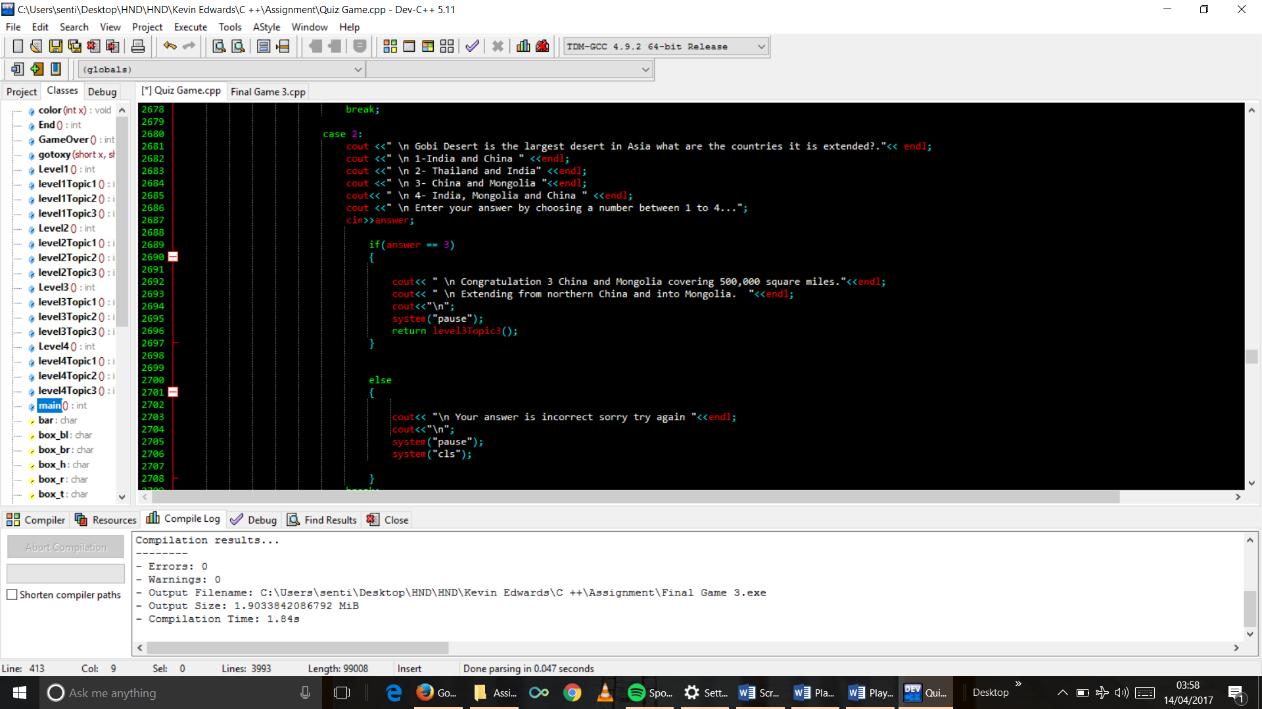

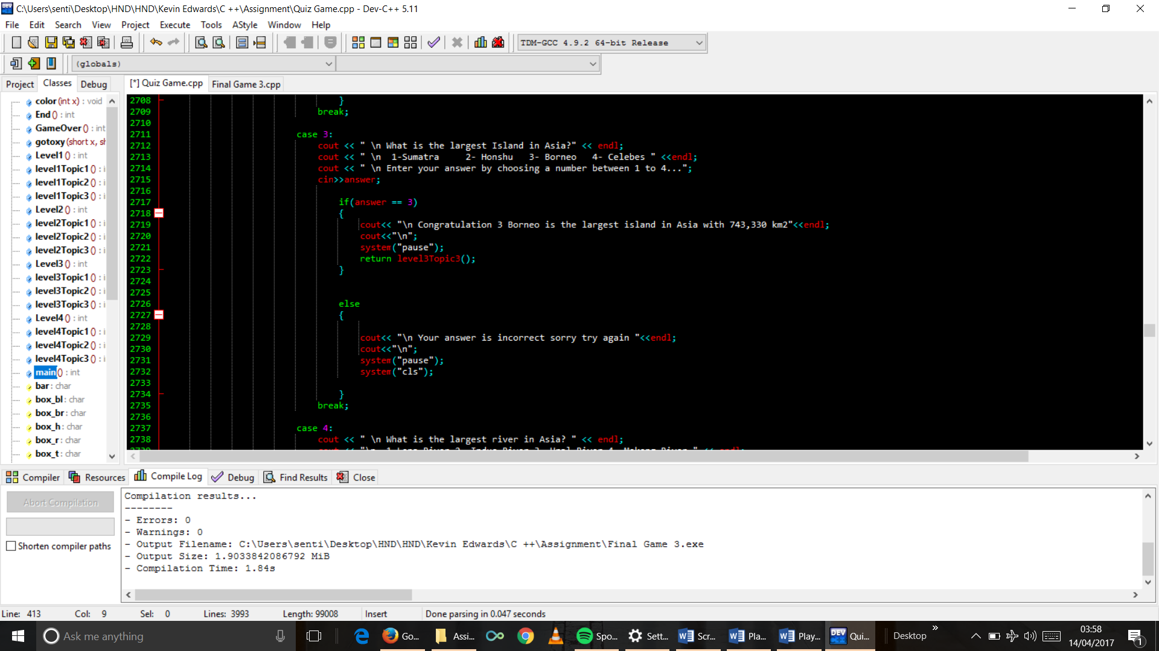

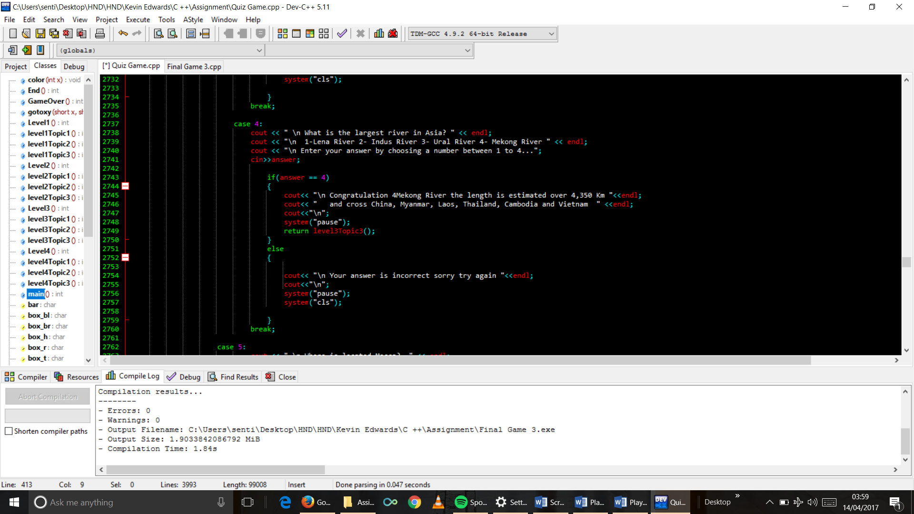

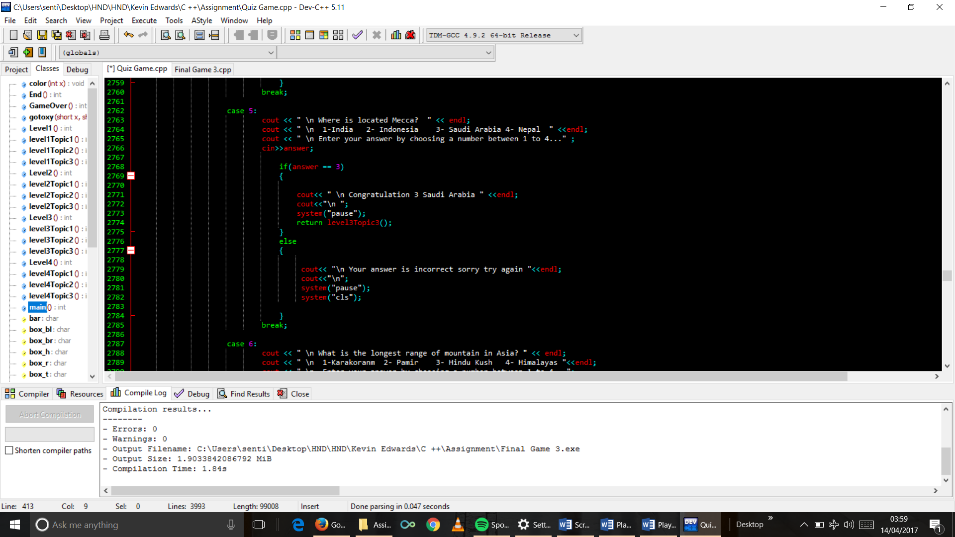

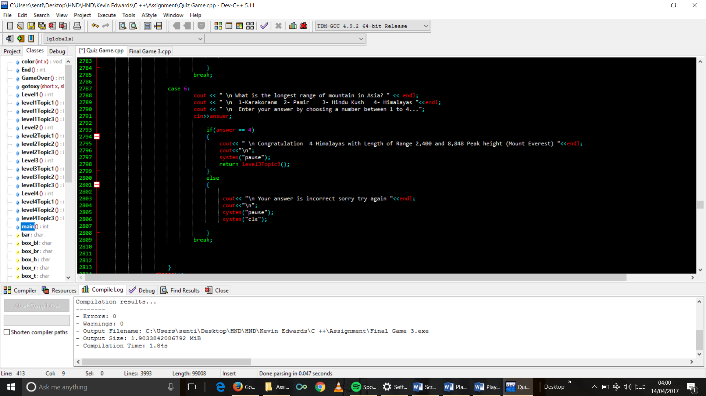

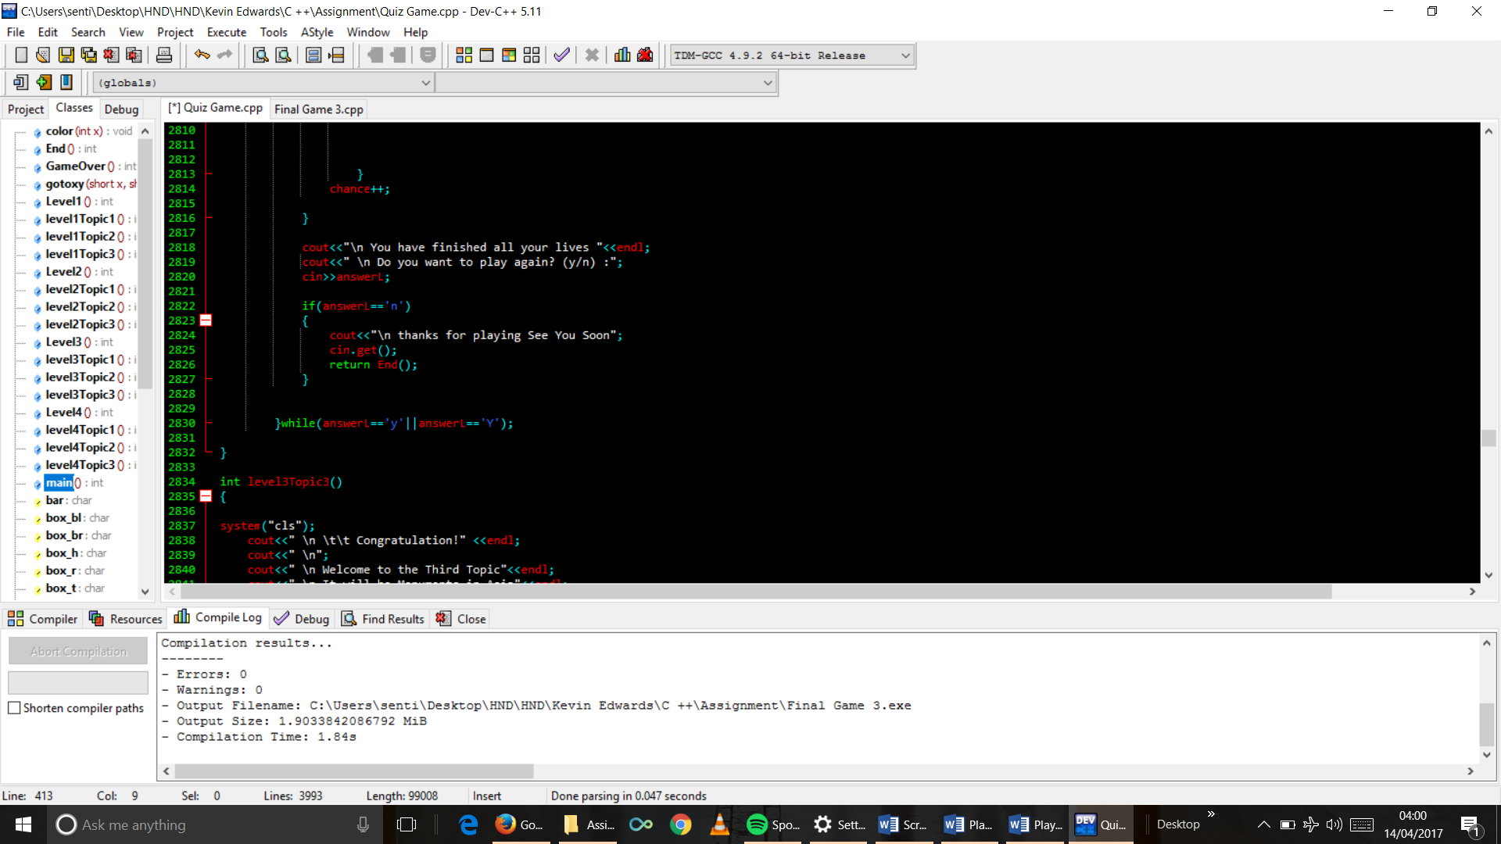

1. Topic 3 function code

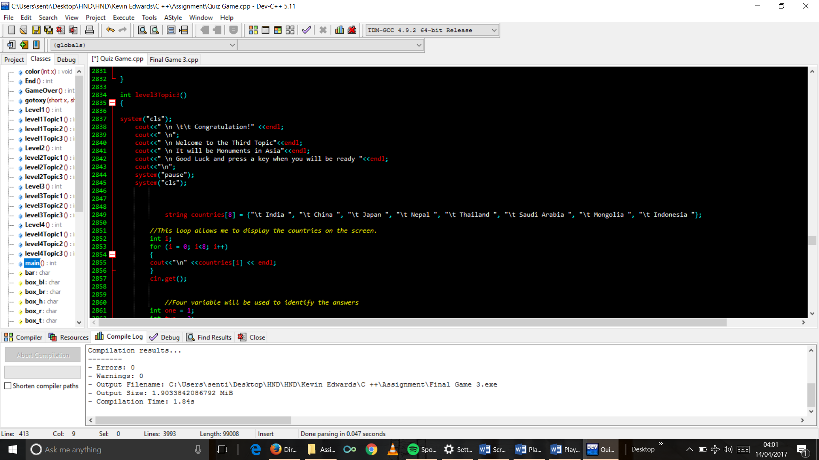

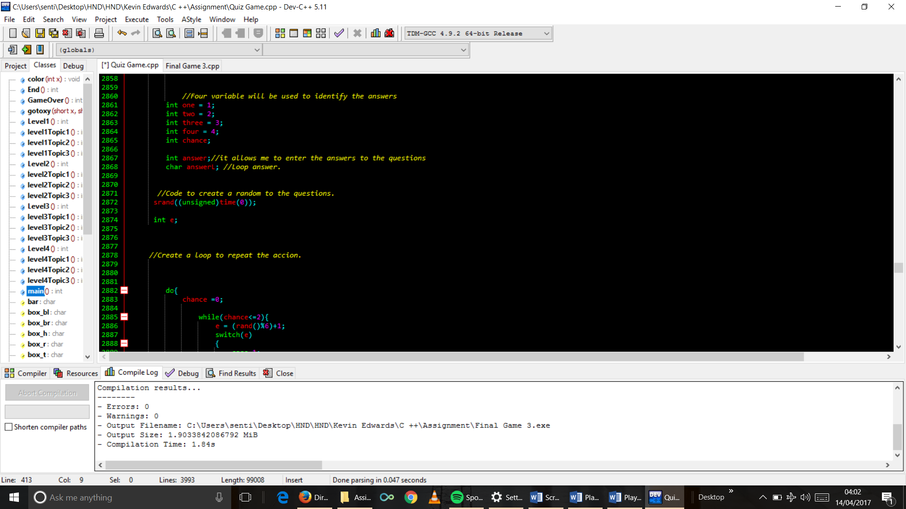

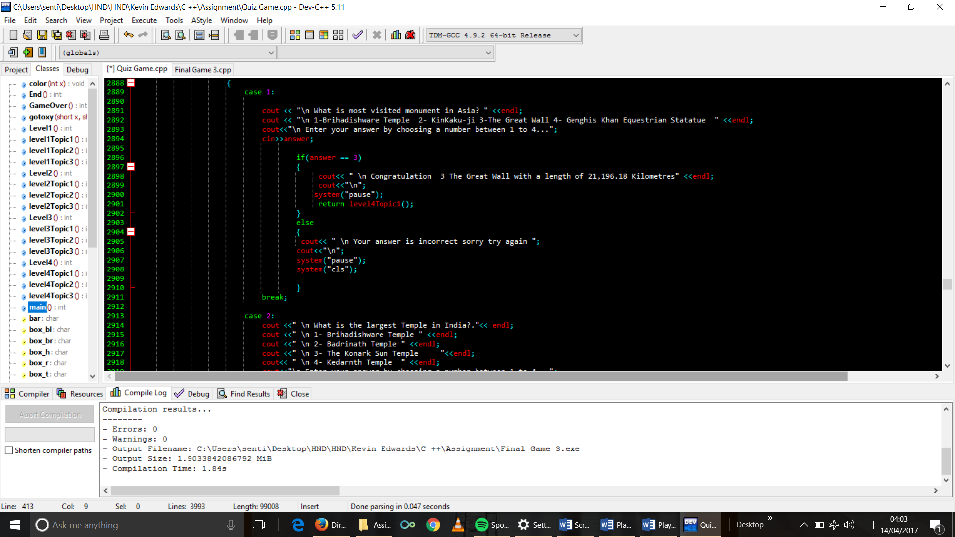

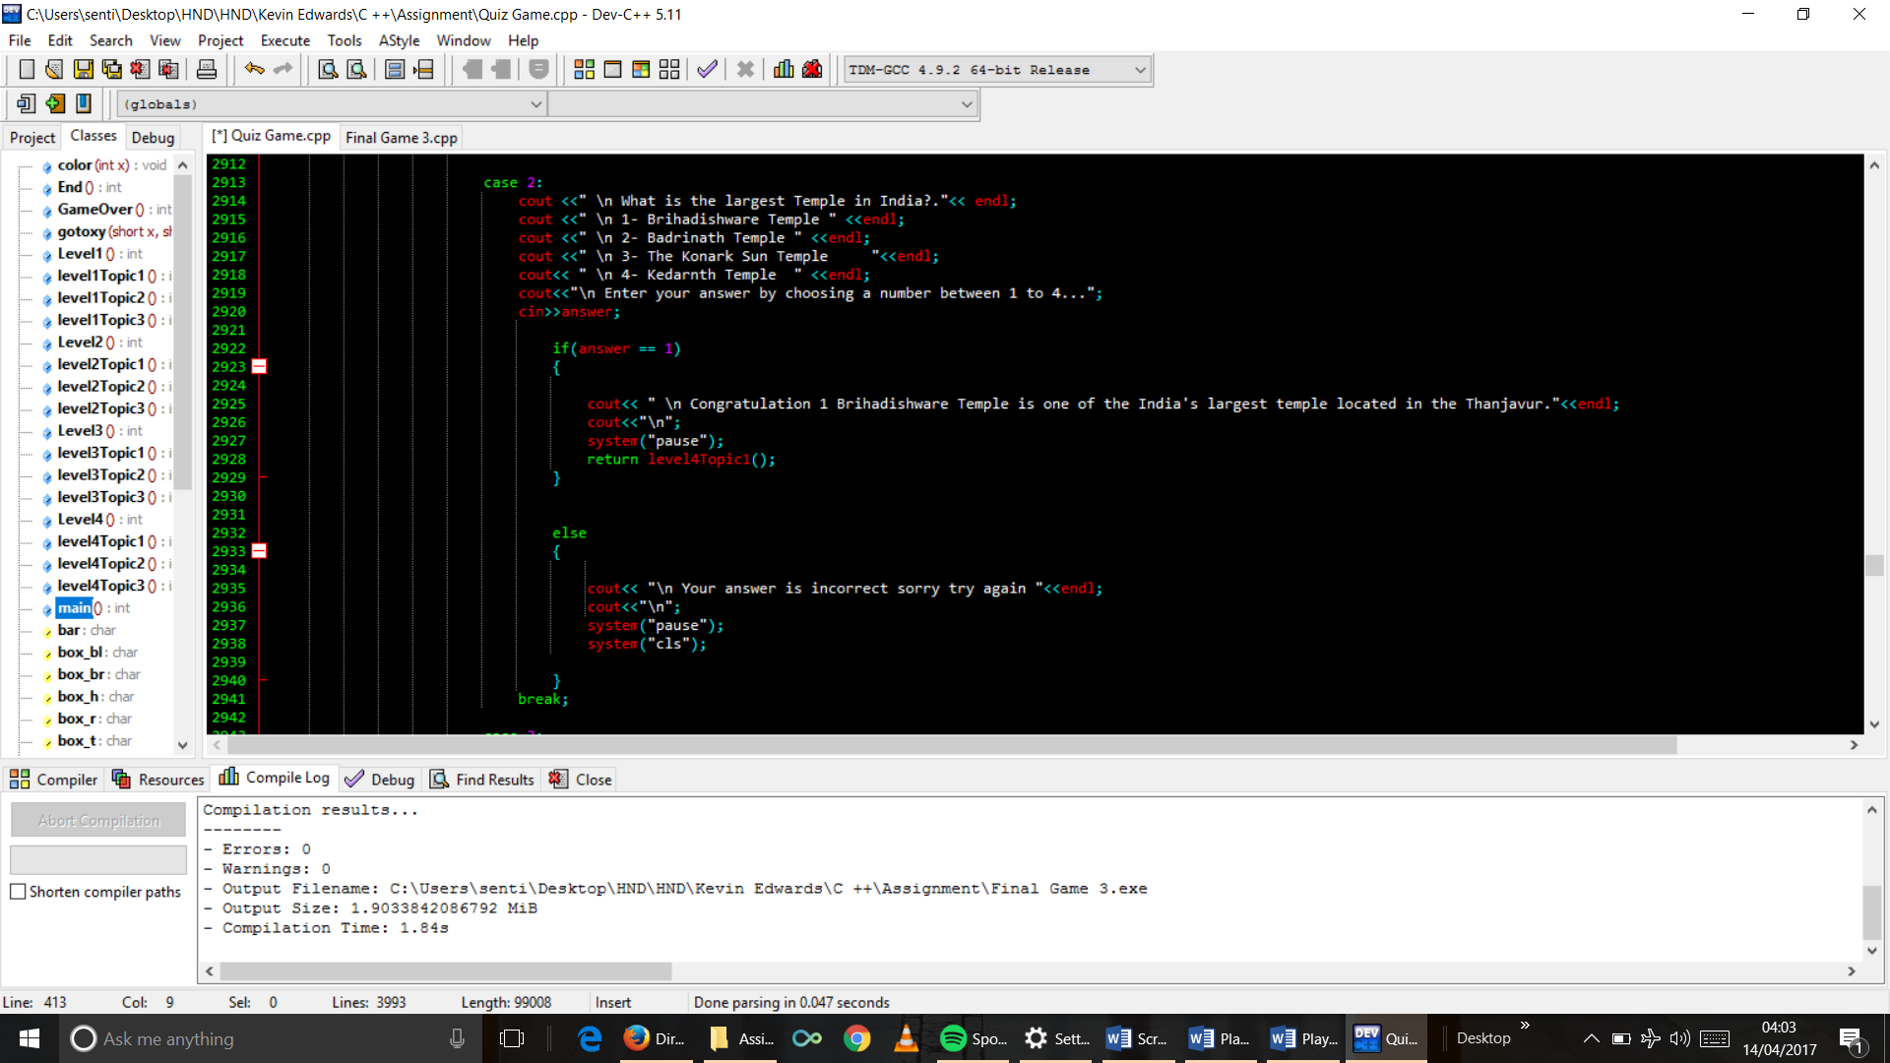



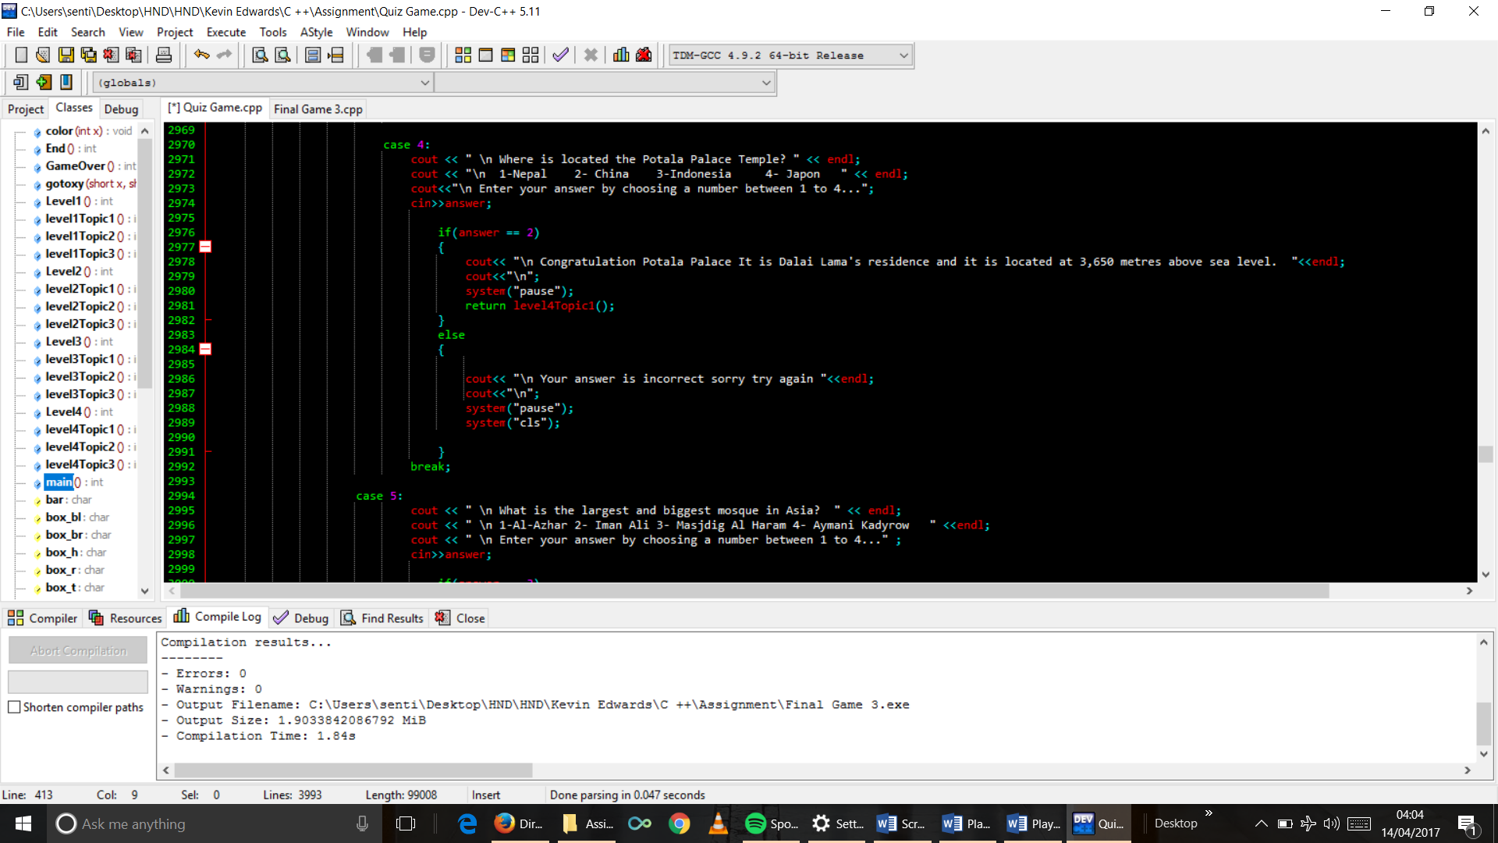

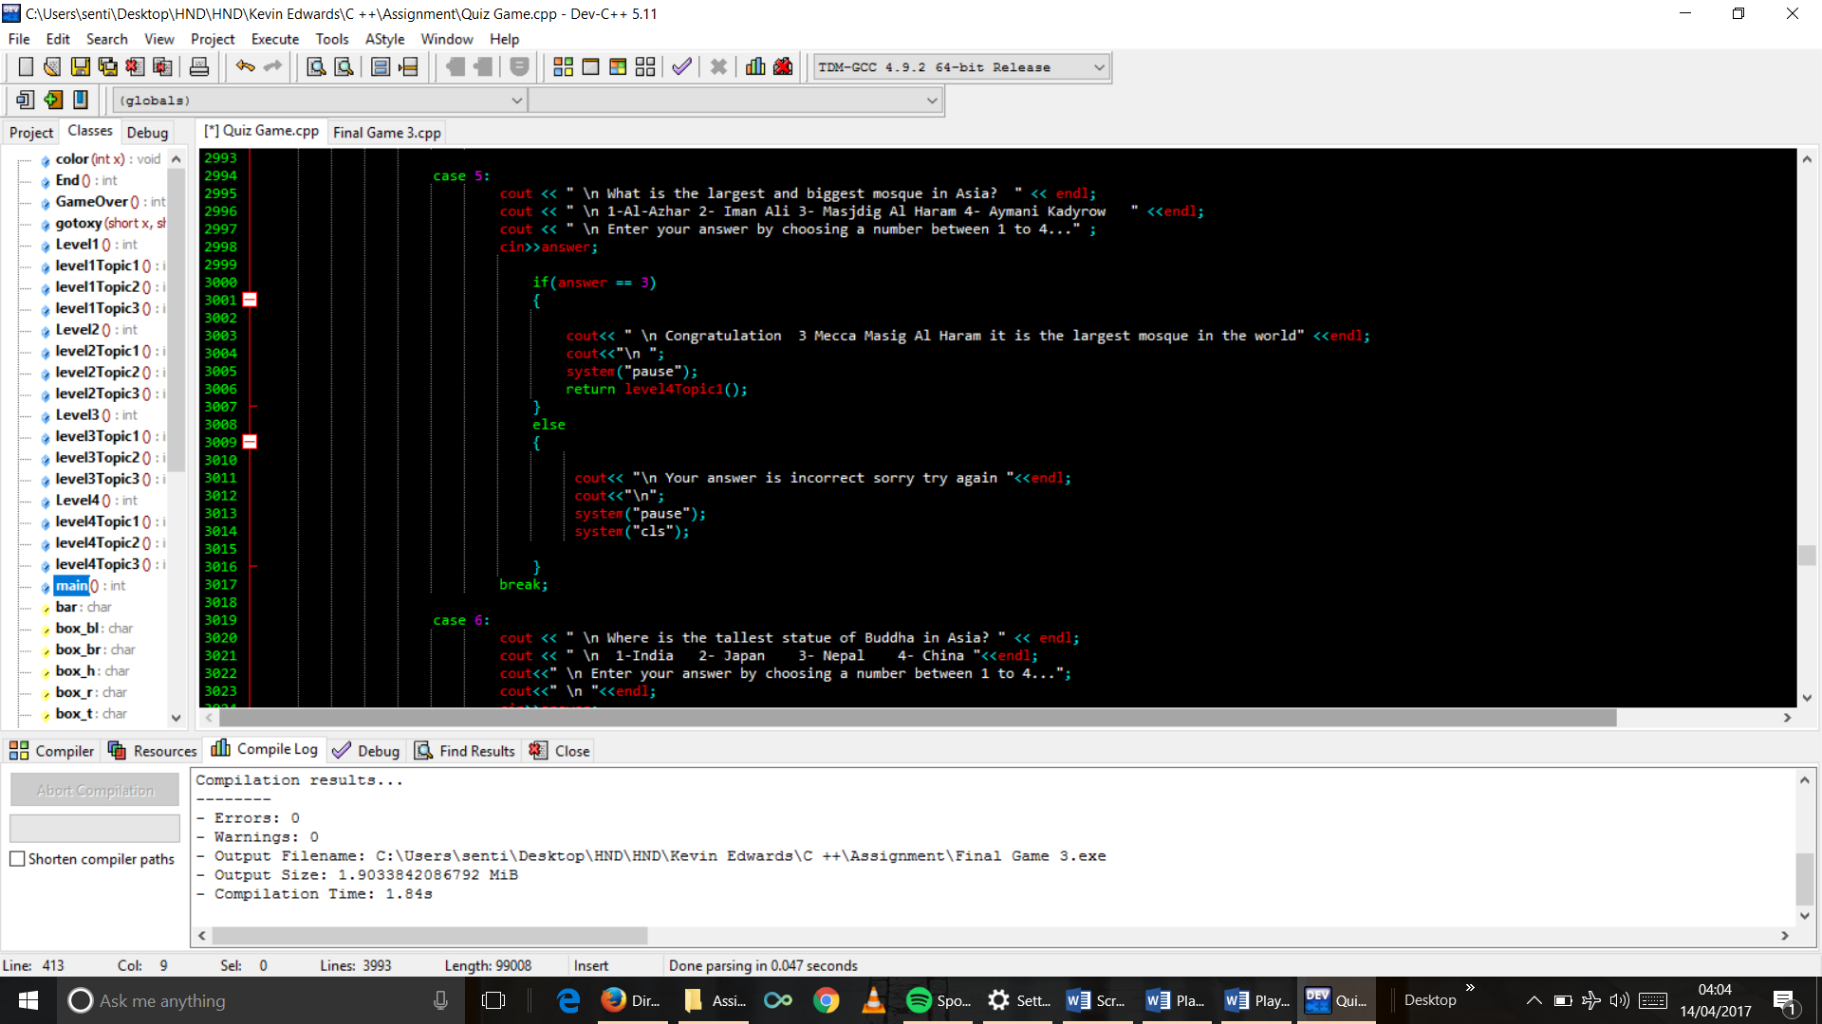

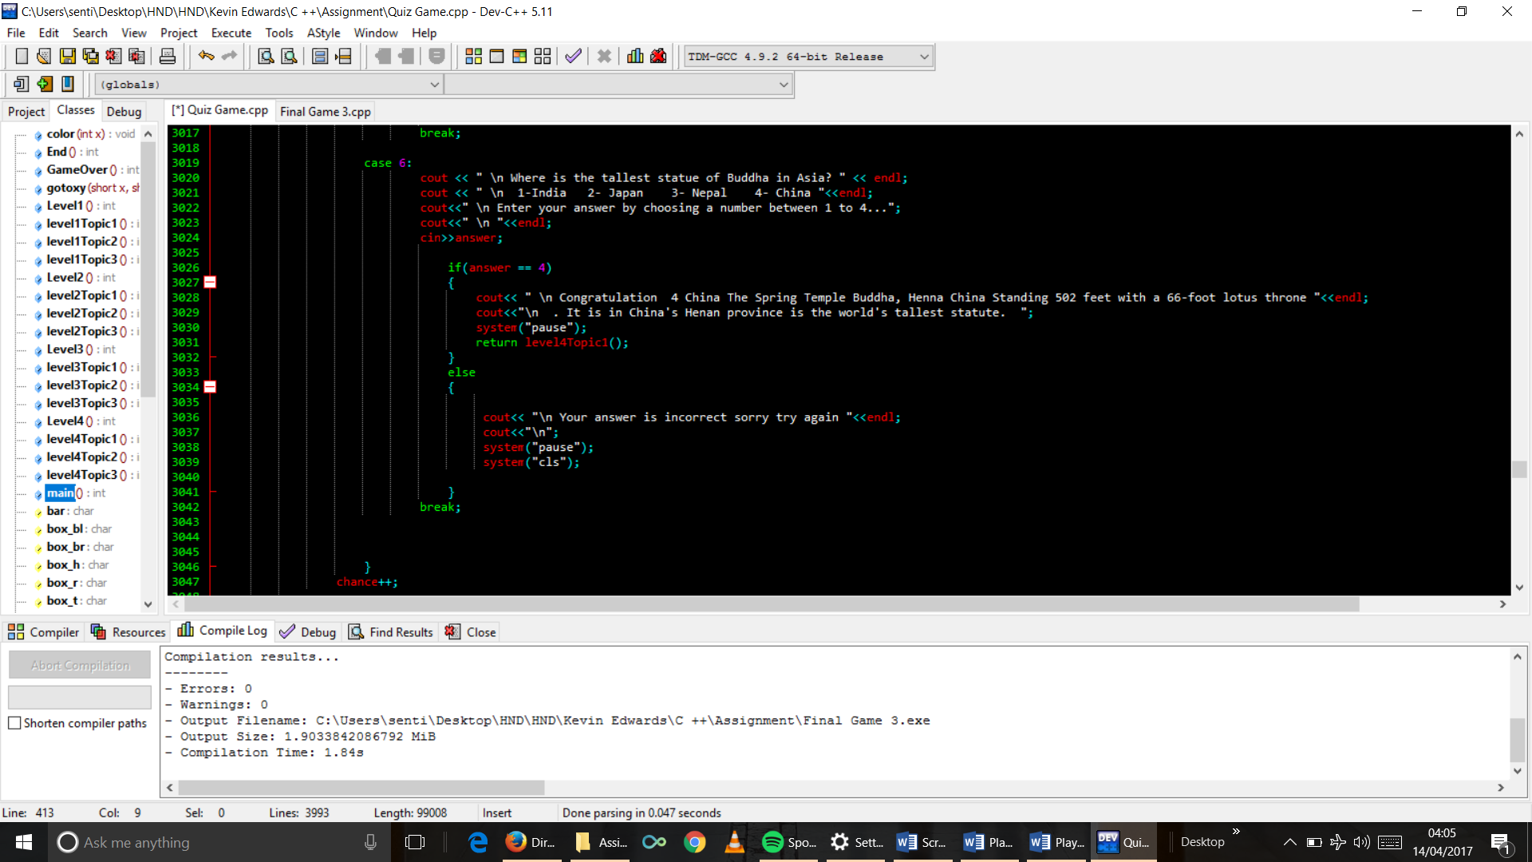

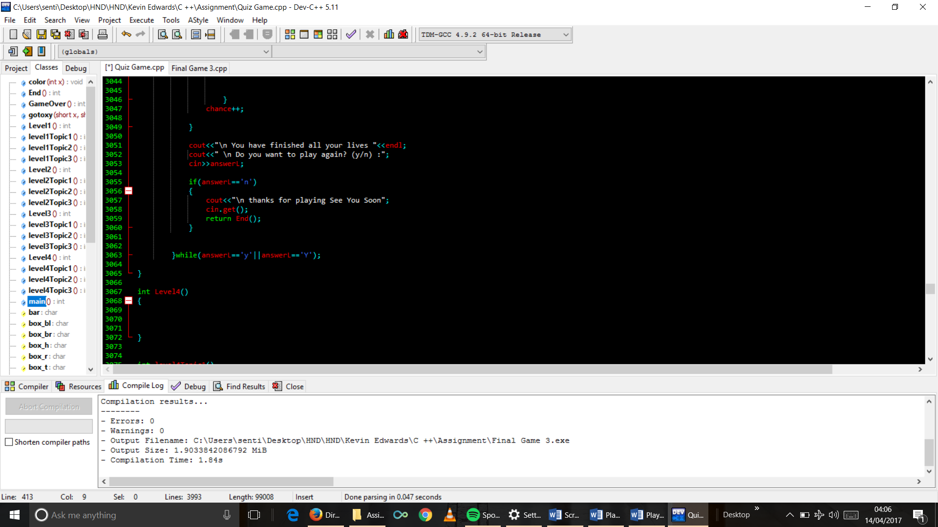

1. Level 4 function code



1. Topic 1 function code

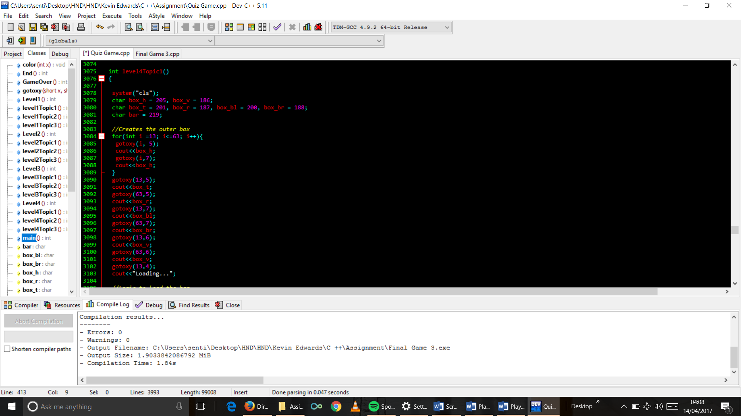











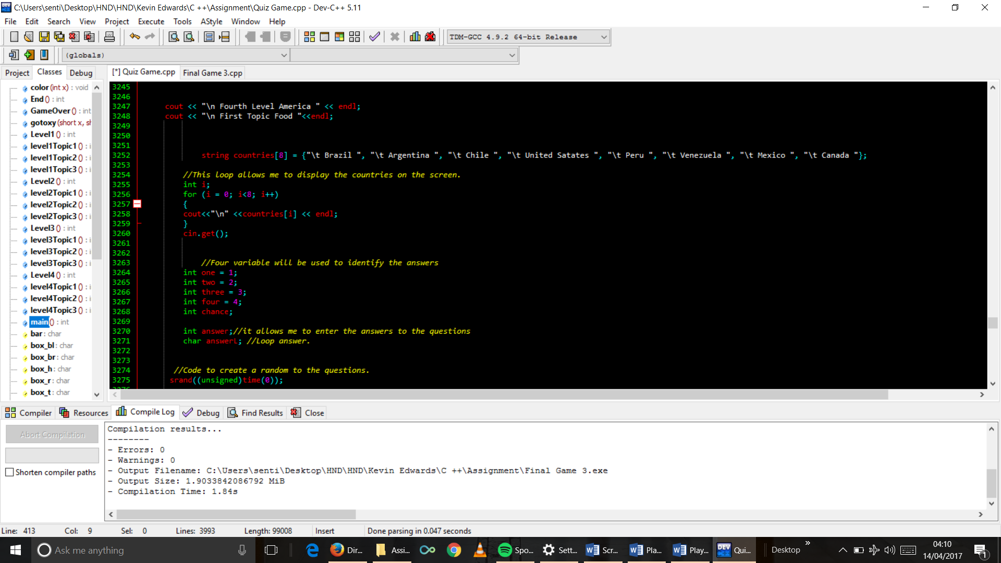

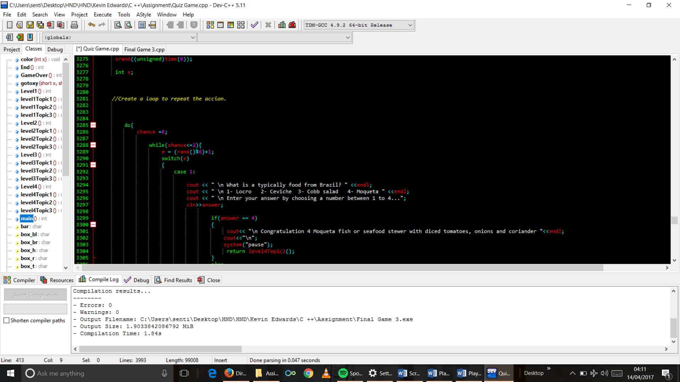

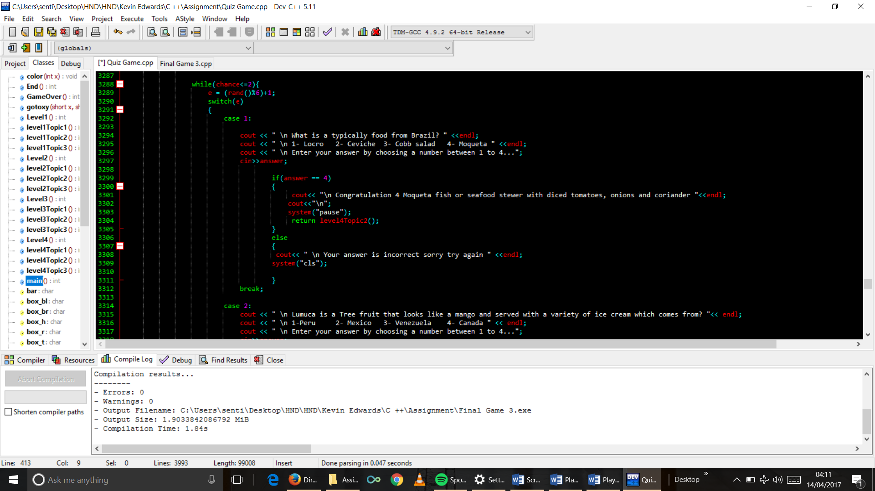

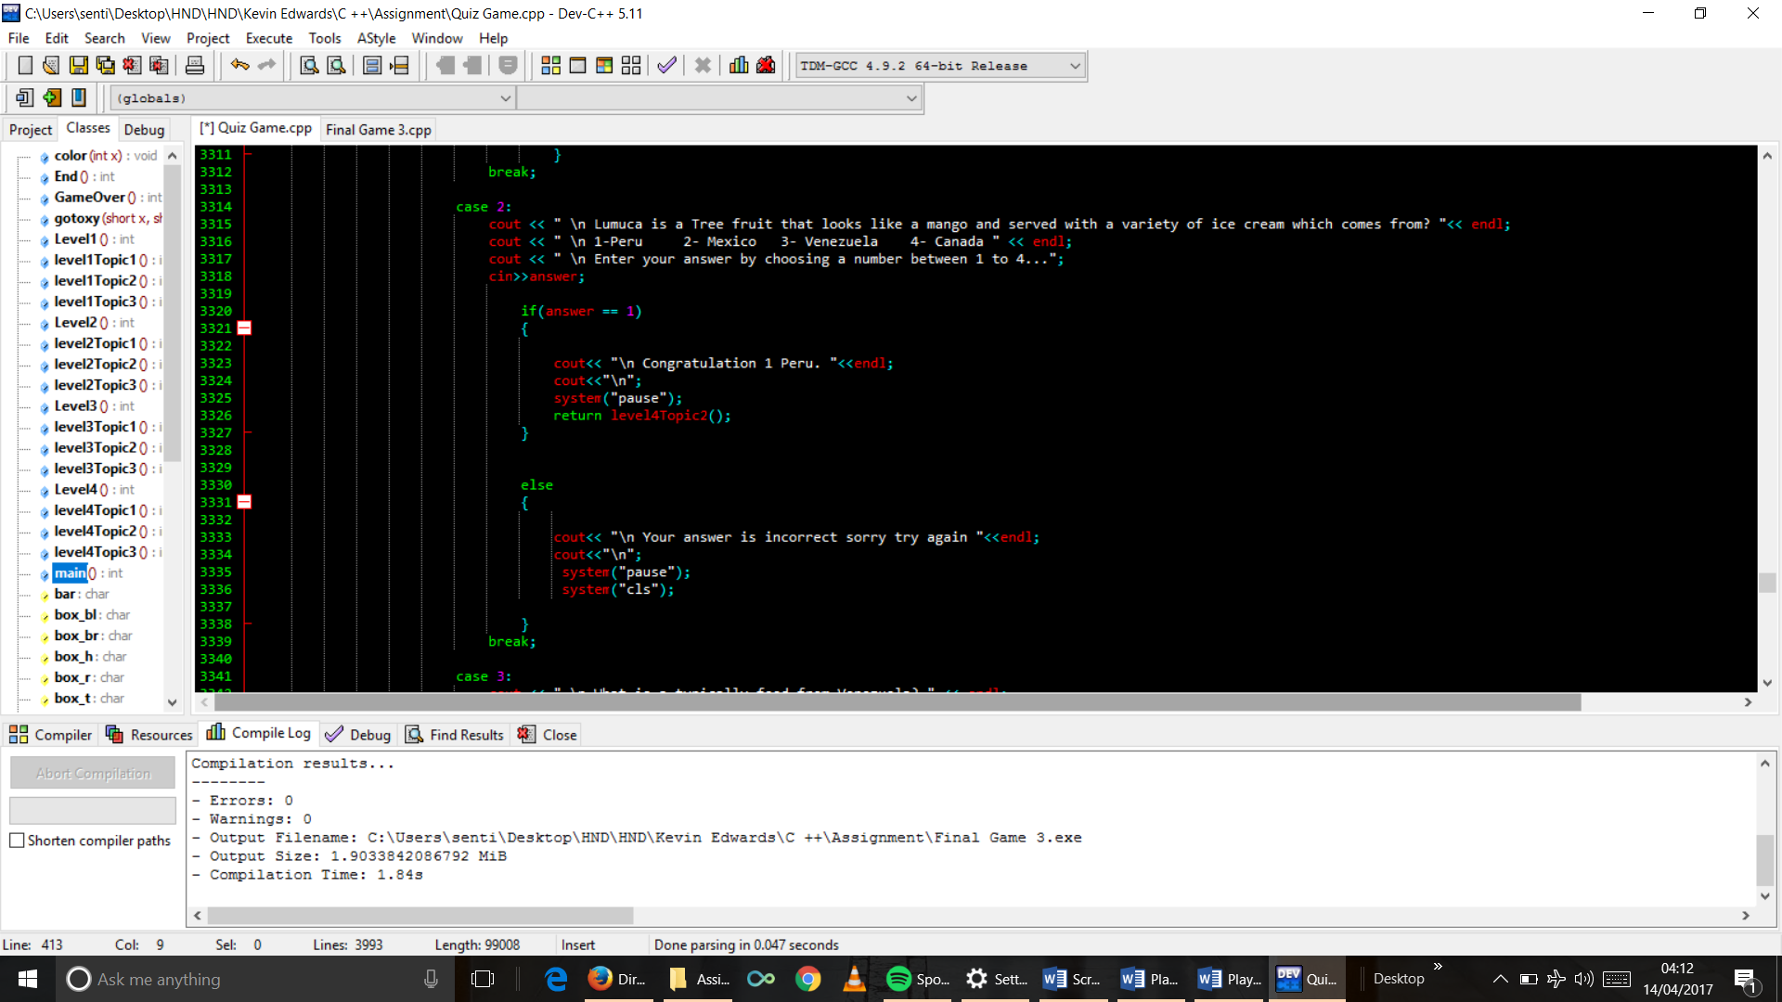

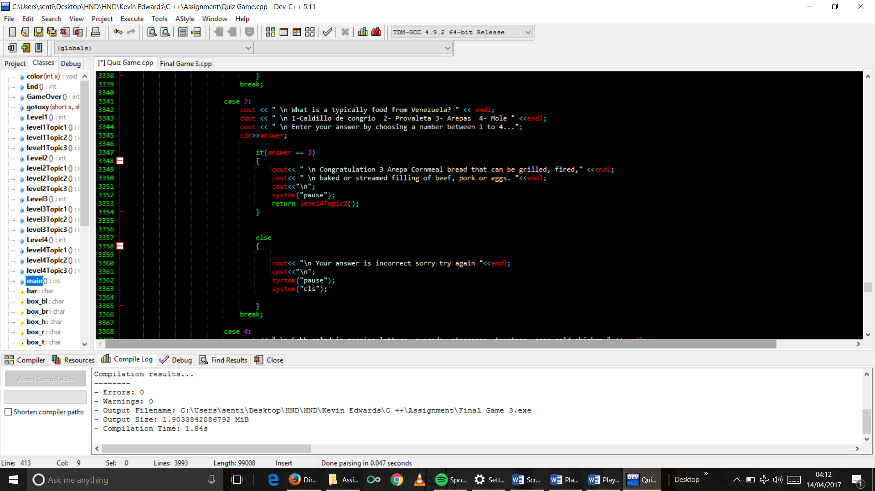

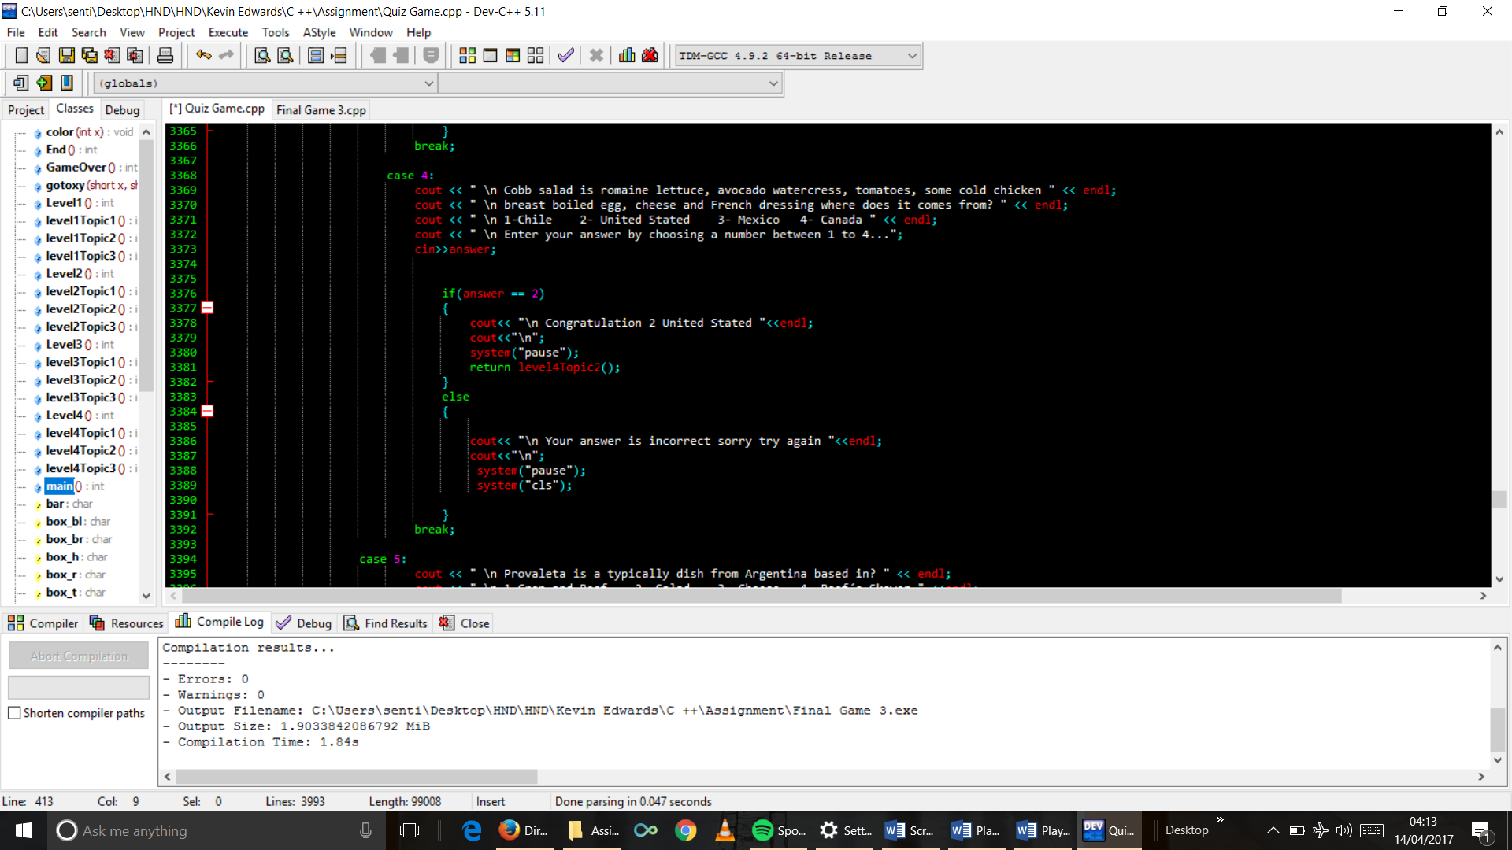

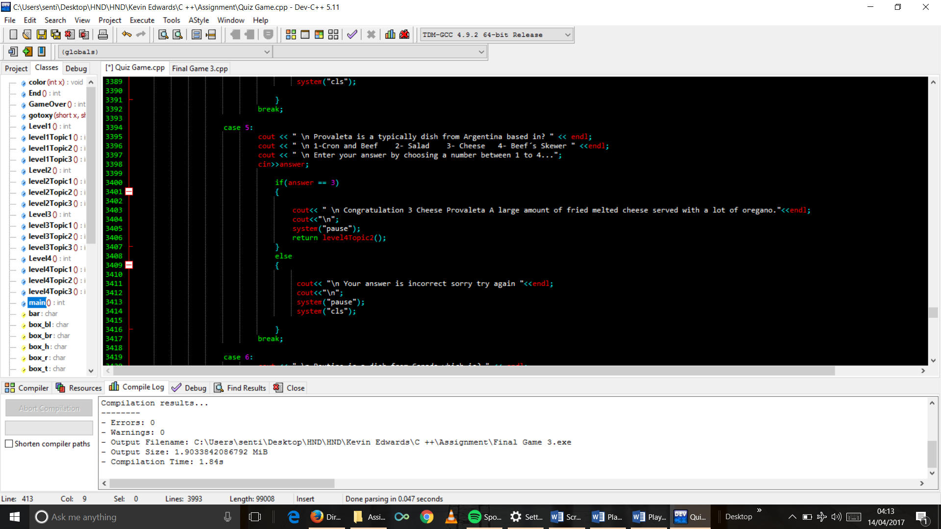

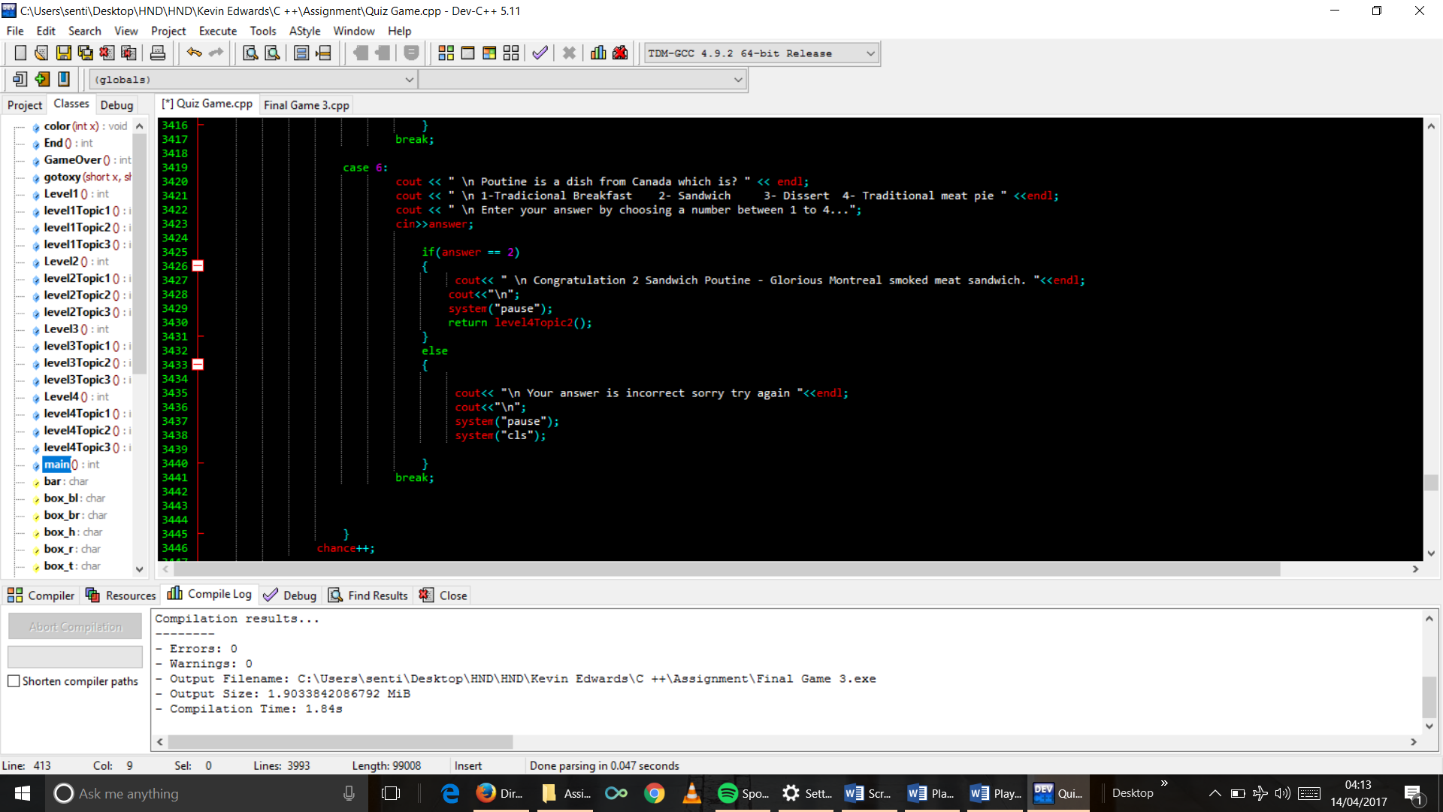

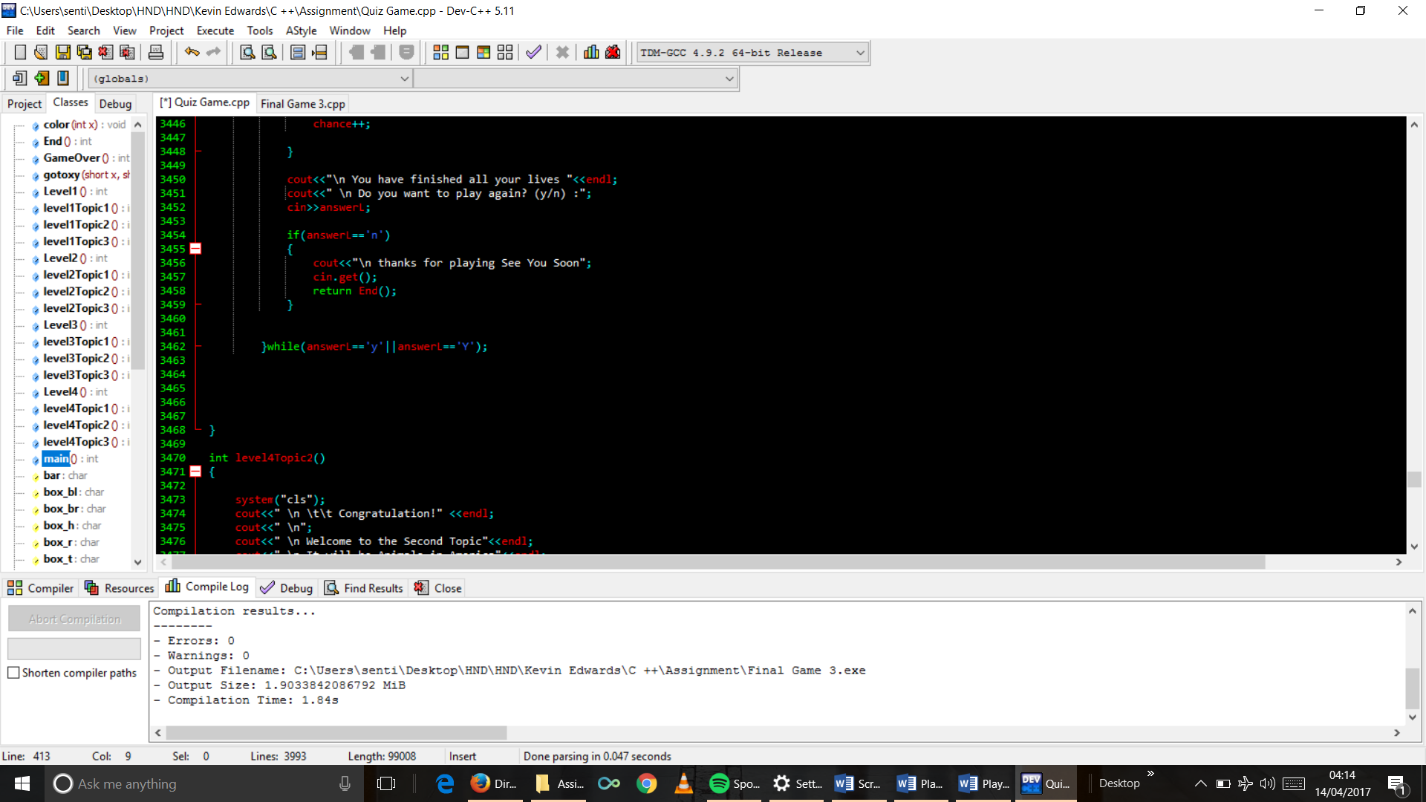

1. Topic 2 function code

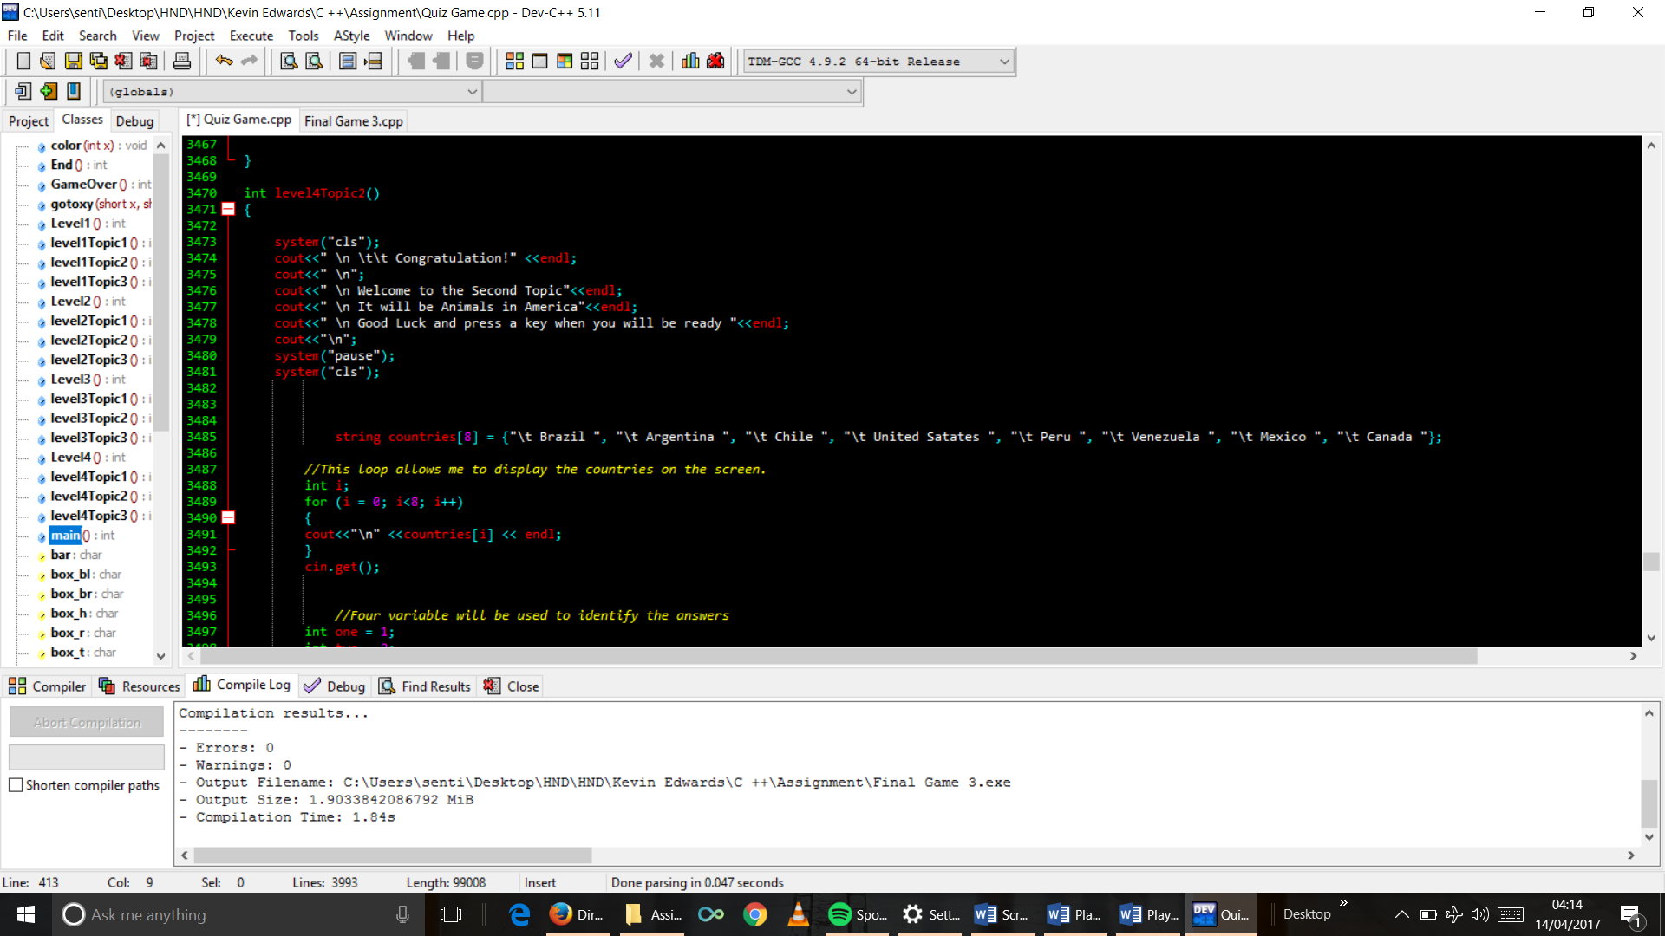

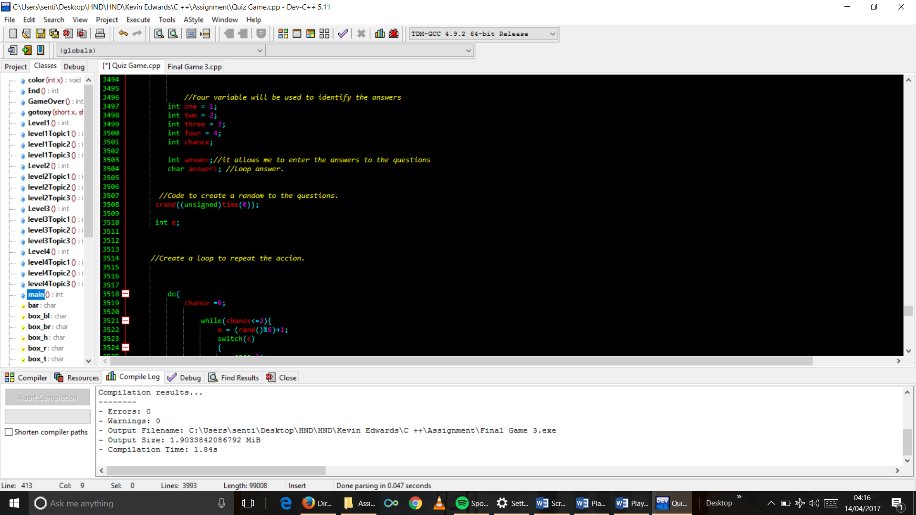

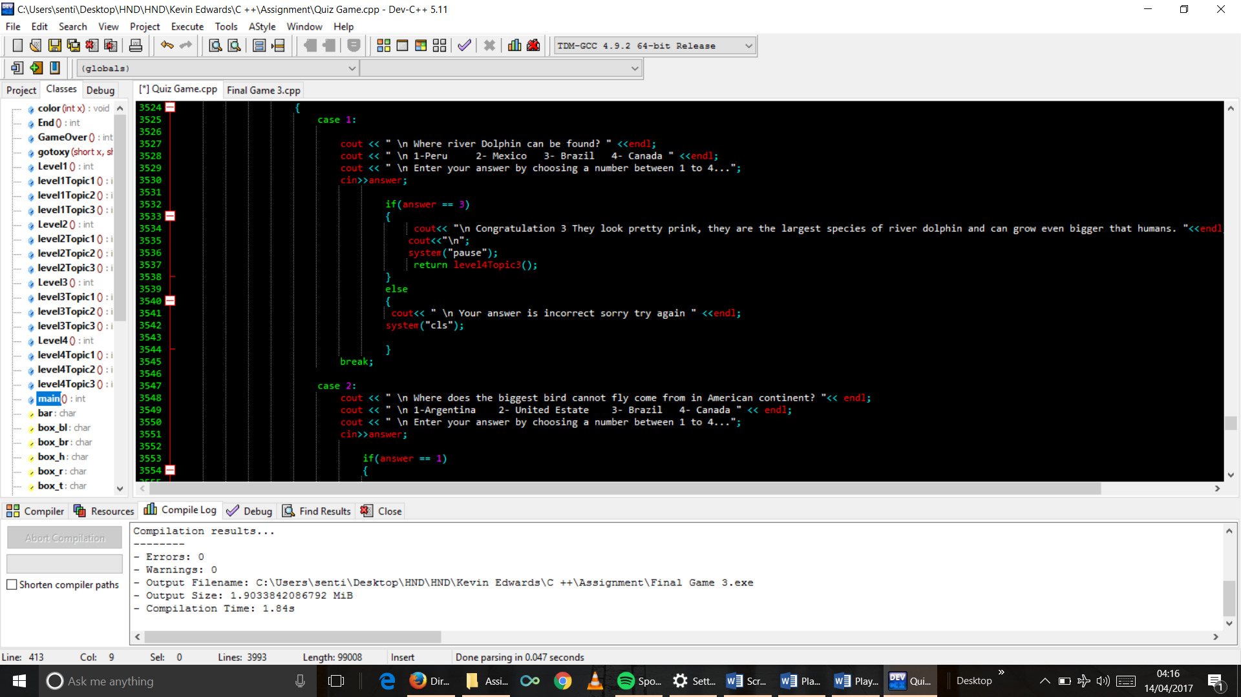

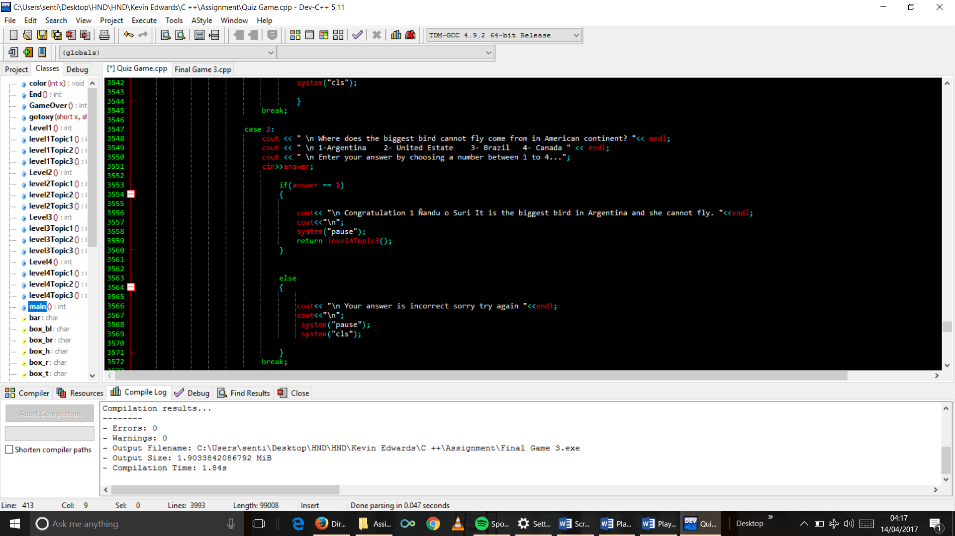

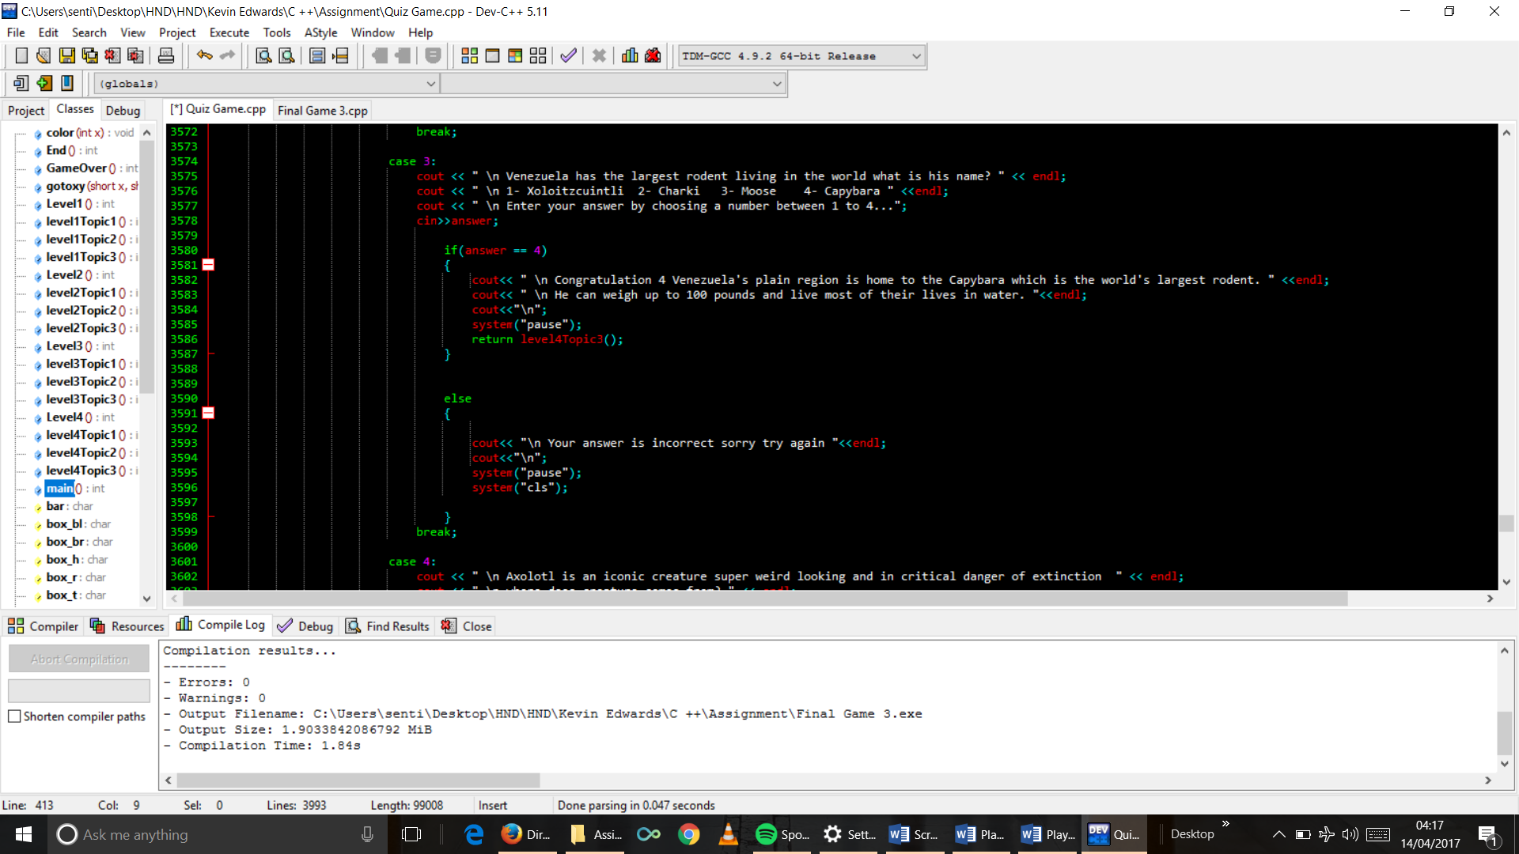

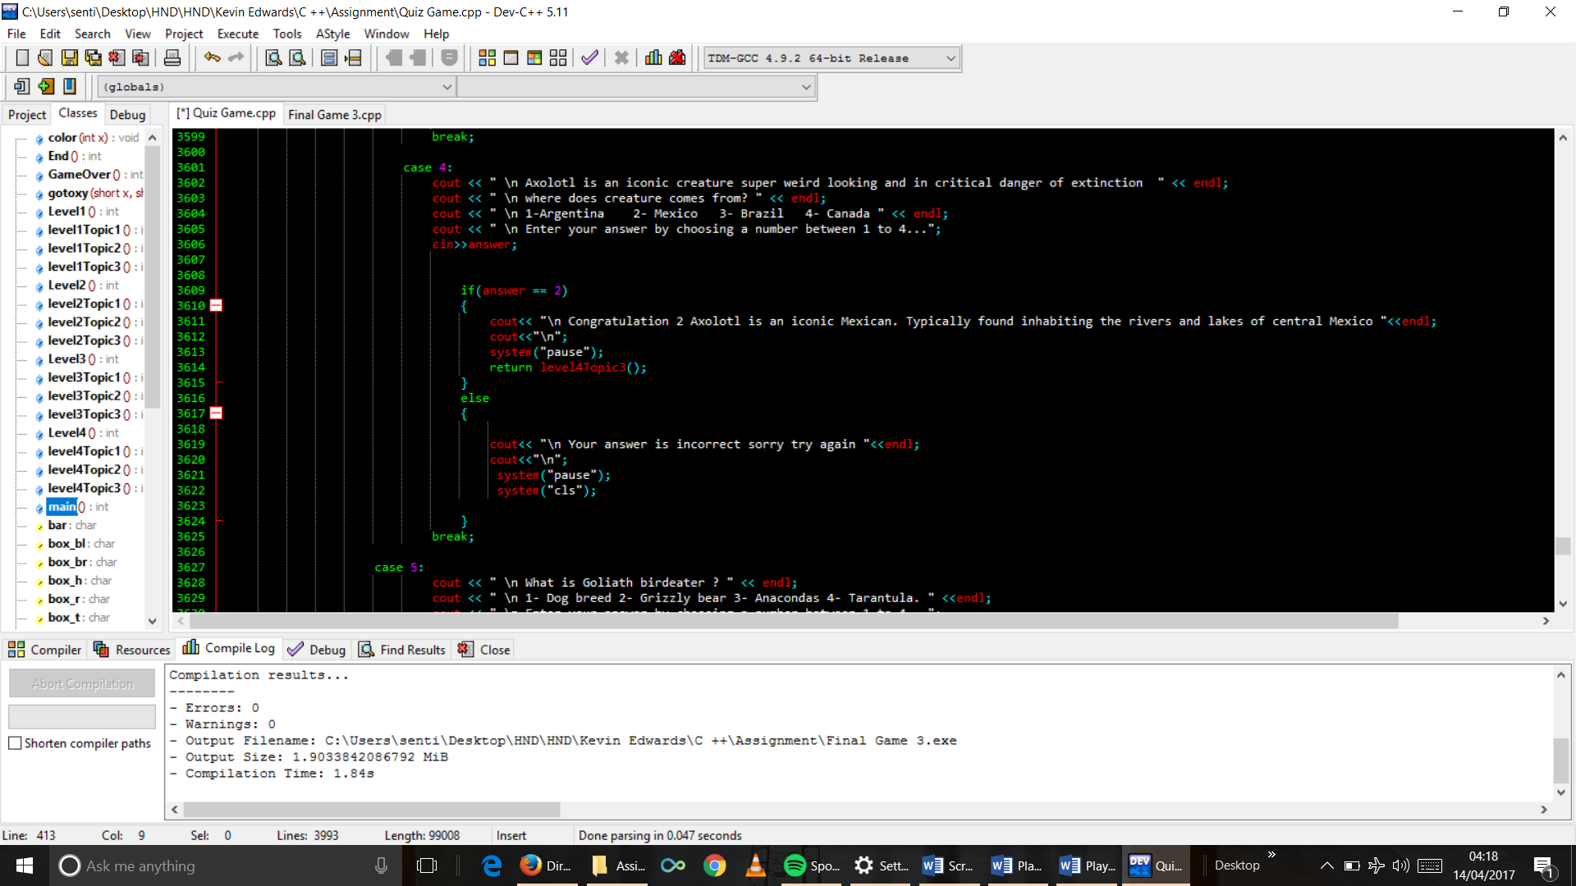

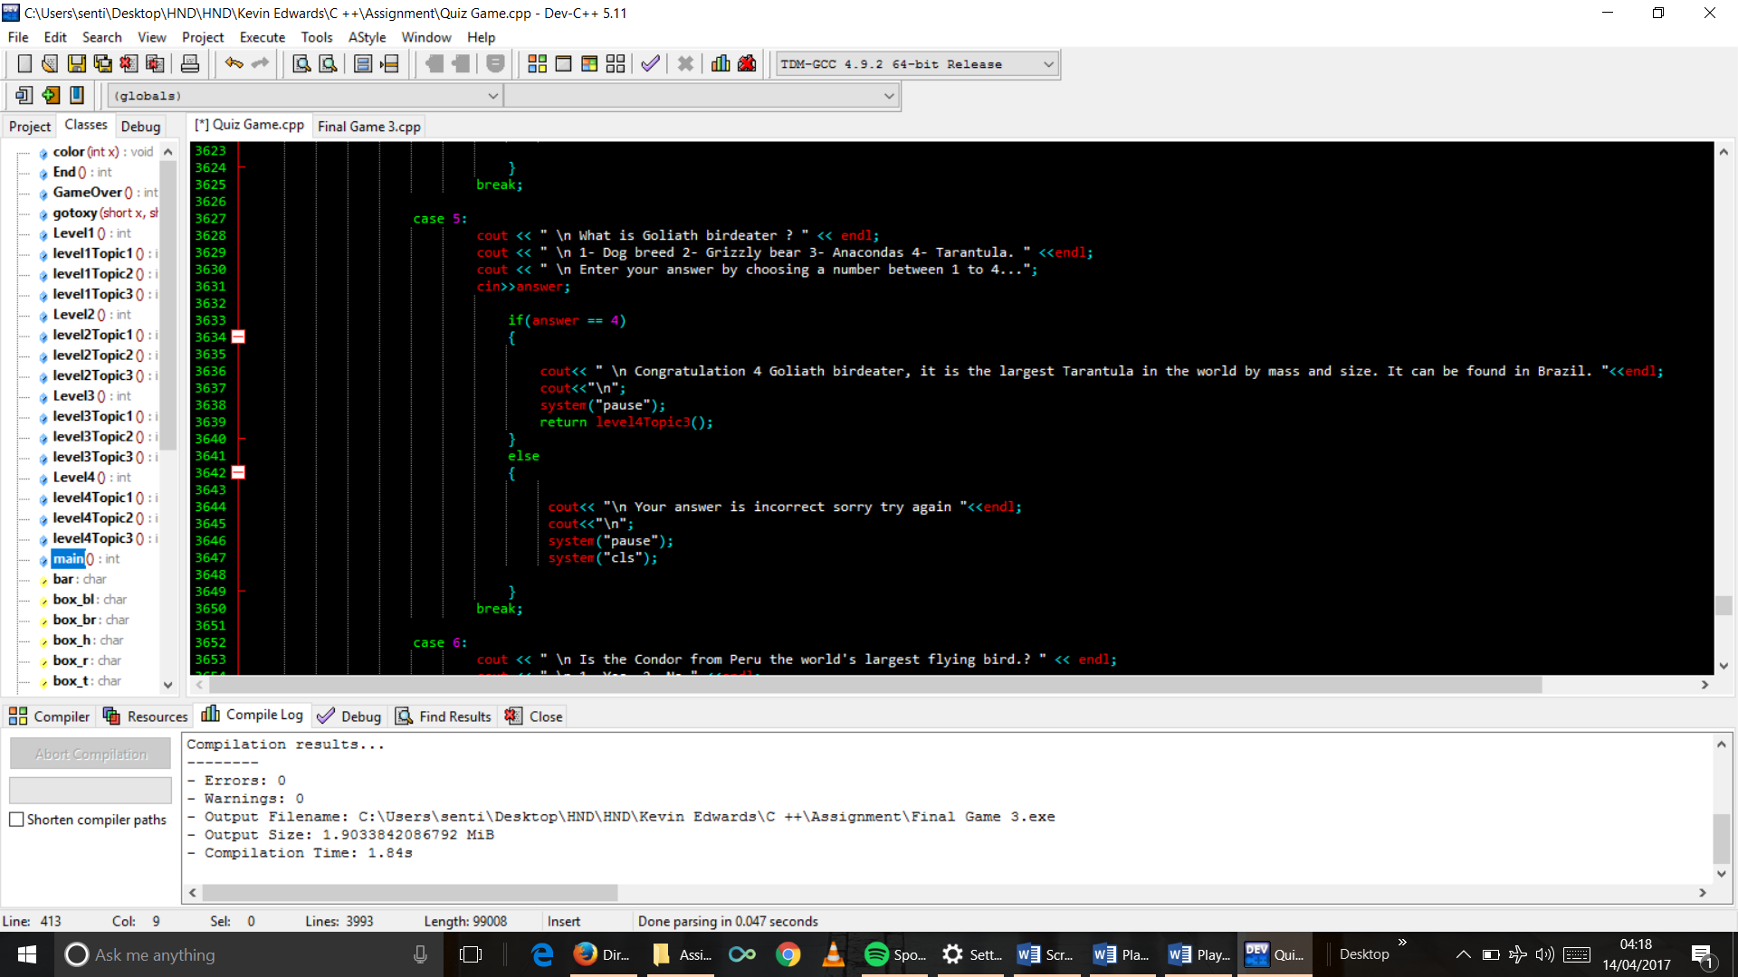

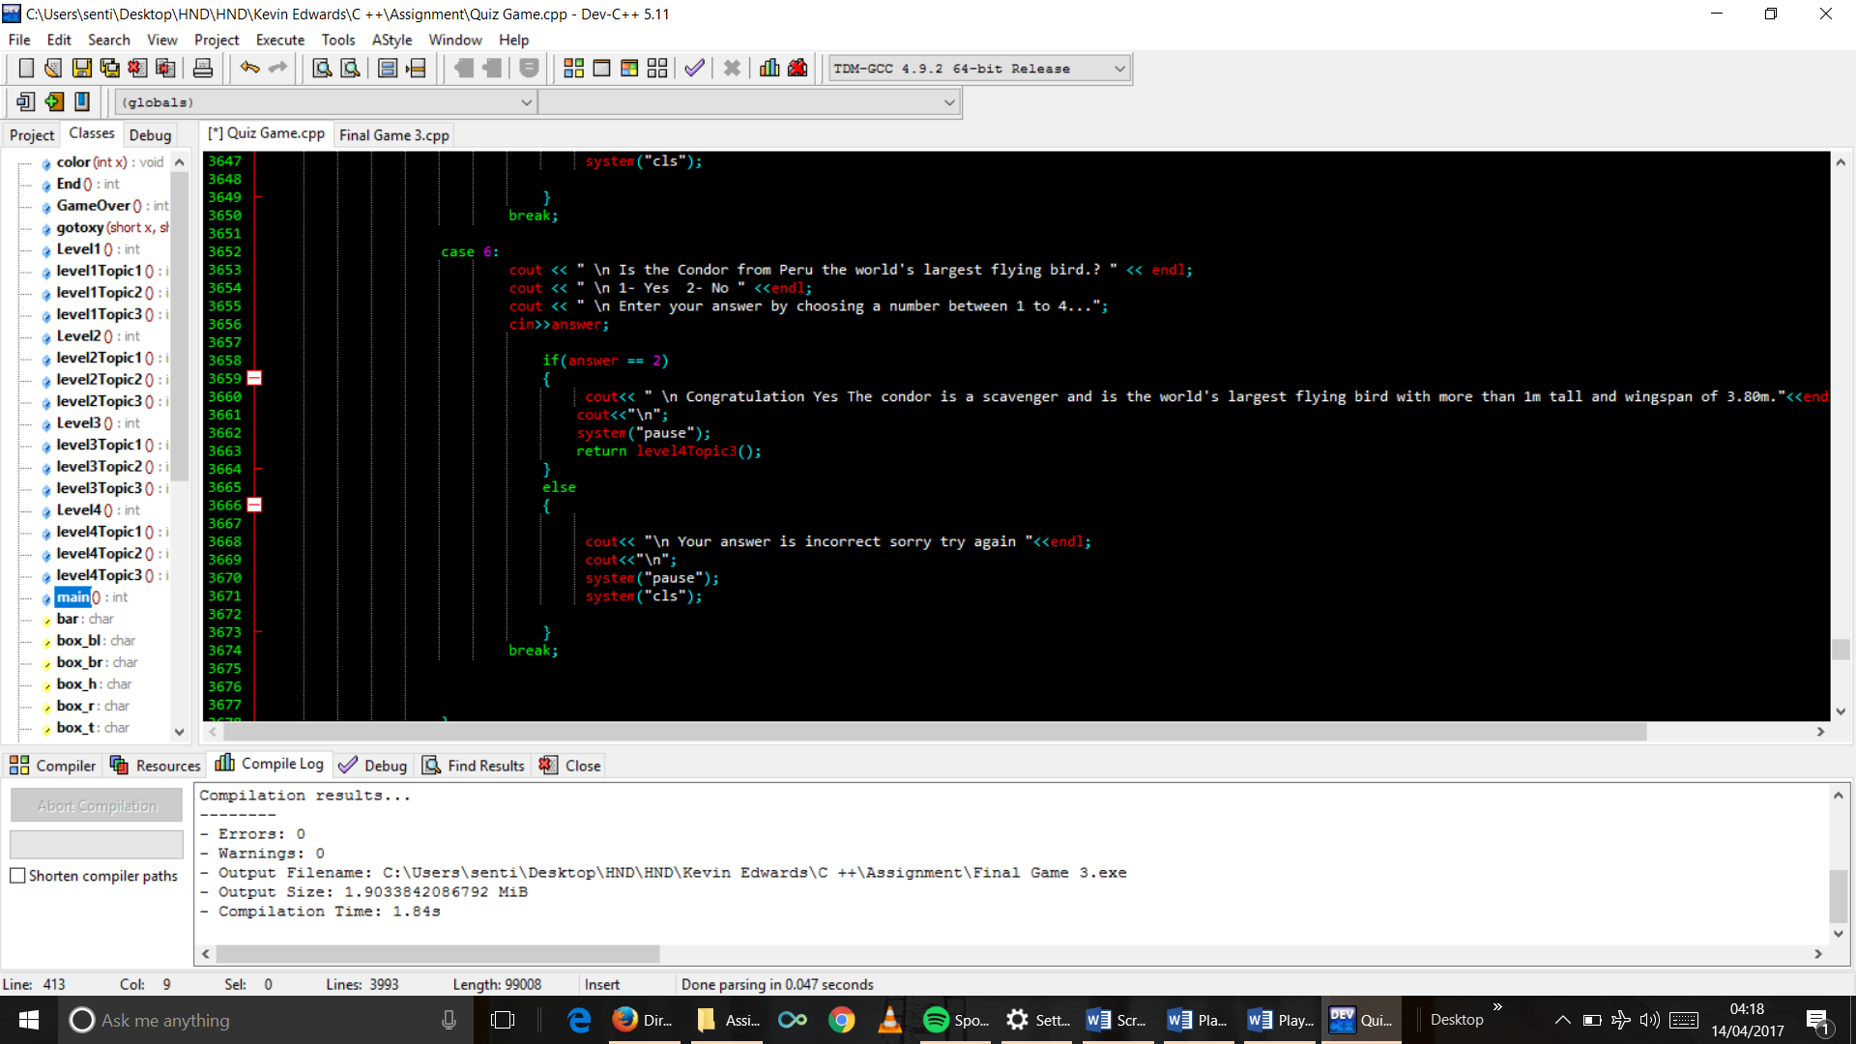

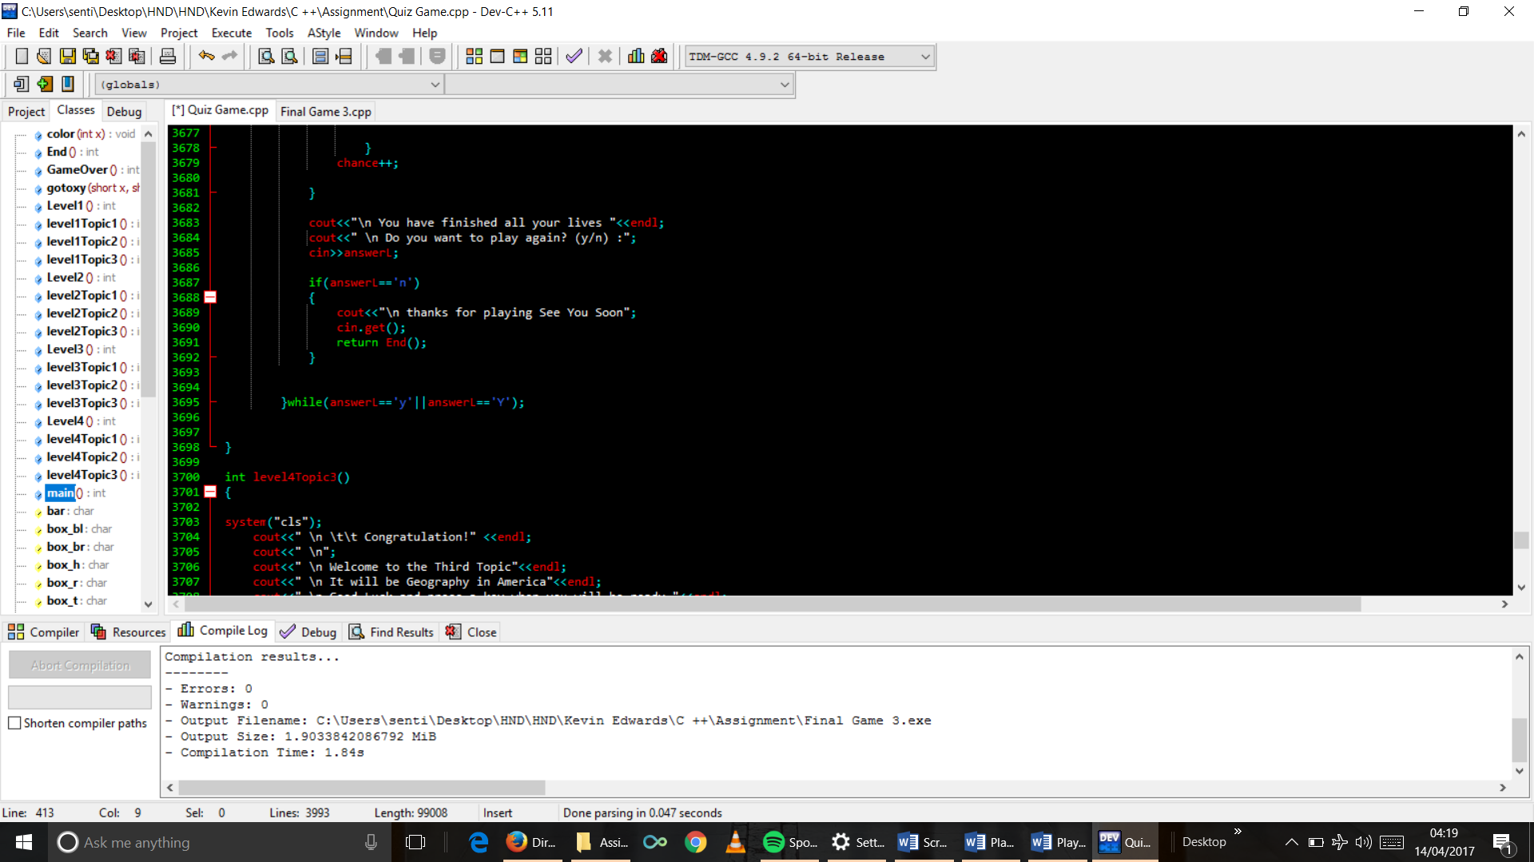

1. Topic 3 function code

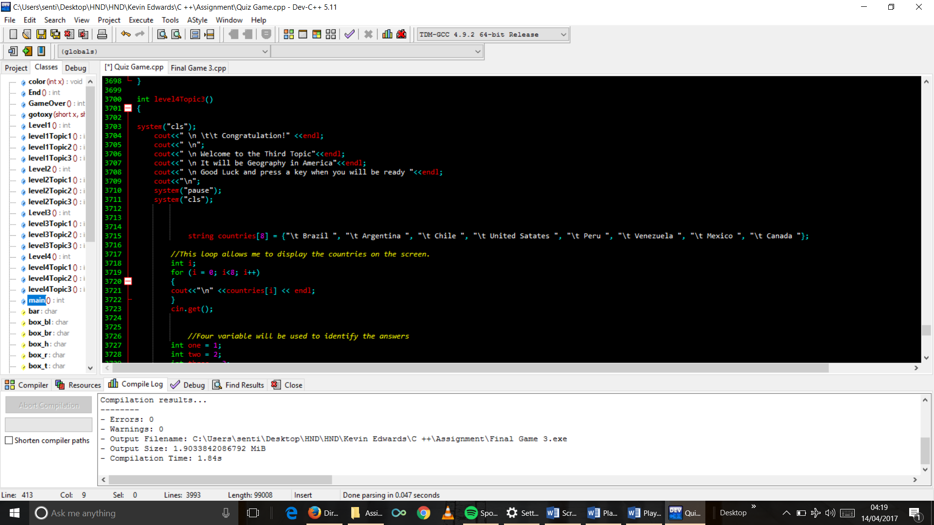

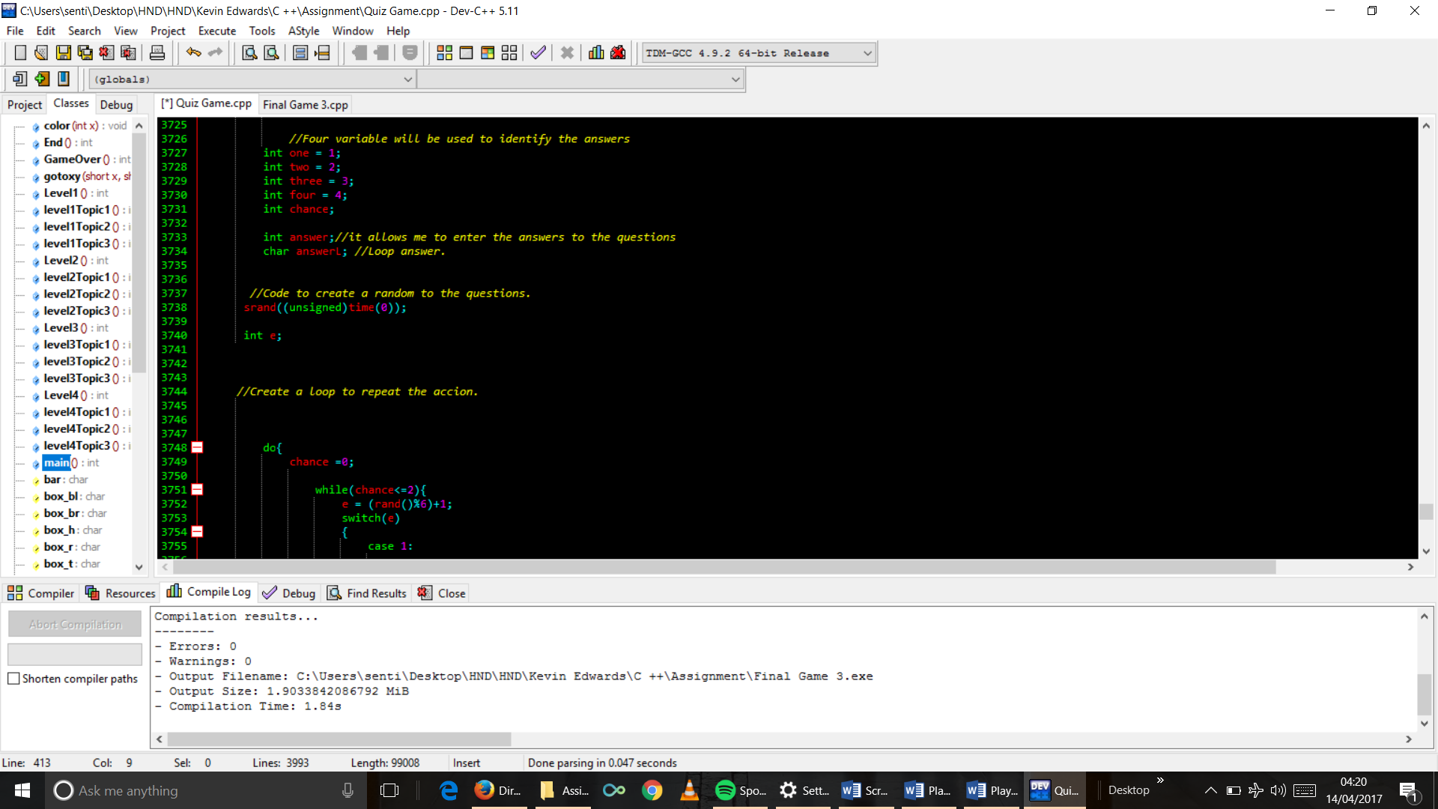

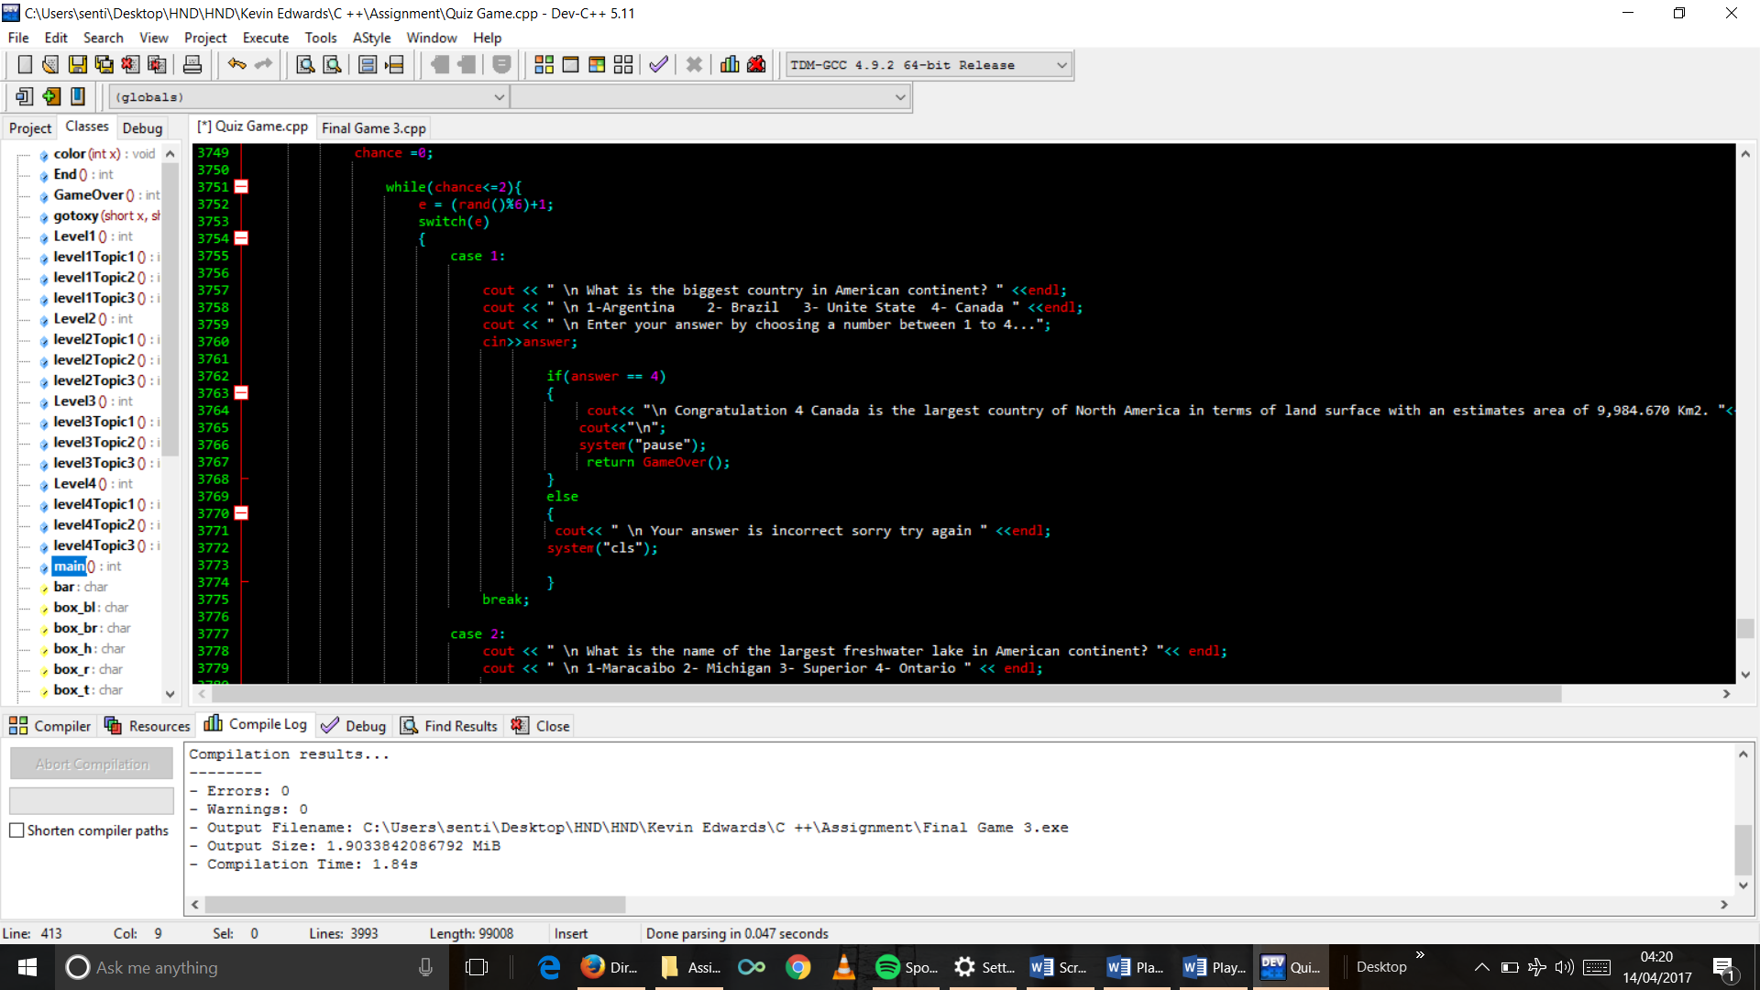

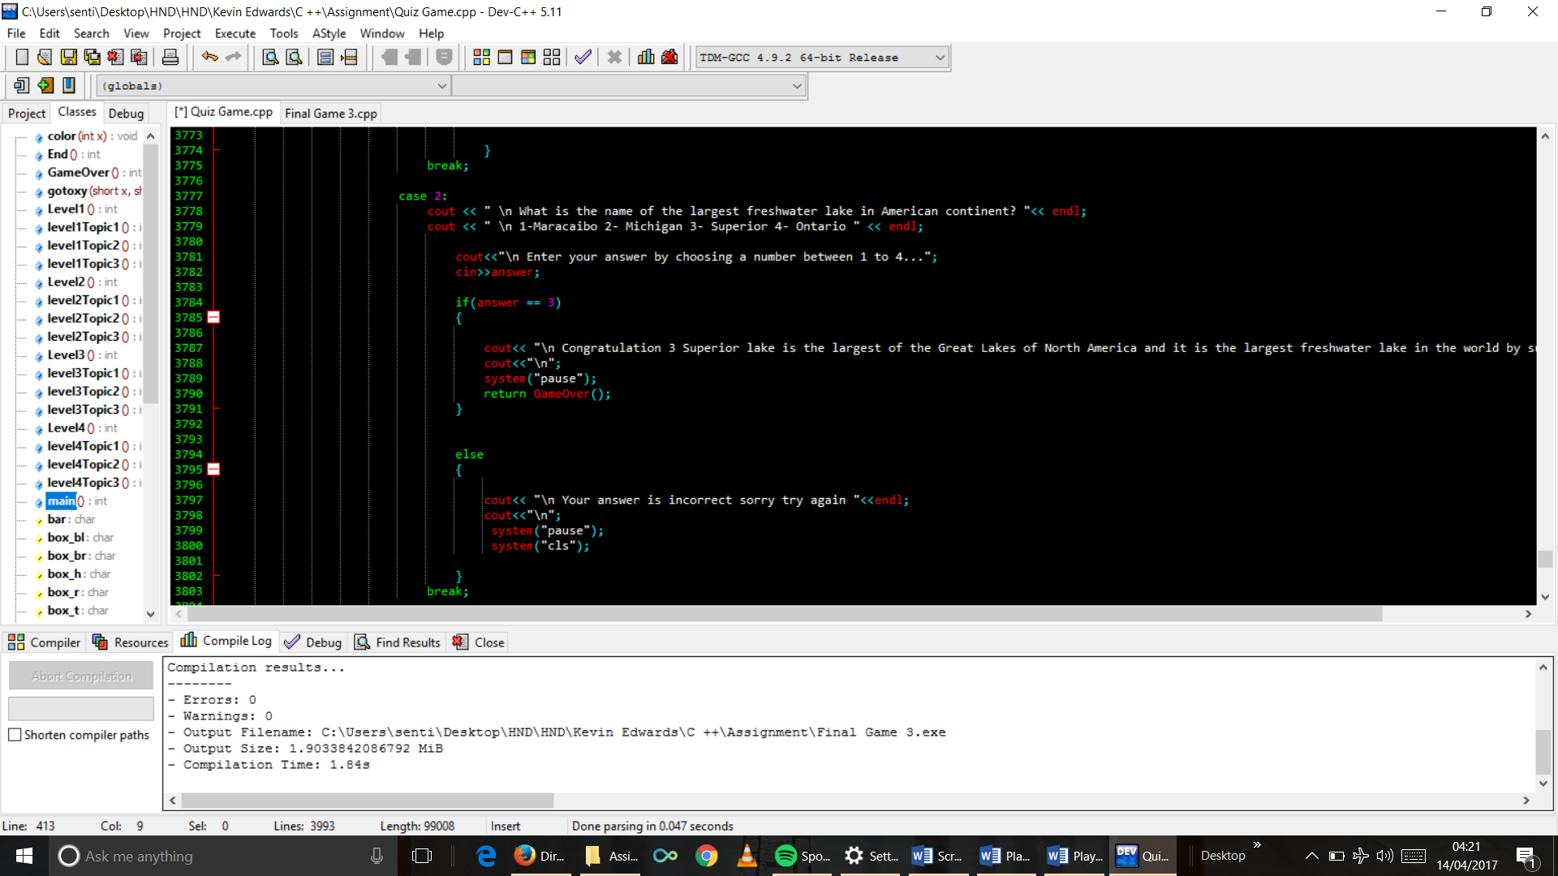

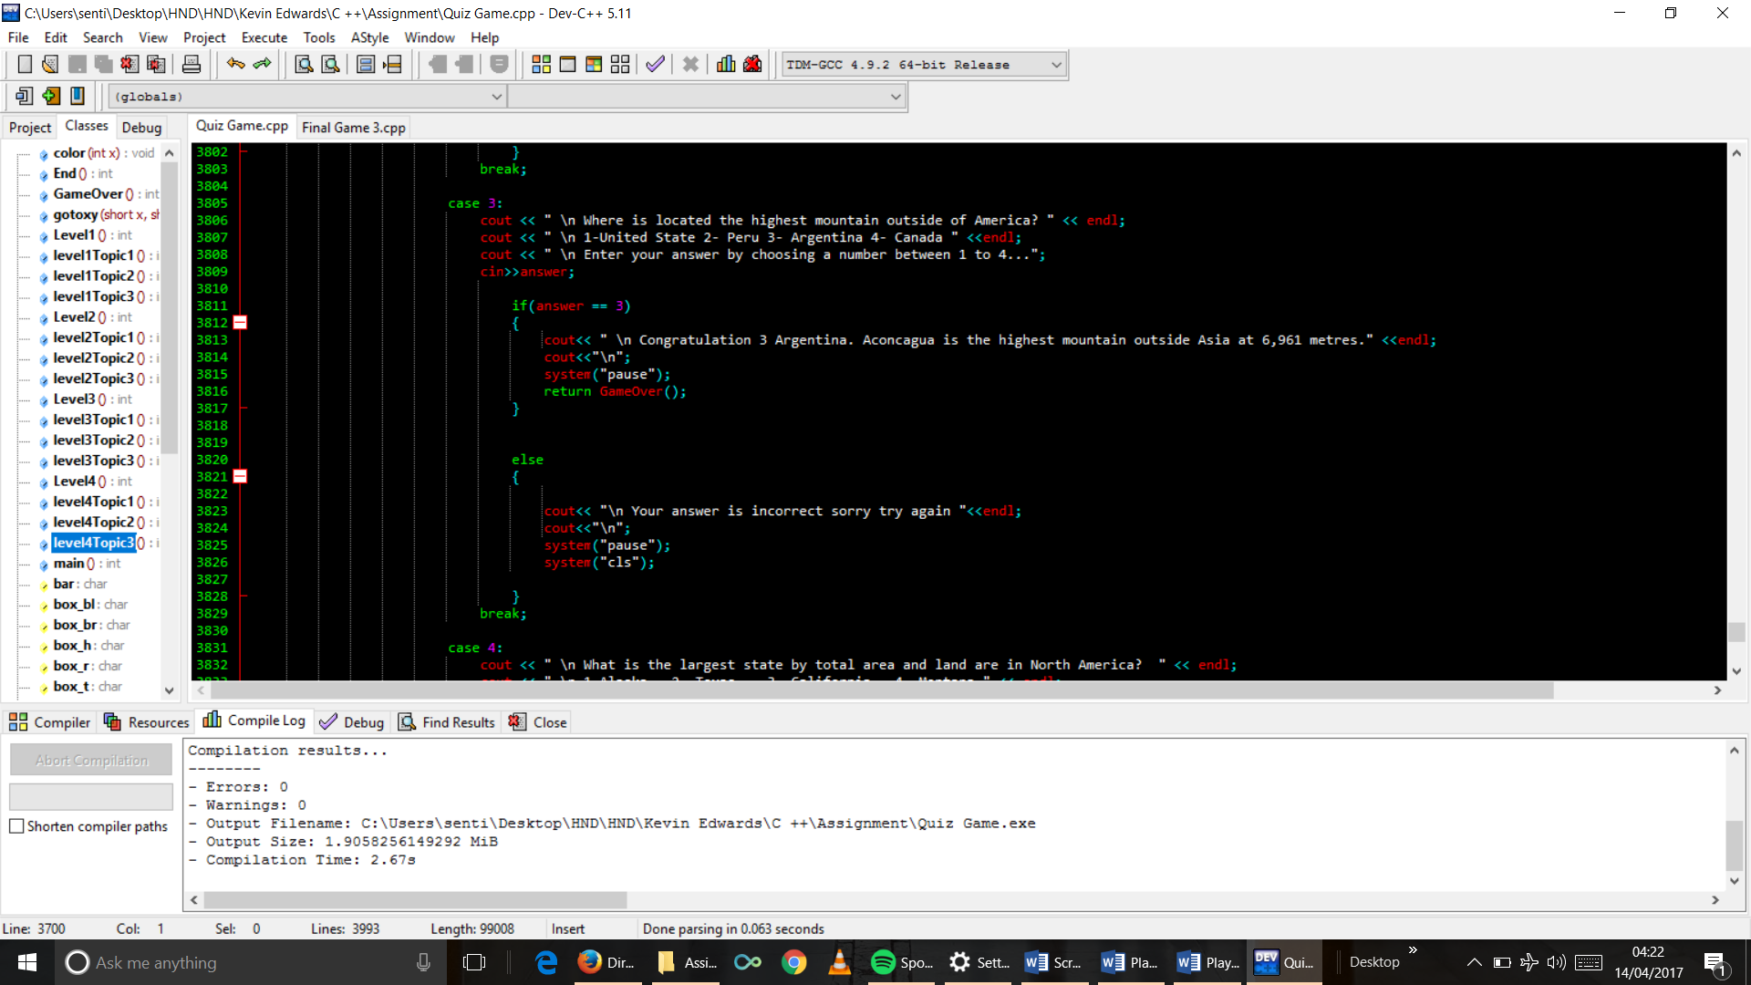

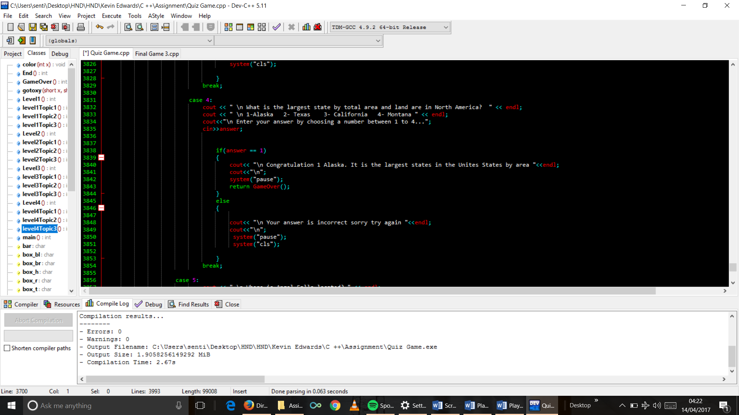

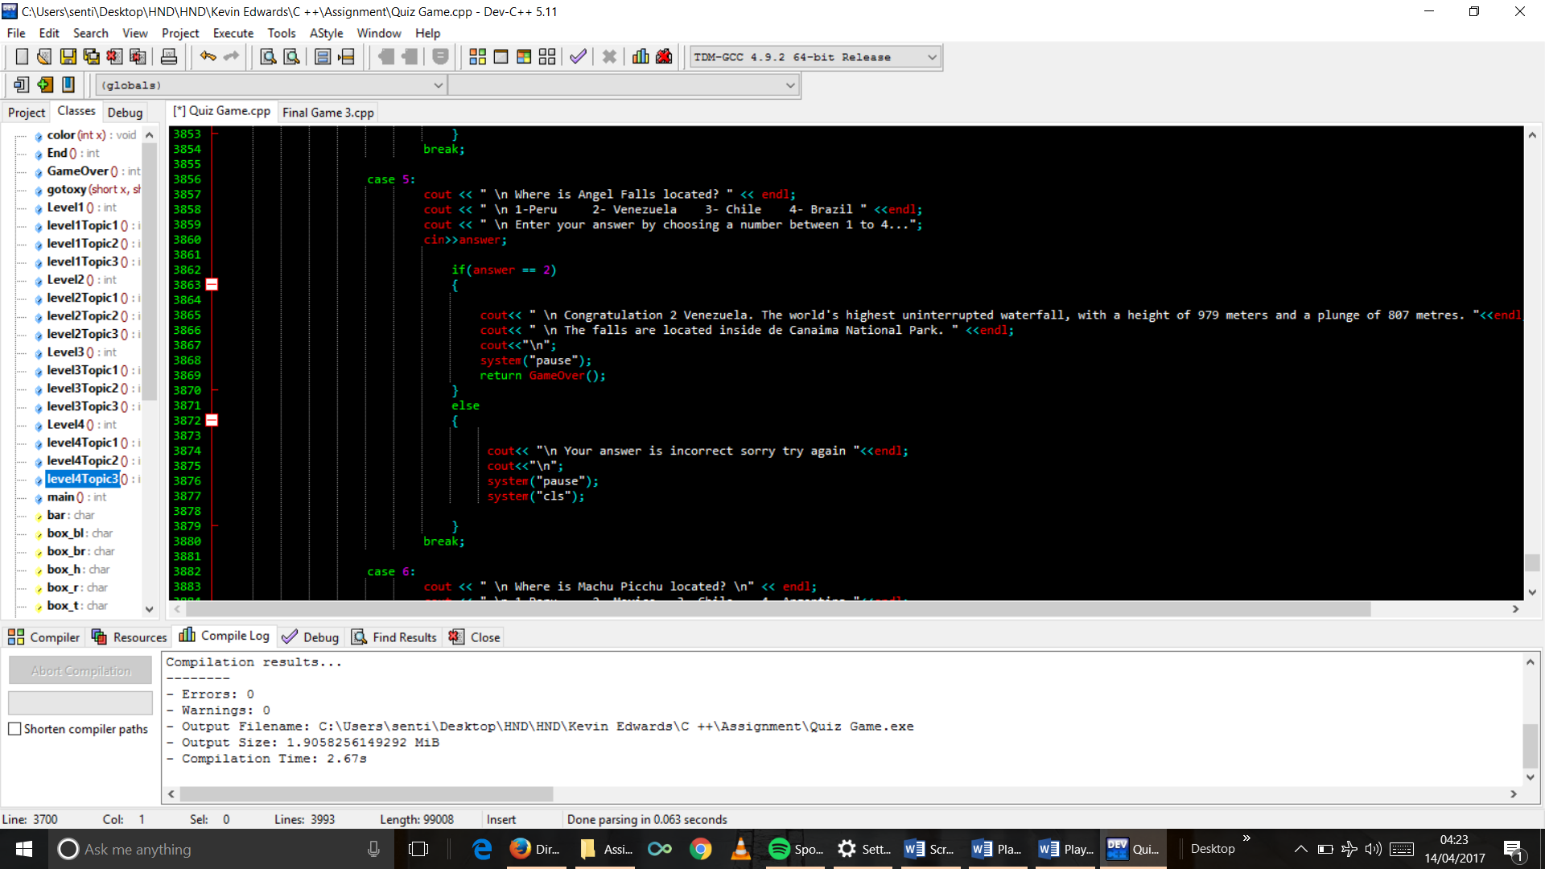

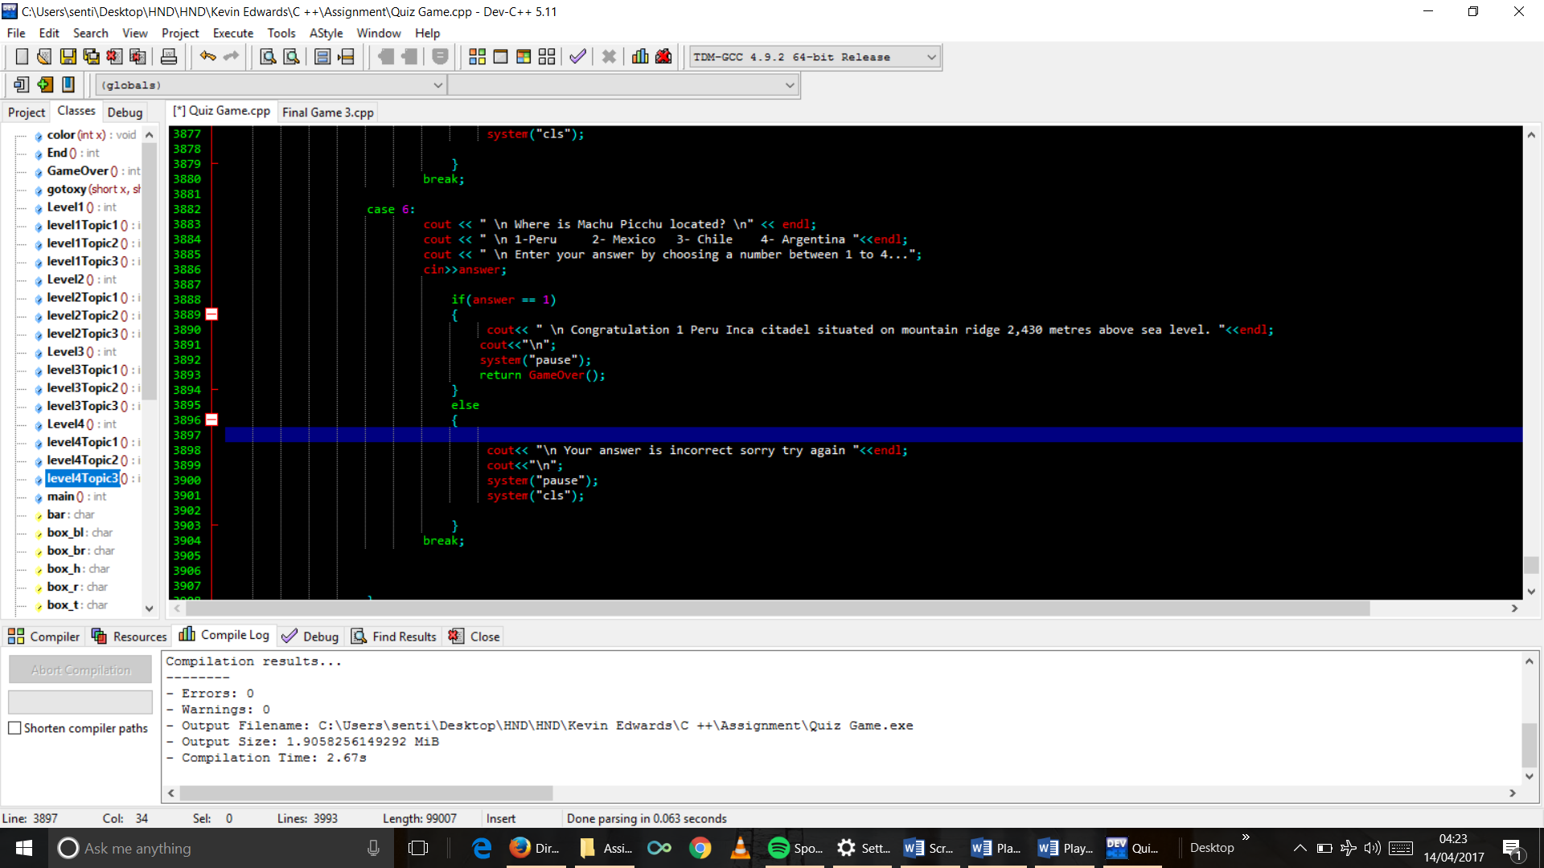

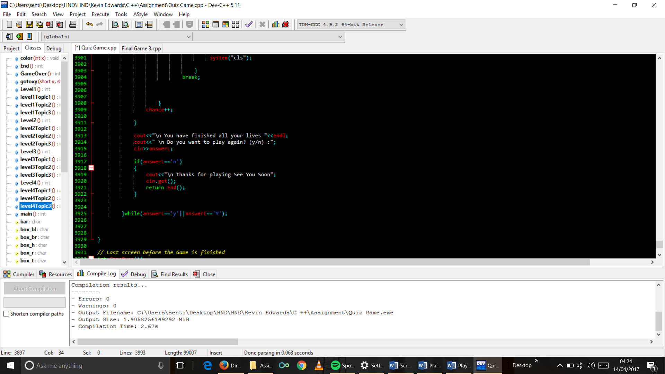

1. GameOver function code

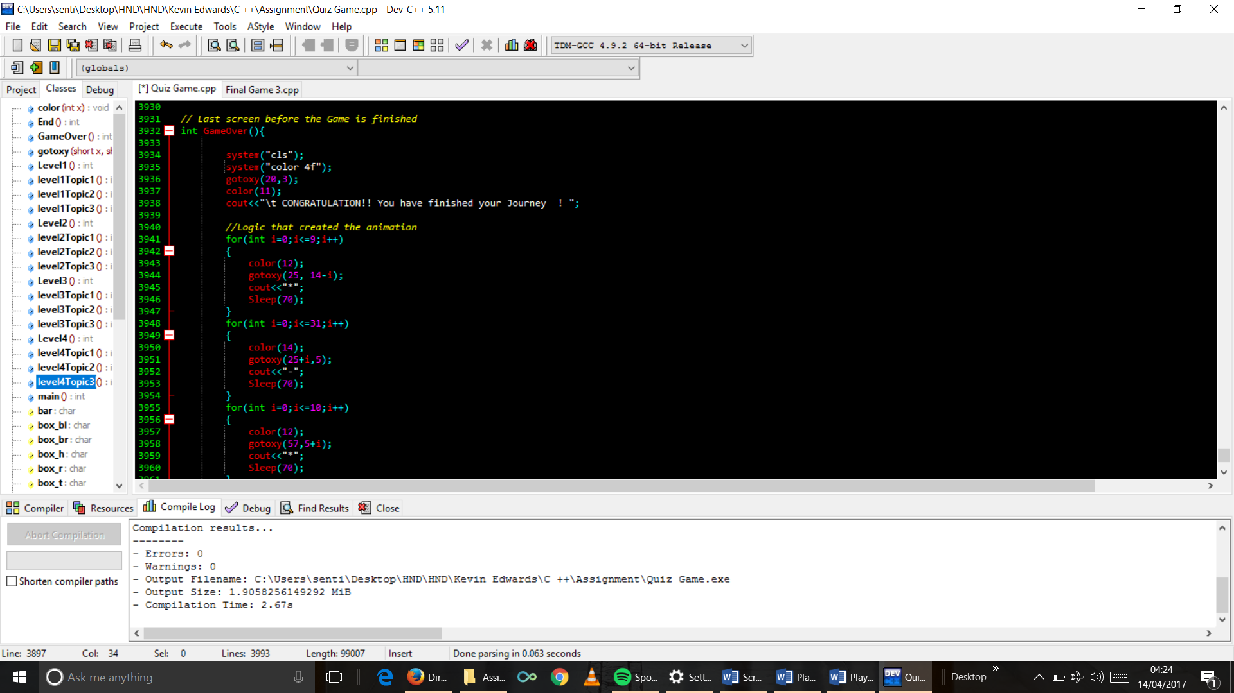

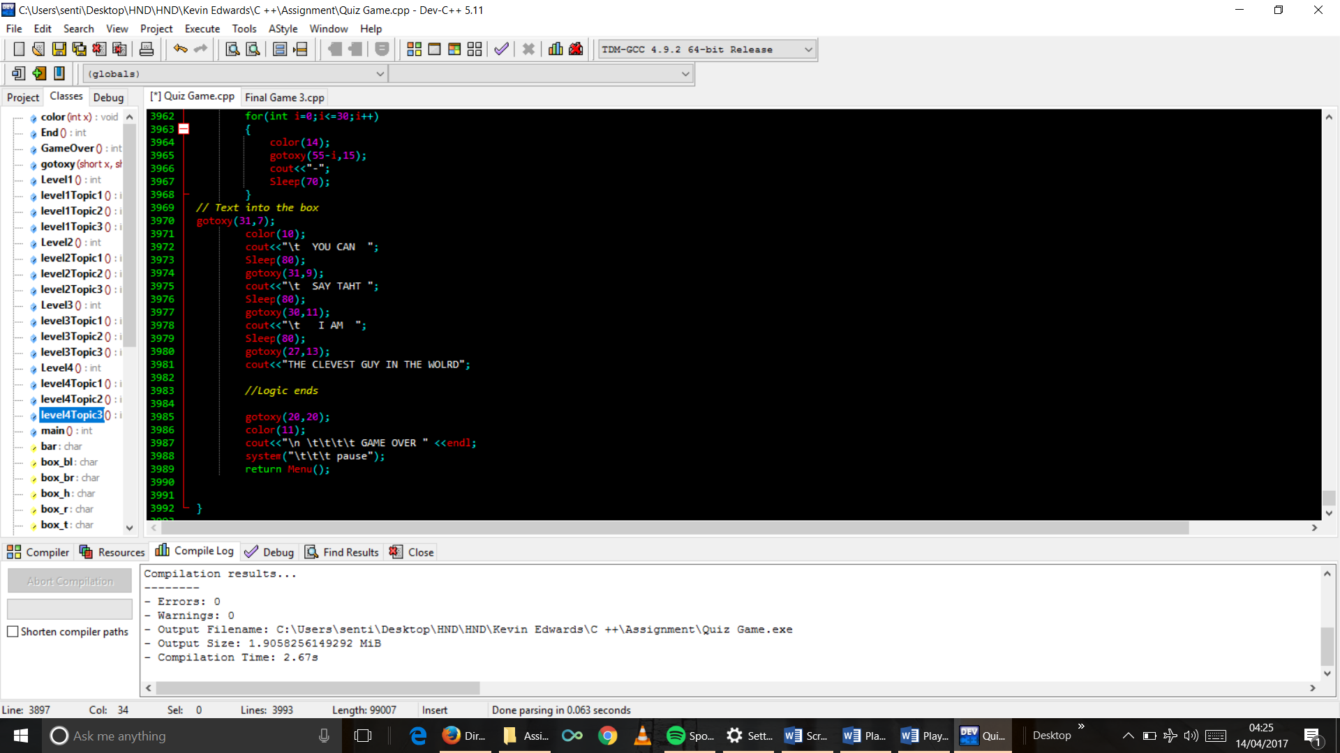

# User Guide.

**Quiz around the Wold.**

This is a Game which will test your knowledge about Capitals, Food, Monuments and Geography around the world.

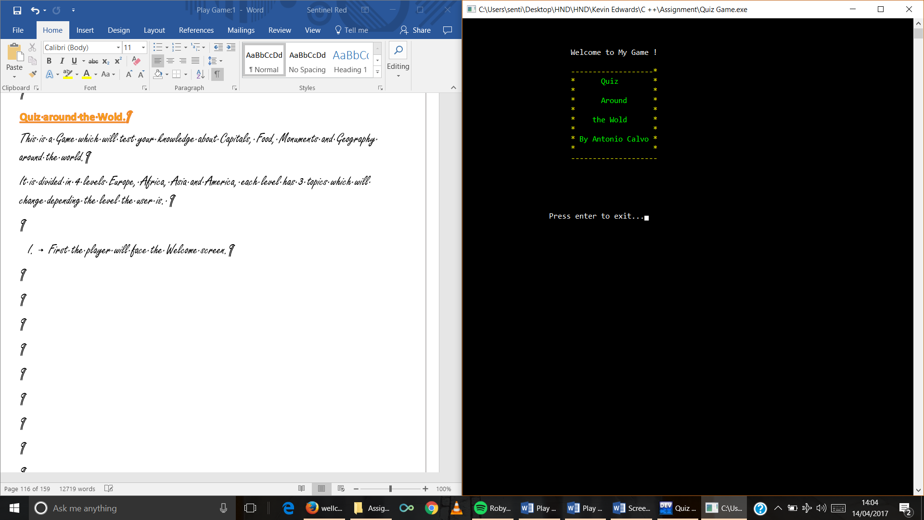It is divided in 4 levels Europe, Africa, Asia and America, each level has 3 topics which will change depending the level the user is.

1. First the player will face the Welcome screen.

Presenting the Game with a small animation and my name.

1. Second Main Menu screen which display 3 options.

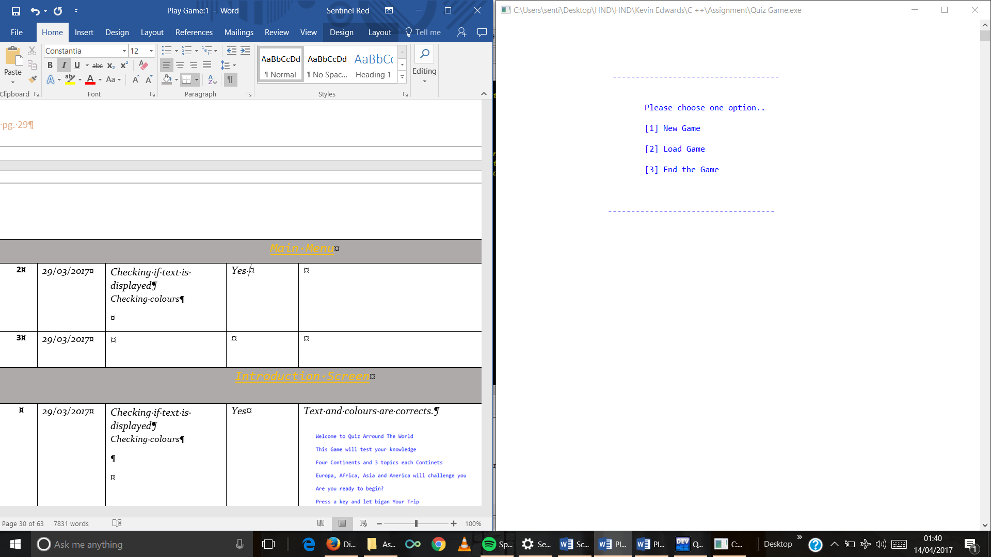New Game It starts the Game

Load Game It allows the player to load a game previously saved.

End the Game .It allows the player to quick the Game

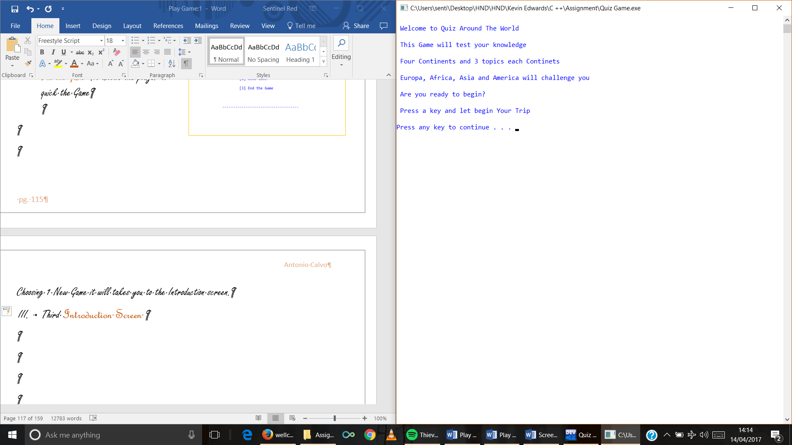Choosing 1 New Game it will takes you to the Introduction screen.

1. Third Introduction Screen

It is a small introduction of the Game.

1. 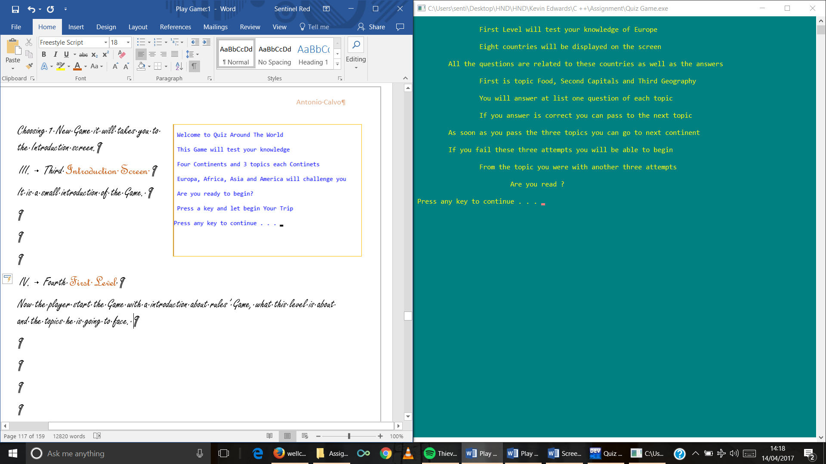Fourth First Level

Now the player start the Game with an introduction about rules’ Game, what this level is about and the topics he is going to face.

First Level will be Europe

* First topic is Food
* Second topic is Capitals
* 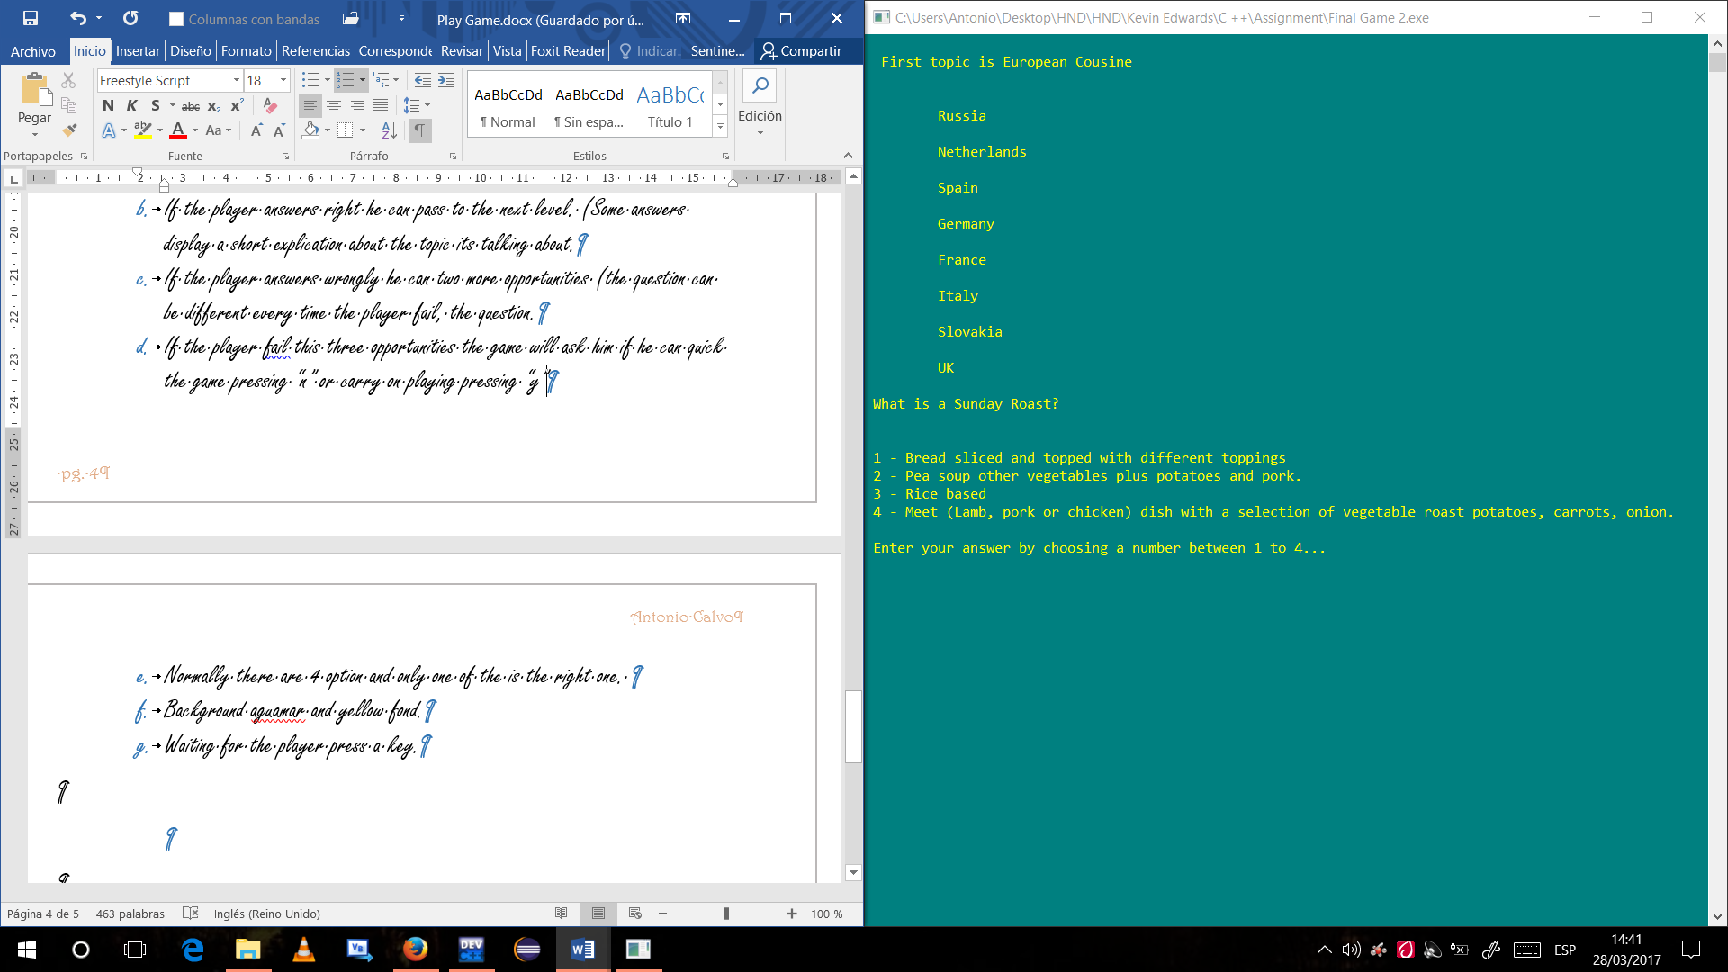Third is Geography

Every level has eight countries and all questions are about these eight countries.

The countries will be displayed in every topic.

Most of the questions have 4 options and few of them have 2 options and only one is correct.

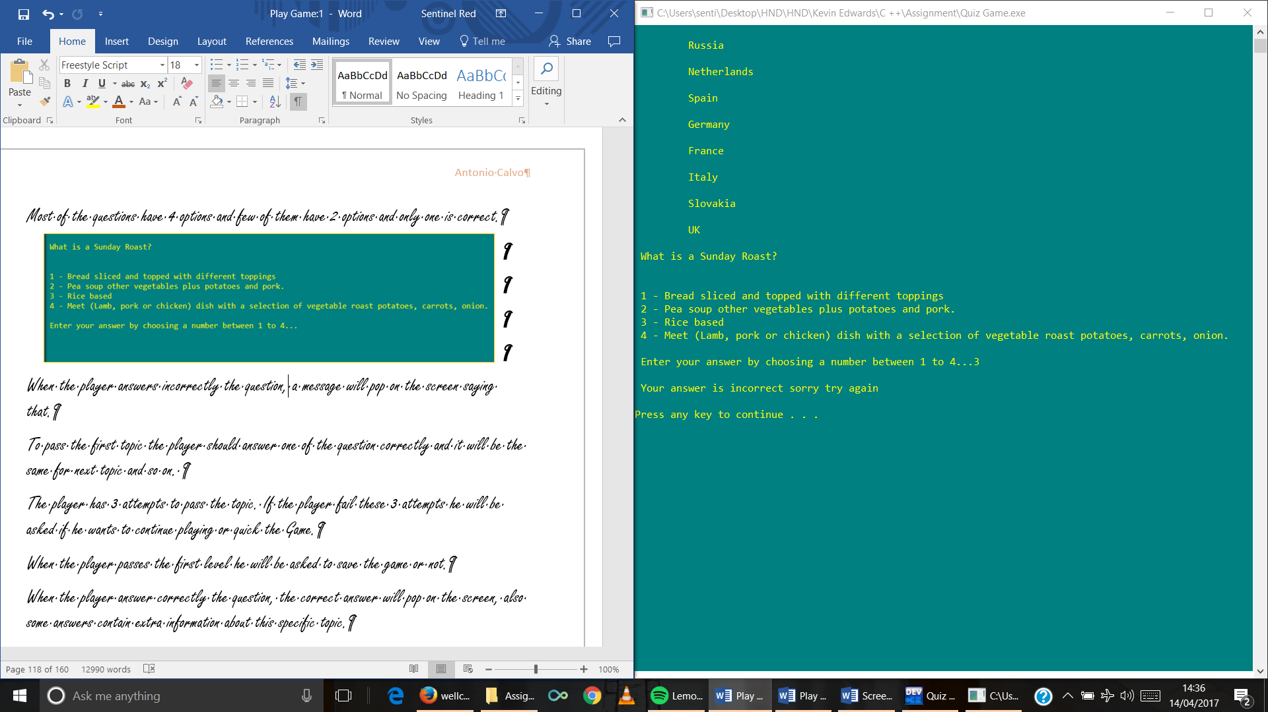When the player answers incorrectly the question, a message will pop on the screen saying that.

The player has 3 attempts to pass the topic. If the player fail these 3 attempts he will be asked if he wants to continue playing or quick the Game.

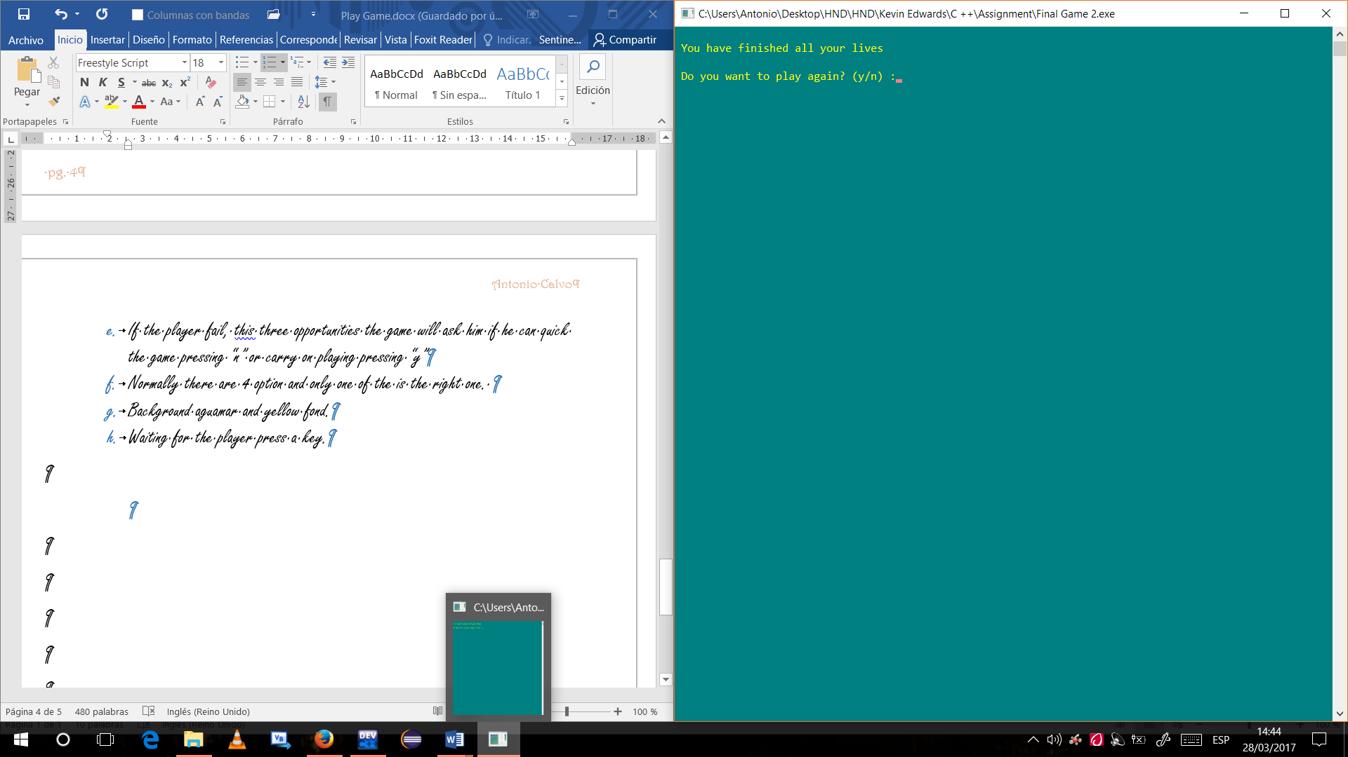

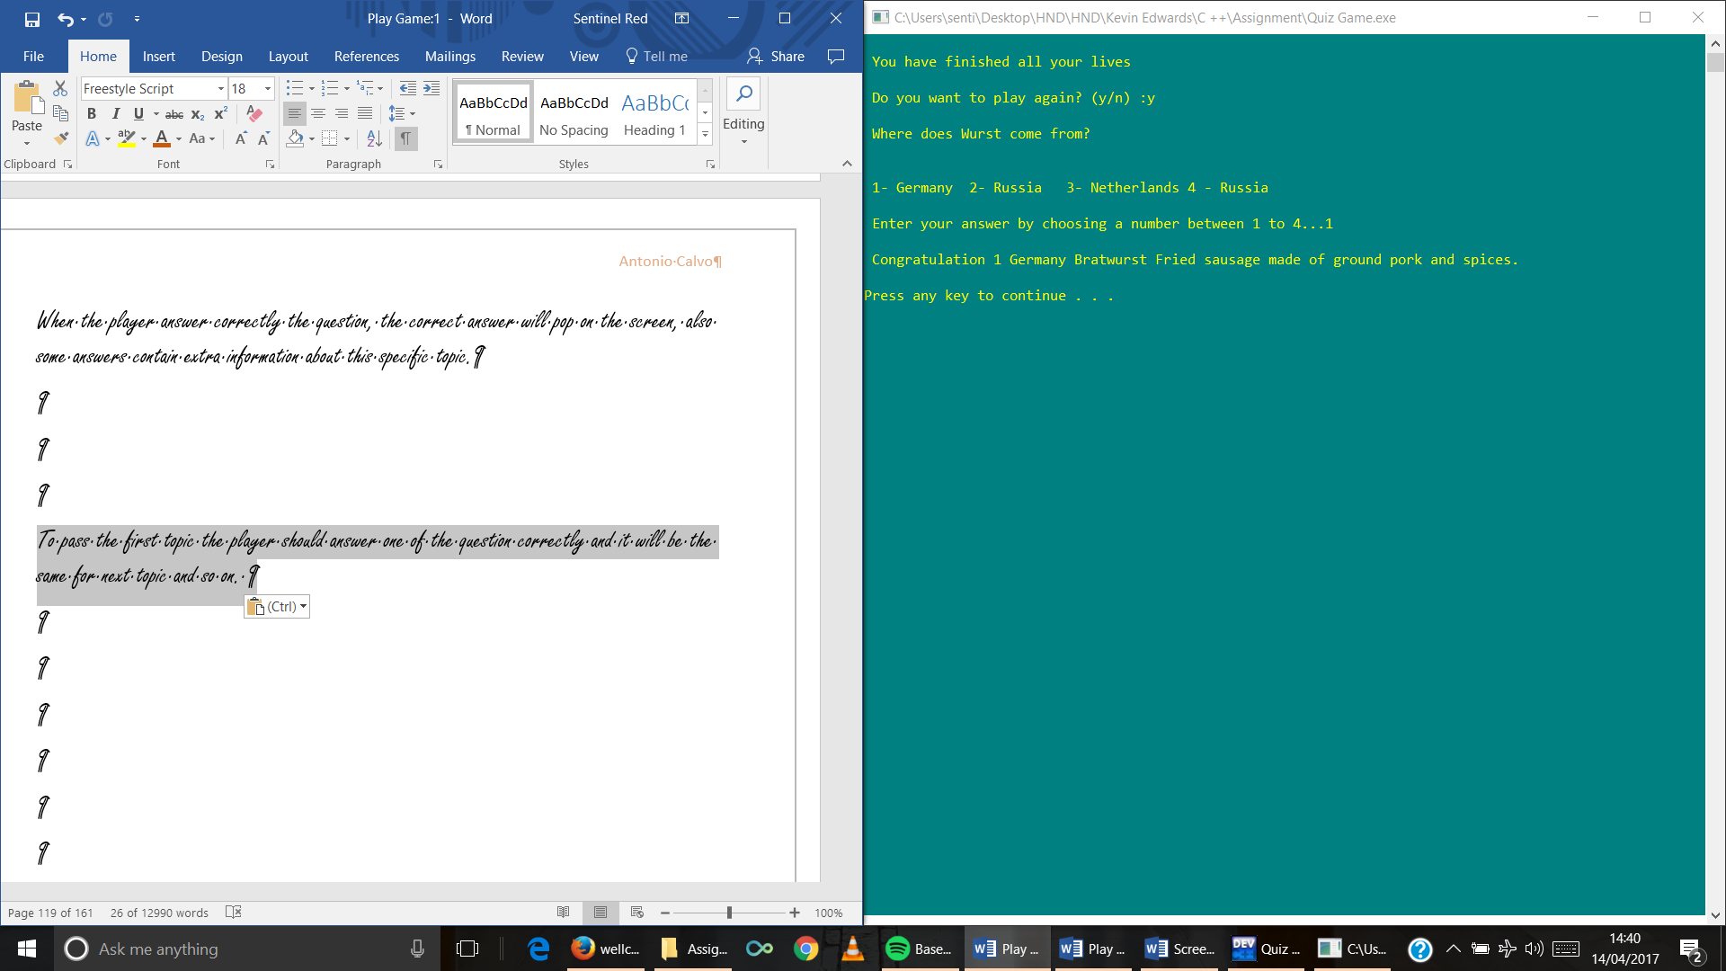When the player answer correctly the question, the correct answer will pop on the screen, also some answers contain extra information about this specific topic.

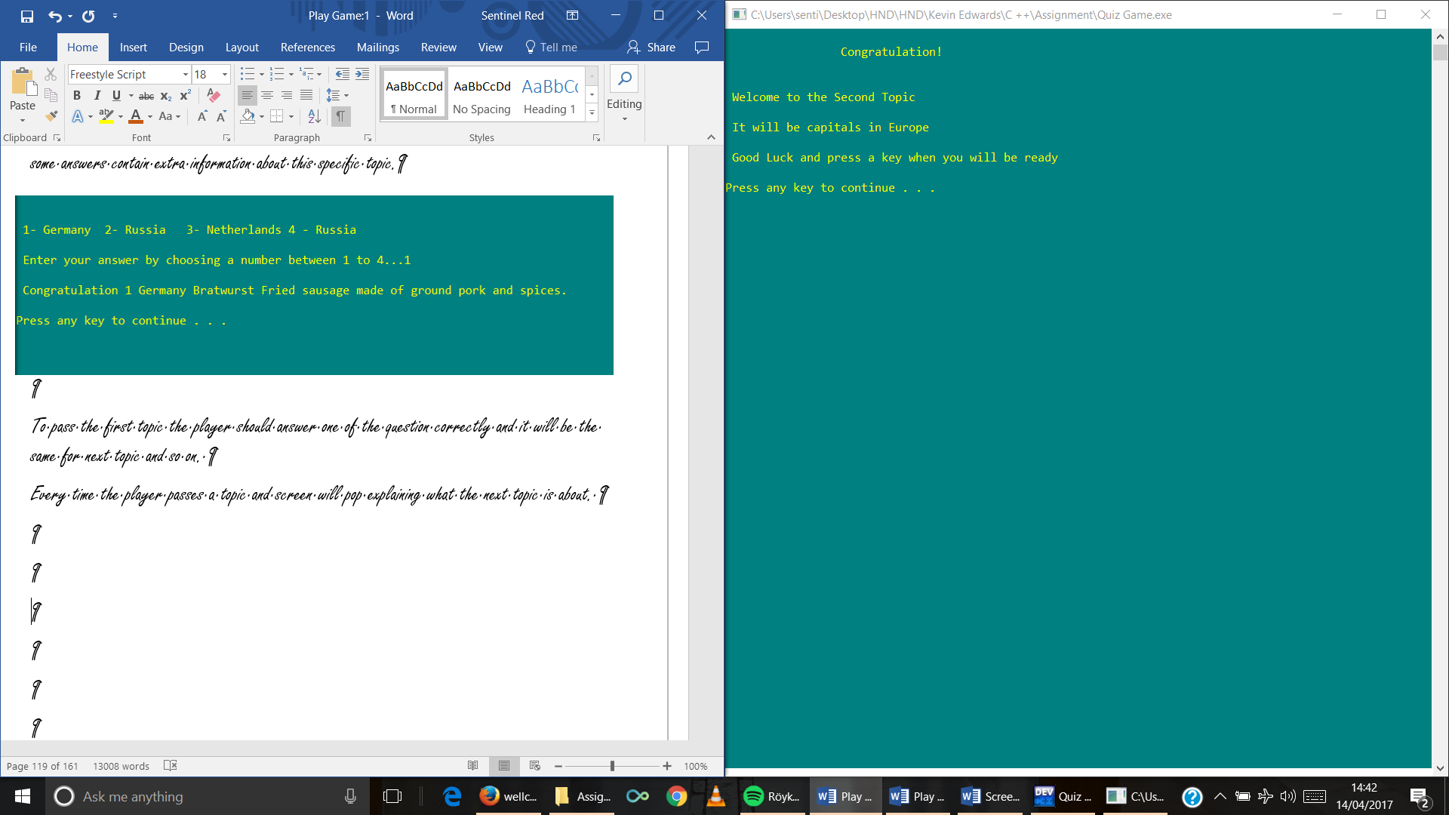To pass the first topic the player should answer one of the question correctly and it will be the same for next topic and so on.

Every time the player passes a topic and screen will pop explaining what the next topic is about.

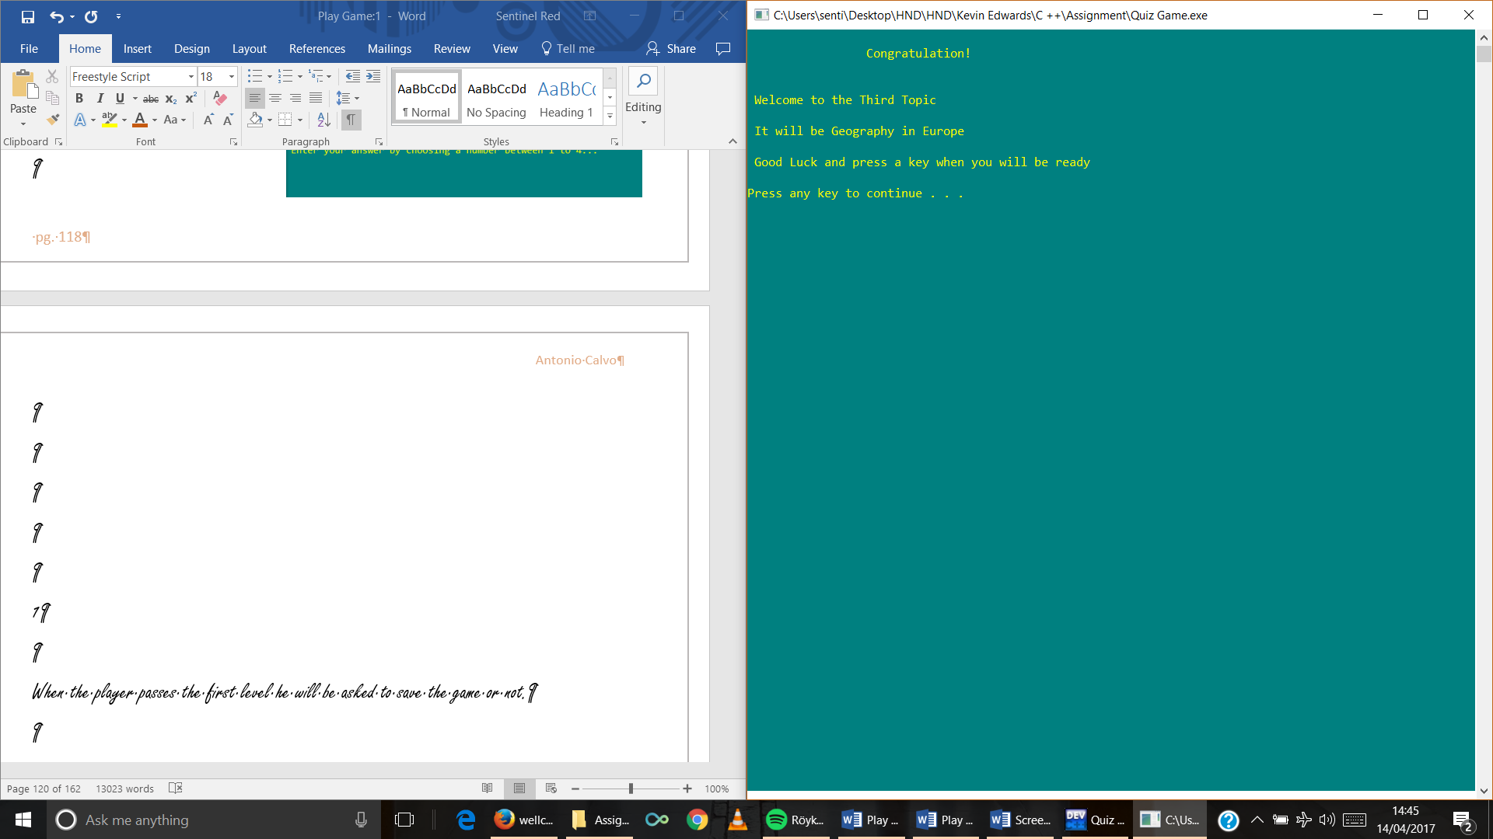

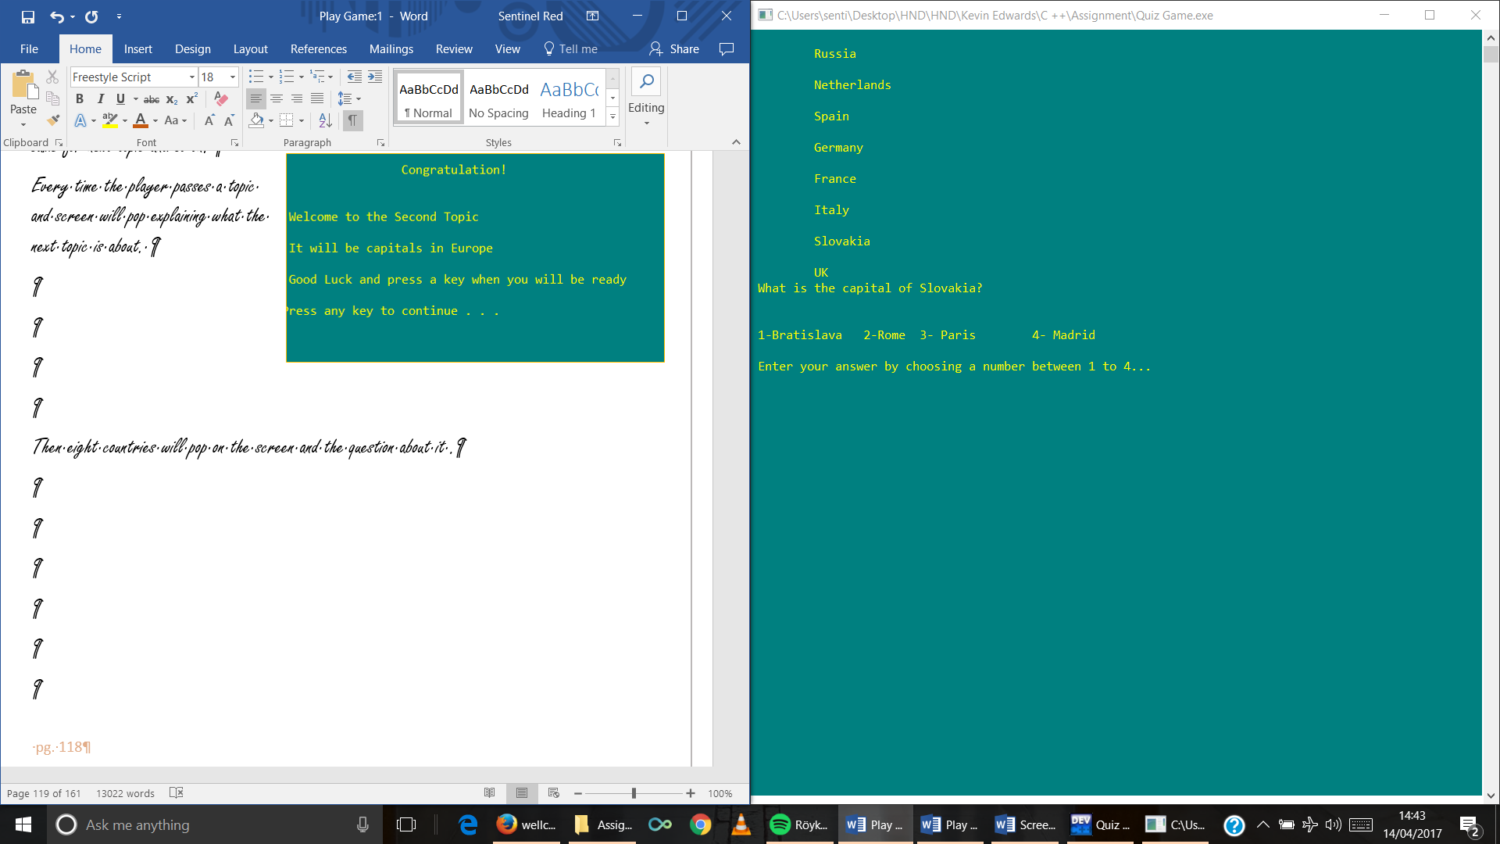

Then the countries will pop on the screen again and the question about it.

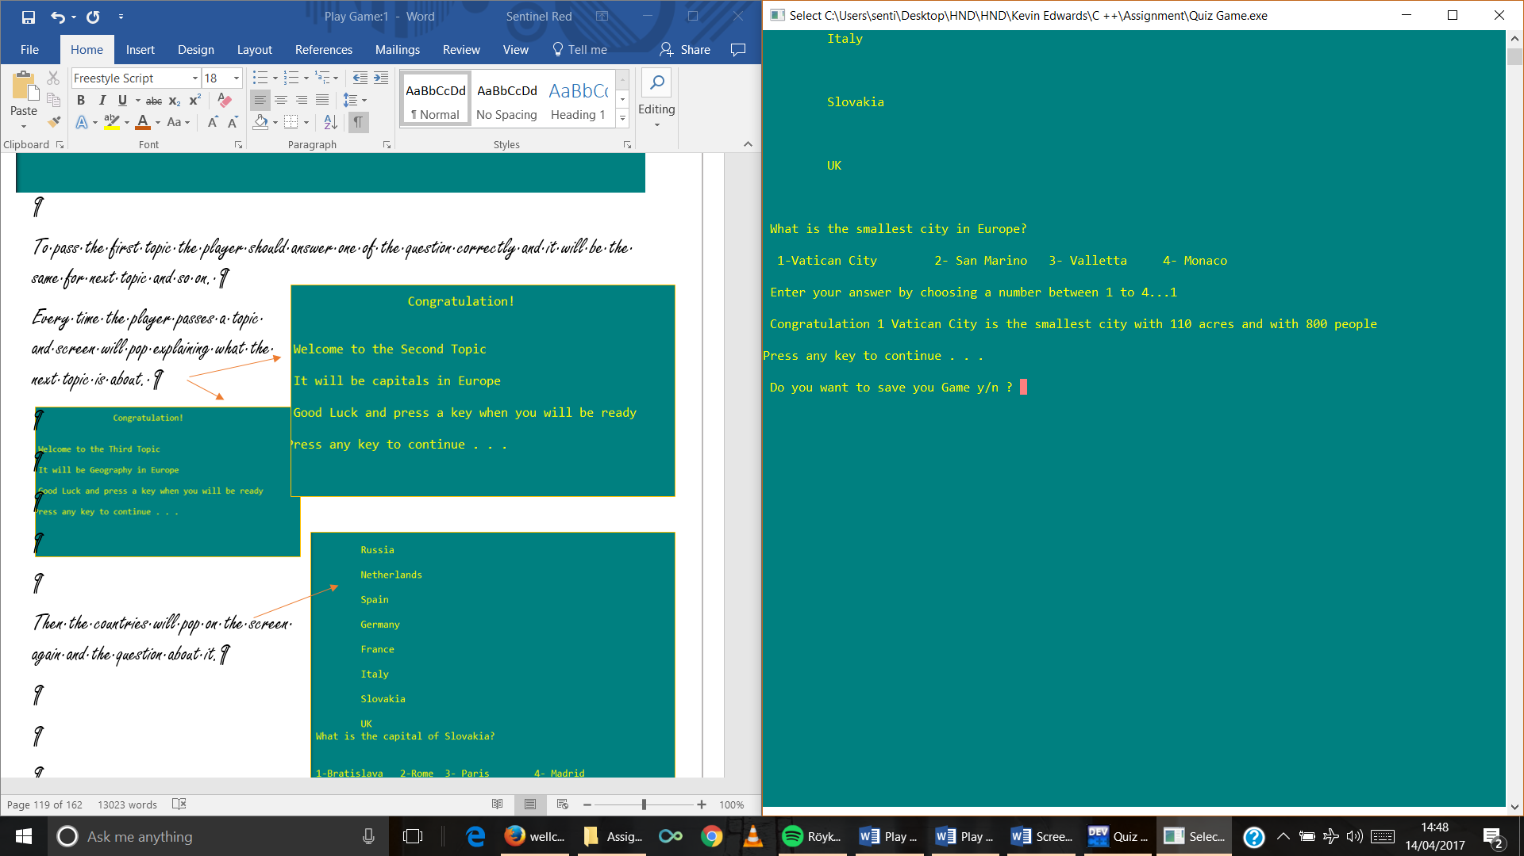When the player passes the first level he will be asked to save the game or not.

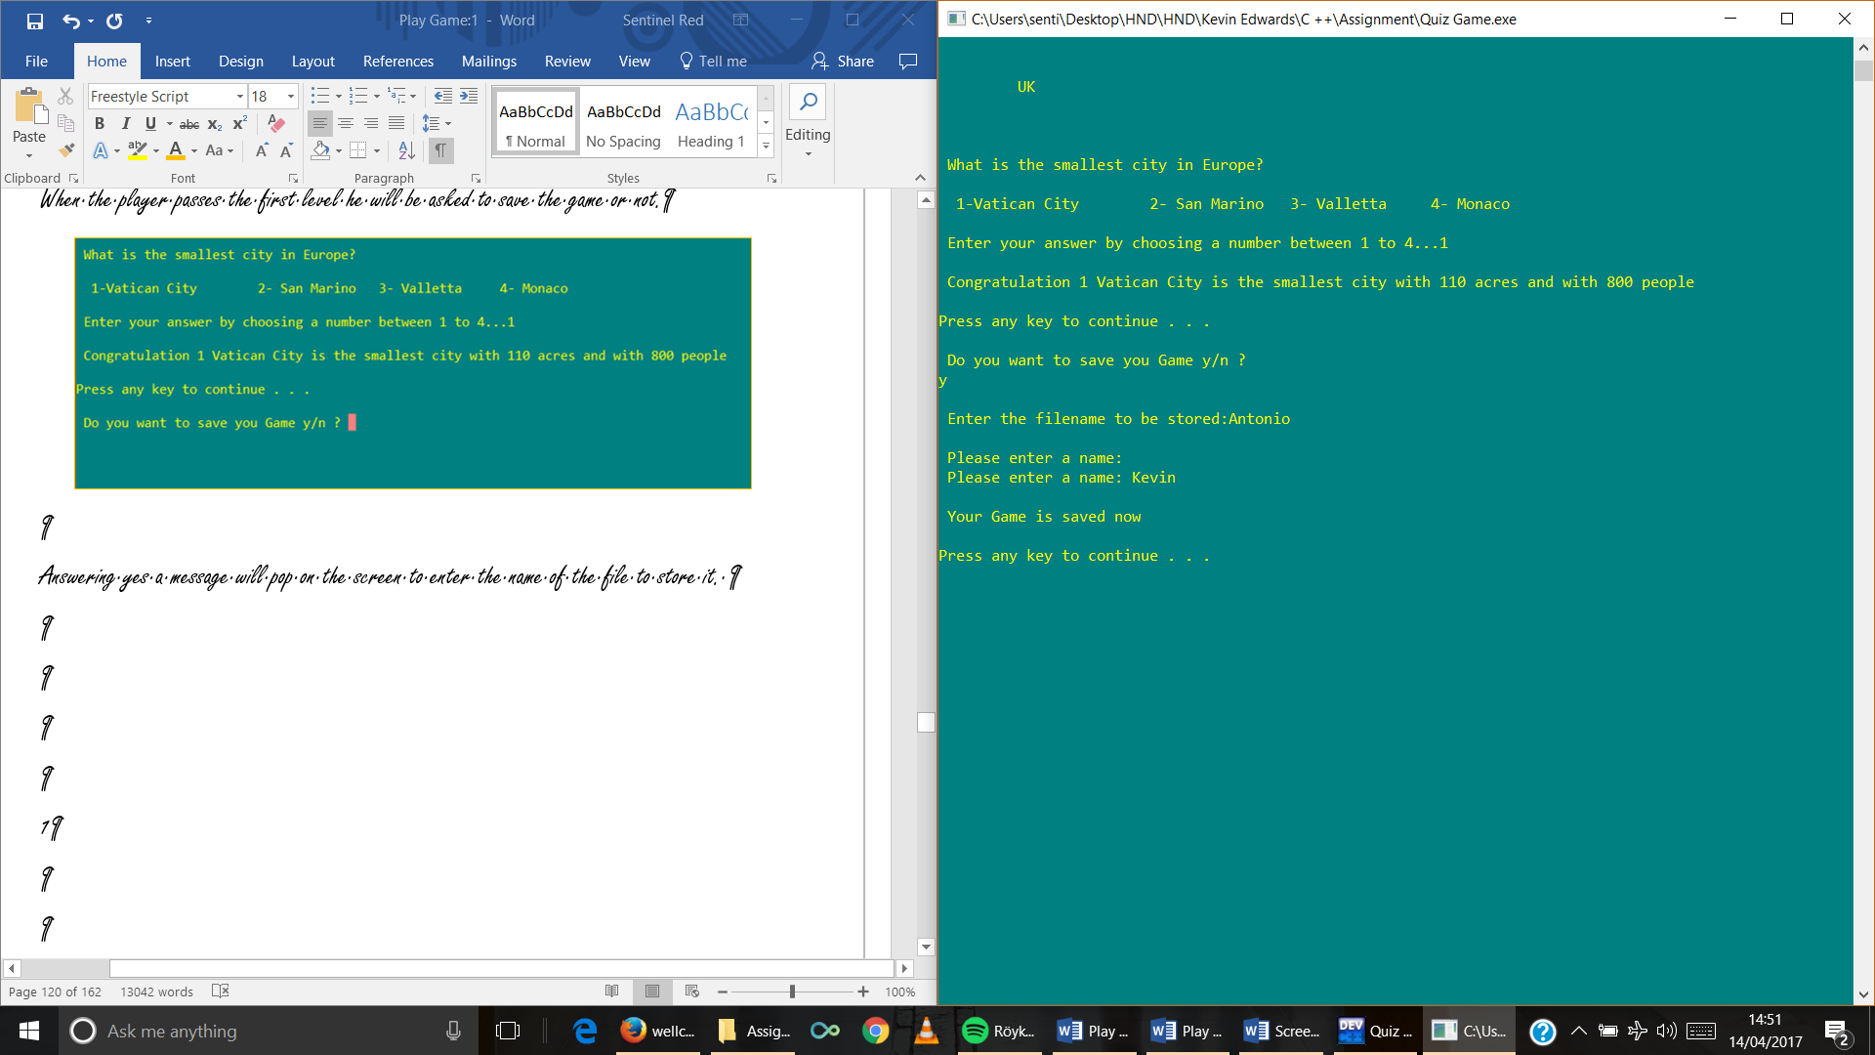Answering yes, a message will pop on the screen to enter the name of the file to store it.

Then a message pops saying that it is saved and pressing a key the player will continue playing the Game

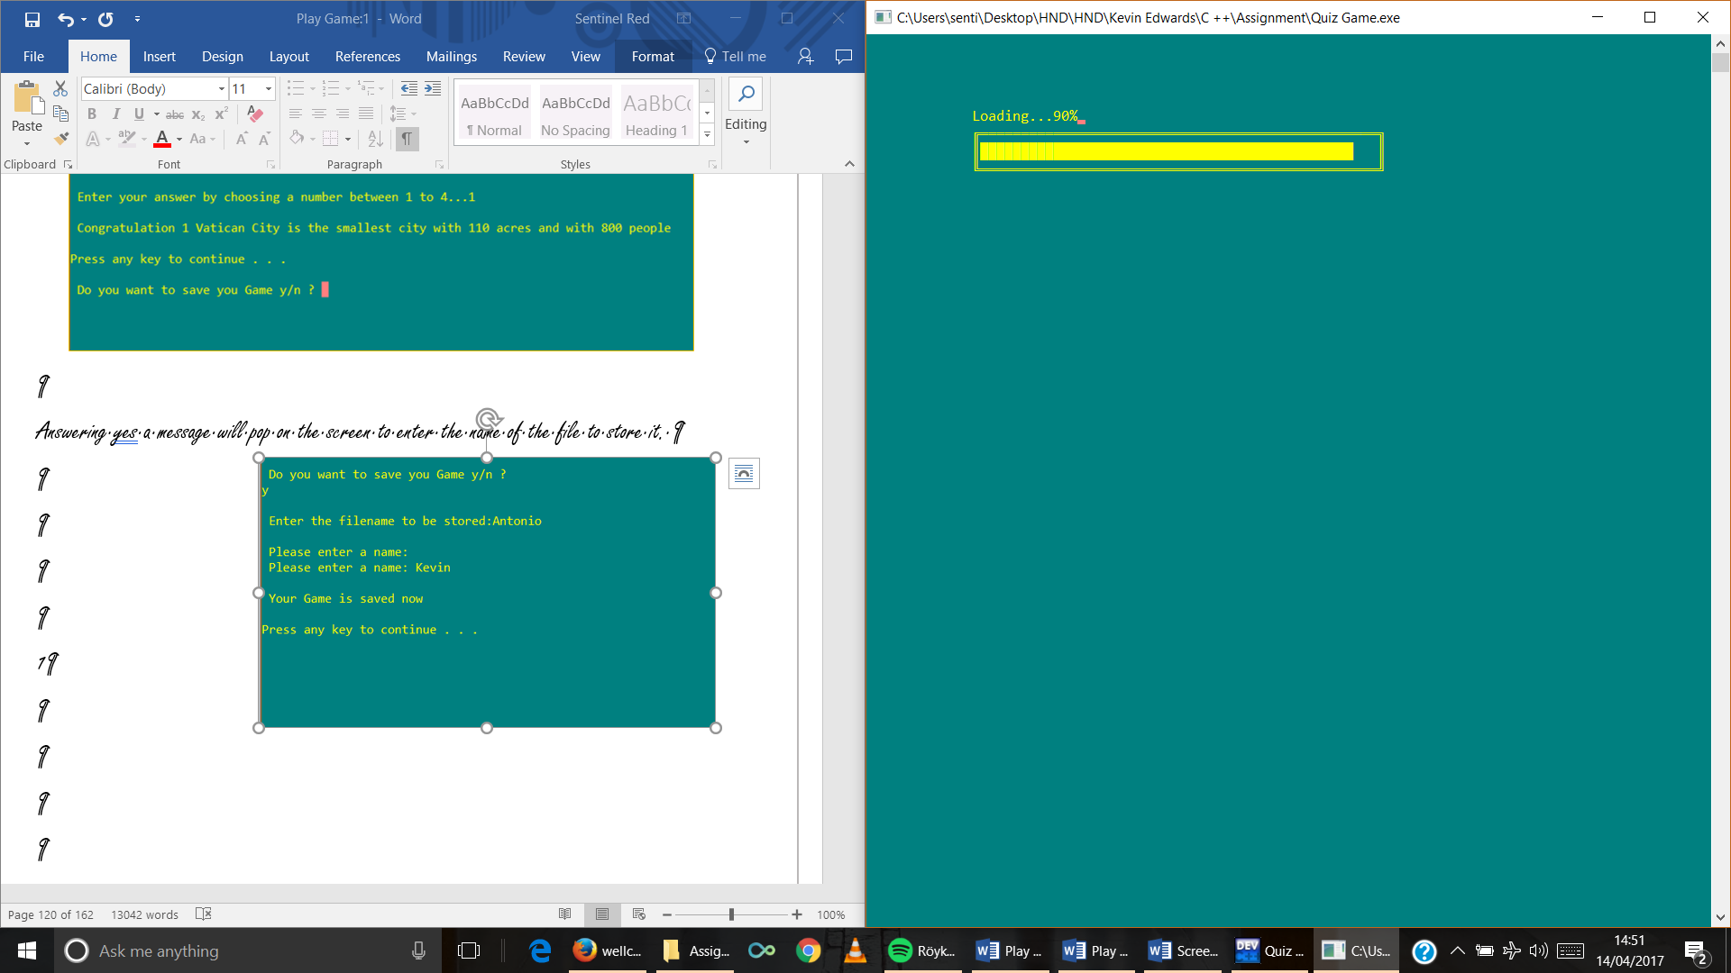

1. Fifth Second Level

When the player pass the second level a presentation screen will remind the player the Game’s rules and will inform him about the new continent and topics are about.

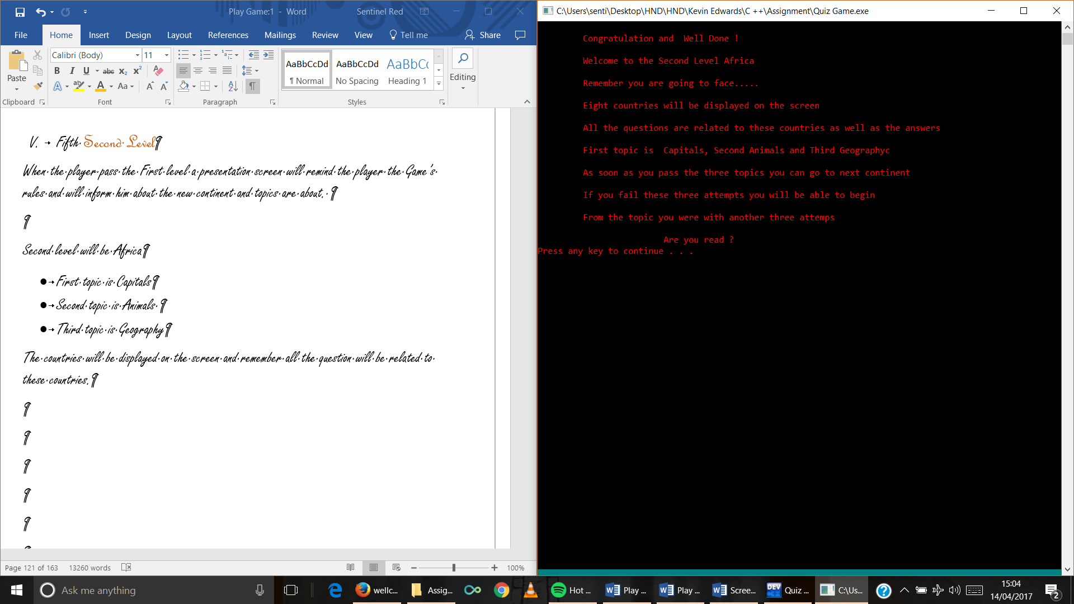

Second level will be Africa

* First topic is Capitals
* Second topic is Animals
* Third topic is Geography

The countries will be displayed on the screen and remember all the question will be related to these countries.

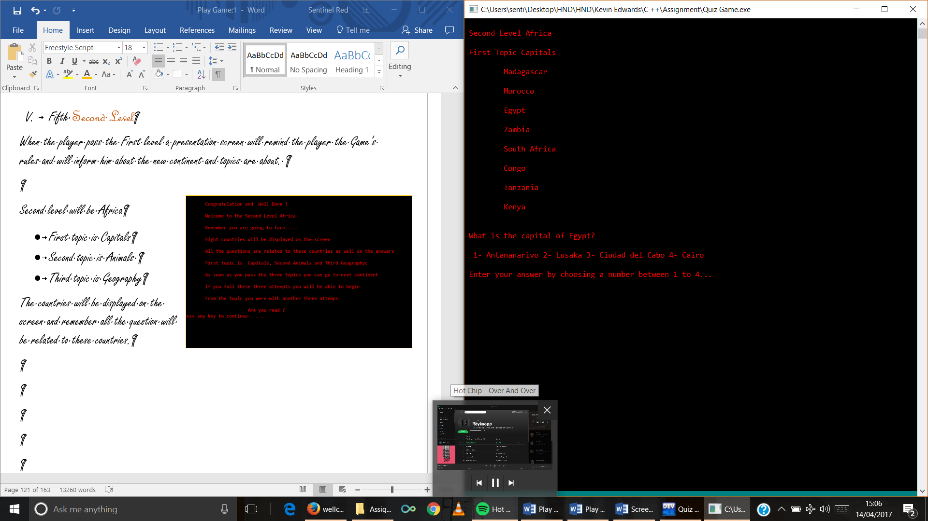

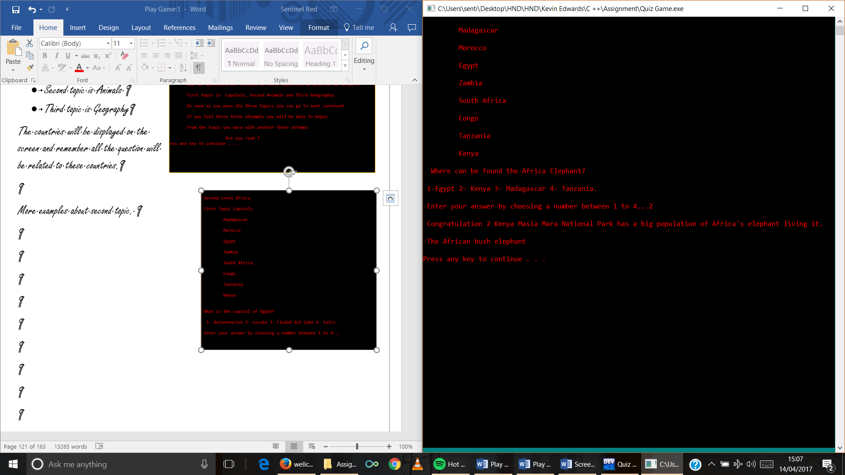More examples about Second Level.

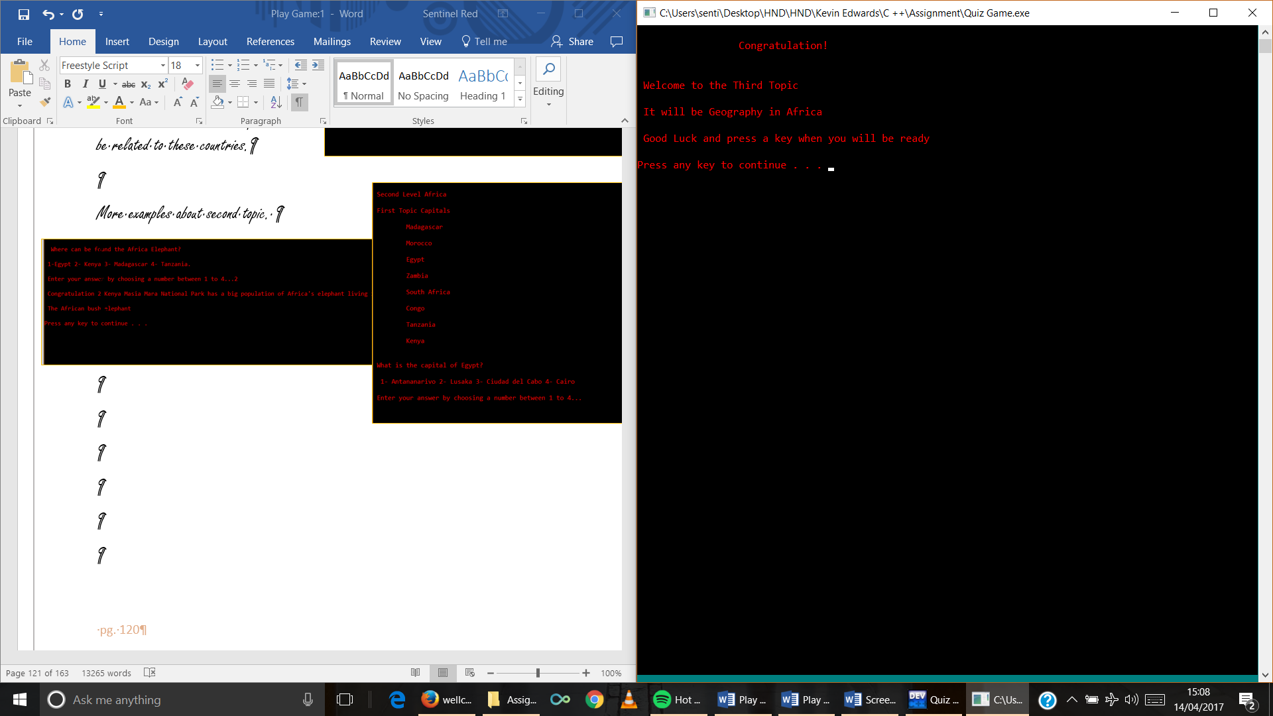

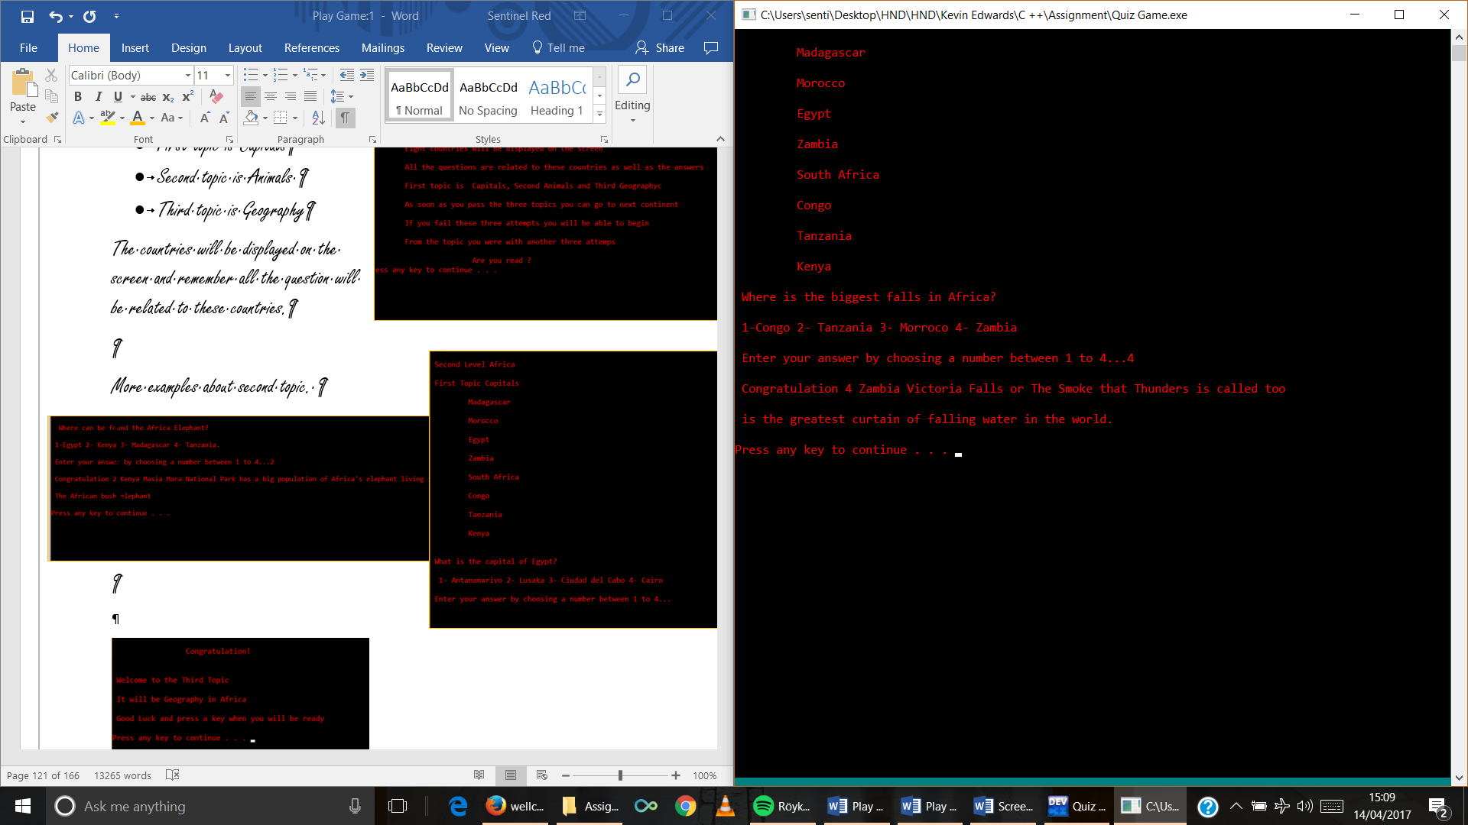

1. Third Level

When the player pass the Third level a presentation screen will remind the player the Game’s rules and will inform him about the new continent and topics are about.

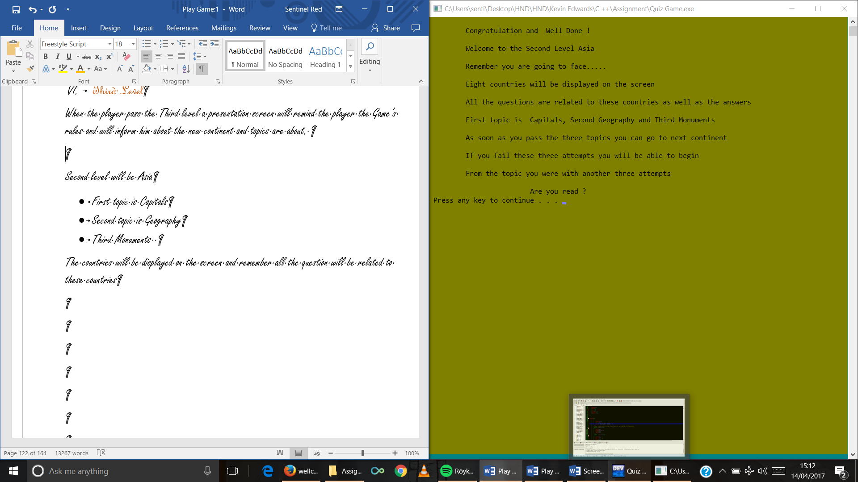

Second level will be Asia

* First topic is Capitals
* Second topic is Geography
* Third Monuments

The countries will be displayed on the screen and remember all the question will be related to these countries

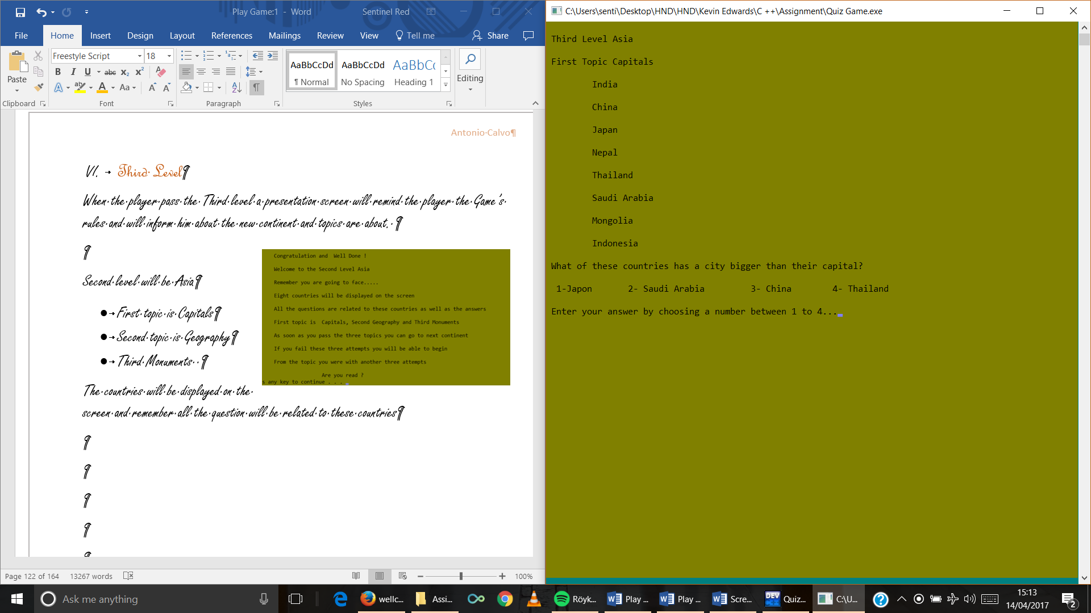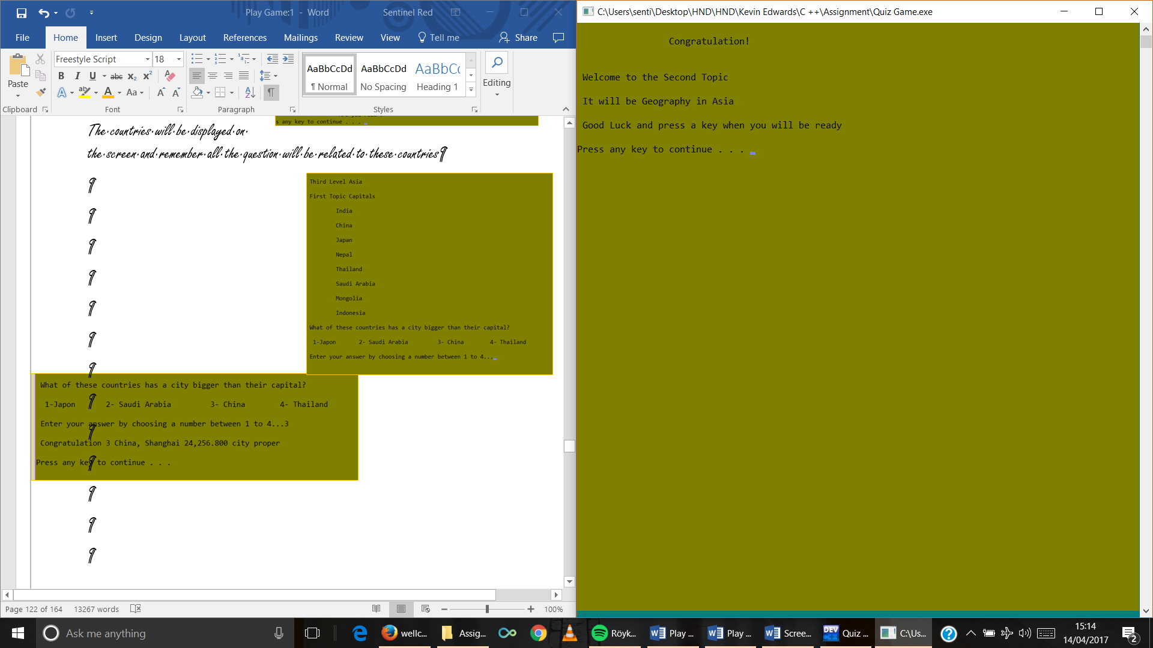More examples about Third Level

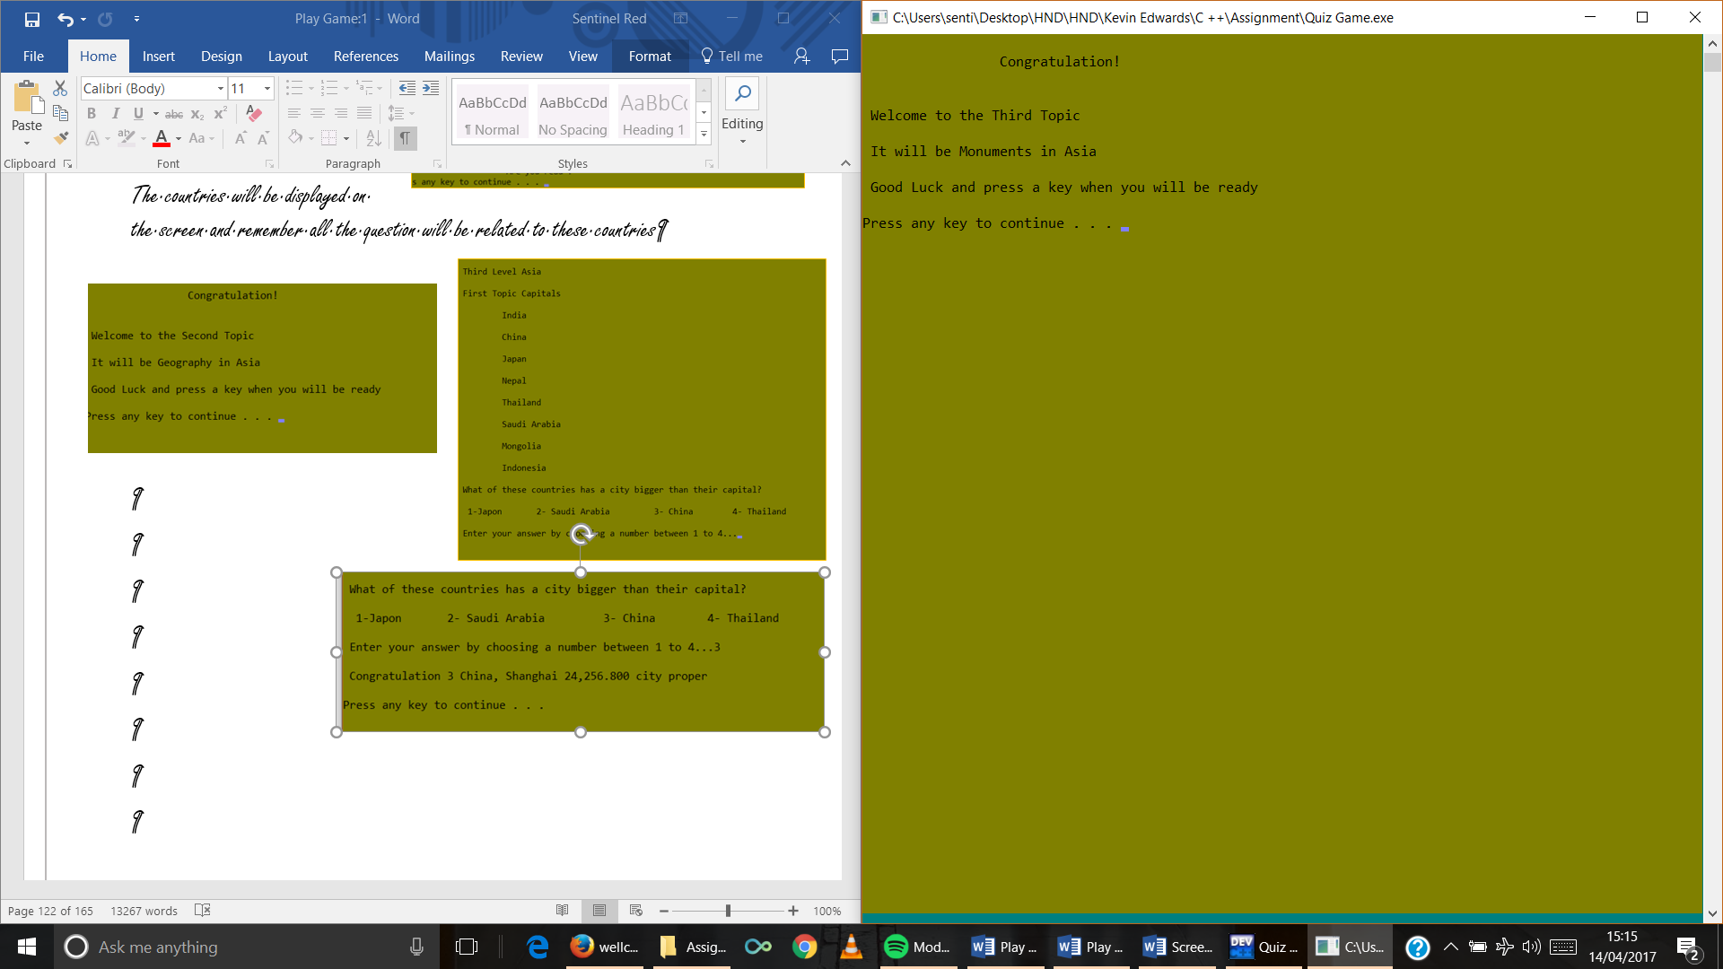

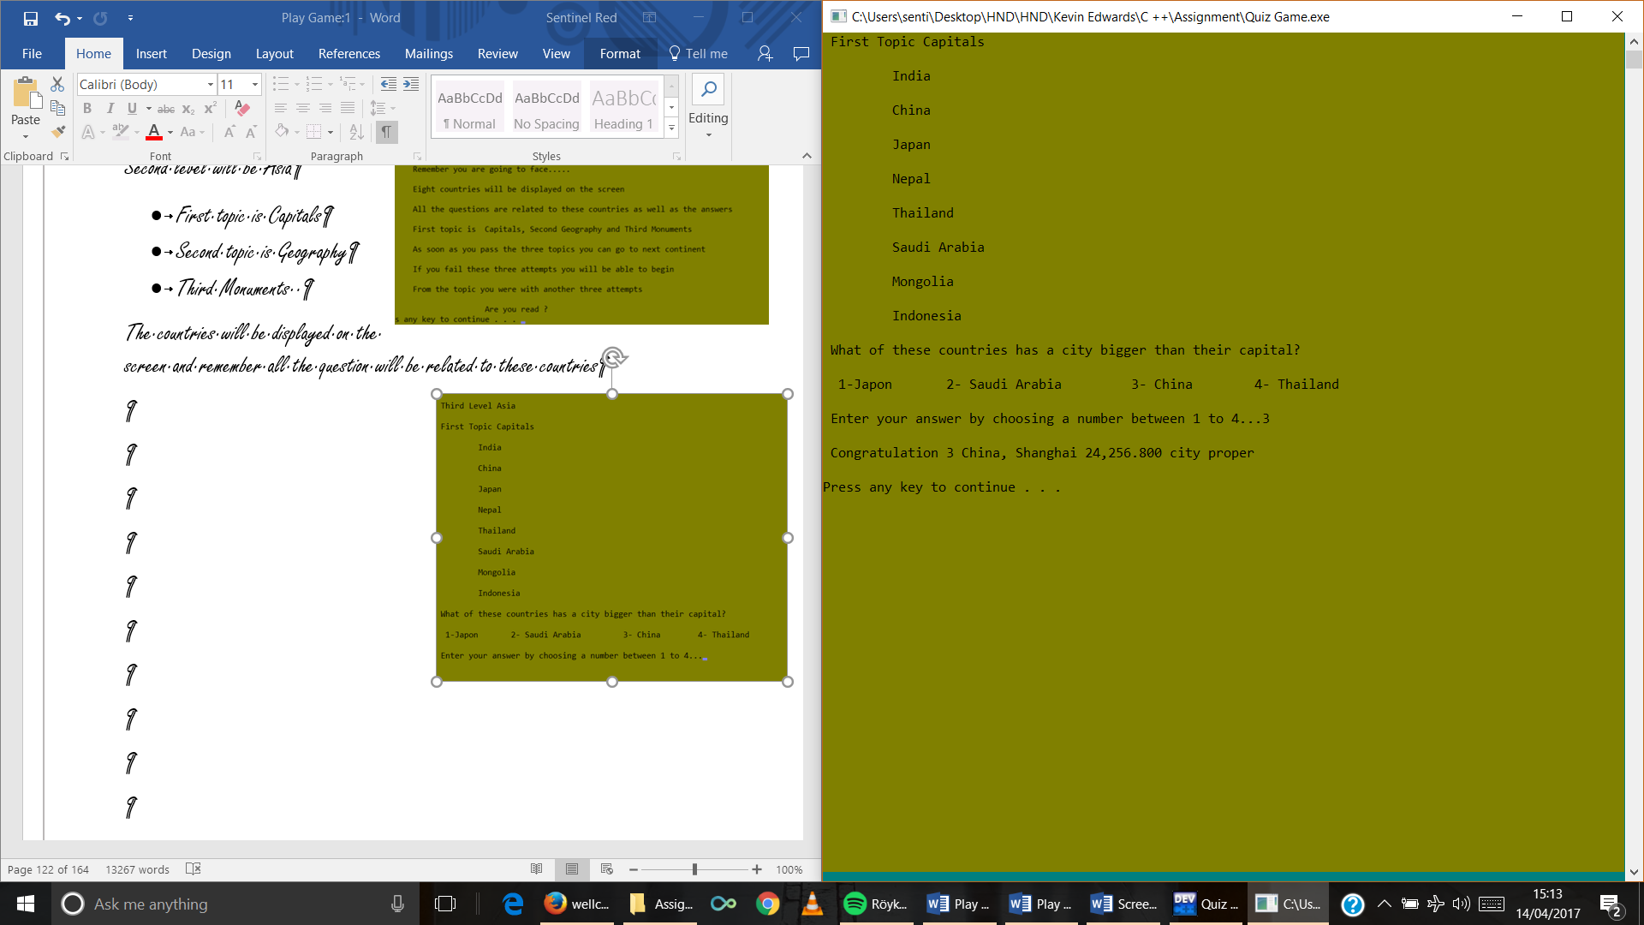

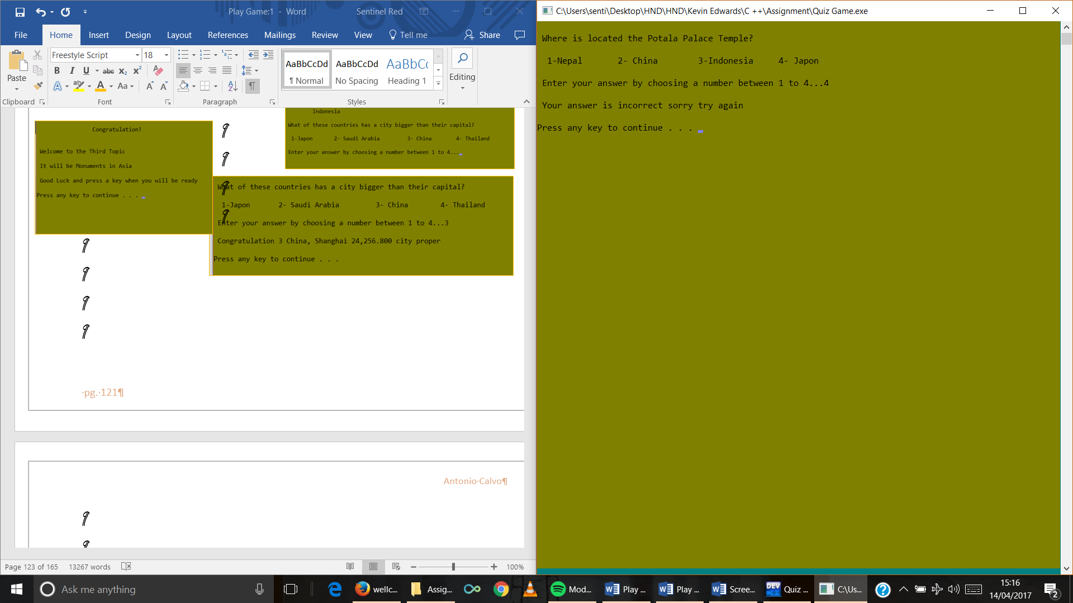

1. Fourth Level

When the player pass the Fourth level a presentation screen will remind the player the Game’s rules and will inform him about the new continent and topics are about.

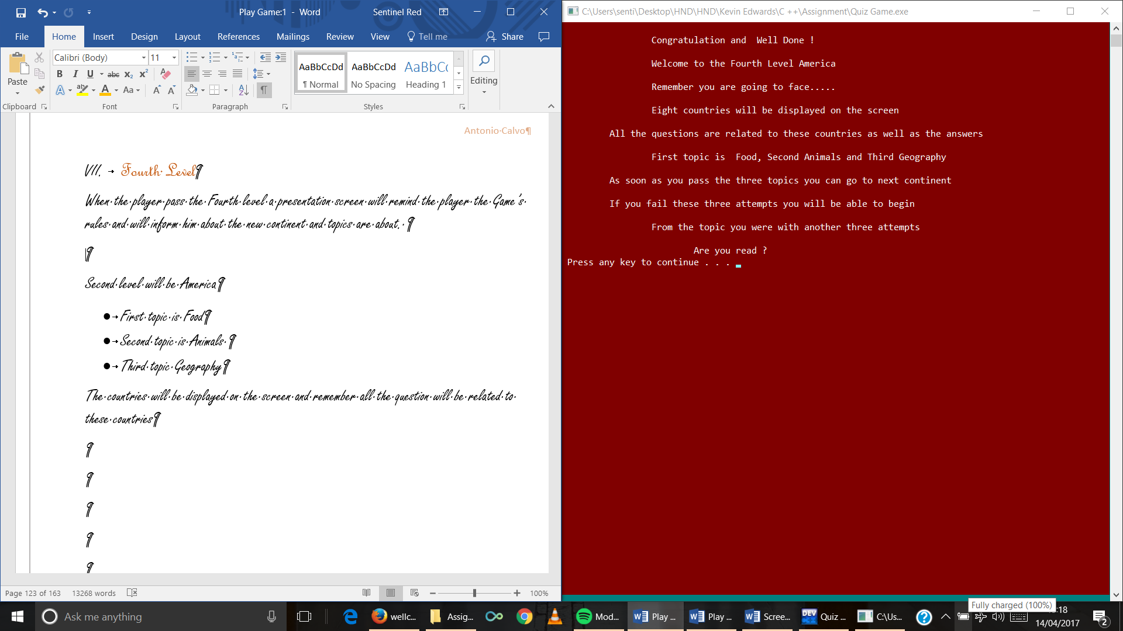

Second level will be America

* First topic is Food
* Second topic is Animals
* Third topic Geography

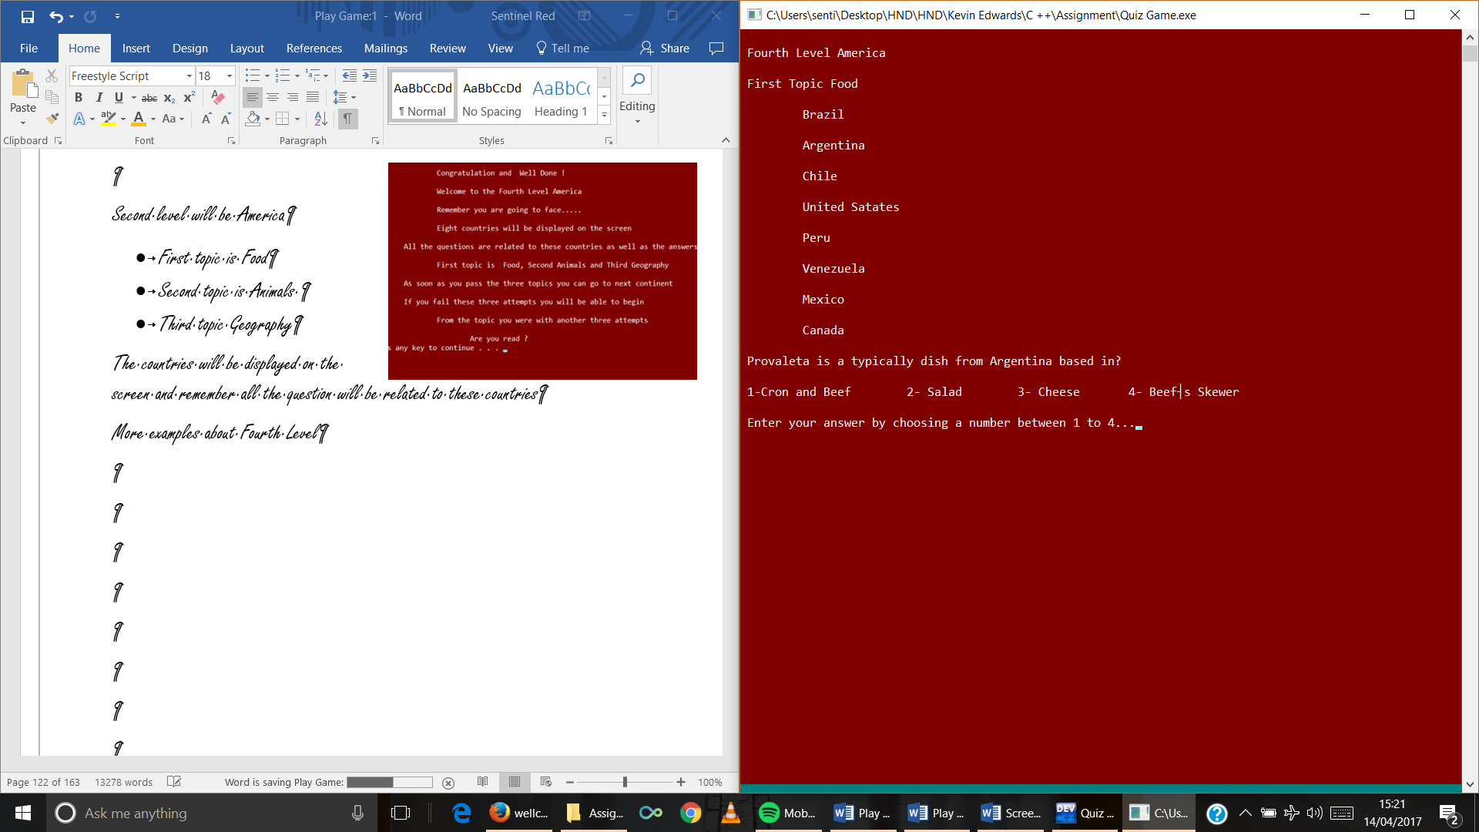The countries will be displayed on the screen and remember all the question will be related to these countries

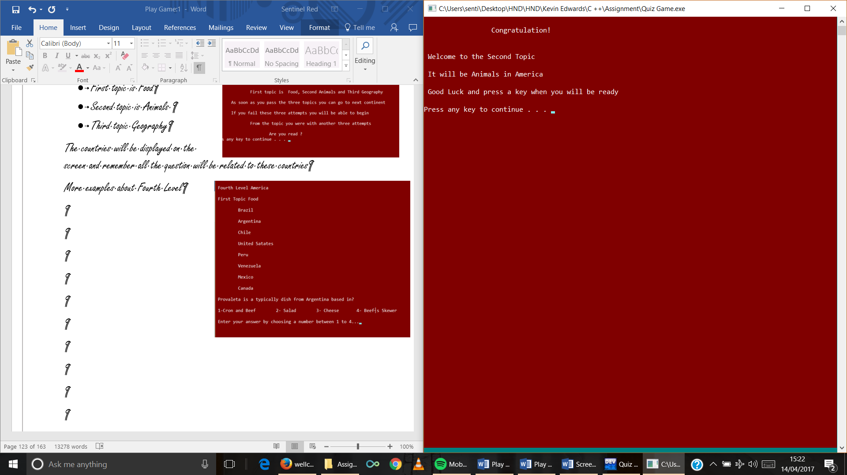More examples about Fourth Level

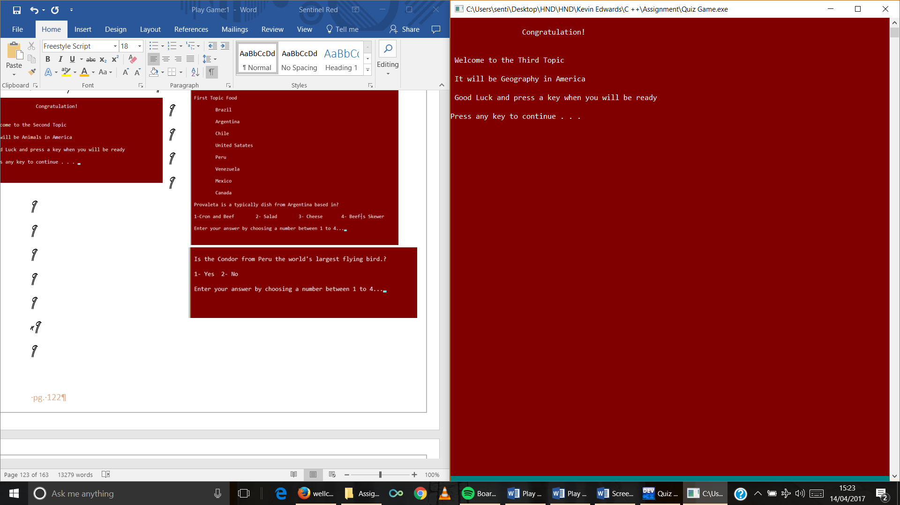

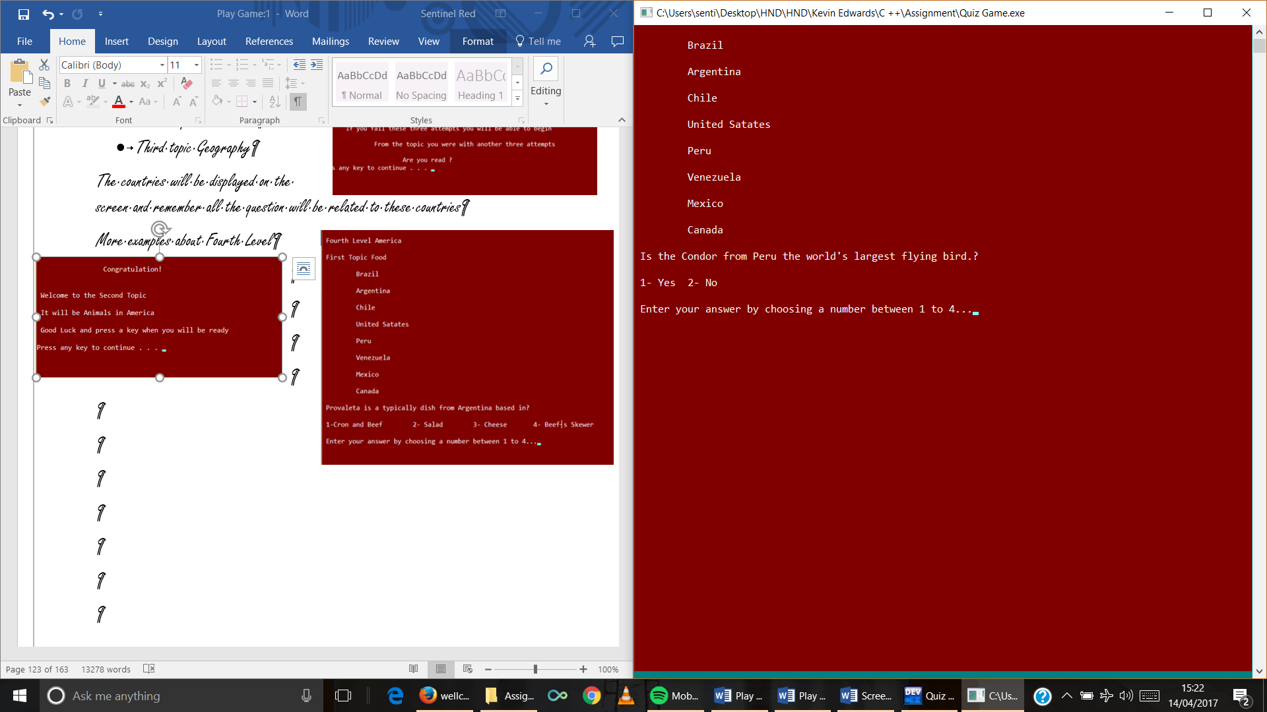

1. Game Over’s screen

When the player passes the Game, and ending screen will pop displaying a small animation, text and GAME OVER.

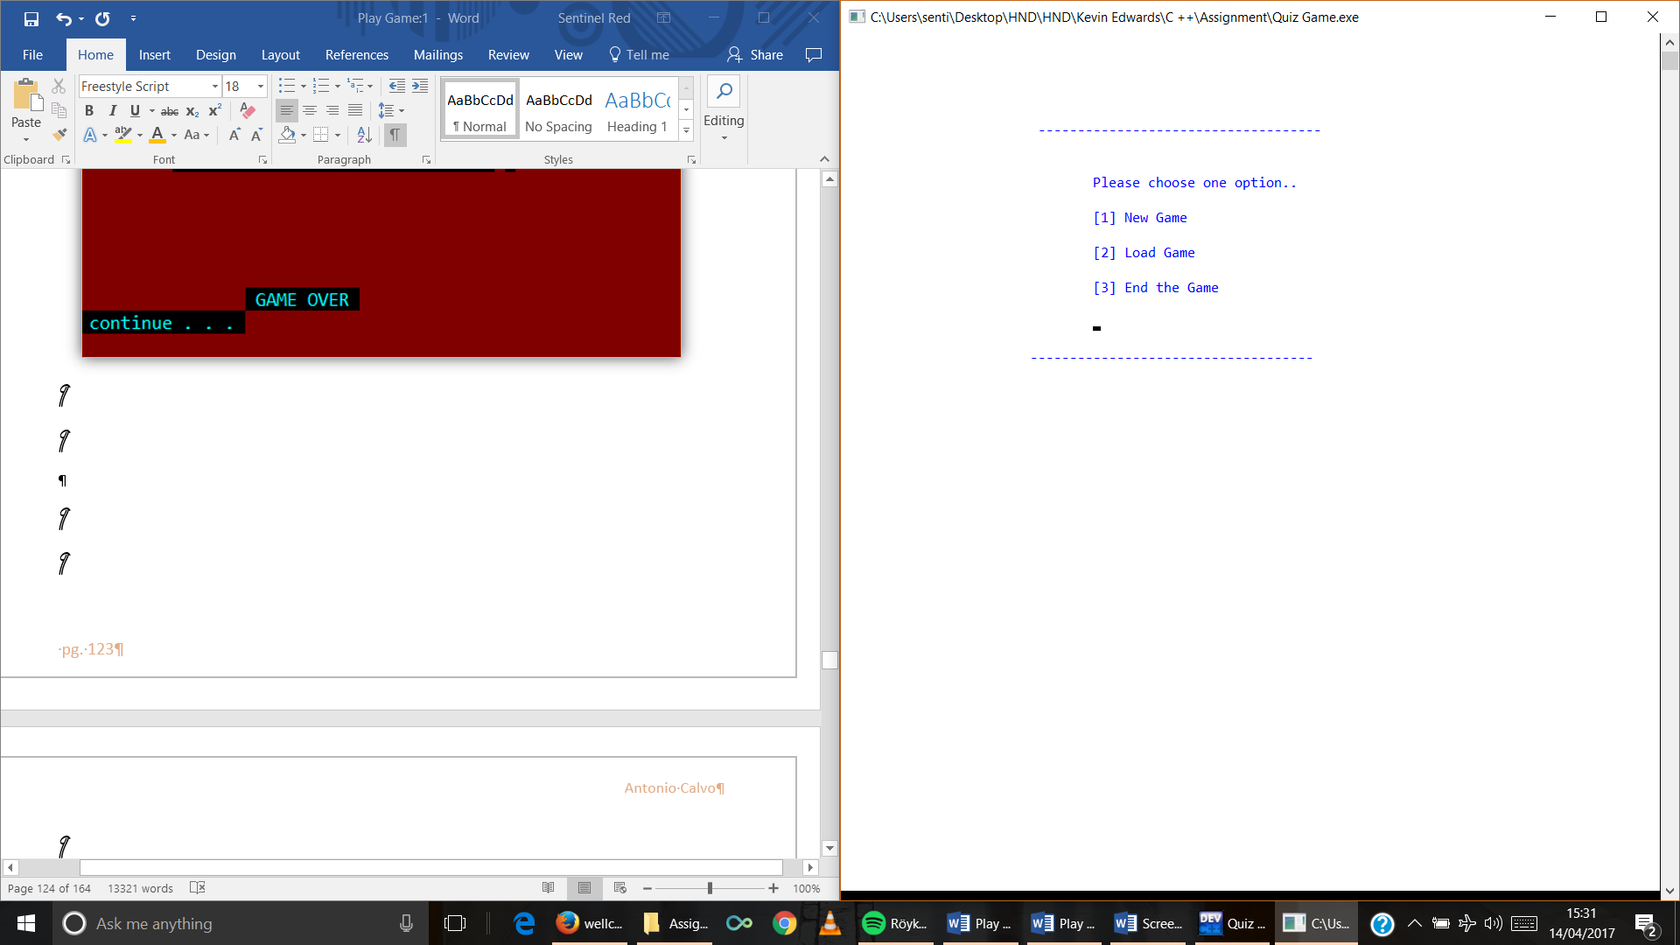When the player finish the game automatically it will return to the Main Menu when the player press a key.

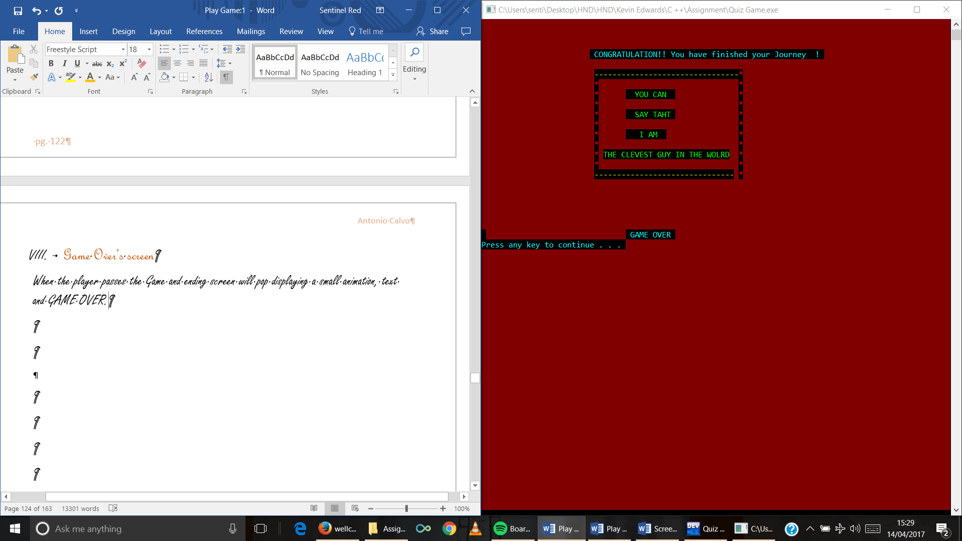

1. Load Game

Choosing number 2 option Load Game the player can open the file was stored.

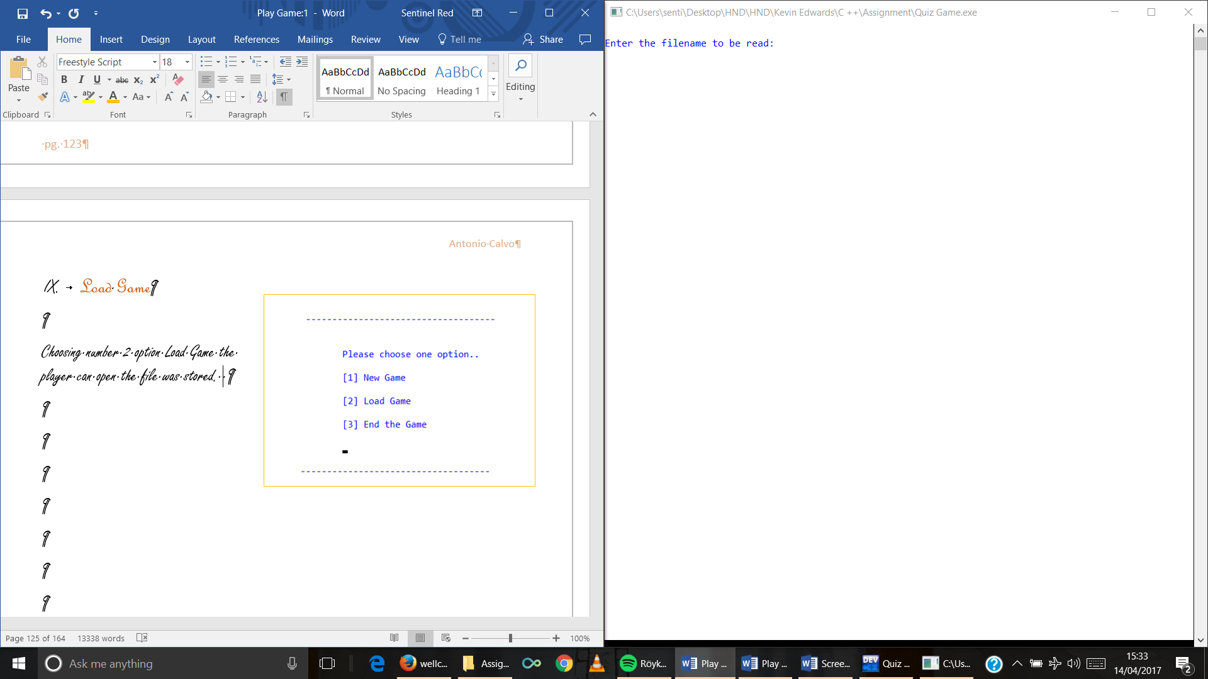

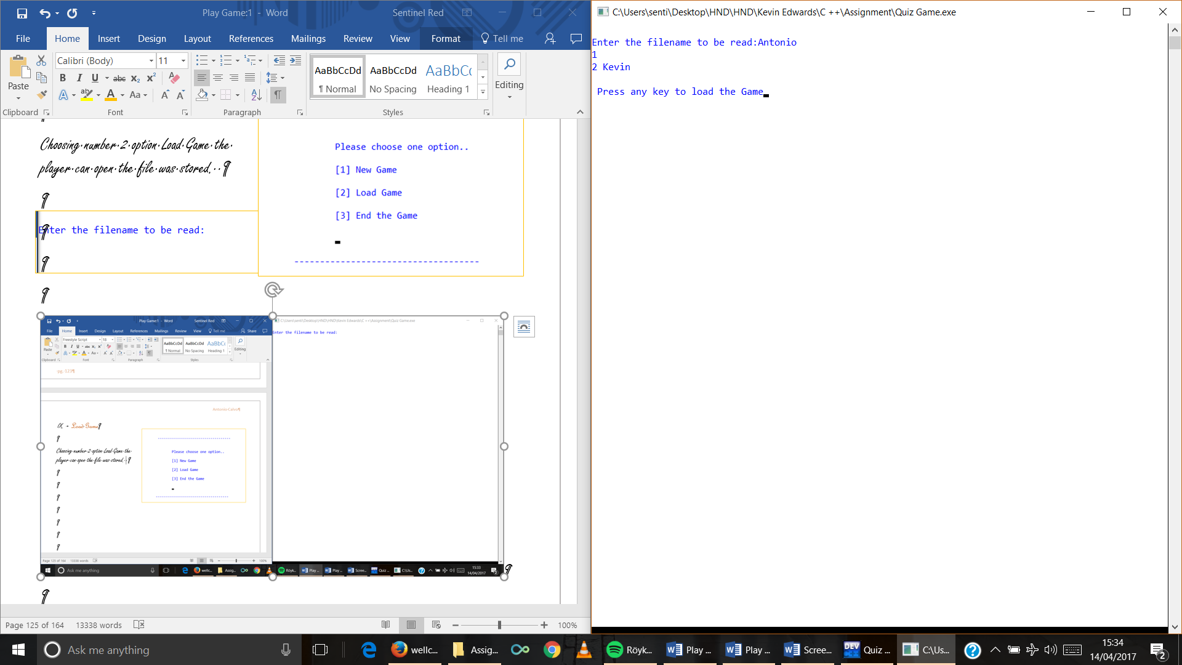Then it will take me to the level It was saved.

The player will be taken to the Second Level.

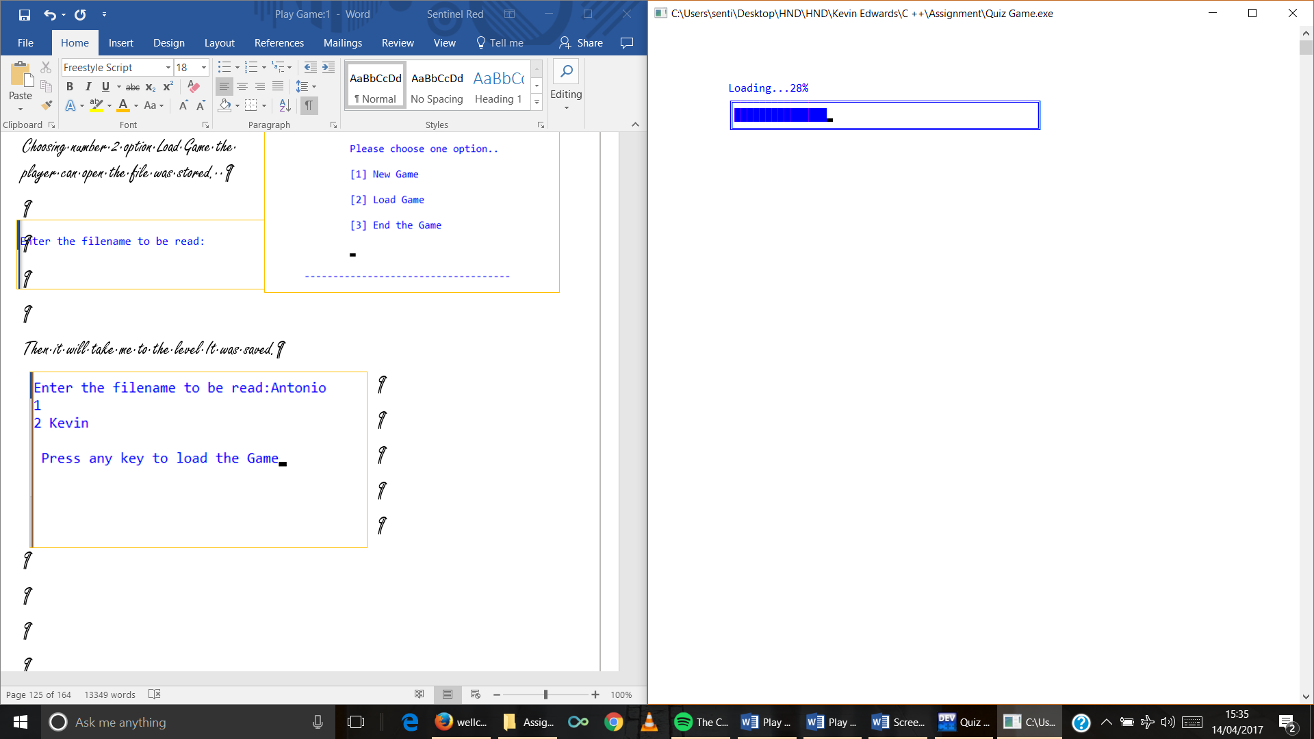

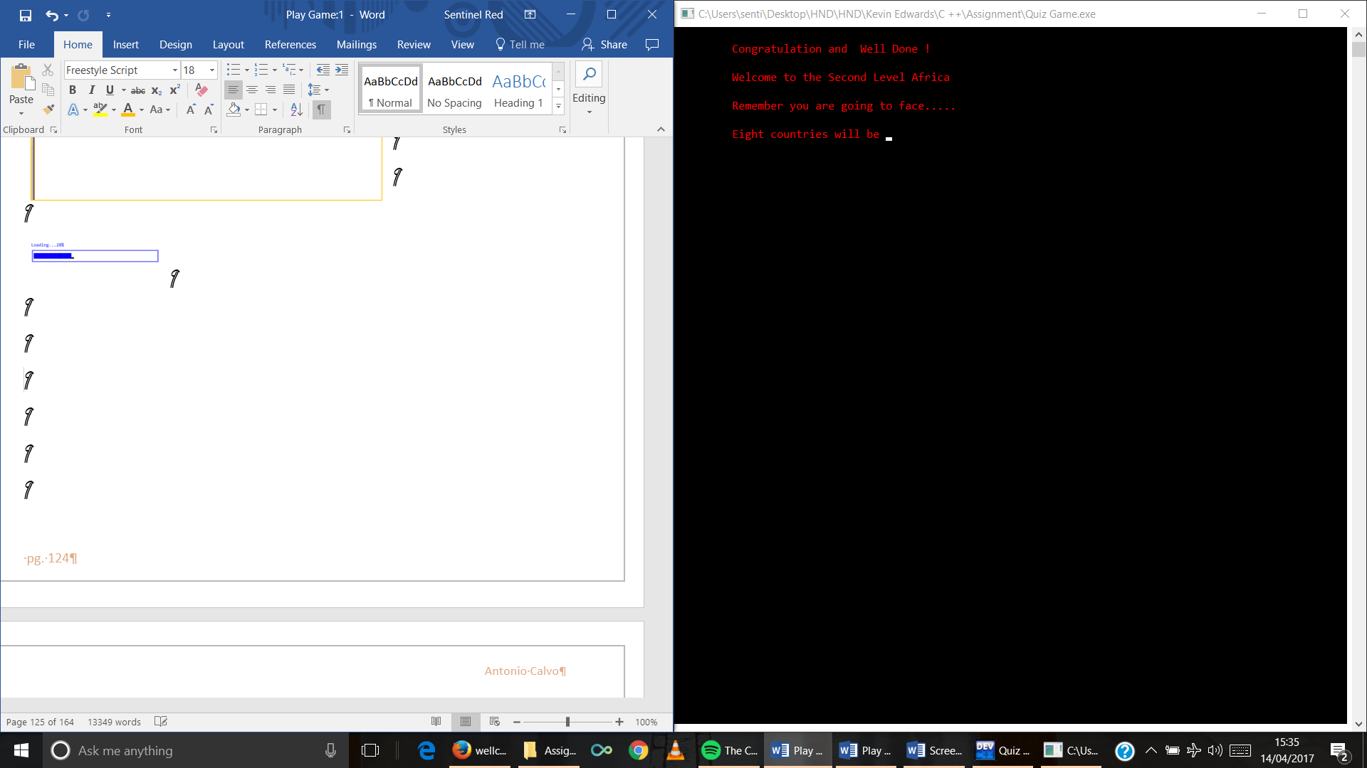

1. End Screen

Choosing End the Game number tree it will take the player to End screen.

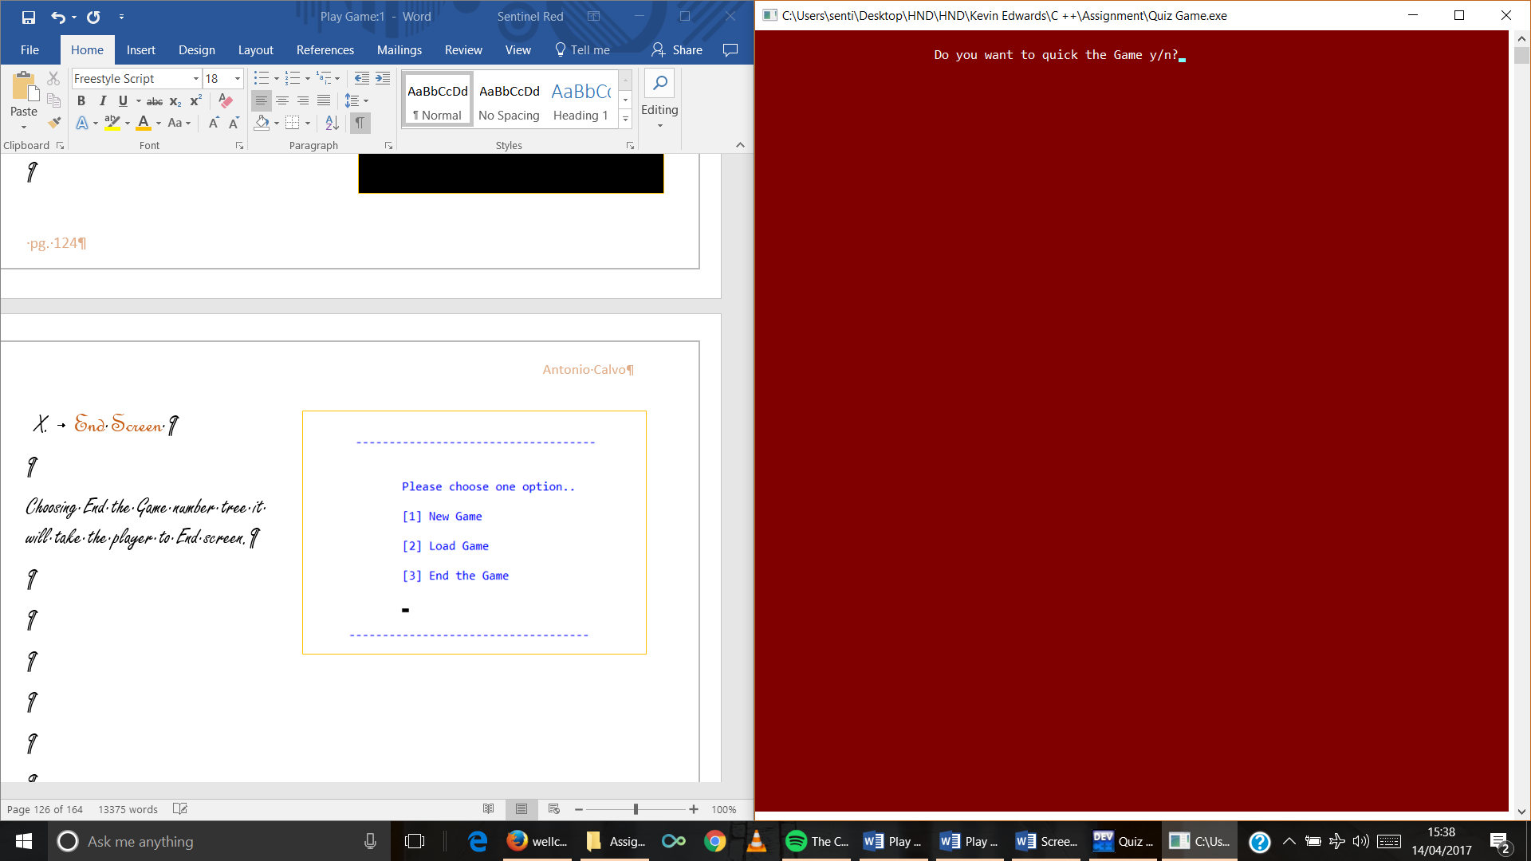

If the player chooses ‘n’ automatically he will be back to the Main Menu

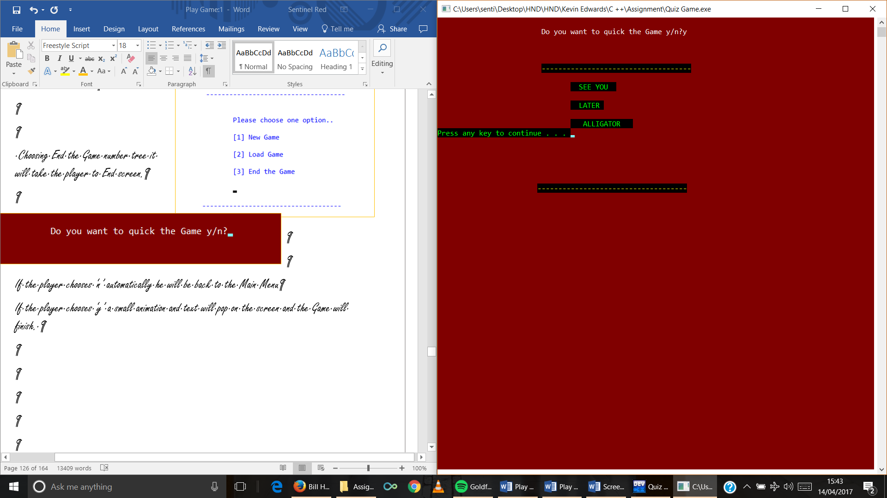If the player chooses ‘y’ a small animation and text will pop on the screen and the Game will finish.

I hope that you will enjoy playing Quiz Around the World….SEE YOU LATER ALLIGATOR.

# Extra Information

This is all the information have got to create the Game as well as the answer of the questions.

Question List.

Europe Countries.

Russia.

Germany.

France.

Italy.

Spain.

Slovakia.

UK.

. Netherlands.

Food

**Russia**

* Borsch (Beet cabbage red soup).
* Pelmeni or Russian dumplings. (dumplings packed meat of lamb, pork or beef)
* Blinis (Crepes )

**Germany**

* Wurst (sausage) Bratwurst (Fried sausage made of ground pork and spices.)
* Rote Grutze (Red fruit pudding )
* Bezel (soft, white pretzels made and sometime different seeds on.)

**France**

* Chocolate soufflé (Crispy chocolate crust with an oozing creamy chocolate )
* Beef Bourguignon (A Stew made of beef braised in red wine.)
* Confit de canard (Duck’s dish marinated in salt, garlic and thyme.)

**Spain**

* Tortilla Espanola (Spanish’s potato omelette)
* Paella (Rice based)
* Gazpacho or salmorejo (Chilled tomato soup)

**Netherlands**

* Pannenkoeken (Dutch pancakes )
* Erwtensoep (pea soup other vegetable plus potatoes and pork)
* Bitterballen (little meatballs made of beef or chicken, veal or mushroom.)

**UK (England)**

* Fish and chips (fish (cod haddock or plaice) dipped in batter and deep fried)
* Sunday Roast (Meet (Lamb, pork or chicken) dish with a selection of vegetable roast potatoes, carrots, onion. )
* Full English breakfast (fried bacon, a sausage, a fried tomatoes and slice of fried bread.)

**Italy**

* Bruschetta (Bread sliced and topped with different toppings)
* Tiramisu (sponge finger soaked in coffee with a creamy mascarpone. )
* Pizza (pipping hot pizza (tomato and cheese) with a big range of ingredients which ca be mixed on.)

<http://food.ndtv.com/lists/10-best-italian-recipes-699798>

**Slovakia**

* Halusky (sheep cheese gnocchi with small pieces of bacon)
* Kapustnica (Cabbage Soup smoked meat sausages and mushrooms )
* Zemlovka (sweet pudding made form apples.)

1. What is a typical dessert in Italy?

1-Tiramisu 2-Zemlovka 3-Pannenkoken 4-Confit de canard

Solution is: 1-Tiramisiu (sponge finger soaked in coffee with a creamy mascarpone.)

1. What is a Sunday Roast?
2. Bread sliced and topped with different toppings.
3. Pea soup other vegetables plus potatoes and pork.
4. Rice based.
5. Meet (Lamb, pork or chicken) dish with a selection of vegetable roast potatoes, carrots, onion.

Solution is: 4- Meet (Lamb, pork or chicken) dish with a selection of vegetable roast potatoes, carrots, onion.

1. What is a typical dish from Russia?

1-Rote Grutze 2-Beef Bourguignon 3- Pelmeni 4- Pizza

Solution is: 3 Pelmeni or Russian dumplings. (dumplings packed meat of lamb, pork or beef)

1. What is a Paella?
2. Dumplings packed meat of lamb, pork or beef Pea soup other vegetables plus potatoes and pork.
3. Soft, white pretzels made and sometime different seeds on.
4. Duck’s dish marinated in salt, garlic and thyme.
5. Rice based

Solution is: 4- Rice based

1. Where does Wurst come from?

1-Germany 2- Italy 3- Netherlands 4- Russia

Solution 1Germany Bratwurst (Fried sausage made of ground pork and spices.)

1. Is Halusky a typical dish from?

1-Germany 2-Slovakia 3- Netherlands 4- Spain

Solution 2- Slovakia sheep cheese gnocchi with small pieces of bacon.

Capital

1. What is the capital of Slovakia?

1-Bratislava 2-Rome 3- Paris 4- Madrid

Solution 1 Bratislava

What is the capital of Roma?

1-Spain 2-Russia 3- Netherlands 4- Italy

Solution 2 Roma

1. Is Madrid the capital of?

1-Russia 2-Slovakia 3- Netherlands 4- Spain

Solution 4 Spain

1. Is Moscow the capital of?

1-Germany 2-Slovakia 3- Russia 4- Spain

Solution 3 Russia

1. What is the capital of Italy?

1-Berlin 2-Paris 3- Amsterdam 4- Rome

Solution 4

1. What is the capital of France?

1-Bratislava 2- Paris 3- Moscow 4- Rome

Solution 4

1. Berlin is the capital of?

1-Slovakia 2- Netherland 3- Germany 4- Italy

Geography

**Russia**

* Moscow baggiest city in population
* The Volga River is the longest river in Europe 2,290 miles.
* Mount Elbrus is the highest mountain (5,642)
* Ural Mountains with a length of 2,500 Km

**Germany**

**Italy**

* Vatican City is the smallest city with 110 acres and with 800 people

**Slovakia**

**France**

* Mont Blanch Third highest mountain (4,810)

**Spain**

**Netherlands**

**UK(England )**

1. What is the biggest river in Europe?

1-Ebro 2- Danube 3- Volga 4- Rin

Solution 3 The Volga River is the longest river in Europe 2,290 miles.

1. What is the smallest city in Europe?

1-Vatican City 2- San Marino 3- Valletta 4- Monaco

Solution 1 Vatican City is the smallest city with 110 acres and with 800 people

1. Mont Elbrus is the biggest mount in Europe and is it located in?

1-Geramany 2- Italy 3- France 4- Russian

Solution 4 Russian Mount Elbrus is the highest mountain (5,642 metres)

1. Which of this city hasn’t canals into the city?

1-Brujas 2- Barcelona 3- Utrecht 4- Venice

Solution 2 Barcelona

1. What is the biggest range of mountains in Europe?

1-Capatos 2- Alps 3- Ural 4- Pyrenees

Solution 3 Ural Mountains with a length of 2,500 Km and is the border between Russian and Asia.

1. Where is located the Alhambra Palace?

1-Spain 2- France 3- Germany 4- England

Solution 1Spain (Granada)

Africa Countries.

Madagascar

Morocco

Egypt

Zambia

South Africa

Congo

Tanzania

Kenya

**Madagascar** –

* Antananarivo Capital
* Madagascar is the largest Africa island which is located off the East coast of Africa and it is the 4th largest island in the world.
* Lemurs are clade of primates’ endemic to the island of Madagascar.

**Morocco** –

* Rabat Capital
* Atlas Mountain located in Tublkal National Park (4,167 metres)

**Egypt**

* El Cairo Capital
* El temple de Karnak (Ciudad Luxor) Amon The Great pyramid of the world in Khufu Pyramid of Khufu or Pyramid of Cheops (230 metres) and it is the oldest. Pyramid of Khafre or of Chephren (215.5 metres Pyramid of) second Red Pyramid of Menkaure located in Giza 215 metres
* Rio Nile The longest river in Africa which a runs a total distance of 4,160 miles. The Nile River is also the longest river in the world.
* Egypt Nile crocodile is the second largest crocodile in the world.
* Cairo the biggest city and the second in Africa after Lagos Nigeria

**Zambia**

* Lusaca Capital
* Victoria Falls “The Smoke that Thunders” called the greatest curtain of falling water in the world.
* They speak English.

**Congo**

* Brazzaville
* They speak French
* The Congo River is the second largest river in the world by discharge after the Amazon and the world´s deepest river with measure depths in excess of 22om.
* Coltan Precious mineral used primarily for the production of tantalum capacitors used in many electronic devices such as mobile phones and almost used in every kind of electronic device.
* Largest diamond producer and the third largest in the world by volume

**Tanzania** –

* Dodoma capital
* Olduvai in Tanzania is one of the most important paleoanthropological sites in the world. Very important for understanding of early human evolution. It is placed in the Great Rift Valley.
* Mount Kikimanjaro approximately 4,900
* Most complete skeletons Turkana boy

**Tanzania**

* Selous Capital
* Game Reserve 55,000 the second biggest park in Africa

**Kenya**

* Capital Nairobi
* Mount Kenya 5199 The highest peaks of the mountain are Batian 5199 metres. It is the highest mountain in Kenya and the second highest in Africa.
* Ostrich The larges bird in the world they can reach a height 2.6 and weight for 135kg the cannot fly but they are very fast runners.

**South** **Africa**

* The second biggest country in Africa (1,219.090)
* There are 3 different capitals. Pretoria executive power Bloemfontein Judicial power and Ciudad del Cabo del power legislative
* White Rhino it is the stronghold for this species they are the biggest rhinos in the world and

Capitals

1. What is the capital of Kenya?
2. Nairobi 2- Ciudad del Cabo 3- Dodoma 4 Cairo

Solution; 1-Nairobi

1. What is the capital of Egypt?
2. Antananarivo 2- Lusaka 3- Ciudad del Cabo 4 Cairo

Solution; 4-Cairo

1. What is the country with more than one capital?
2. Congo 2- Kenya 3- South Africa4 Tanzania

Solution; 3 South Africa

1. Is Casablanca the capital of Morocco?
2. Yes 2- No

Solution; 2 No

1. Is Brazzaville capital of?

1- Congo 2- Madagascar 3- Tanzania 4 Egipto

Solution; 1 Congo

1. Which of them is a capital of South Africa?
2. Nairobi 2- Lusaka 3- Pretoria 4 Dodoma

Solution; 3 Pretoria.

Animal

1. Where are Lemurs from?

1-Congo 2- Zambia 3- Madagascar 4 Kenya

Solution; 3 Madagascar.

1. Where is located the biggest population of White Rhino?

1-Zambia 2- Tanzania 3- Madagascar 4 South Africa

Solution; 4 Shout Africa. It is the stronghold country at Kruger National Park

1. Where are located the biggest population of ostrich?

1-Morroco 2- Kenya 3- Madagascar 4 Congo

Solution; 2 Kenya They are the largest birds in the world and they cannot fly.

1. The biggest crocodrile in Africa is located in?

1-Egypt 2- Kenya 3- South Africa4 Tanzania

Solution; 1 Egypt Nile crocodrile is the second largest crocodile in the world.

1. Where is living the biggest Gorilla in the world?

1-Kenya 2- Madagascar 3- Tanzania 4 Congo

Solution; 4 Congo The Greatest and biggest apes is only found in the forests of Congo.

1. Where can be found the Africa Elephant?

1-Egypt 2- Kenya 3- Madagascar 4 Tanzania

Solution; 2 Kenya Masia Mara National Park has a big population of Africa’s elephant living it.

Geography

1. What is the biggest river in Africa?

1-Kasai River 2- Congo River 3- Nile River 4 River Niger

Solution; 3 Nile River is the longest river in Africa(6,853Km)

1. Where is the biggest falls in Africa?

1-Congo 2- Tanzania 3- Morocco 4 Zambia

Solution; 4 Zambia Victoria Falls or “The Smoke that Thunders” is called too is the greatest curtain of falling water in the world.

1. What is the deepest river in Africa?

1-Kasai River 2- Congo River 3- Nile River 4 River Niger

Solution; 2 Congo River It deepest river in the world with Deep in excess of over 200 metres.

1. Where is the highest mountain in Africa located?

1-Egypt 2- Zambia 3- Morocco 4 Tanzania

Solution; 4 Tanzania Kilimanjaro or Kibo is the highest mountain in Africa with 5885 metres

1. Where can be found the very important mineral called “Coltan”?

1-Congo 2- Zambia 3- South Africa4 Tanzania

Solution; 1 Congo It is a vital element in creating capacitors for electronics elements that control current flow inside miniature circuit boards (It is used almost all cell phones, laptops etc.).

1. What is the biggest Pyramid in world?

1-Pyramid of Khefre 2- Pyramid of Menkaure 3- Pyramid of Cheops 4 Pyramid Saqqaa

Solution; 3 Pyramid of Khufu or (Pyramid of Cheops) it is the oldest and largest highest with 146.5 metres.

Asia Countries.

India

China

Japan

Nepal

Thailand

Saudi Arabia

Mongolia

Indonesia

Capital

**India**

* Tag Mahal, Agra It combines elements of Mahal Persian, Ottoman Turkish and Indian architectural styles.
* Delhi
* Victoria Memorial located in the capital of West Bengal. One of the major attraction of Kolkata and serves as a museum.
* Brihadishware Temple is one of the India’s largest temple located in the Thanjavur . .

**China**

* Beijing
* Shanghai 24,256.800 city proper
* Lama Temple in Beijing also Known as the Harmony and Peace Palace Lamasery.
* Potala Palace in Lhasa in the capital of Tibet 3,650 metres above sea level.
* The Great Wall with a length of 21,196.18 Kilometres

**Japan**

* Tokyo Largest city in Asia by Population 37.8 million metropolitan area.
* The Great Buddha of Kamajura is a colossal outdoor representation of Amida Buddha.
* Kinkaku-ji or Temple of Golden Pavilion is most popular tourist attraction in Japan and Tokyo
* Moutn Fuji is the highest mountain in Japan at 3,776 metres.

**Nepal**

* Kathmandu
* Dubar Square of Kathmandu it is a Durbar Square.

**Thailand**

* Bangkok is the city which has been visited the most.
* Grand Palace of the Kings of Siam is the most famous attraction in the bustling city of Bangkok
* Phang Nga bay Beautiful caves aquatic grottoes and limestone islands.Nepal
* Nepal

**Saudi Arabia**

* Riad
* Medain Saleh parcel archaeological site in Saudi Arabia
* Mecca Masig Al Haram it is the largest mosque in the world

**Mongolia**

* Ulan Bator
* Genghis Khan Equestrian Statue 40 metres at Tsonjin Bodog

**Indonesia**

* Jakarta
* National Monument in Jacarta with 132 metres built to commemorate the struggle for Indonesian independence

Capitals

1. What is the capital of Indonesia?

1-Bangkok 2- Ulan Bator 3- Kathmandu 4- Jakarta

Solution 4 Jakarta with a population of 10,075,310

1. What of these countries has a city bigger than their capitals?

1-Japon 2- Saudi Arabia 3- China 4- Thailand

Solution 3 China, Shanghai 24,256.800 city proper

1. What is the biggest capital in Asia by population including his metropolitan area?

1-Delhi 2- Tokyo 3- Bangkok 4- Kathmandu

Solution 2 Tokyo Largest city in Asia by Population 37.8 million metropolitan area.

1. What is the capital of Nepal?

1-Delhi 2- Tokyo 3- Kathmandu 4- Riad

Solution 3 Kathmandu.

1. What is the capital most visited in Asia in 2016?

1-Bangkok 2- Tokyo 3- Beijing 4- Jakarta

Solution 1 Bangkok estimated 21,47m overnight visitors expected.

1. What is capital of Mongolia?

1-Kathmandu 2- Jakarta 3- Ulan Bator 4- Riad

Solution 3 Ulan Bator.

Geography

1. Where is the biggest statue of Buddha in Asia?

1-India 2- Japan 3- China 4- Nepal

Solution 3 Standing 502 feet with a 660-foot lotus throne. It is in China’s Henan province is the world’s tallest statute.

1. Gobi Desert is the largest desert in Asia what are the countries it is extended.

1-India and China 2- Thailandand India 3- China and Mongolia

4- India, Mongolia and China

Solution 3 China and Mongolia covering 500,000 square miles. Extending from northern China and into Mongolia.

1. What is the largest Island in Asia?

1-Sumatra 2- Honshu 3- Borneo 4- Celebes

Solution 3 Borneo is the largest island in Asia with 743,330 km2

1. What is the largest river in Asia?

1-Lena River 2- Indus River 3- Ural River 4- Mekong River

Solution 4Mekong River the length is estimated over 4,350 Km and cross China, Myanmar, Laos, Thailand, Cambodia and Vietnam

1. Where is located Mecca?

1-India 2- Indonesia 3- Saudi Arabia 4- Nepal

Solution 3 Saudi Arabia

1. What is the longest range of mountain in Asia?

1-Karakoranm 2- Pamir 3- Hindu Kush 4- Himalayas

Solution 4 Himalayas with Length of Range 2,400 and 8,848 Peak height (Mount Everest)

Monuments

1. What is most visited monument in Asia?

1-Brihadishware Temple 2- KinKaku-ji 3-The Great Wall 4- Genghis Khan Equestrian Statute

Solution 3 The Great Wall with a length of 21,196.18 Kilometres

1. What is the largest Temple in India?

1- Brihadishware Temple 2- Badrinath Temple 3- The Konark Sun Temple 4- Kedarnth Temple

Solution 1 Brihadishware Temple is one of the India’s largest temple located in the Thanjavur . .

1. Where is the Tag Mahal Located?

1-India 2- Japan 3- Saudi Arabia 4- Thailand

Solution 1 India. Tag Mahal, Agra It combines elements of Mahal Persian, Ottoman Turkish and Indian architectural styles.

1. Where is located the Potala Palace Temple?

1-Nepal 2- China 3-Indonesia 4- Japan

Solution 1 Potala Palace It is Dalai Lama’s residence and it is located at 3,650 metres above sea level.

1. What is the largest and biggest mosque in Asia?

1-Al-Azhar 2- Iman Ali 3- Masjdig Al Haram 4- Aymani Kadyrow

Solution 3 Mecca Masig Al Haram it is the largest mosque in the world

1. Where is the tallest statue of Buddha in Asia?

1-India 2- Japan 3- Nepal 4- China

Solution 4 China The Spring Temple Buddha, Henna China Standing 502 feet with a 66-foot lotus throne. It is in China’s Henan province is the world’s tallest statute.

America Countries.

Brazil

Argentina

Chile

United States

Peru

Venezuela

Mexico

Canada

**Brasil**

* Moqueta (fish or seafood are stewed in diced tomatoes, onions and coriander.)
* Feijoada (A black bean stew with various types of beef and sausage.)
* Brigadeiro (Chocolate truffles made with condensed mild instead of cream and covered in chocolate sprinkles.)

**Argentina**

* Provaleta (A large amount of fried melted cheese served with a lot of oregano.)
* Locro (National dish traditionally sever on May 25, made from white corn, beef or pork, tripe and red chorizo as well as other vegetables.)
* Dulce de Leche (Caramelized mild an sugar sauce)

**Chile**

* Caldillo de congrio (Conger eel soup) (it is always steaming hot and served in a clay dish accompanied with mussels and clams)
* Pastel de Choclo (Corn and beef casserole and Humitas)
* Chorillana(Popular Chilean favourite consists of a large plate of sliced beef with French fries covered with either scrambled or fried eggs and fired onion.)

**United Stated**

* Key lime pie(The official state pie of Florida, this sassy tart has made herself a worldwide reputation )
* Cobb salad (Originated back East with lettuce, and avocado, some romaine, watercress, tomatoes, some cold chicken breast, boiled egg, chives, cheese and French dressing. )
* Thanksgiving dinner (Meal of turkey roasted or deep fried dressing old loaf bread or cornbread, cranberry sauce, masked and sweet potatoes, green bead onion rings and pumpkin pie. )

**Peru**

* Ceviche(Bite size chunks of raw white fish, normally sea bass, which is marinated in lemon, onion and chilies and served with boiled sweet potatoes and corn.)
* Lumuca (Tree fruit that looks like a mango, and served with a variety of ice cream.)
* Anticuchos (Skewers of grilled, marinated meat)

**Venezuela**

* Arepa (Cornmeal bread that can be grilled, fired, baked or streamed filling of beef, pork or eggs.)
* Tajadas (Fried ripe plantain slices which are caramelized go give a sweet taste.)
* Chivo al coco (Goat meat is cooked with coconut milk and served with mofongo)

**Canada**

* Poutine (Glorious Montreal smoked meat sandwich)
* Nanaimo bars (Usually make of chocolate ganache, vanilla custard, and crushed cookies.)
* Tourtiere (Traditional Quebecois meat pie that´s usually made with beef, pork or veal)

**Mexico**

* Chilaquiles (Tradicional breakfast dish features lightly fried corn tortillas cut into quarters and topped with Green or red salsa. Scrambled or fired eggs and pulled chicken.)
* Elote (Name for corn on the cob in Mexican. Traditionally boiled and served either on a stick or in cups)
* Mole(Mole comes in many different flavours and varieties containing a complex mixture of more than 20 ingredients from chili peppers to chocolate. Black and green moles are most common. )

Food

1. What is a typically food from Brazil?

1-Locro 2- Ceviche 3- Cobb salad 4- Moqueta

Solution 4 Moqueta (fish or seafood stewer in diced tomatoes, onions and coriander.)

1. Lumuca is a Tree fruit that looks like a mango and served with a variety of ice cream which comes from?

1-Peru 2- Mexico 3- Venezuela 4- Canada

Solution 1 Peru.

1. What is a typically food from Venezuela?

1-Caldillo de congrio 2- Provaleta 3- Arepas 4- Mole

* Solution 3 Arepa (Cornmeal bread that can be grilled, fired, baked or streamed filling of beef, pork or eggs.)

1. Cobb salad is romaine lettuce, avocado watercress, tomatoes, some cold chicken breast boiled egg, cheese and French dressing, so where does it comes from?

1-Chile 2- United Stated 3- Mexico 4- Canada

Solution 2 United Stated

1. Provaleta is a typically dish from Argentina based in?

1-Cron and Beef 2- Salad 3- Cheese 4- Beef´s Skewer

* Solution 3 Cheese (Provaleta A large amount of fried melted cheese served with a lot of oregano.)

1. Poutine is a dish from Canada which is?

1-Tradicional Breakfast 2- Sandwich 3- Dissert 4- Traditional meat pie

Solution 2 Sandwich (Poutine - Glorious Montreal smoked meat sandwich)

Animal

**Brazil**

* Anacondas (The largest snaked found in tropical South America)
* Amazon River Dolphin (They look pretty prink and can grow even bigger that humans)
* Goliath birdeater, it is the largest Tarantula in the world by mass and size.

**Argentina**

* Ñandu o Suri It is the biggest bird in Argentina and she cannot fly

**Chile**

* Megellanic Penguin where there is the biggest community of them. Sea lions

**United Stated**

Grizzly bear is a large subspecies of brown inhabiting North America

**Peru**

* Pero has some of the greatest biodiversity in the world because of the presence of Andes and amazon Rainforest. And Pacific Ocean
* It is the largest of South American camelids. Used as a pack animal, and its meat is consumed in Bolivia and in Peru only dried called Charki.
* Condor The condor is a scavenger and is the world’s largest flying bird with more than 1m tall and wingspan of 3.80m.

**Venezuela**

* Venezuela’s plain region is home to the Capybara which is the world’s largest rodent. He can weigh up to 100 pounds and live most of their lives in water.

**Mexico**

* Axolotl is an iconic Mexican creature is super weird looking and in critical danger of extinction. Typically found inhabiting the rivers and lakes of central Mexico
* Xoloitzcuintli it is a domestic dog breed. Hairless dogs are typically of medium saw and black.

**Canada**

Moose or elk is part of the deer family and they are the largest extant species in the deer family.

Bighorn sheep native to North America. These horns can weigh up to 14 kilograms

1. Where river Dolphin can be found?

1-Peru 2- México 3- Brazil 4- Canada

Solution 3 They look pretty prink, they are the largest species of river dolphin and can grow even bigger that humans.

1. Where does the biggest bird cannot fly come from in American continent?

1-Argentina 2- United Estate 3- Brazil 4- Canada

Solution 1 Ñandu o Suri It is the biggest bird in Argentina and she cannot fly

1. Venezuela has the largest rodent living in the world what is his name?

1- Xoloitzcuintli 2- Charki 3- Moose 4- Capybara

* Solution 4 Venezuela’s plain region is home to the Capybara which is the world’s largest rodent. He can weigh up to 100 pounds and live most of their lives in water.

1. Axolotl is an iconic creature super weird looking and in critical danger of extinction where does creature comes from?

1-Argentina 2- Mexico 3- Brazil 4- Canada

* Solution 2 Axolotl is an iconic Mexican. Typically found inhabiting the rivers and lakes of central Mexico

1. What is Goliath birdeater ?

1- Dog breed 2- Grizzly bear 3- Anacondas 4- Tarantula

* Solution 4 Goliath birdeater, it is the largest Tarantula in the world by mass and size. It can be found in Brazil.

1. Is the Condor from Peru the world’s largest flying bird.?

1- Yes 2- No -

Solution 2 Yes The condor is a scavenger and is the world’s largest flying bird with more than 1m tall and wingspan of 3.80m.

Geography

**Brazil**

**Argentina** Aconcagua is the highest mountain outside Asia at 6,961 metres.

**Chile**

**United Stated (**Superior lake is the largest of the Great Lakes of North America and it is the largest freshwater lake in the world by surface area.)

It is the largest states in the Unites States by area

**Peru**

Inca citadel situated on mountain ridge 2,430 metres above sea level.

**Venezuela** The world’s highest uninterrupted waterfall, with a height of 979 meters and a plunge of 807 metres. The falls are located inside de Canaima National Park.

**Mexico**

**Canada** (Canada is the largest country of North America in terms of lad surface with an estimates area of 9,984.670 Km2)

1. What is the biggest country in American continent?

1-Argentina 2- Brazil 3- Unite State 4- Canada

Solution 4 Canada is the largest country of North America in terms of land surface with an estimates area of 9,984.670 Km2

1. What is the name of the largest freshwater lake in American continent?

1-Maracaibo 2- Michigan 3- Superior 4- Ontario

Solution 3 Superior lake is the largest of the Great Lakes of North America and it is the largest freshwater lake in the world by surface area.

1. Where is located the highest mountain outside of America?

1-United State 2- Peru 3- Argentina 4- Canada

Solution 3 Argentina. Aconcagua is the highest mountain outside Asia at 6,961 metres.

1. What is the largest state by total area and land are in North America?

1-Alaska 2- Texas 3- California 4- Montana

Solution 1 Alaska. It is the largest states in the Unites States by area

1. Where is Angel Falls located?

1-Peru 2- Venezuela 3- Chile 4- Brasil

Solution 2 Venezuela. The world’s highest uninterrupted waterfall, with a height of 979 meters and a plunge of 807 metres. The falls are located inside de Canaima National Park.

1. Where is Machu Picchu located?

1-Peru 2- Mexico 3- Chile 4- Argentina

Solution 1 Peru Inca citadel situated on mountain ridge 2,430 metres above sea level.

# Evaluation

*I would like to begin saying I have learnt a lot about C++ these weeks. Also, I have enjoyed fighting with the code till It has done every I wanted.*

*When I began this Game, I thought that it would be much easier than It have been. I could realize how many things must be considered to create a piece of code as that. I have never thought a simple Game as I have done it could have so many of code and the dimension it has. To compile the information the Game needed it was my first step to understand that It wouldn’t be as easy as I thought at the beginning. On the other hand, thanks for that I know more information about many topics than before.*

*The structure of the code and how organise all the functions to make it work was a real challenge. It has been my first time creating a code of this dimension and basically the code must be well structured from the beginning. Otherwise, you can be lost in your own code. In addition to structure code from other sources it can be a good challenge too. Sometimes I have searched different sources to improve my code as well as I took code which was provided to make improvements. However, this code most of the time should be modified to make it work in your code so it is able to belong a part of your own code.*

*Concluding during this assignment I could work with code as I haven’t done before this has made me to improve a lot and also it has made me to feel much confident doing programming. I only have a bad feedback and I would be when I start to feel confident and understand the basics of this language we must move on to another topic and this frustrate me a bit being honest. A part from it, I am happy about I have learnt and how I have improved these weeks working on this assignment.*

*Antonio. Calvo.*